Additional Information

Table S1. Results of joinpoint regression analysis of trends in crop yields, by crop type and district, in Kerala, India, in 2004-2018.

 | Segment 1 |  |  |  | Joinpoint between segments 1 & 2 |  |  |  | Segment 2 |  |  |  | Joinpoint between segments 2 & 3 |  |  |  | Segment 3
 | Annual change | (95% CI) |  |  | Year | (95% CI) |  |  | Annual change | (95% CI) |  |  | Year | (95% CI) |  |  | Annual change | (95% CI)
All districts combined
Banana | 73.29 | (30.90 , | 115.67)
Cardamom | -3.46 | (-18.92 , | 11.99) |  | 2010 | (2006 , | 2014) |  | 44.94 | (29.48 , | 60.39) |  | 2017 | (2014 , | 2017) |  | -210.81 | (-226.27 , | -195.36)
Cashew | -23.78 | (-32.36 , | -15.20)
Plantain | -81.96 | (-169.88 , | 5.96) |  | 2016 | (2015 , | 2016) |  | 9874.62 | (9786.69 , | 9962.54) |  | 2017 | (2016 , | 2017) |  | -10029.70 | (-10117.62 , | -9941.78)
Pulses | 26.92 | (4.49 , | 49.35)
Rice | 36.42 | (22.94 , | 49.91)
Sweet potato | 11376.74 | (11129.57 , | 11623.91) |  | 2005 | (2005 , | 2006) |  | 168.52 | (-78.65 , | 415.69)
Tapioca | -1500.27 | (-3259.91 , | 259.37) |  | 2006 | (2005 , | 2008) |  | 1164.38 | (929.24 , | 1399.52) |  | 2014 | (2007 , | 2016) |  | -136.58 | (-693.03 , | 419.86)
Alappuzha
Banana | 329.67 | (212.44 , | 446.90) |  | 2014 | (2013 , | 2016) |  | -794.90 | (-1271.08 , | -318.73)
Cardamom
Cashew | -15.06 | (-21.38 , | -8.75)
Plantain | -27.60 | (-115.07 , | 59.86)
Pulses | -1017.12 | (-1032.34 , | -1001.90) |  | 2005 | (2005 , | 2006) |  | -7.92 | (-23.14 , | 7.30) |  | 2017 | (2016 , | 2017) |  | 677.44 | (662.22 , | 692.66)
Rice | 36.08 | (-0.58 , | 72.75)
Sweet potato | 0.00 | (-79.80 , | 79.80) |  | 2009 | (2008 , | 2010) |  | -1538.23 | (-1618.03 , | -1458.44) |  | 2010 | (2009 , | 2011) |  | 51.59 | (12.65 , | 90.53)
Tapioca | 383.64 | (-556.25 , | 1323.52)
Ernakulam
Banana | 95.63 | (26.23 , | 165.03) |  | 2017 | (2015 , | 2017) |  | -2598.63 | (-2668.03 , | -2529.23)
Cardamom
Cashew | -2.58 | (-29.45 , | 24.28) |  | 2007 | (2005 , | 2011) |  | -46.62 | (-73.49 , | -19.76) |  | 2011 | (2009 , | 2013) |  | 0.30 | (-6.88 , | 7.48)
Plantain | 73.57 | (-9.09 , | 156.22)
Pulses | -7951.15 | (-7989.22 , | -7913.09) |  | 2005 | (2005 , | 2006) |  | -24.85 | (-62.92 , | 13.21)
Rice | 27.48 | (19.75 , | 35.21)
Sweet potato | -5.05 | (-18.00 , | 7.90) |  | 2012 | (2011 , | 2013) |  | 462.94 | (449.99 , | 475.89) |  | 2013 | (2012 , | 2014) |  | 0.00 | (-24.18 , | 24.18)
Tapioca | 885.84 | (548.99 , | 1222.70)
Idukki
Banana | 158.47 | (91.43 , | 225.51)
Cardamom | -5.67 | (-23.68 , | 12.34) |  | 2010 | (2007 , | 2013) |  | 56.92 | (38.91 , | 74.93) |  | 2017 | (2014 , | 2017) |  | -253.35 | (-271.36 , | -235.35)
Cashew | -20.37 | (-28.35 , | -12.39)
Plantain | -537.33 | (-1129.19 , | 54.53) |  | 2008 | (2005 , | 2011) |  | 335.62 | (19.26 , | 651.99) |  | 2015 | (2009 , | 2017) |  | -1009.49 | (-1945.30 , | -73.68)
Pulses | 17.17 | (8.59 , | 25.76) |  | 2015 | (2014 , | 2015) |  | 3017.78 | (3009.19 , | 3026.37) |  | 2016 | (2015 , | 2016) |  | 3.38 | (-5.21 , | 11.97)
Rice | -8.21 | (-24.43 , | 8.01)
Sweet potato | 15.37 | (-740.79 , | 771.54) |  | 2009 | (2008 , | 2010) |  | 15971.88 | (15215.71 , | 16728.05) |  | 2010 | (2009 , | 2011) |  | -833.33 | (-1202.31 , | -464.36)
Tapioca | -226.56 | (-1579.67 , | 1126.55) |  | 2008 | (2005 , | 2012) |  | 3347.05 | (1993.94 , | 4700.16) |  | 2013 | (2011 , | 2014) |  | -1747.52 | (-2704.32 , | -790.73)
Kannur
Banana | 1974.56 | (1886.02 , | 2063.11) |  | 2005 | (2005 , | 2007) |  | -1735.34 | (-1823.88 , | -1646.80) |  | 2007 | (2006 , | 2008)
Cardamom
Cashew | -32.24 | (-51.62 , | -12.85)
Plantain | 435.37 | (-215.01 , | 1085.76) |  | 2006 | (2005 , | 2007) |  | -653.46 | (-1303.84 , | -3.08) |  | 2009 | (2006 , | 2012) |  | 58.39 | (-0.98 , | 117.76)
Pulses | -9.76 | (-21.86 , | 2.35) |  | 2017 | (2016 , | 2017) |  | 957.60 | (945.49 , | 969.70)
Rice | 25.11 | (13.67 , | 36.56)
Sweet potato | -1.09 | (-71.31 , | 69.13) |  | 2009 | (2007 , | 2010) |  | -760.65 | (-830.87 , | -690.43) |  | 2010 | (2009 , | 2011) |  | 69.11 | (34.84 , | 103.37)
Tapioca | 2247.13 | (1574.32 , | 2919.93) |  | 2009 | (2006 , | 2015) |  | 743.55 | (341.47 , | 1145.63) |  | 2017 | (2008 , | 2017) |  | -5657.86 | (-6059.94 , | -5255.78)
Kasargod
Banana | 15.41 | (-176.08 , | 206.89)
Cardamom
Cashew | -31.38 | (-45.43 , | -17.33)
Plantain | -510.84 | (-800.24 , | -221.44) |  | 2009 | (2006 , | 2014) |  | -81.01 | (-199.15 , | 37.14)
Pulses | -7309.67 | (-7362.51 , | -7256.83) |  | 2005 | (2005 , | 2006) |  | 77.74 | (24.90 , | 130.57)
Rice | 2.96 | (-5.46 , | 11.38)
Sweet potato | 2.48 | (-1558.27 , | 1563.22) |  | 2009 | (2005 , | 2014) |  | 11827.44 | (10266.69 , | 13388.19) |  | 2010 | (2009 , | 2017) |  | -1711.49 | (-2473.06 , | -949.93)
Tapioca | -154.84 | (-568.52 , | 258.83) |  | 2012 | (2008 , | 2014) |  | 4671.01 | (879.60 , | 8462.43) |  | 2015 | (2013 , | 2016) |  | -2681.86 | (-4577.56 , | -786.15)
Kollam
Banana | 35.23 | (-9.48 , | 79.95)
Cardamom
Cashew | -62.50 | (-75.41 , | -49.59) |  | 2011 | (2009 , | 2013) |  | -2.43 | (-15.34 , | 10.48)
Plantain | 32.44 | (-86.21 , | 151.10)
Pulses | -1123.84 | (-1143.24 , | -1104.44) |  | 2005 | (2005 , | 2006) |  | 11.98 | (-7.42 , | 31.37) |  | 2015 | (2012 , | 2017) |  | -234.59 | (-340.83 , | -128.35)
Rice | -22.37 | (-38.90 , | -5.83)
Sweet potato | 0.00 | (0.00 , | 0.00)
Tapioca | 600.05 | (332.43 , | 867.67)
Kottayam
Banana | -65.51 | (-110.08 , | -20.93)
Cardamom | -12.99 | (-17.95 , | -8.04) |  | 2009 | (2007 , | 2011) |  | -1.97 | (-3.99 , | 0.05)
Cashew | 97.09 | (75.56 , | 118.62) |  | 2005 | (2005 , | 2008) |  | -30.76 | (-52.29 , | -9.23) |  | 2010 | (2007 , | 2013) |  | 1.38 | (-6.05 , | 8.81)
Plantain | -91.21 | (-159.67 , | -22.76)
Pulses | -4.64 | (-13.53 , | 4.25)
Rice | 66.56 | (35.70 , | 97.42) |  | 2013 | (2010 , | 2016) |  | -55.59 | (-131.18 , | 20.00)
Sweet potato | -750.00 | (-1178.66 , | -321.34) |  | 2012 | (2008 , | 2013) |  | 7131.78 | (6703.12 , | 7560.44) |  | 2013 | (2009 , | 2017) |  | 139.53 | (-738.96 , | 1018.03)
Tapioca | -50998.90 | (-51322.88 , | -50674.92) |  | 2005 | (2005 , | 2006) |  | 888.30 | (564.32 , | 1212.27)
Kozhikode
Banana | 70.88 | (-7.67 , | 149.42)
Cardamom | 0.59 | (-0.35 , | 1.53)
Cashew | -27.07 | (-35.53 , | -18.61)
Plantain | -489.04 | (-724.94 , | -253.14) |  | 2009 | (2008 , | 2012) |  | 79.19 | (-17.12 , | 175.50)
Pulses | -19.83 | (-44.92 , | 5.26)
Rice | 6.01 | (-4.85 , | 16.87)
Sweet potato | -4.29 | (-106.78 , | 98.21) |  | 2009 | (2008 , | 2010) |  | 4768.48 | (4665.98 , | 4870.97) |  | 2010 | (2009 , | 2011) |  | -134.48 | (-184.49 , | -84.47)
Tapioca | 269.69 | (8.75 , | 530.64)
Malappuram
Banana | -42.12 | (-196.30 , | 112.05) |  | 2010 | (2008 , | 2011) |  | 1737.73 | (1583.56 , | 1891.91) |  | 2011 | (2010 , | 2014) |  | -189.45 | (-311.34 , | -67.57)
Cardamom | -0.86 | (-2.24 , | 0.51)
Cashew | 371.01 | (358.66 , | 383.35) |  | 2005 | (2005 , | 2006) |  | -53.40 | (-65.74 , | -41.06)
Plantain | -732.76 | (-1139.11 , | -326.41) |  | 2009 | (2005 , | 2011) |  | 60.33 | (-105.57 , | 226.22)
Pulses | -788.47 | (-795.33 , | -781.61) |  | 2005 | (2005 , | 2008) |  | 21.14 | (14.28 , | 28.00) |  | 2015 | (2014 , | 2017) |  | -300.66 | (-375.80 , | -225.53)
Rice | 55.52 | (27.03 , | 84.02)
Sweet potato | 10688.16 | (10578.19 , | 10798.14) |  | 2005 | (2005 , | 2006) |  | 135.00 | (25.03 , | 244.97) |  | 2011 | (2007 , | 2017) |  | -22.42 | (-88.14 , | 43.30)
Tapioca | -539151.71 | (-539444.71 , | -538858.70) |  | 2005 | (2005 , | 2006) |  | 4292.58 | (3999.57 , | 4585.59) |  | 2007 | (2006 , | 2010) |  | -242.34 | (-535.34 , | 50.67)
Palakkad
Banana | 176.48 | (89.83 , | 263.14)
Cardamom | 0.97 | (-0.61 , | 2.55) |  | 2016 | (2005 , | 2016) |  | -84.48 | (-86.06 , | -82.89) |  | 2017 | (2014 , | 2017) |  | -0.72 | (-2.30 , | 0.86)
Cashew | -22.33 | (-28.30 , | -16.37)
Plantain | -274.32 | (-438.09 , | -110.54)
Pulses | 50.22 | (13.44 , | 87.00)
Rice | 22.74 | (0.71 , | 44.77)
Sweet potato | 0.42 | (-295.20 , | 296.04) |  | 2009 | (2008 , | 2010) |  | 7851.57 | (7555.96 , | 8147.19) |  | 2010 | (2009 , | 2011) |  | -310.11 | (-454.36 , | -165.87)
Tapioca | 520.53 | (276.15 , | 764.90)
Pathanamthitta
Banana | 590.01 | (-139.38 , | 1319.39) |  | 2006 | (2005 , | 2010) |  | -29.52 | (-72.64 , | 13.61)
Cardamom | -105.46 | (-106.87 , | -104.05) |  | 2005 | (2005 , | 2006) |  | -0.37 | (-1.79 , | 1.04)
Cashew | -61.88 | (-79.83 , | -43.92) |  | 2007 | (2006 , | 2008) |  | -14.56 | (-16.98 , | -12.14)
Plantain | 9176.45 | (9042.94 , | 9309.96) |  | 2005 | (2005 , | 2006) |  | -11680.822 | (-11814.34 , | -11547.31) |  | 2006 | (2006 , | 2007) |  | 43.89 | (-89.62 , | 177.40)
Pulses | -36.38 | (-89.90 , | 17.14)
Rice | 73.50 | (40.52 , | 106.49)
Sweet potato | -60506.41 | (-60894.48 , | -60118.34) |  | 2006 | (2006 , | 2007) |  | 10.99 | (-377.08 , | 399.06)
Tapioca | 4500.41 | (4083.62 , | 4917.20) |  | 2005 | (2005 , | 2006) |  | -22082.43 | (-22499.22 , | -21665.64) |  | 2006 | (2006 , | 2007) |  | 670.67 | (253.88 , | 1087.46)
Thiruvnanthapuram
Banana | 95.40 | (14.31 , | 176.49)
Cardamom
Cashew | 164.75 | (159.85 , | 169.65) |  | 2005 | (2005 , | 2006) |  | -34.45 | (-39.35 , | -29.55) |  | 2014 | (2006 , | 2017) |  | 5.33 | (-8.87 , | 19.53)
Plantain | 20.33 | (-157.03 , | 197.69) |  | 2016 | (2015 , | 2016) |  | 72119.67 | (71942.30 , | 72297.03) |  | 2017 | (2016 , | 2017) |  | -72435.78 | (-72613.14 , | -72258.42)
Pulses | -1009.03 | (-1033.22 , | -984.85) |  | 2005 | (2005 , | 2007) |  | 30.65 | (6.47 , | 54.83) |  | 2017 | (2016 , | 2017) |  | 1809.98 | (1785.80 , | 1834.16)
Rice | 5.60 | (-11.75 , | 22.96)
Sweet potato | -5.08 | (-12.69 , | 2.53) |  | 2012 | (2011 , | 2013) |  | -310.12 | (-317.73 , | -302.51) |  | 2013 | (2012 , | 2014) |  | 0.00 | (-15.59 , | 15.59)
Tapioca | 1154.32 | (976.37 , | 1332.26)
Thrissur
Banana | 92.05 | (-30.15 , | 214.26) |  | 2017 | (2016 , | 2017) |  | -7218.00 | (-7340.20 , | -7095.79)
Cardamom
Cashew | -16.82 | (-23.05 , | -10.59)
Plantain | 58.72 | (-47.95 , | 165.40)
Pulses | 142.25 | (62.51 , | 221.99) |  | 2008 | (2005 , | 2011) |  | -3.42 | (-37.86 , | 31.02)
Rice | 64.50 | (46.68 , | 82.32)
Sweet potato | -29195.24 | (-29601.37 , | -28789.10) |  | 2005 | (2005 , | 2006) |  | -260.26 | (-666.39 , | 145.88)
Tapioca | 2078.21 | (1319.38 , | 2837.03)
Wayanad
Banana | 55.80 | (-44.75 , | 156.36)
Cardamom | 0.98 | (-9.62 , | 11.58) |  | 2009 | (2005 , | 2016) |  | 17.18 | (2.19 , | 32.17) |  | 2014 | (2011 , | 2017) |  | -32.34 | (-47.33 , | -17.36)
Cashew | -24.03 | (-39.20 , | -8.85)
Plantain | -40.47 | (-173.80 , | 92.86)
Pulses | 19.92 | (-9.21 , | 49.05)
Rice | 15.61 | (6.78 , | 24.44)
Sweet potato | 14.16 | (-64.61 , | 92.93) |  | 2009 | (2008 , | 2010) |  | 3904.46 | (3825.69 , | 3983.24) |  | 2010 | (2009 , | 2011) |  | 22.02 | (-16.41 , | 60.46)
Tapioca | -2936.54 | (-5383.30 , | -489.78) |  | 2007 | (2005 , | 2008) |  | 6329.60 | (1436.08 , | 11223.12) |  | 2010 | (2008 , | 2011) |  | -2404.16 | (-2938.09 , | -1870.24)
CI: confidence interval; 95% CIs of annual change that do not include null are highlighted in bold.

Table S2. Results of joinpoint regression analysis of rainfall by district in Kerala, India, in 2004-2018.

 | Segment 1 |  |  |  | Joinpoint between segments 1 & 2 |  |  |  | Segment 2
 | Annual change | (95% CI) |  |  | Year | (95% CI) |  |  | Annual change | (95% CI)
All districts combined | -46.91 | (-78.54 , | -15.28)
Alappuzha | -28.25 | (-70.45 , | 13.95)
Ernakulam | -44.03 | (-81.65 , | -6.41)
Idukki | -106.42 | (-191.74 , | -21.09)
Kannur | 14.18 | (-54.57 , | 82.93) |  | 2013 | (2009 , | 2016) |  | -241.78 | (-427.70 , | -55.85)
Kasargod | 99.09 | (-20.22 , | 218.40) |  | 2011 | (2009 , | 2014) |  | -205.68 | (-324.99 , | -86.36)
Kollam | -2.30 | (-39.49 , | 34.89)
Kottayam | -28.29 | (-70.55 , | 13.96)
Kozhikode | -55.61 | (-102.51 , | -8.70)
Malappuram | -46.87 | (-94.56 , | 0.81)
Palakkad | -31.90 | (-76.73 , | 12.93)
Pathanamthitta | -0.59 | (-42.18 , | 41.00)
Thiruvnanthapuram | -16.62 | (-56.13 , | 22.88)
Thrissur | -47.33 | (-94.90 , | 0.23)
Wayanad | -58.25 | (-108.45 , | -8.04)

CI: confidence interval; 95% CIs of annual change that do not include null are highlighted in bold.

Table S3. Changes in average area under cultivation (hectares) and total production for each crop (tonnes), before and after the 2011 pesticide bans.

Crop | Average area under cultivation (hectare) |  |  | Average annual total production (in ‘000 kilograms)
 | 2004-2011 | 2012-2018 | % Change | 2004-2011 | 2012-2018 | % Change
Banana | 57,040 | 59,601 | 4.50 | 462,190 | 515,384 | 11.50
Cardamom | 41,216 | 39,690 | -3.70 | 8,549 | 15,250 | 78.37
Cashew | 58,144 | 44,268 | -23.86 | 47,427 | 27,850 | -41.27
Plantain | 50,784 | 55,088 | 8.50 | 385,064 | 393,178 | 2.10
Pulses | 5,375 | 2,788 | -48.12 | 4,118 | 2,535 | -38.43
Rice | 236,833 | 194,351 | -17.93 | 582,908 | 531,434 | -8.83
Sweet Potato | 437 | 283 | -35.35 | 5,744 | 4,242 | -26.13
Tapioca | 81,505 | 68,972 | -15.38 | 2,548,228 | 2,585,167 | 1.45

Source: Department of Economics and Statistics, Government of Kerala [52]

Table S4. Shares of different sectors in Gross Value Added (GVA) and Employment, Kerala and India (2017-18)
Source: Kerala Economic Review, 2019 [51]
% Gross Value Added  (GVA; total value of goods and services produced by each sector of the economy) |  |  | % Shares in Employment
Agriculture, livestock, forestry and fishing (accounted for in the primary sector) | Kerala (GVA) | India (GVA) | Kerala | India
 | 9.5 | 14.9 | 16.7 | 41.8
SECTORS
Primary  (Agriculture & allied services) | 10.2 | 17.9 | 16.9 | 42.2
Secondary  (Manufacturing/industrial services) | 27.7 | 28.2 | 31.1 | 25.1
Tertiary  (Distribution services. E.g.- trade, banking, tourism) | 62.1 | 53.9 | 51.9 | 32.8

Figure S1. Trends in crop yields by district over the study period (2004-2018)
- Alappuzha
Banana | Cardamom
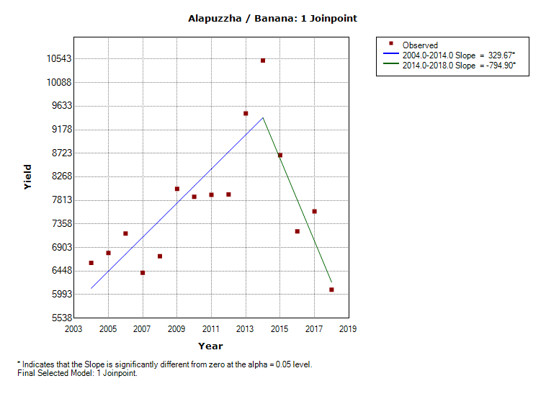
Cashew | Plantain
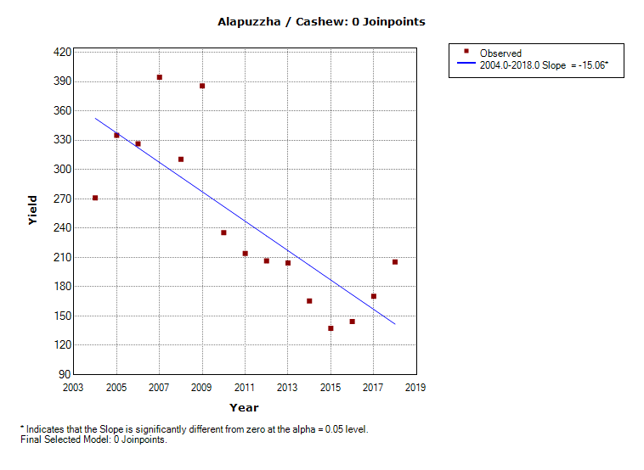 | 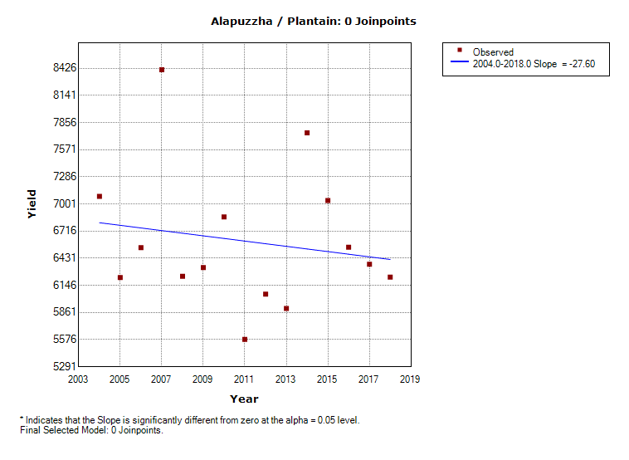
Pulses | Rice
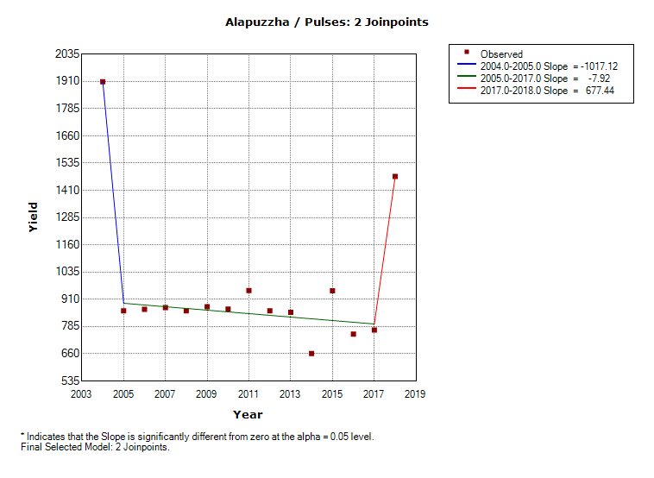 | 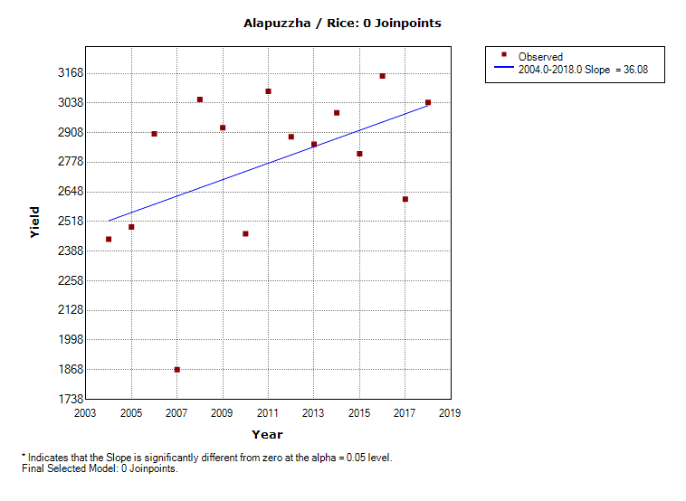
Sweet Potato | Tapioca
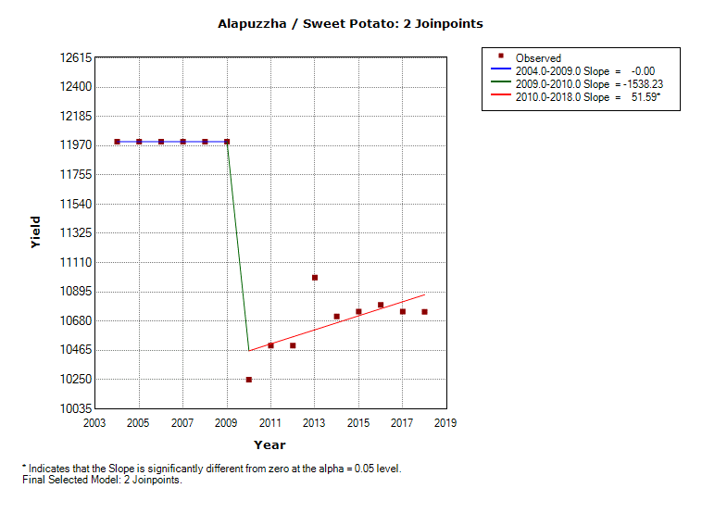 | 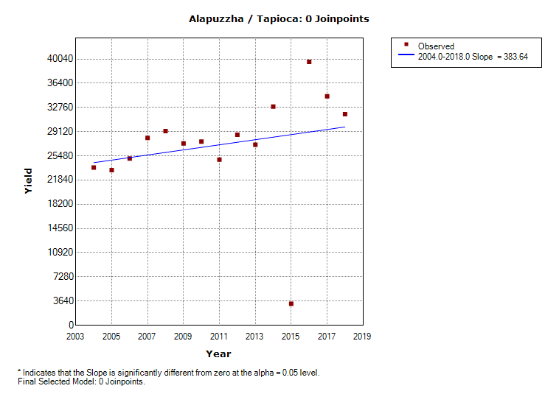

- Ernakulam
Banana | Cardamom
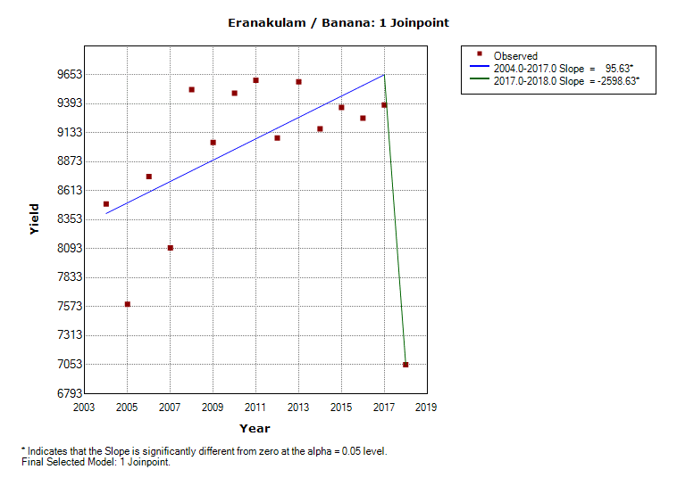
Cashew | Plantain
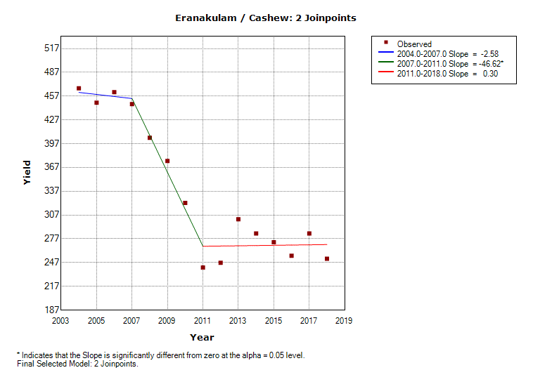 | 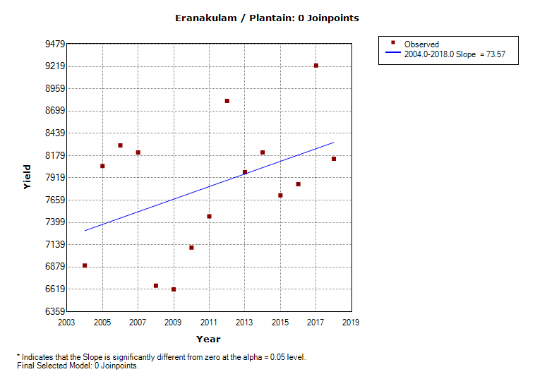
Pulses | Rice
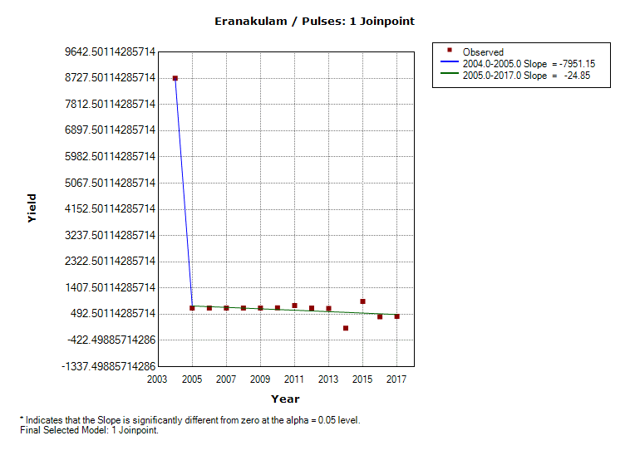 | 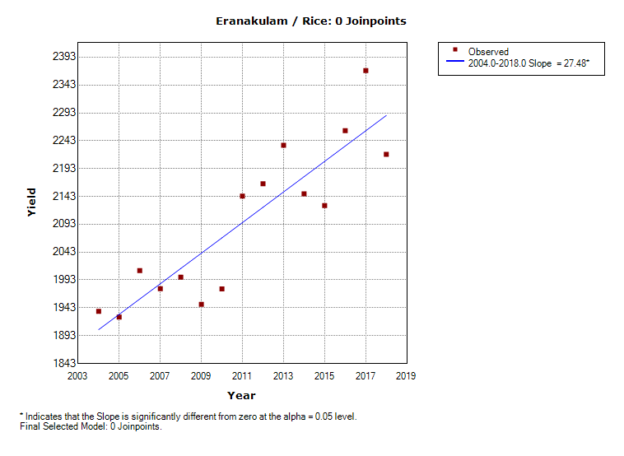
Sweet Potato | Tapioca
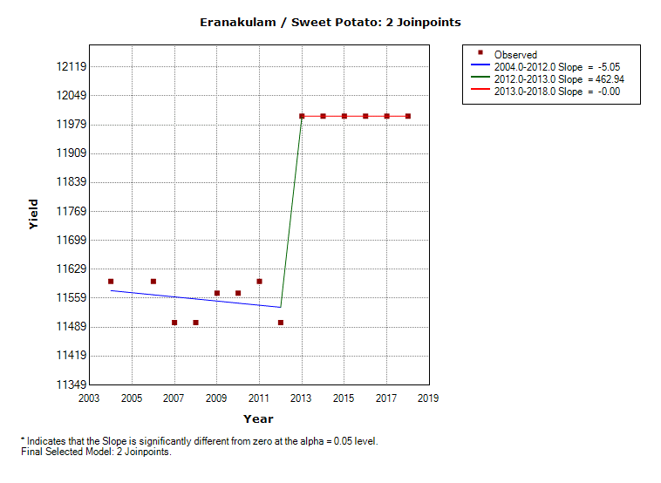 | 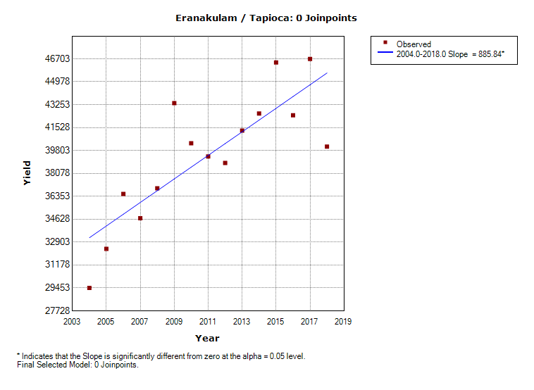

- Idukki
Banana | Cardamom
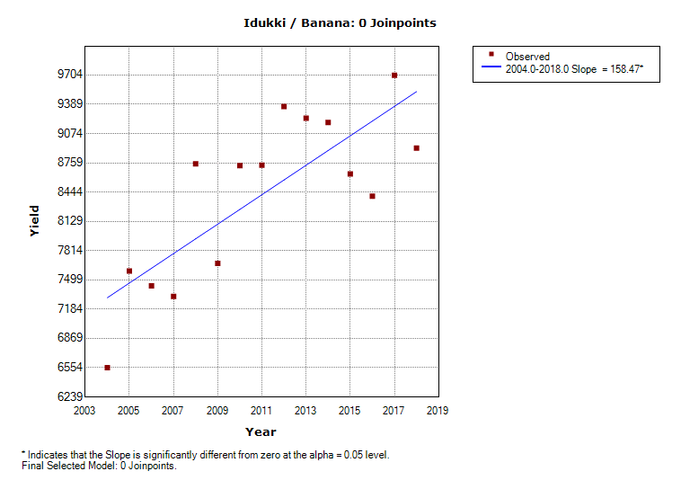 | 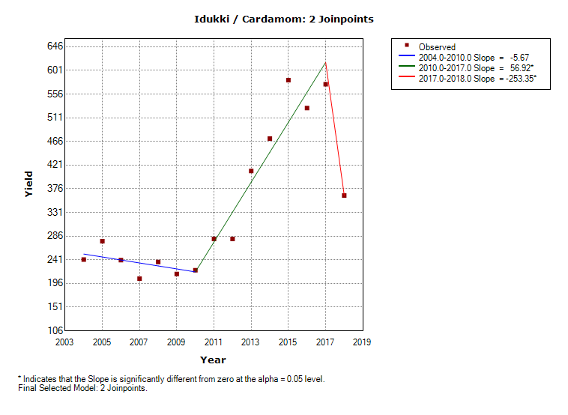
Cashew | Plantain
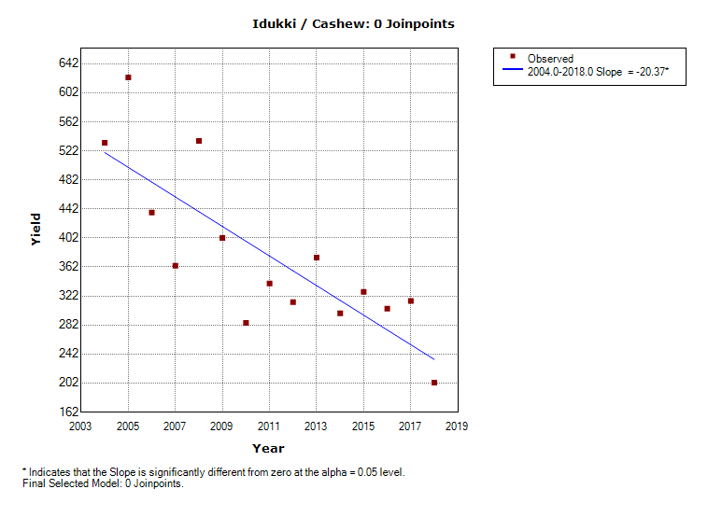 | 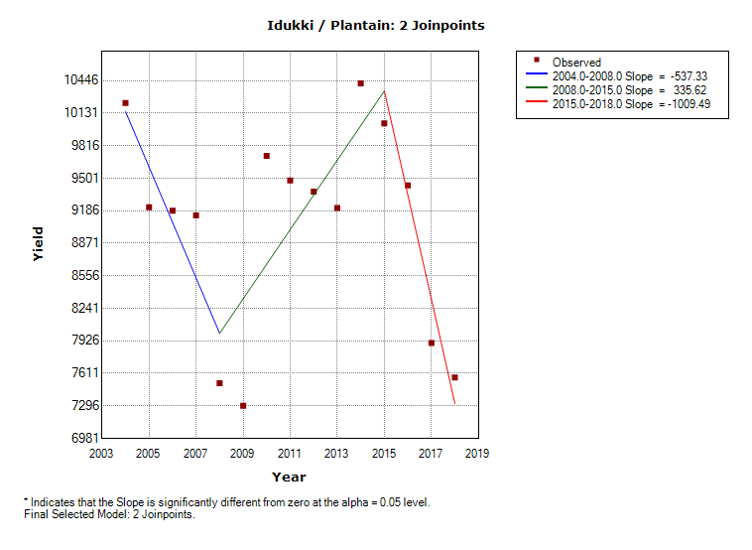
Pulses | Rice
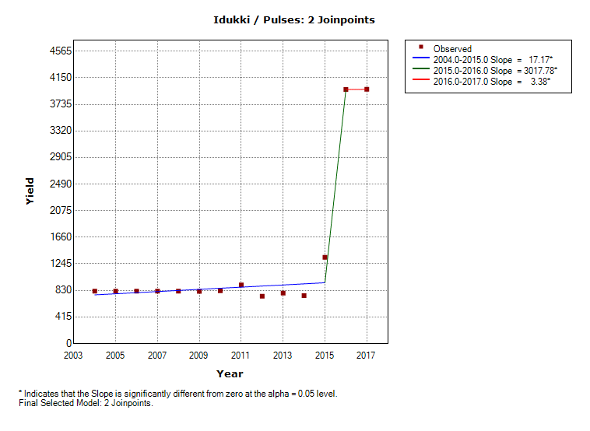 | 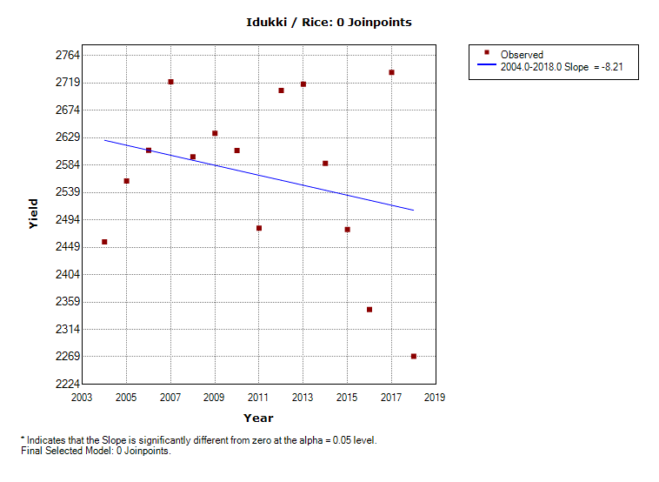
Sweet Potato | Tapioca
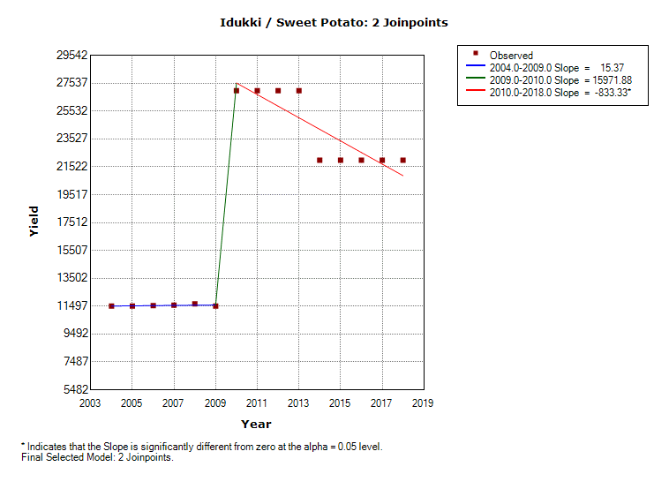 | 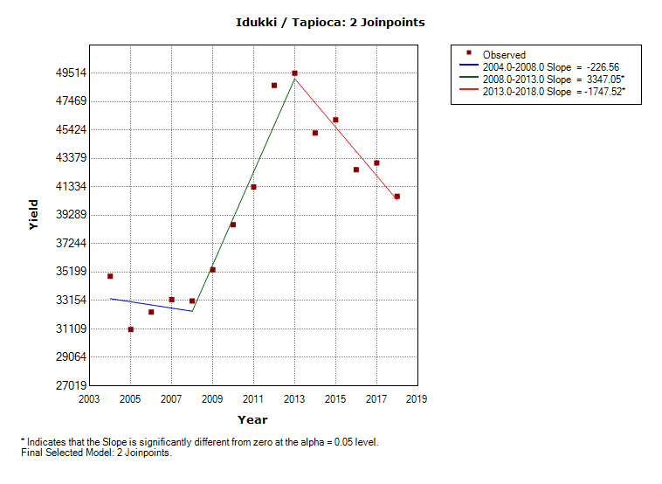

- Kannur
Banana | Cardamom
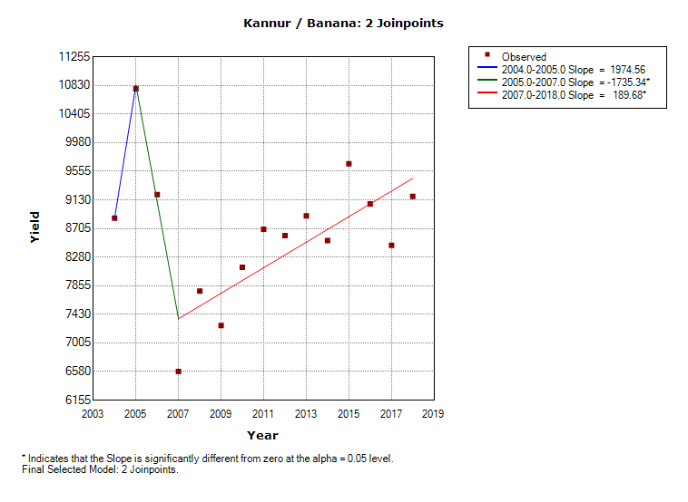
Cashew | Plantain
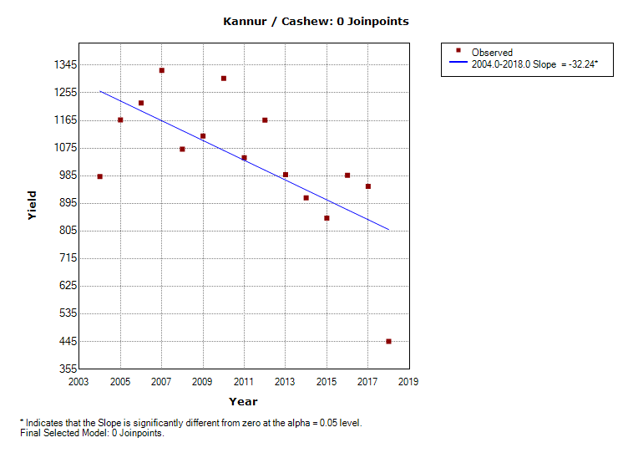 | 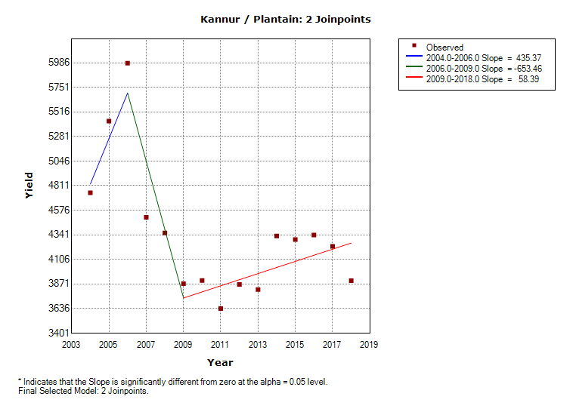
Pulses | Rice
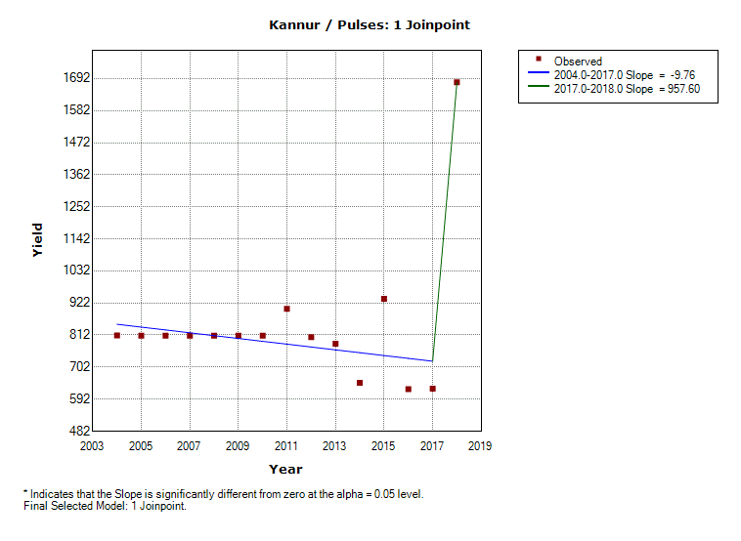 | 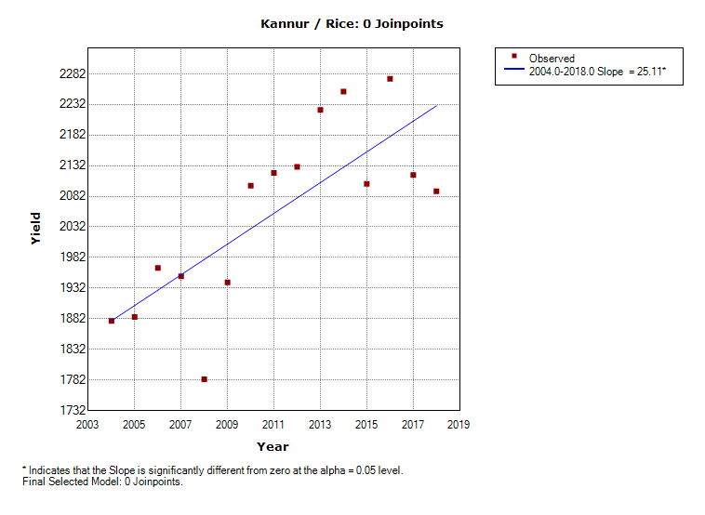
Sweet Potato | Tapioca
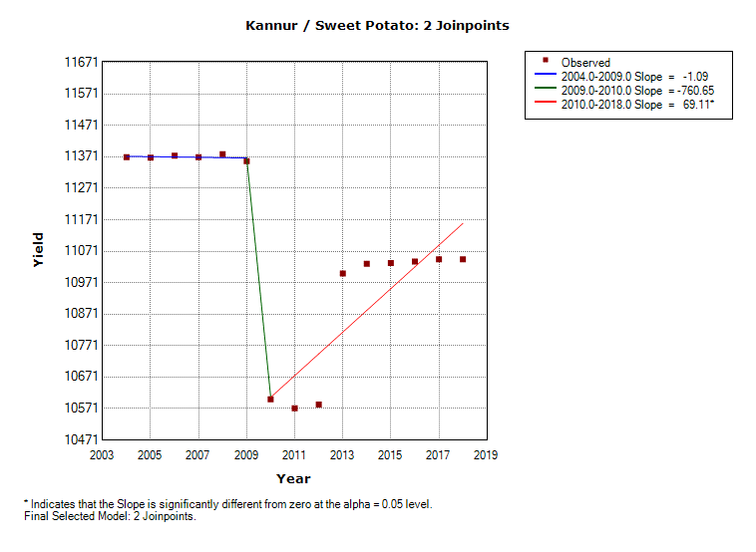 | 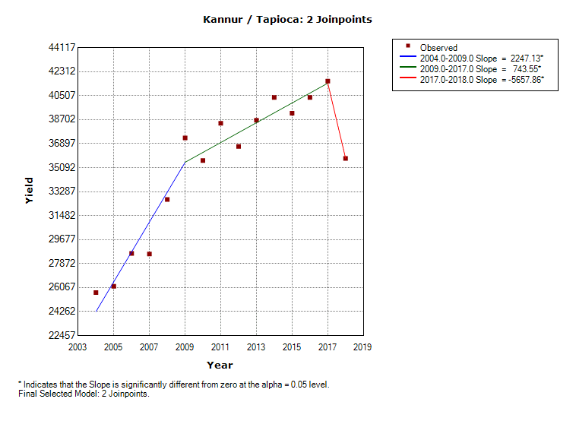

- Kasargod
Banana | Cardamom
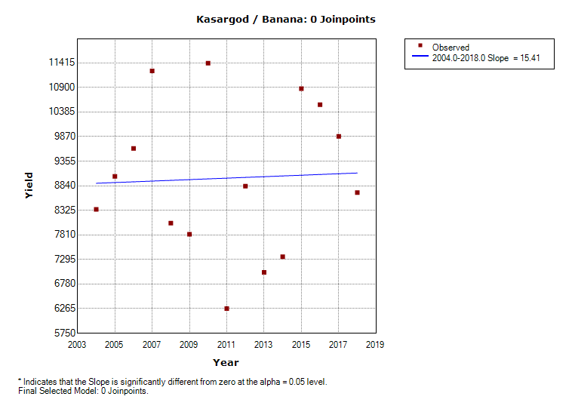
Cashew | Plantain
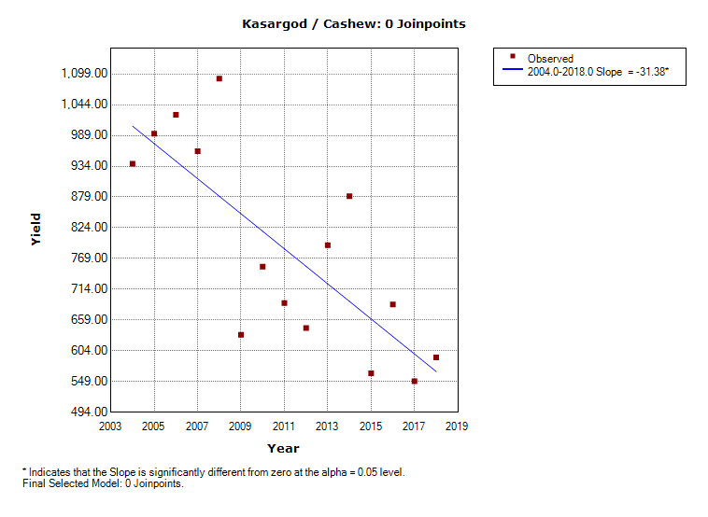 | 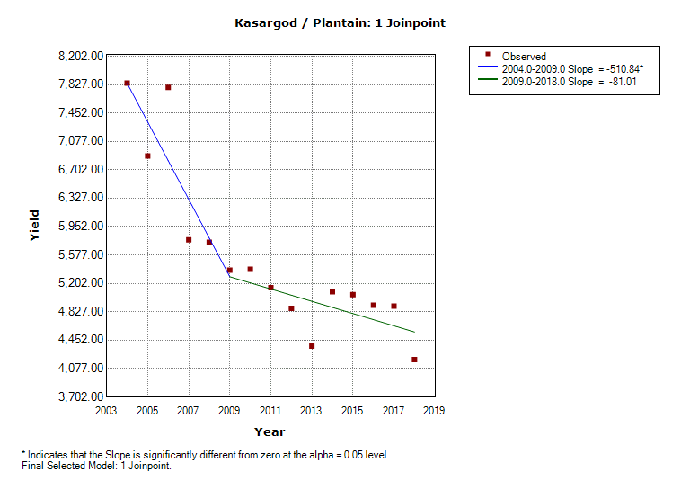
Pulses | Rice
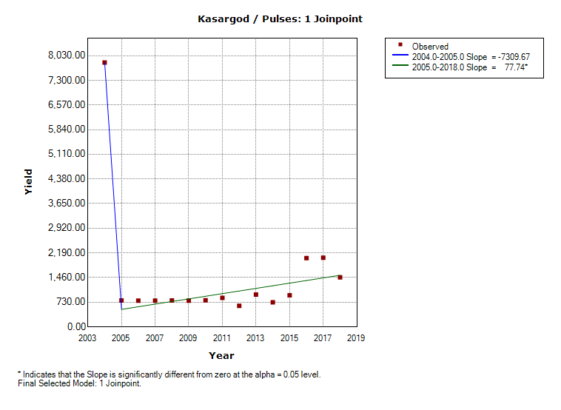 | 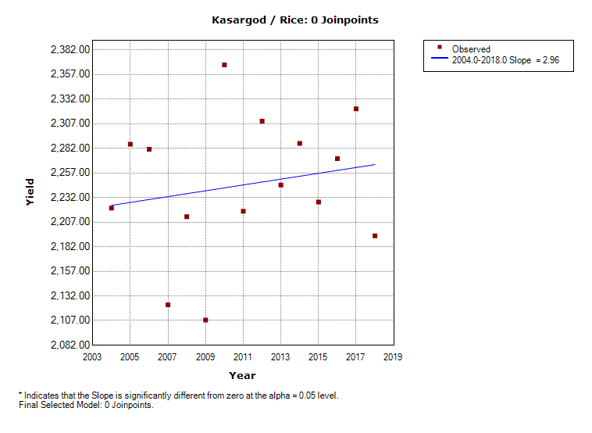
Sweet Potato | Tapioca
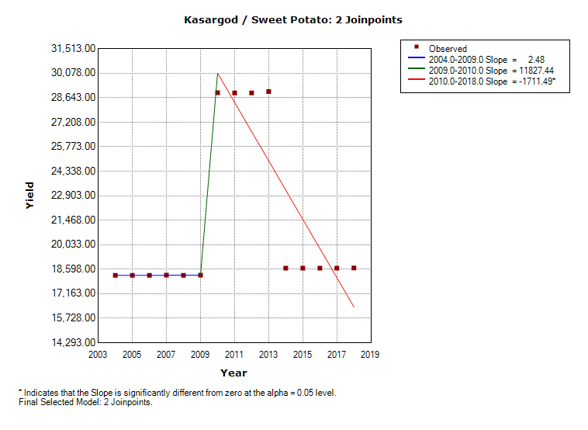 | 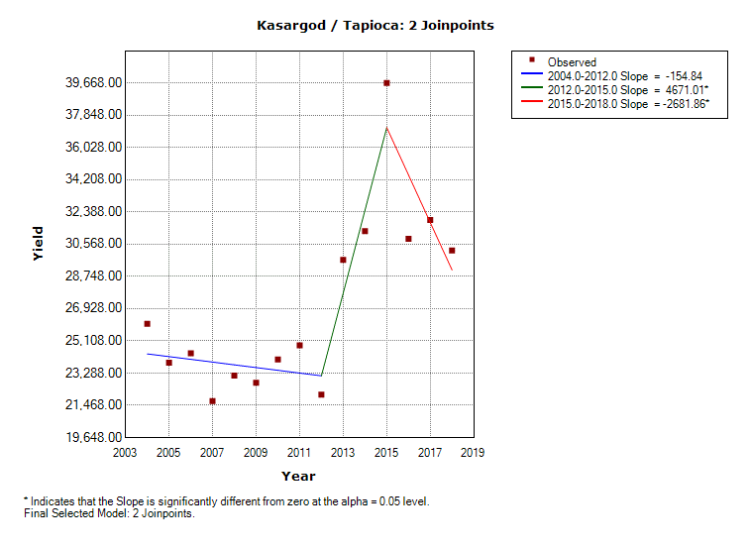

- Kollam
Banana | Cardamom
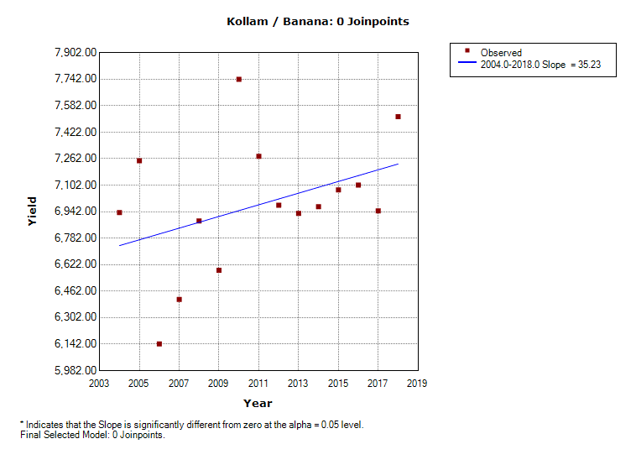
Cashew | Plantain
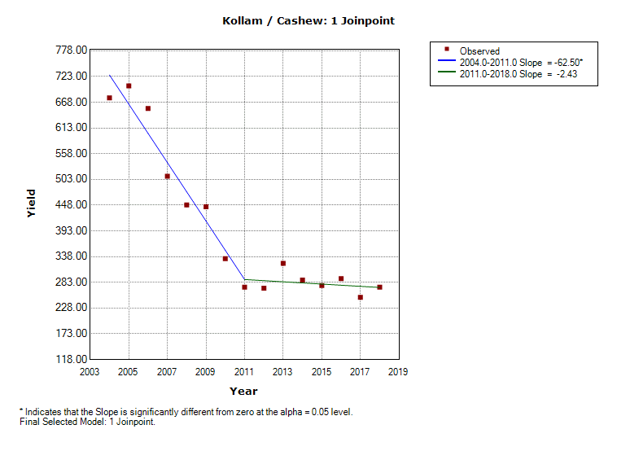 | 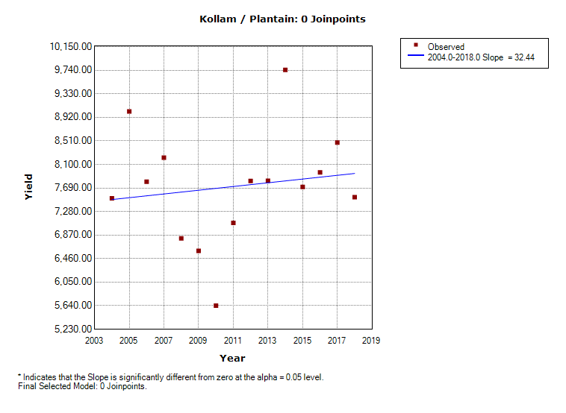
Pulses | Rice
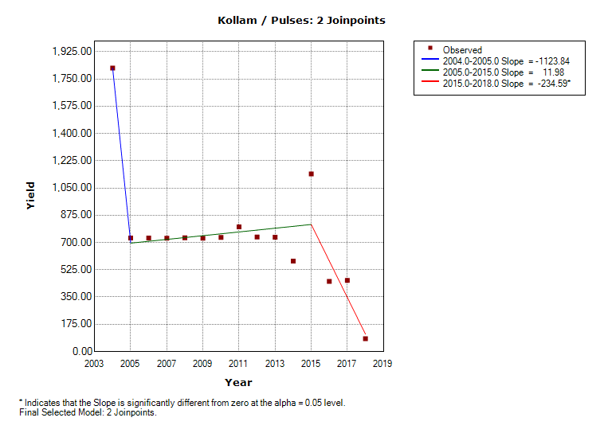 | 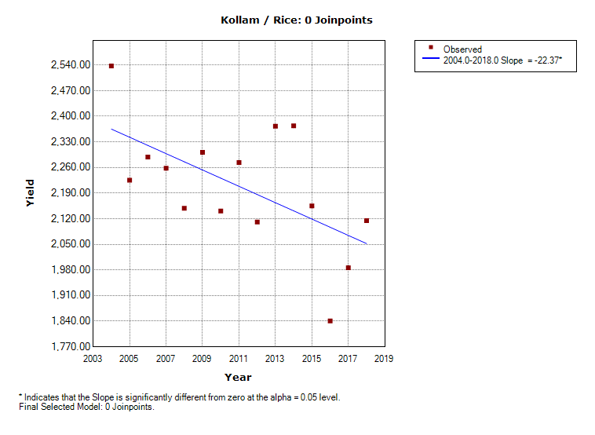
Sweet Potato | Tapioca
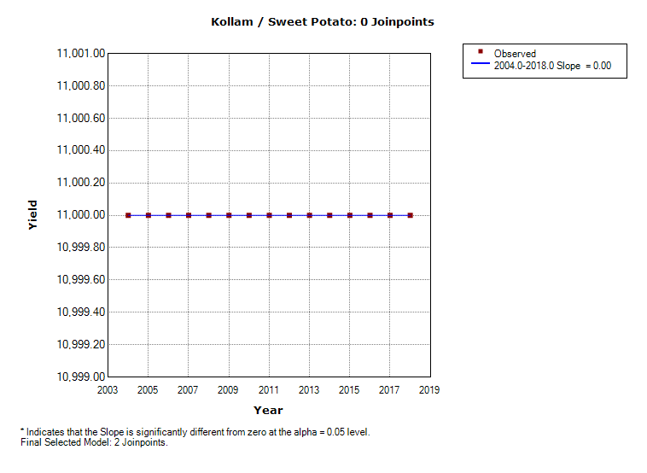 | 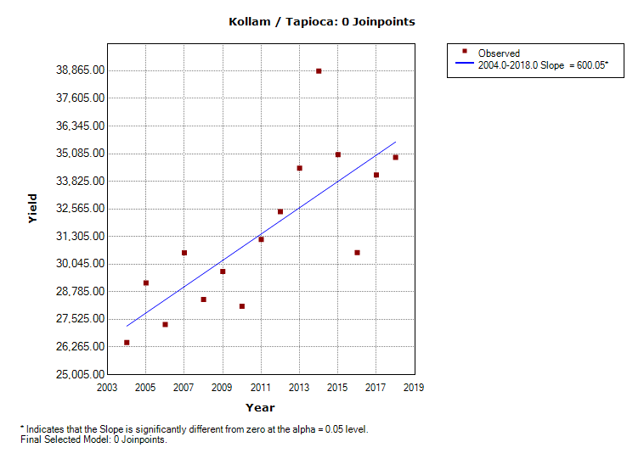

- Kottayam
Banana | Cardamom
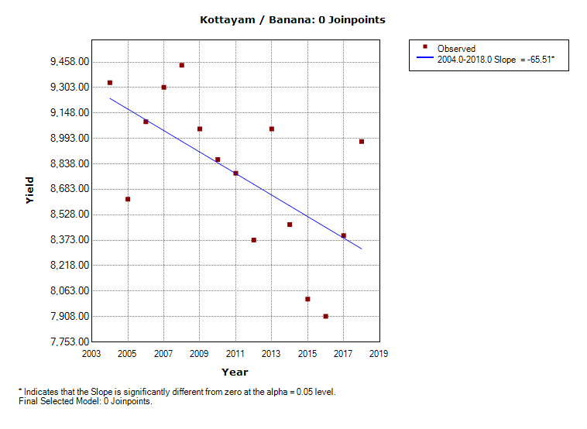 | 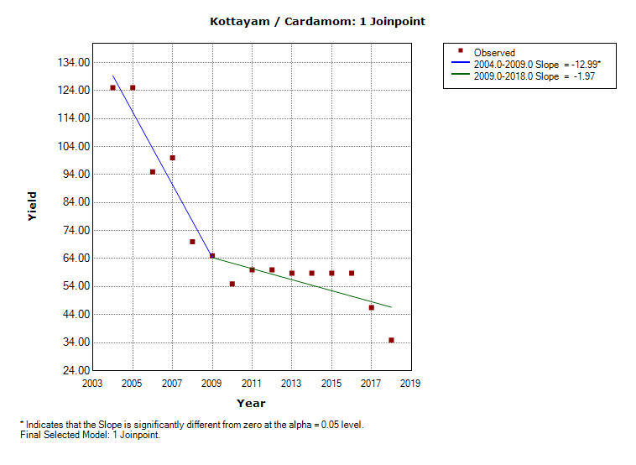
Cashew | Plantain
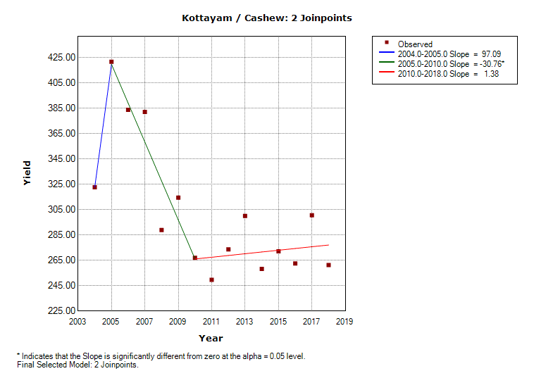 | 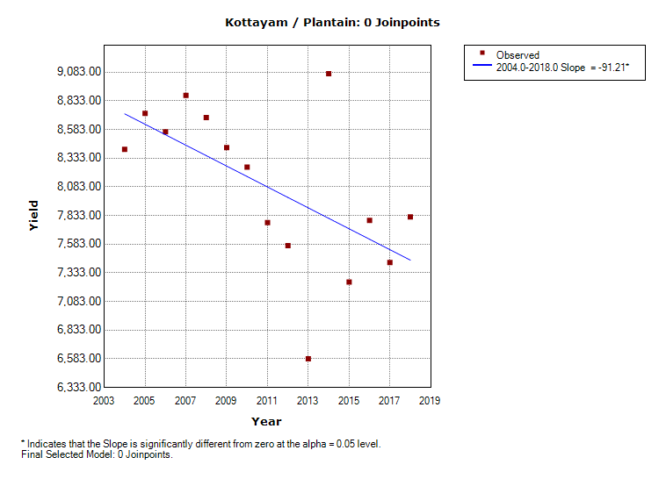
Pulses | Rice
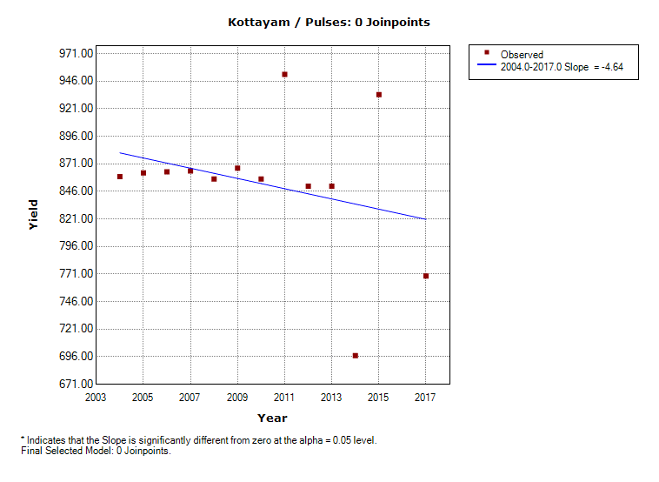 | 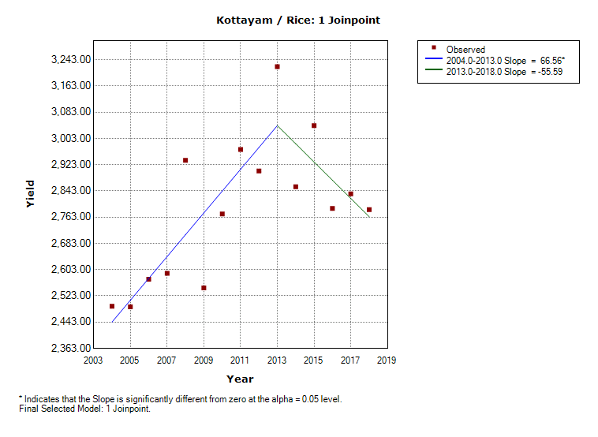
Sweet Potato | Tapioca
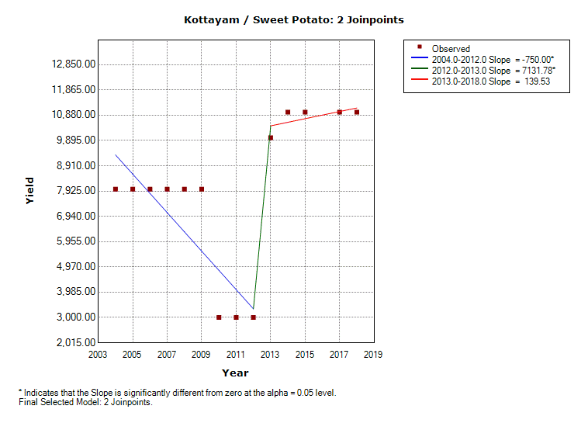 | 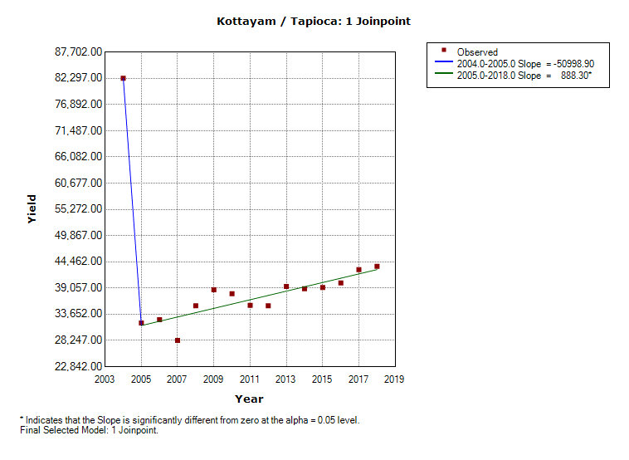

- Kozhikode
Banana | Cardamom
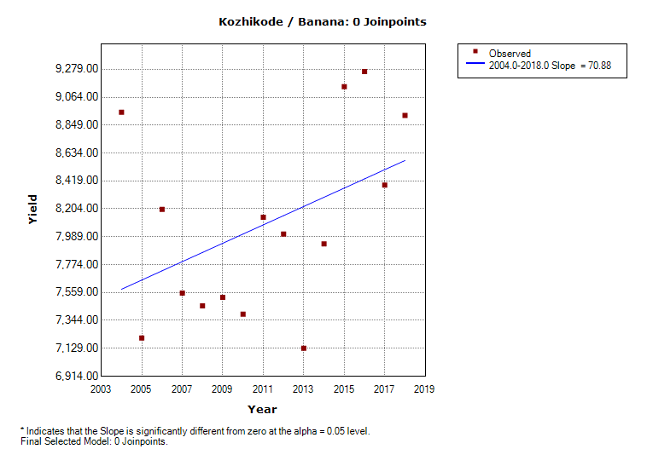 | 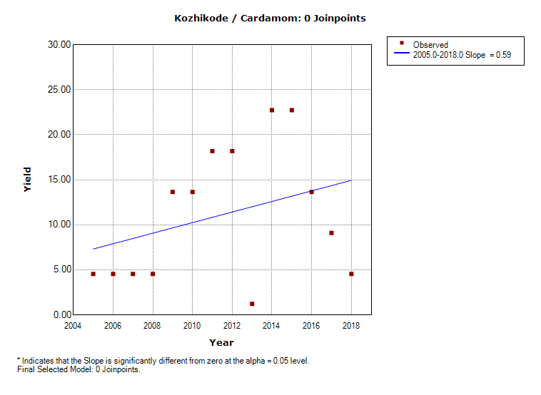
Cashew | Plantain
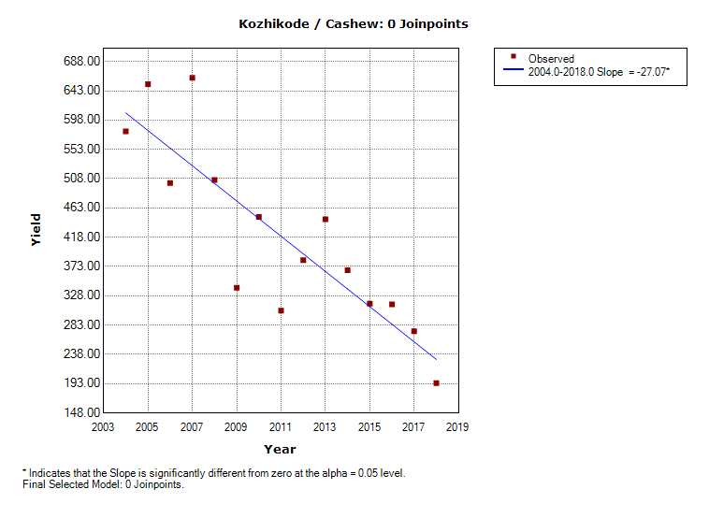 | 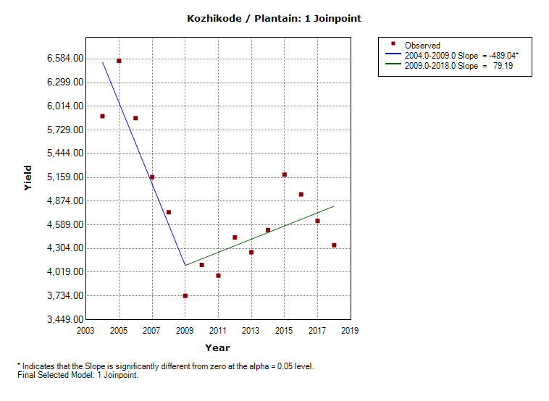
Pulses | Rice
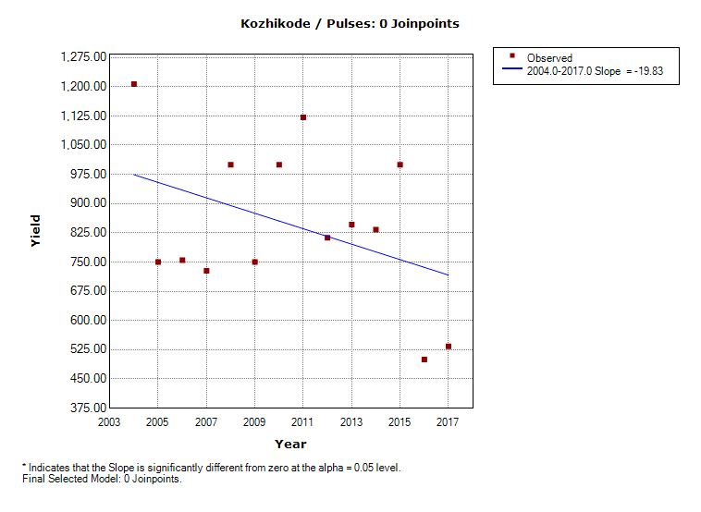 | 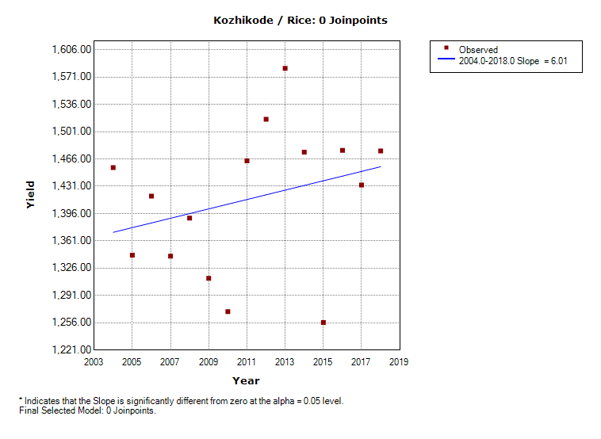
Sweet Potato | Tapioca
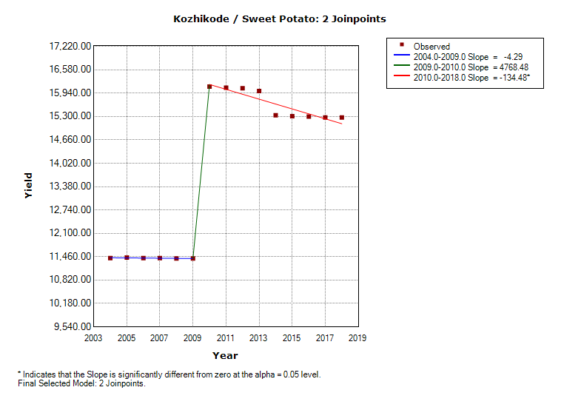 | 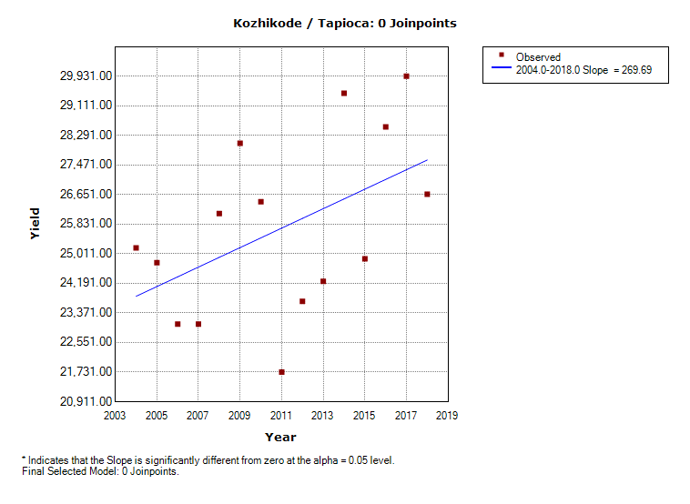

- Malappuram
Banana | Cardamom
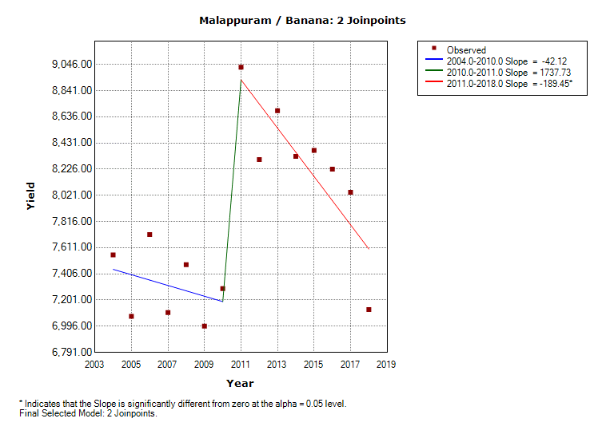 | 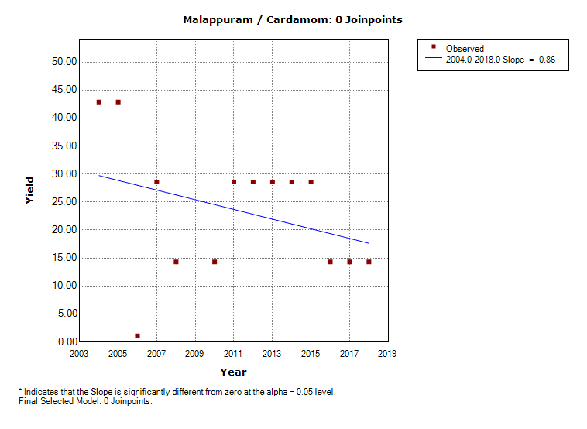
Cashew | Plantain
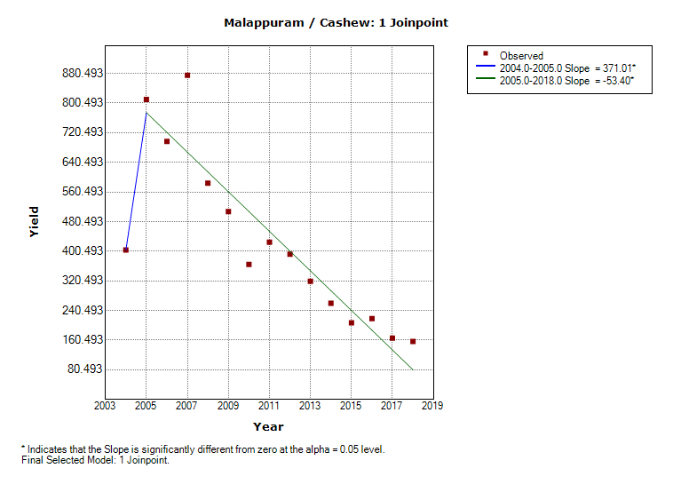 | 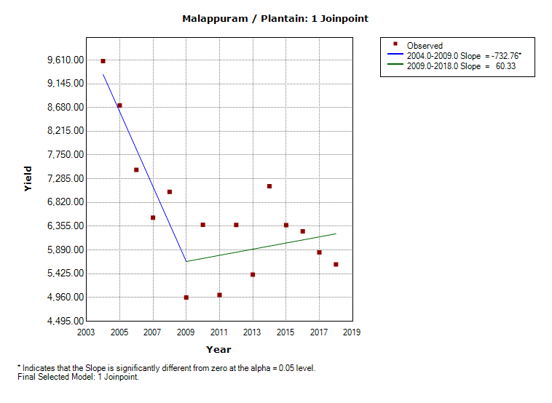
Pulses | Rice
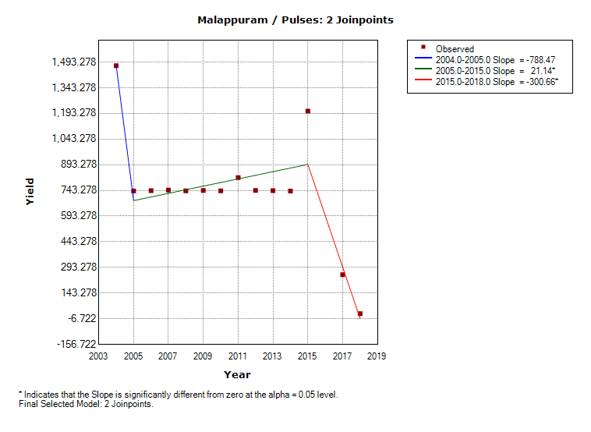 | 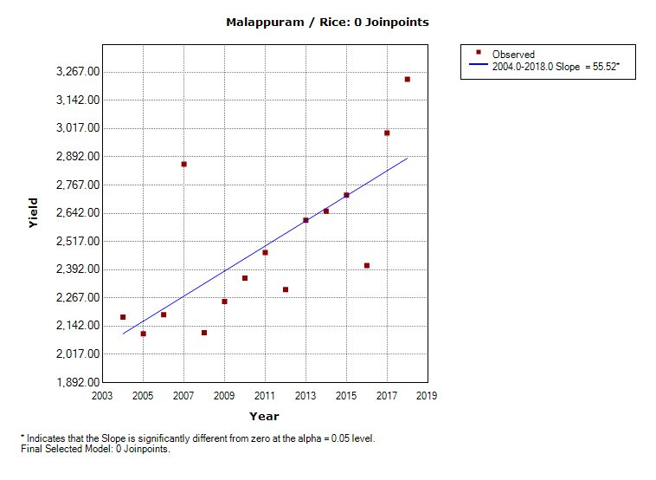
Sweet Potato | Tapioca
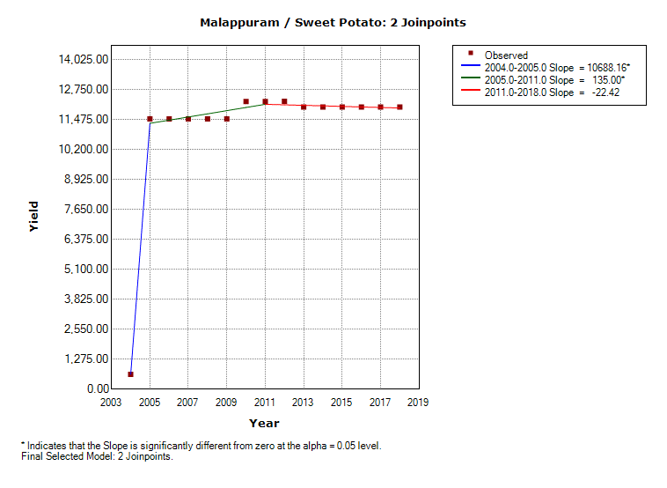 | 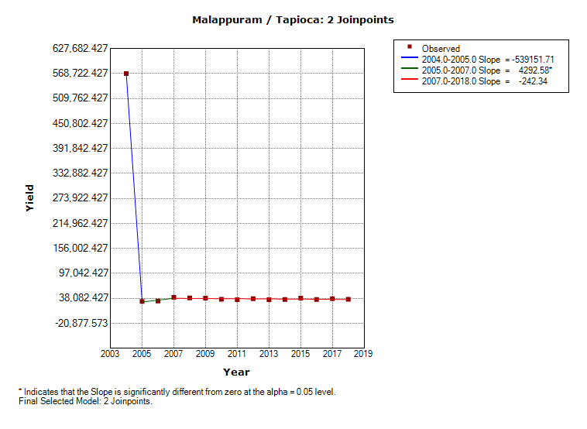

- Palakkad
Banana | Cardamom
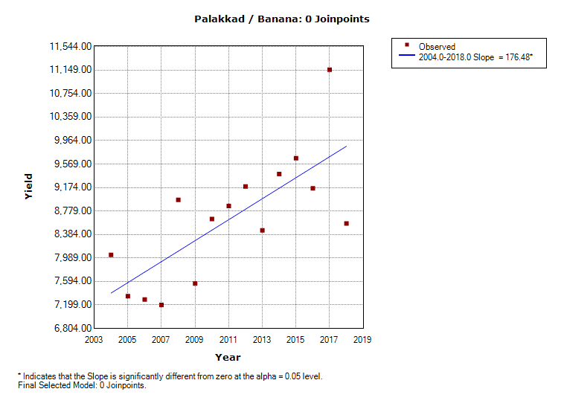 | 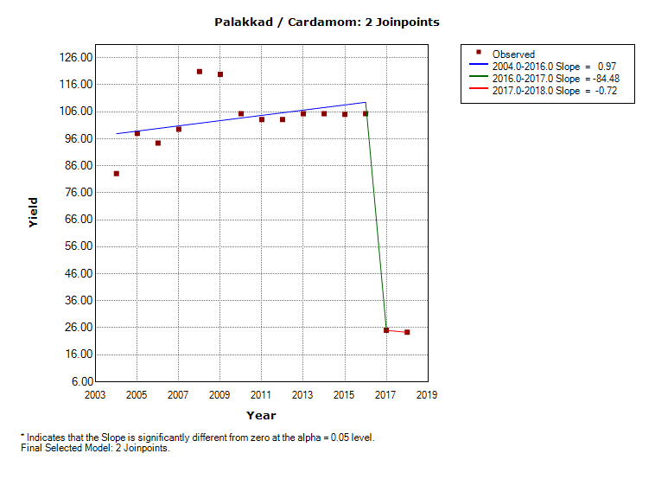
Cashew | Plantain
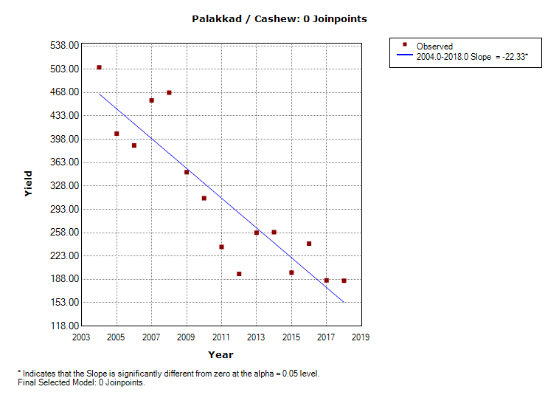 | 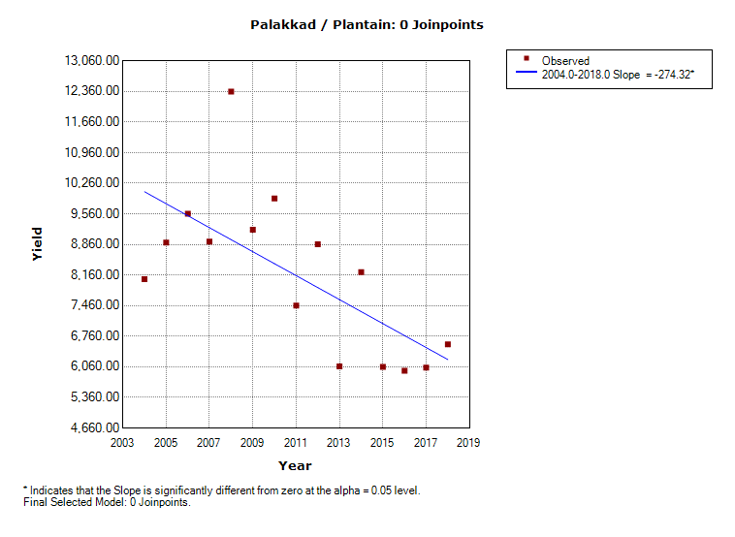
Pulses | Rice
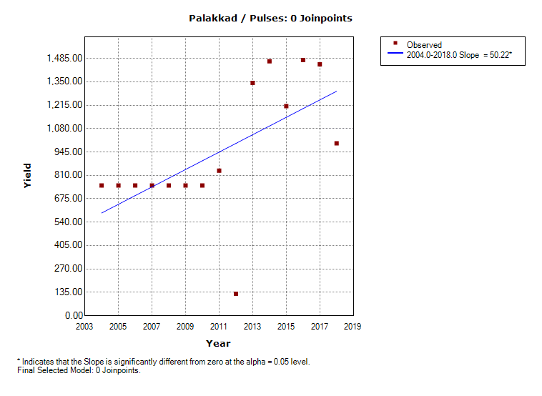 | 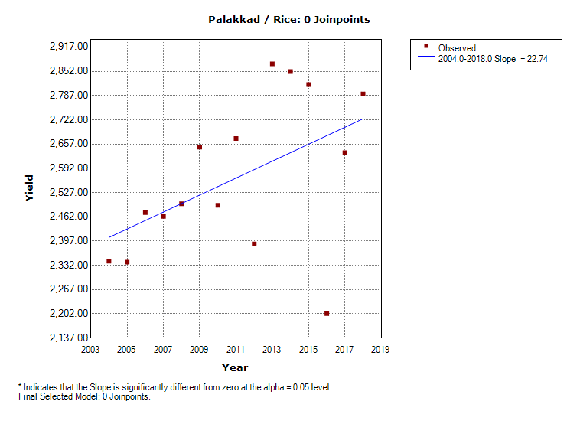
Sweet Potato | Tapioca
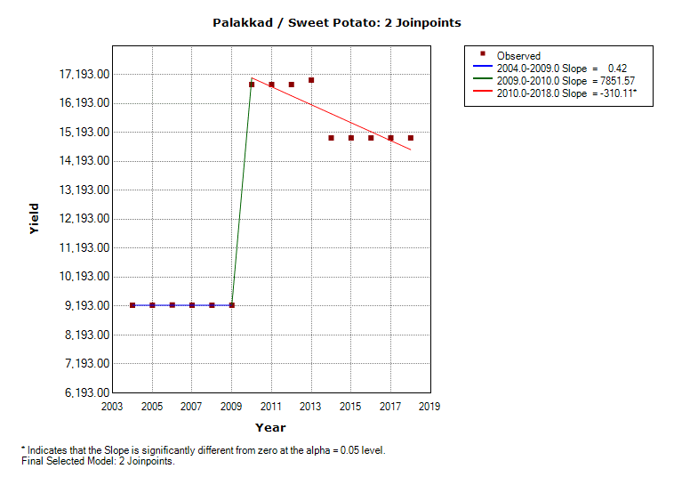 | 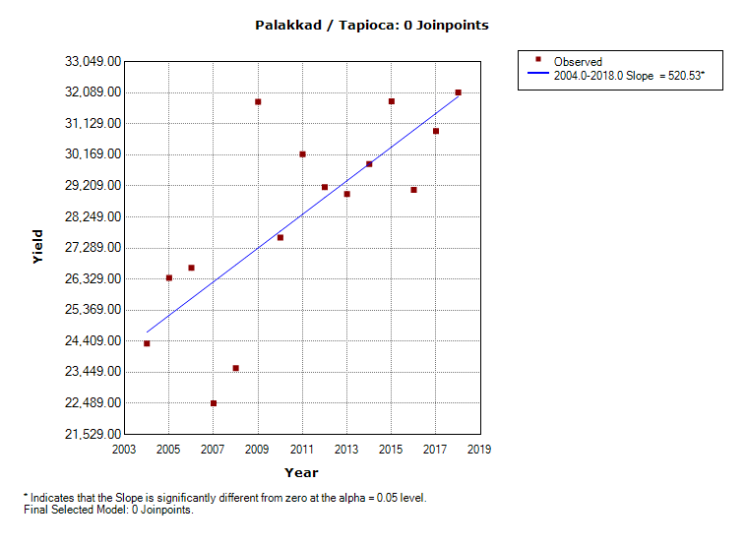

- Pathanamthitta
Banana | Cardamom
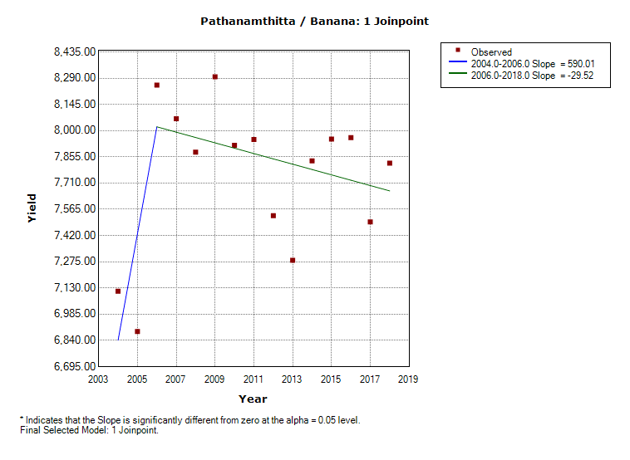 | 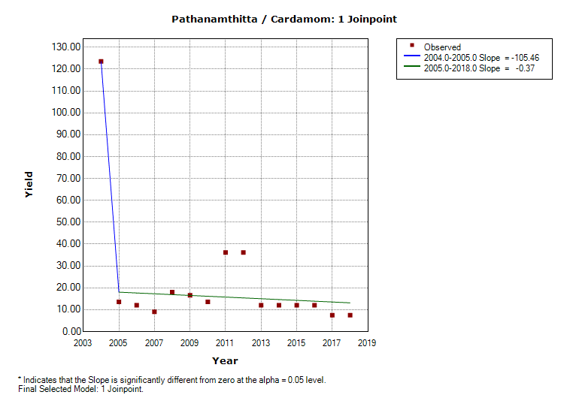
Cashew | Plantain
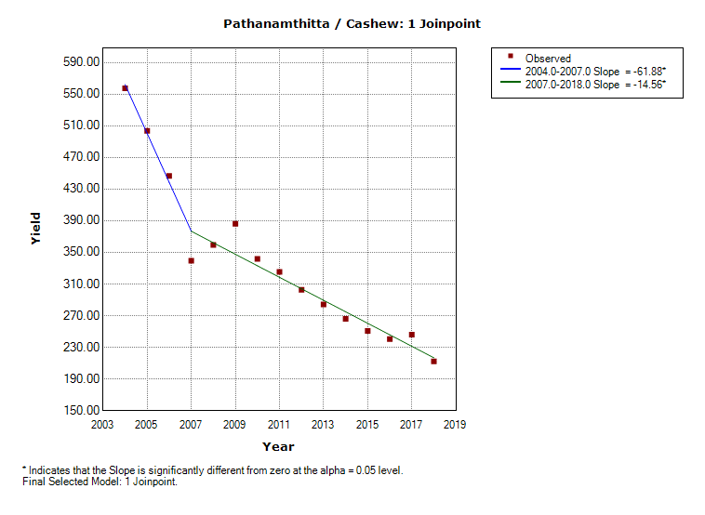 | 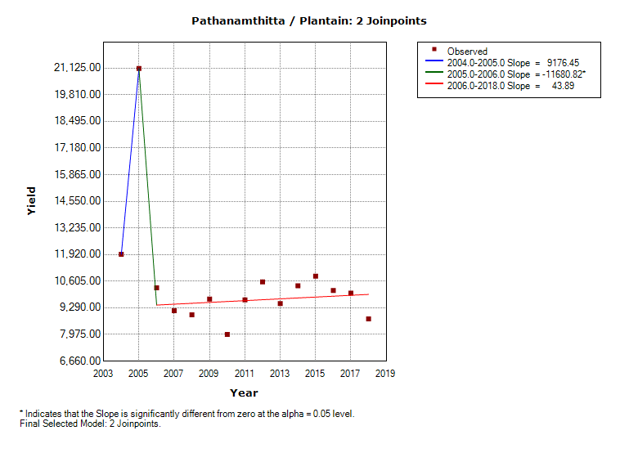
Pulses | Rice
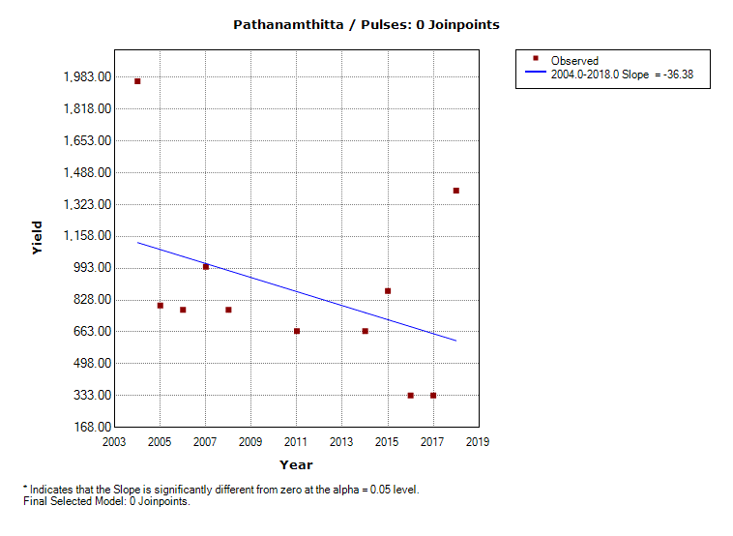 | 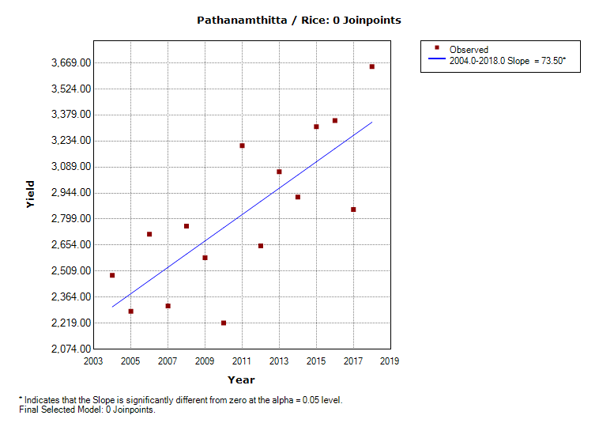
Sweet Potato | Tapioca
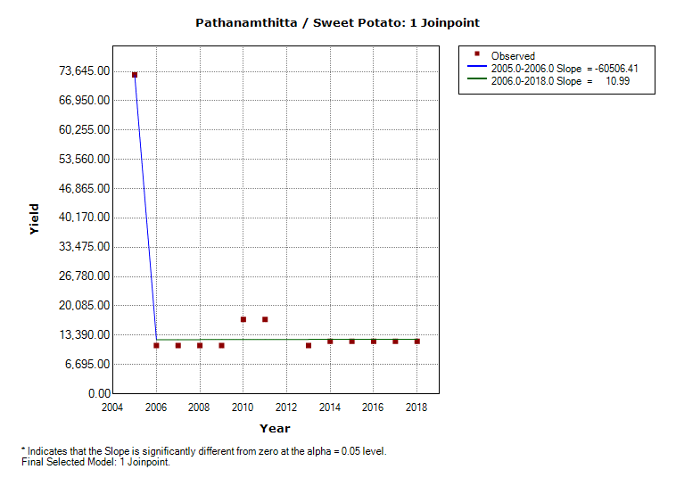 | 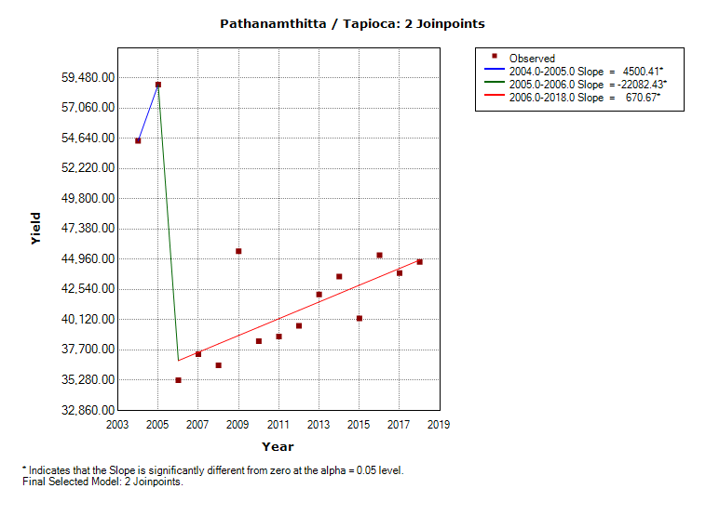

- Thiruvananthapuram
Banana | Cardamom
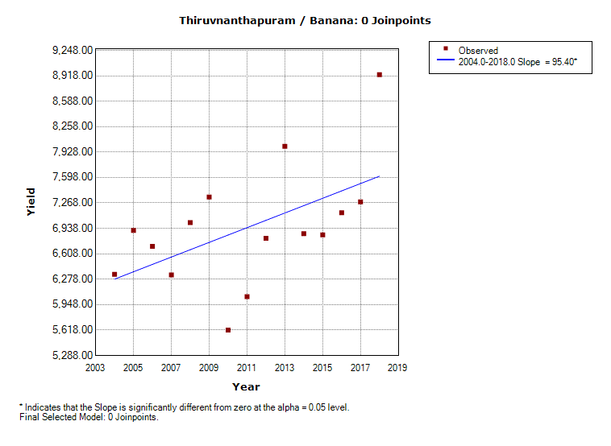
Cashew | Plantain
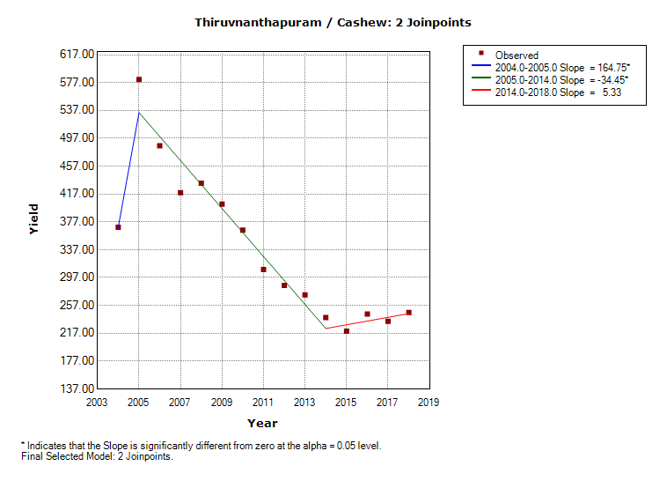 | 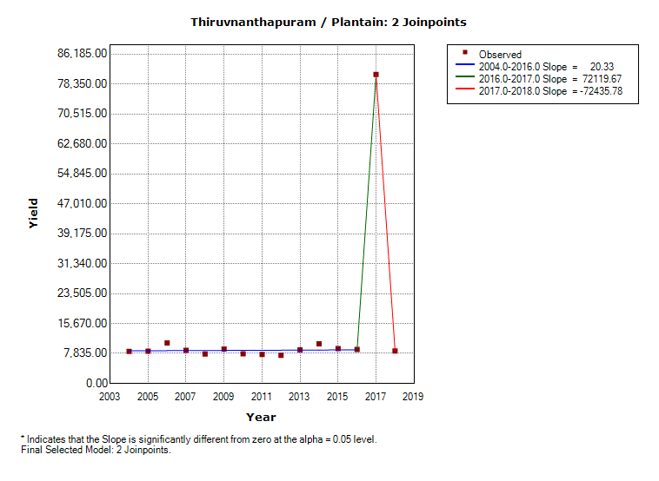
Pulses | Rice
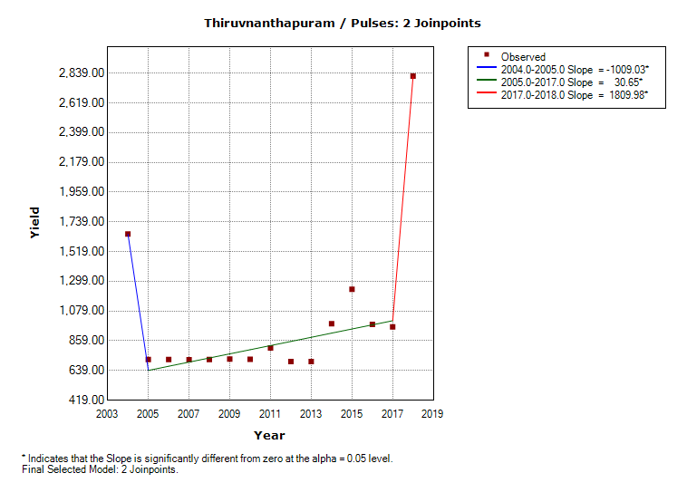 | 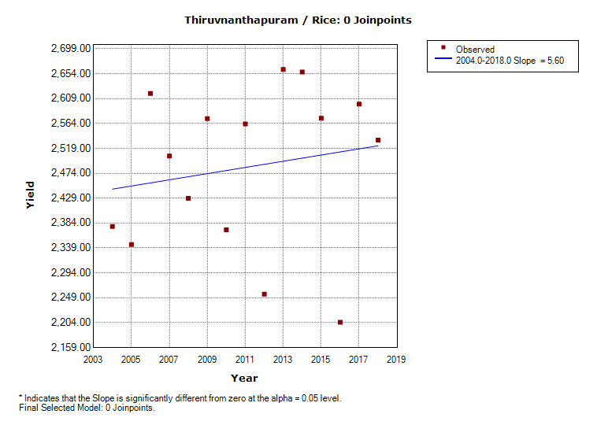
Sweet Potato | Tapioca
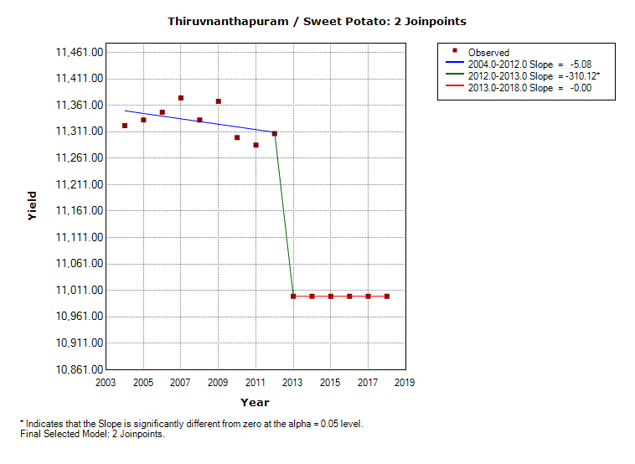 | 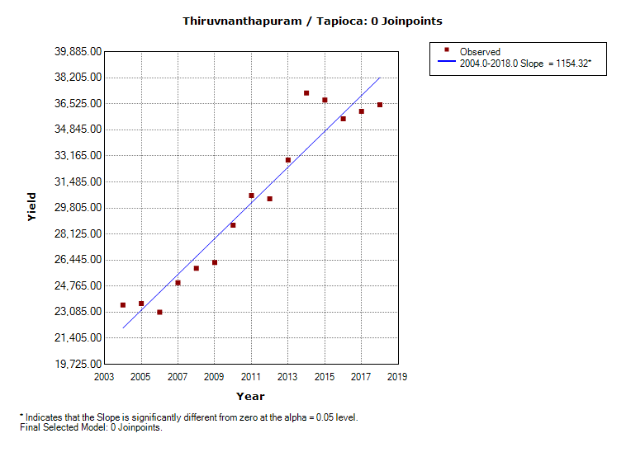

- Thrissur
Banana | Cardamom
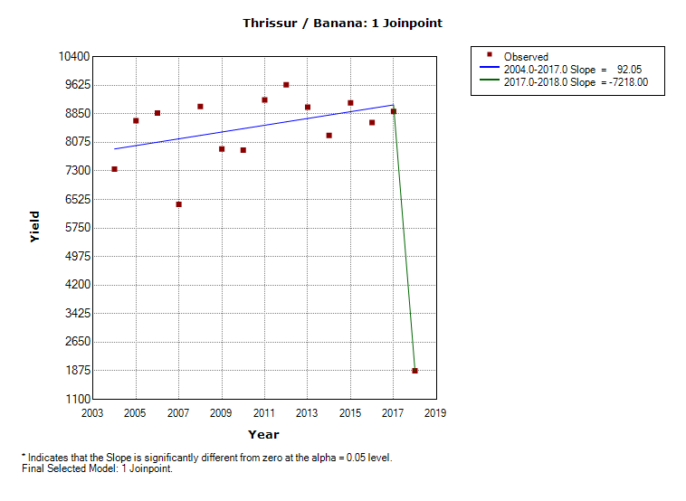
Cashew | Plantain
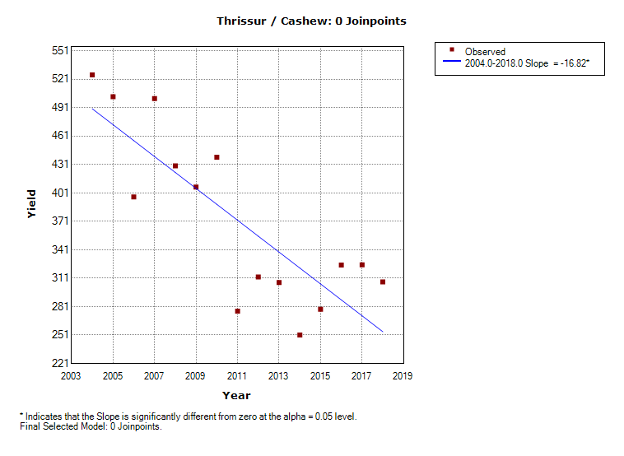 | 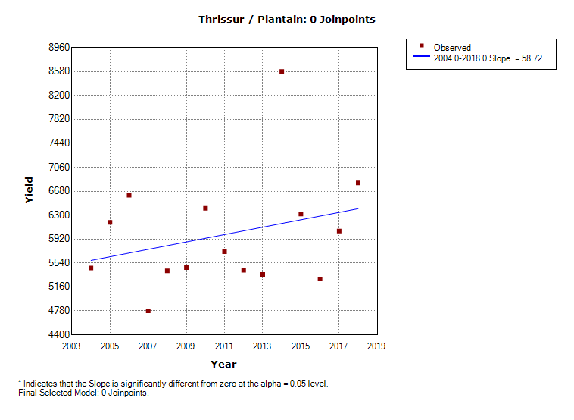
Pulses | Rice
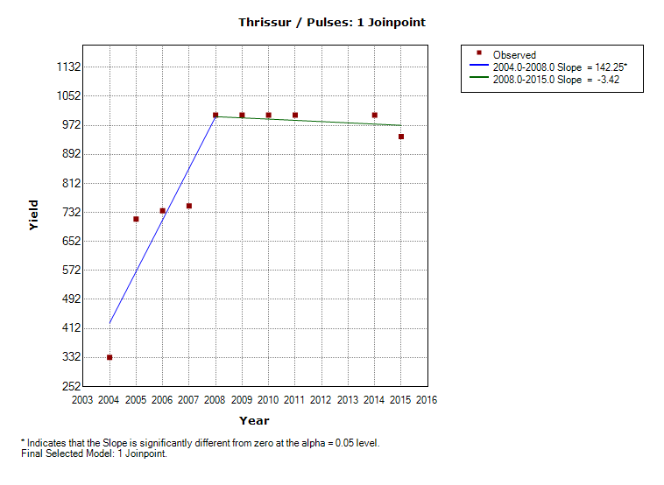 | 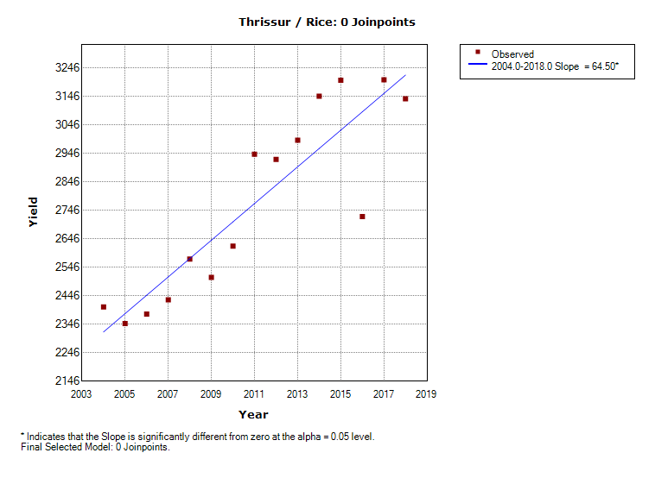
Sweet Potato | Tapioca
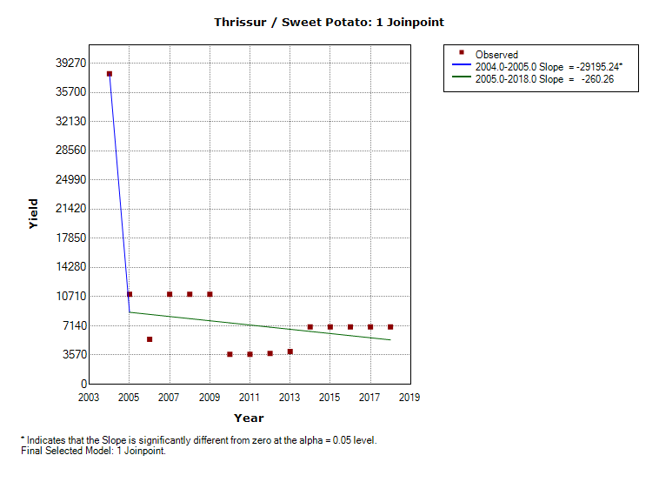 | 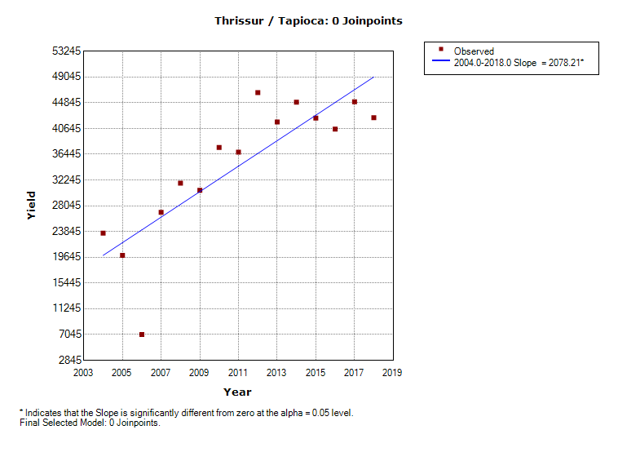

- Wayanad
Banana | Cardamom
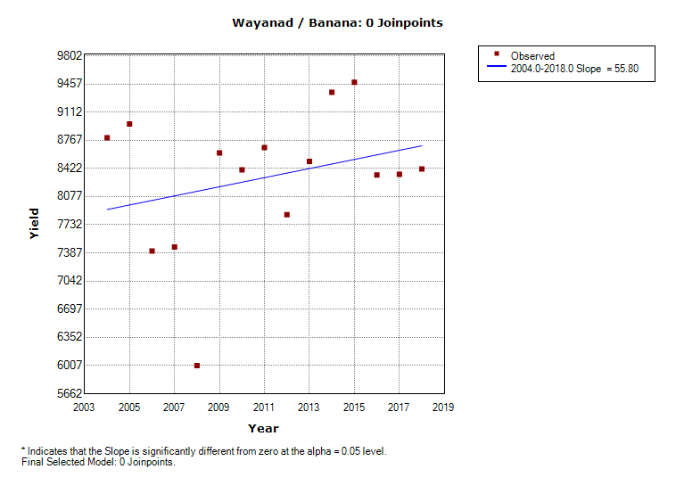 | 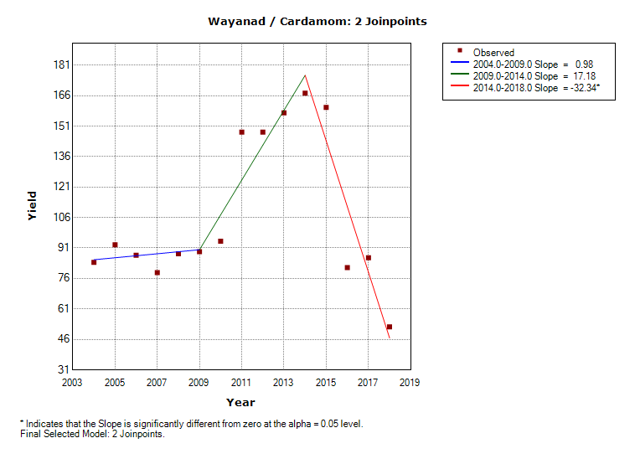
Cashew | Plantain
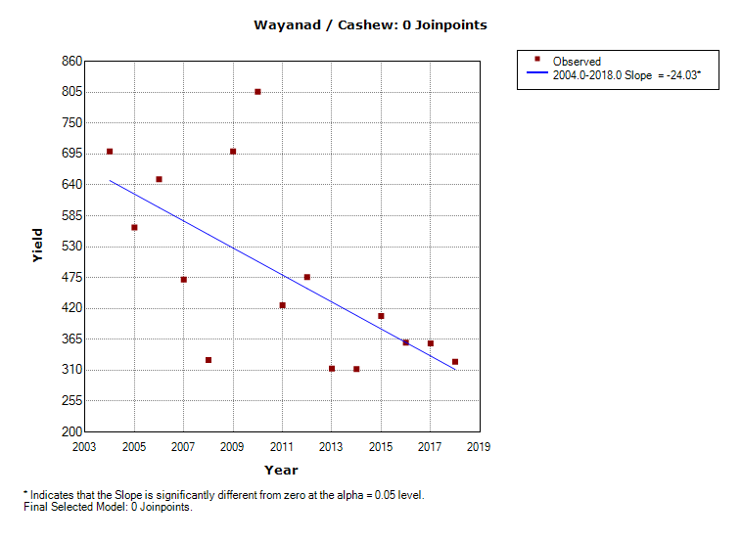 | 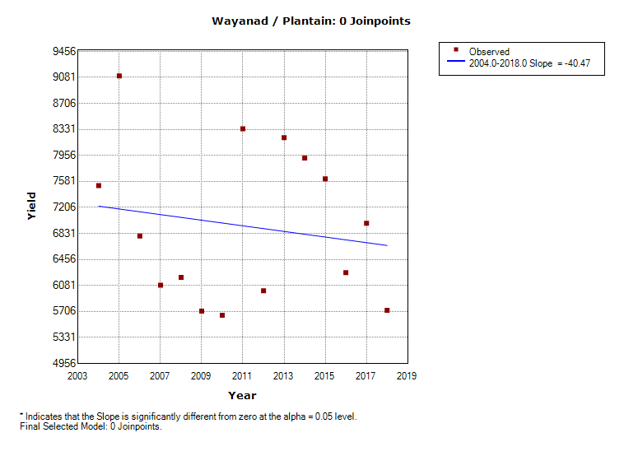
Pulses | Rice
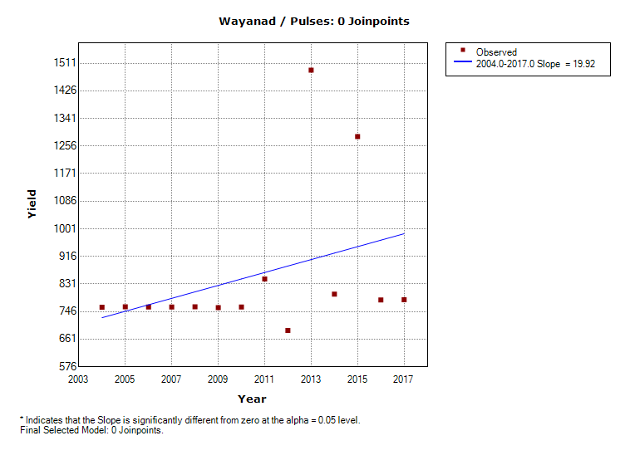 | 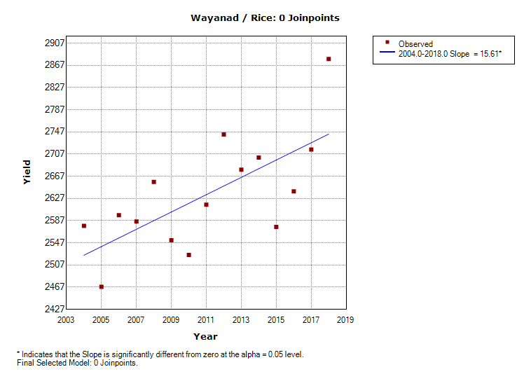
Sweet Potato | Tapioca
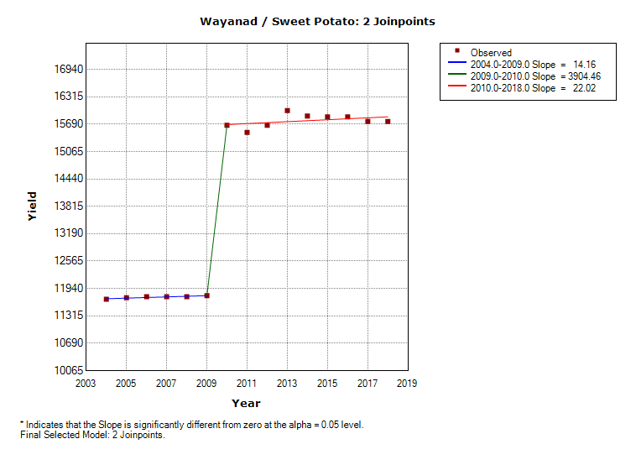 | 