Additional file 1: Appendices

Appendix S1: Food items used in the FFQ to develop 12 food groups calculated in overall diet in last 28 days
Food items in FFQ – 28 days | Food Groups
1. Maize | A. Grains and cereals
2. Cassava | A. Grains and cereals
3. Rice | A. Grains and cereals
4. Millet | A. Grains and cereals
5. Wheat | A. Grains and cereals
6. White/Yellow Sweet Potato | B. White roots and tubers
7. Irish Potato | B. White roots and tubers
8. Beans and/or other lentils | C. Pulses
9. Groundnuts | D. Nuts and seeds
10. Milk products | E. Dairy
11. Organ meat | F. Meat
12. Poultry (chicken) | F. Meat
13. Beef | F. Meat
14. Pork | F. Meat
15. Goat/Lamb | F. Meat
16. Insects | F. Meat
17. Other meat (bush meat) | F. Meat
18. Small mormyrids | G. Fish
19. Small swamp mix | G. Fish
20. Small cichlids | G. Fish
21. Lake sardines | G. Fish
22. Small catfishes | G. Fish
23. Typically cultivated tilapia | G. Fish
24. Large catfishes | G. Fish
25. Lates (Buka-buka) | G. Fish
26. Large mormyrids | G. Fish
27. Large cichlids | G. Fish
28. Eggs | H. Eggs
29. DGLV (rape, cassava, pumpkin leaves, spinach) | I. Dark Green Leafy Vegetables
30. Orange sweet potato | J. Vitamin A-rich vegetables
31. Carrots, pumpkin and squash | J. Vitamin A-rich vegetables
32. Fruit (mango, lemon, oranges) | K. Fruit (mostly Vitamin A-rich fruits)
33. Vegetables (onion, tomatoes, cabbage, okra, Chinese cabbage) | L. Other vegetables
Excluded from the list: oils and fats; savoury and fried snacks; sweets; sugar-sweetened beverages; condiments and seasonings; other beverages and foods
The 10 fish categories (Food items: 18-27) are made up of 30 fish species asked in the FFQ (see Appendix 2)

Appendix S2: Fish species classification and groups used in the study
Classification | Bemba name | Scientific name | Common name | Size
Small mormyrids | Icele | Petrocephalus & Cyphomyrus | Elephant fishes / Parrot fishes | Small
Small mormyrids | Ishimba | Pollimyrus cf. isidori/castelnaui | Elephant Fish / Dwarf stonebasher | Small
Small mormyrids | Mintesa | Marcusenius macrolepidotus | Bulldog | Small
Small swamp mix (clupeidae, cyprinidae and alestidae) | Bwelele | Micropanchax johnstoni | Banded lampeye or topminnow | Small
Small swamp mix (clupeidae, cyprinidae and alestidae) | Itala | Rhabdalestes spp. | African tetras (robbers | Small
Small swamp mix (clupeidae, cyprinidae and alestidae) | Kasepa | Mixed barbus species | barbinidae (minnows) | Small
Small swamp mix (clupeidae, cyprinidae and alestidae) | Misenga | Barbus paludinosus | Straightfin barbs | Small
Small swamp mix (clupeidae, cyprinidae and alestidae) | Mushipa | Barbus trimaculatus | Threespot barb | Small
Small swamp mix (clupeidae, cyprinidae and alestidae) | Misebele | Alestes macrophthalmus | Torpedo robber | Small
Small swamp mix (clupeidae, cyprinidae and alestidae) | Other small fish | Range of small mixed species |  | Small
Small & medium sized cichlids | Cifinsa | Tilapia ruweti | Okavango tilapia | Small
Small & medium sized cichlids | Cikundu | Pseudocrenilabrus philander | Southern mouthbrooder | Small
Small & medium sized cichlids | Matuku | Tilpia sparrmanii | Banded tilapia | Small
Small & medium sized cichlids | Imbelya | Sargochromis mellandi | Snaileater or Greenbream | Small
Lake sardines | Dagaa | Rastrineobola argentea | Silver cyprinid | Small
Lake sardines | Kapenta | Limnothrissa miodon | Lake Tanganyika sardine | Small
Lake sardines | Chisense | Potamothrissa acutirosis | Sharpnosed sawtooth pellonuline | Small
Small catfishes | Lupata | Schilbe mystus | African butter catfish | Small
Small catfishes | Bomba | Clarias stappersii | Blotched catfish | Small
Small catfishes | Cingongo | Syndontis spp | Squeakers | Small
Typically cultivated tilapia† | Mpende | Coptodon rendalli | Red-breasted tilapia | Large
Typically cultivated tilapia† | Nkamba | Oreochromis machrochir | Greenhead tilapia | Large
Large catfishes | Milonge  Vundu | Clarias gariepinus  Heterabranchus longifilis | Catfish | Large
 |  |  |  | Large
Lates (perch) | BukaBuka | Luciolates stappersii | BukaBuka | Large
Large mormyrids | Mbubu | Mormyrus longirstris | Bottlenose | Large
Large Cichlids | Makoba /  Nsuku | Serranchromis robustus | Yellowbelly Bream | Large
Large Cichlids | Nembwe | Serranochromis spp. | Largemouths | Large
Large Cichlids | Polwe | Serranochromis angusticeps | Thinface Largemouth | Large
Large Cichlids | Other large fish | Range of large serranchromis | Large
† While these two tilapias are technically cichlids, they differ in that they are bred in government hatcheries and promoted in aquaculture development plans. All other cichlids in this list are not promoted for aquaculture, although some, such as Matuku, can be found frequently in farmers’ ponds as they enter through the inlet systems.
Appendix S3: Number of households (%) consuming foods in HDDS.
Statistical significance at or below the 5% indicated with asterisk (*) and calculated using chi-square test
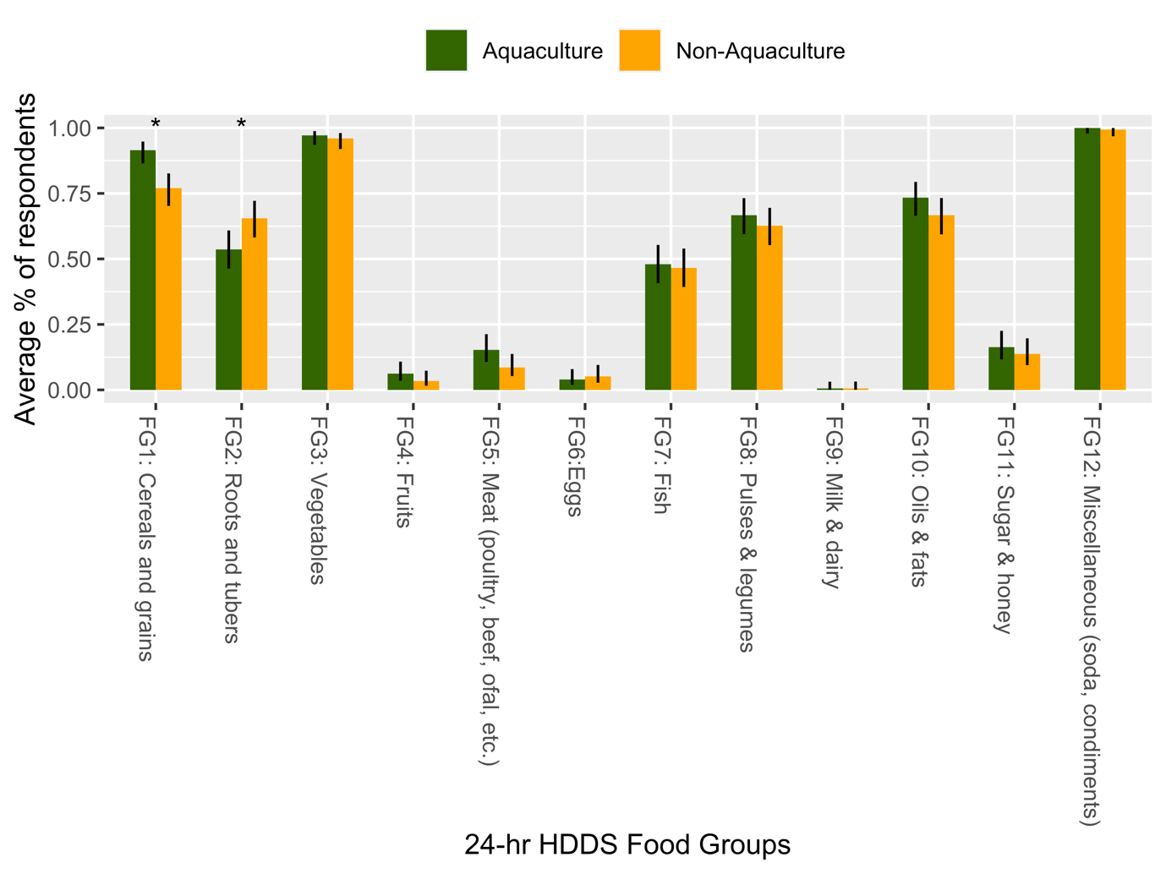

Appendix S4: Average daily rate (in past 28 days) of fish species consumed in households.
Statistical significance at or below the 5% indicated with asterisk (*) and calculated using a one-way ANOVA
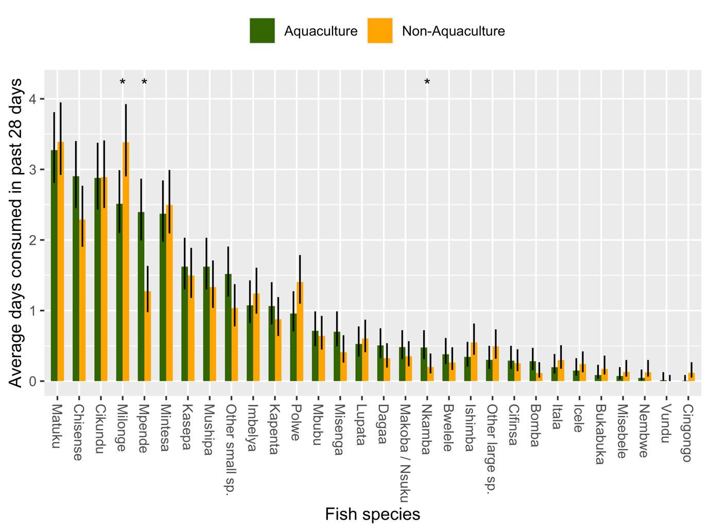

Appendix S5: Results of multilevel probit regression on HFIAS categories
Variables | B | SE | p-value | Exp(B)  - OR - | 95 CI for OR
 |  |  |  |  | Lower | Upper
Log (income +1) | -0.209 | 0.072 | 0.003 | 0.811 | -0.355 | -0.073
Non-aquaculture | 0.629 | 0.212 | 0.003 | 1.875 | 0.214 | 1.047
HH size: 4-7 people | 0.605 | 0.335 | 0.070 | 1.832 | -0.055 | 1.260
HH size: 4> 8 people | 1.052 | 0.378 | 0.005 | 2.864 | 0.311 | 1.795
Age: 35-60 | -0.341 | 0.264 | 0.14 | 0.677 | -0.911 | 0.125
Age: 61-years old | -0.691 | 0.323 | 0.032 | 0.501 | -1.326 | -0.061
Dietary diversity score | -0.235 | 0.081 | 0.003 | 0.790 | -0.393 | -0.08
PCA Dimension 2 | -0.203 | 0.094 | 0.0308 | 0.816 | -0.389 | -0.020
Simpsons index for diet | -7.139 | 2.573 | 0.006 | 0.001 | -12.346 | -2.228
Richness fish species | 0.147 | 0.036 | <0.000 | 1.159 | 0.077 | 0.221

