Appendix 1: Expended search strategy
Variables | Search strategy
- Outcome variable
Food security and nutrition | “nutrition* outcome*” OR “nutrition* status” OR “diet* diversi*” OR micronutrient* OR anthropom* OR food* OR macronutrient* OR nutrition* OR “food consumption*” OR diet* OR “food secur*” OR “food insecur* or food security governance or governance for food security
- Agricultural Interventions
Agricultural practice and extension | agricultur* or land* OR cultivat* or sustainable land management or integrated farming or farm management or sustainable agricultural production OR “organic farming” or land use patterns or sustainable agriculture or ecosystem service* or horticulture or biodiversity or complex model* or Acceptable agricultural practice* or Farmer* or right* or farmers’ right* or farming knowledge or working condition* or agricultural support or agricultural labo*or agricultural productivity or agricultural income* or agricultural diversification or agricultural financing or subsidies or investment intensity or emission or climate change or soil quality or landscape preservation or nature conservation or ecotourism or biodiversity protection or resource preservation or biodiversity management or Pest management or Fertilization or farming technique* or farming input* or On-farm mixing or Between-farm mixing or Diversifi* or Diversified system* or integrated system* or Mixing within the crop“ or agricultur* extension” OR “agricultural commercialization” OR “horticulture” or crop rotation or crop protection or tillage or application of organic manure or contour ploughing or crop rotation or polyculture or precision agriculture or intercropping or Rock and soil bund* or Organic farming or terracing
Homestead production | “homestead production” OR “homestead food production” OR “home garden*” OR “homestead garden” OR “vegetable garden*”
Livestock and dairy | “livestock program*” OR “livestock production*” OR “livestock ownership” OR “dairy production” OR “dairy program” OR “dairy development” OR “animal husbandry” OR “poultry development” OR “poultry production” OR “poultry program” OR “livestock intervention” or livestock* or livestock management or Mixing within the animal system* or integrated crop-livestock system*
Biofortification | biofortif* OR bio-fortif* OR “harvestplus” OR “harvest plus”
Irrigation | Irrigation OR “water management” or water use or water harvesting or groundwater pump* or Treadle pump* or rainfed agriculture
Aquaculture | quacultur* OR fisher* or fishpond”
Value chain | “value chain” OR value-chain OR “value crop*” OR “value-crop*” or market access or Harvesting or Storage or waste disposal or or food storage or Grain storage silo or Distance to market or credit or Extension or organisation membership* or “agricultural commercialization”
Nutrition-sensitive agriculture | “nutrition-sensitive” OR “nutrition sensitive
Policy interventions | program* OR polic* OR strateg* OR legislation* OR law* OR intervention* OR technique* OR planning OR practice* OR fiscal OR regulation* OR sustainable OR tax* OR subsid* OR procurement* OR incentive* or Land tenure or property right* OR “land right*” or land tenure security or regulation or land valuation or land taxation, or land size or land access or documented legal right* or de facto land possession or “land registration” OR “land certification” OR “land tenure regulari*” OR “land reform” or “customary land tenure” OR “land governance” or conversion or freehold* or titl* or codification or recognition or customary or certification
Technology and improved crop varieties | technolog* or crop management software or management-based technolog* or Input- -based technolog* or AgriERP or Agworld or Conservis or FarmLog* Farmbrite or Granular or Agrimap or AGRIVI or CropTracker or FarmERP or Trimble or Accelerating technolog* or defusing technolog* or Indigenous technolog* or exogenous technolog* or or Improved Variet* or High-yielding cereal* or Disease-resistant crop* or mangrove swamp crop* or Chemical Input* or Pesticid* or Laser-land levelling
Agroforestry | Agroforestry or Crop Protection or Wildlife or Landscape or Wildlife Management or Landscape Management or Energy Resource* or fuel or fuel the farm operation* or natural resource management
- Setting
Sub-Saharan african countries | Sub-saharan Africa or Central Africa or Eastern Africa or Southern Africa or Western Africa or Angola or Benin or Botswana or Burkina Faso or Burundi or Cabo Verde or Cameroon or Central African Republic or Chad or Comoros or Congo or Democratic Republic of Congo or Republic of congo or Cote d'Ivoire or Equatorial Guinea or Eritrea Eswatini or Swaziland or Ethiopia or Gabon or Gambia or Ghana or Guinea or Guinea-Bissau or Kenya or Lesotho or Liberia or Madagascar or Malawi or Mali or Mauritania or Mauritius or Mozambique or Namibia or Niger or Nigeria or Rwanda or Sao Tome and Principe or Senegal or Seychelles or Sierra Leone or Somalia or South Africa or South Sudan or Sudan or Tanzania or Togo or Uganda or Zambia or Zimbabwe

Appendix 2. Risk of bias-Eger regression and funnel plots
Food security
H0: beta1 = 0; no small-study effects
beta1 = 0.35
SE of beta1 = 1.054
z = 0.33
Prob > z = 0.7412

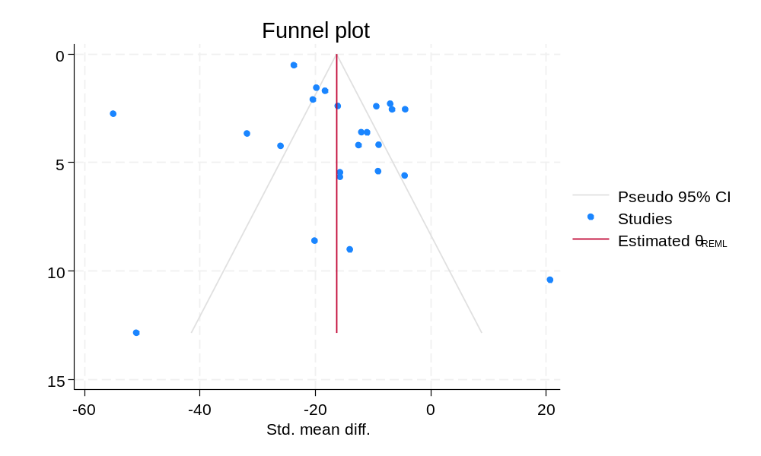

Cereal yield equivalent (kg/ha)
H0: beta1 = 0; no small-study effects
beta1 = 4.16
SE of beta1 = 0.936
z = 4.45
Prob > z = 0.0000
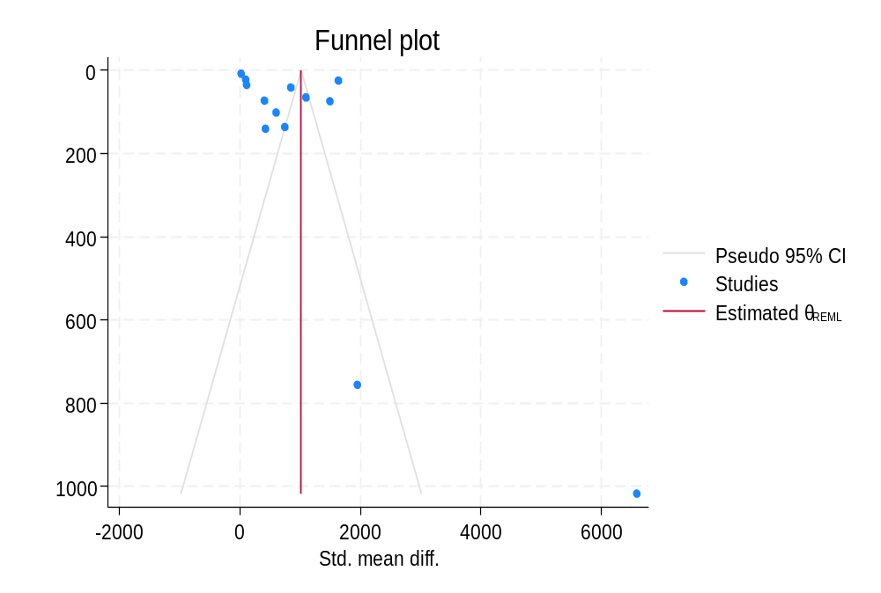

Farm food yield revenue (USD per capita)
H0: beta1 = 0; no small-study effects
beta1 = 1.18
SE of beta1 = 1.244
z = 0.95
Prob > z = 0.3412
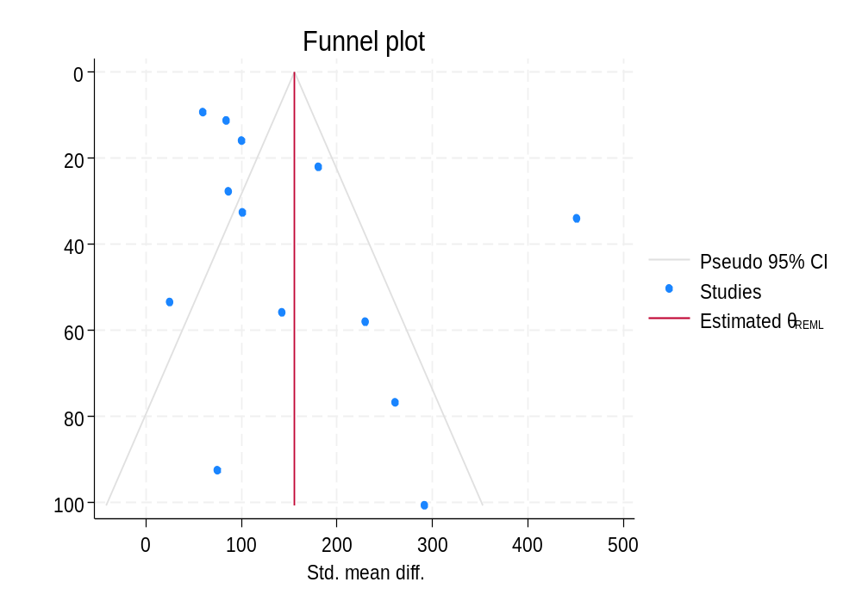

Food and nutrient consumption (%)
H0: beta1 = 0; no small-study effects
beta1 = 1.14
SE of beta1 = 0.564
z = 2.02
Prob > z = 0.0435
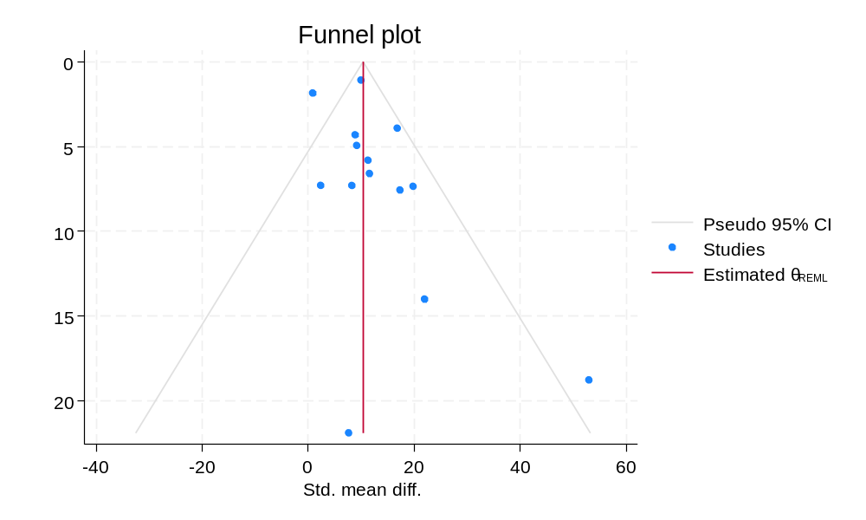

Food composition score (%)
H0: beta1 = 0; no small-study effects
beta1 = 1.97
SE of beta1 = 0.635
z = 3.11
Prob > z = 0.0019

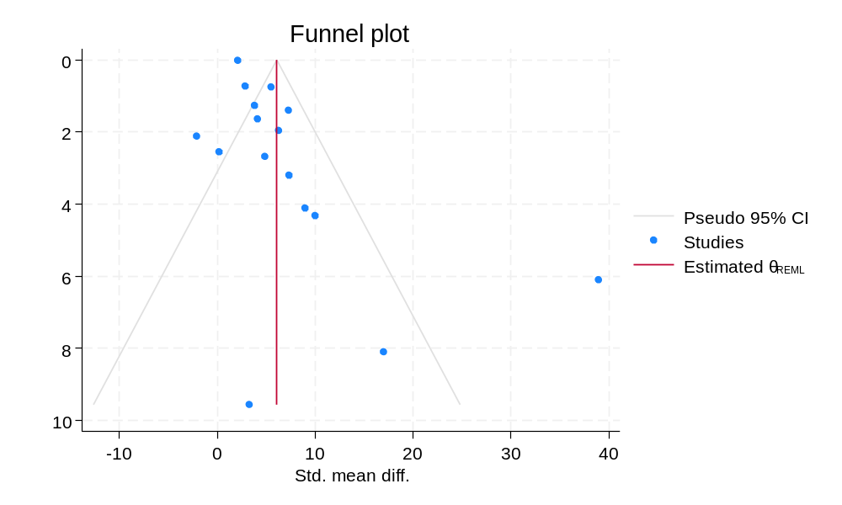

Dietary diversity score
H0: beta1 = 0; no small-study effects
beta1 = 2.10
SE of beta1 = 0.567
z = 3.71
Prob > z = 0.0002
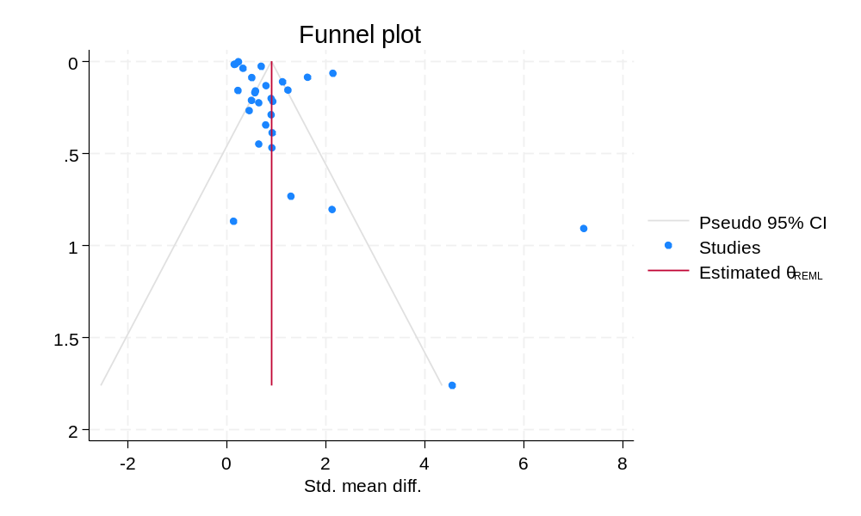

Energy intake (Kcal/person)

H0: beta1 = 0; no small-study effects
beta1 = 0.76
SE of beta1 = 1.130
z = 0.67
Prob > z = 0.5025

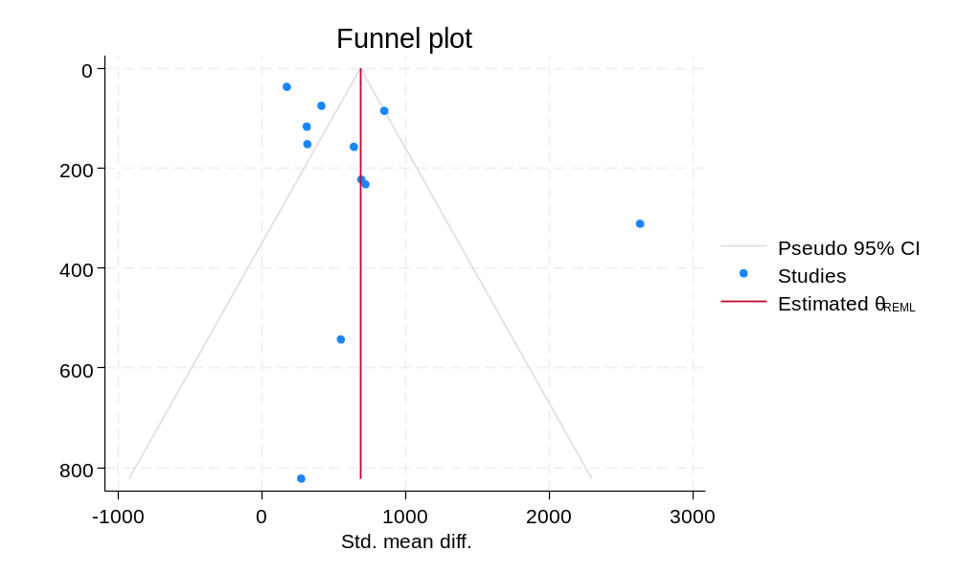

Appendix 3. Supplementary materials on the impact of SOA
Supplemnatry figure: 1 Impact of SOA on overall food food security
1A. By type of intervention
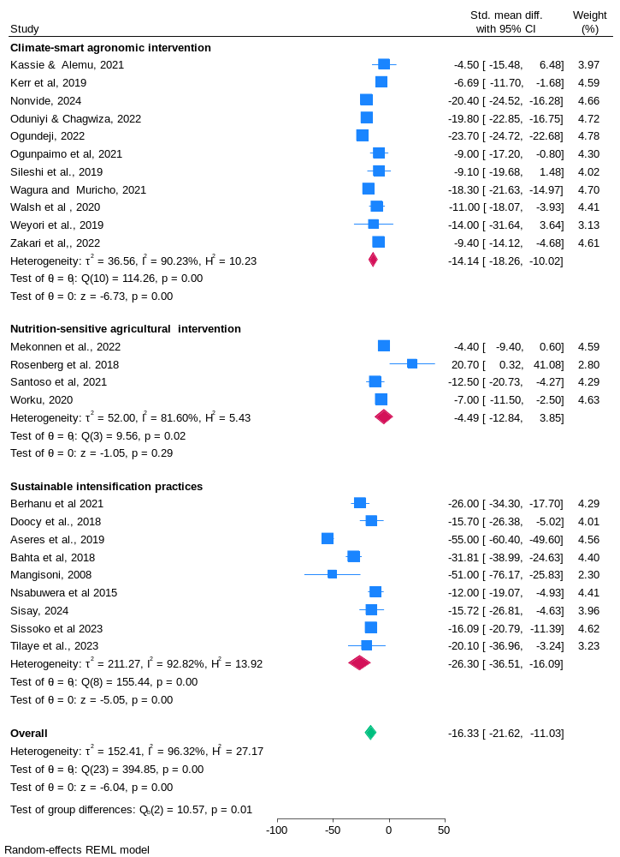

1B. By region
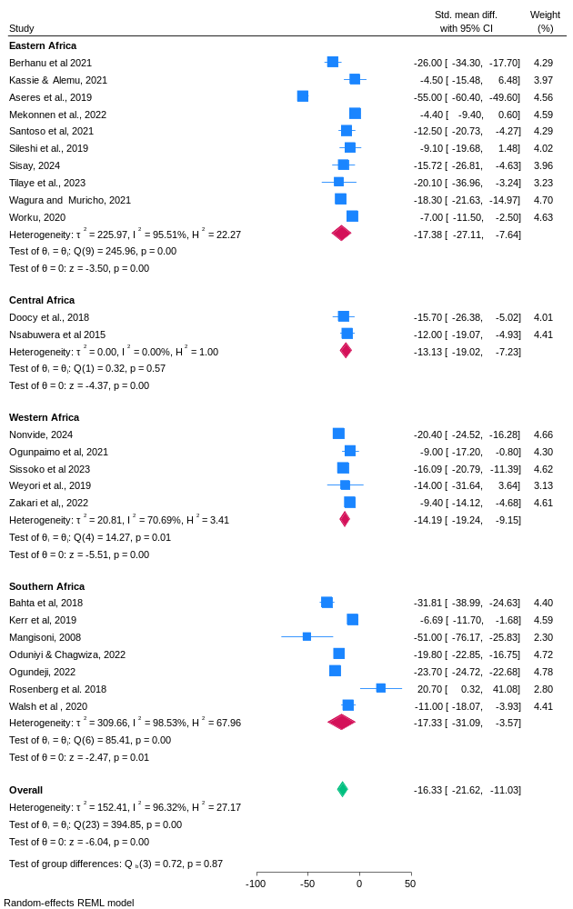
1C. By study design

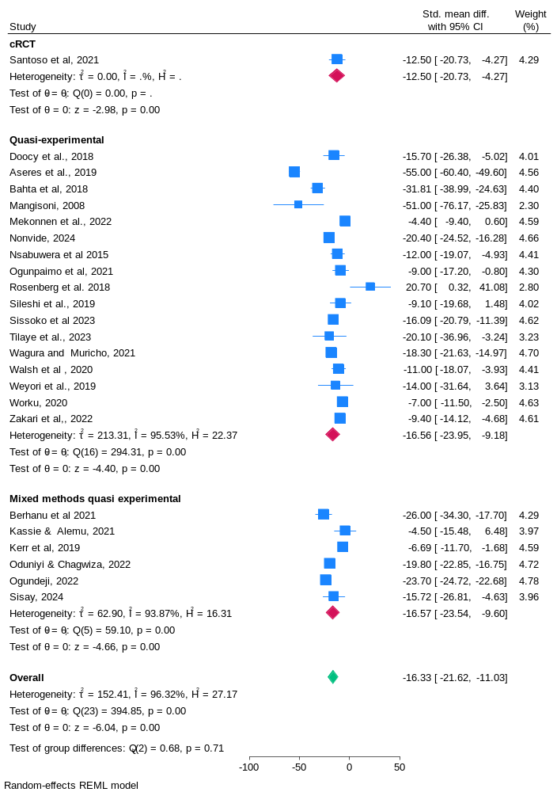

1D. Impact of SOA on food stability

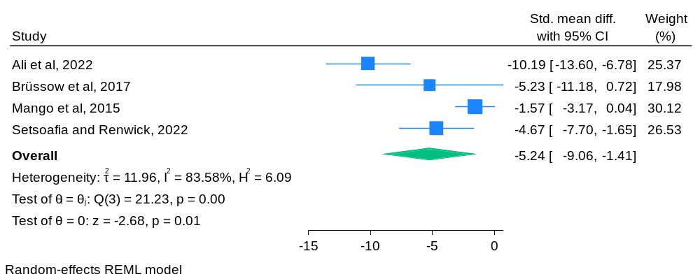

Supplemnatry figure 2: Impact of SOA on food abvailability
2A) Cereal yield equivalent in kg/ha by intervention type
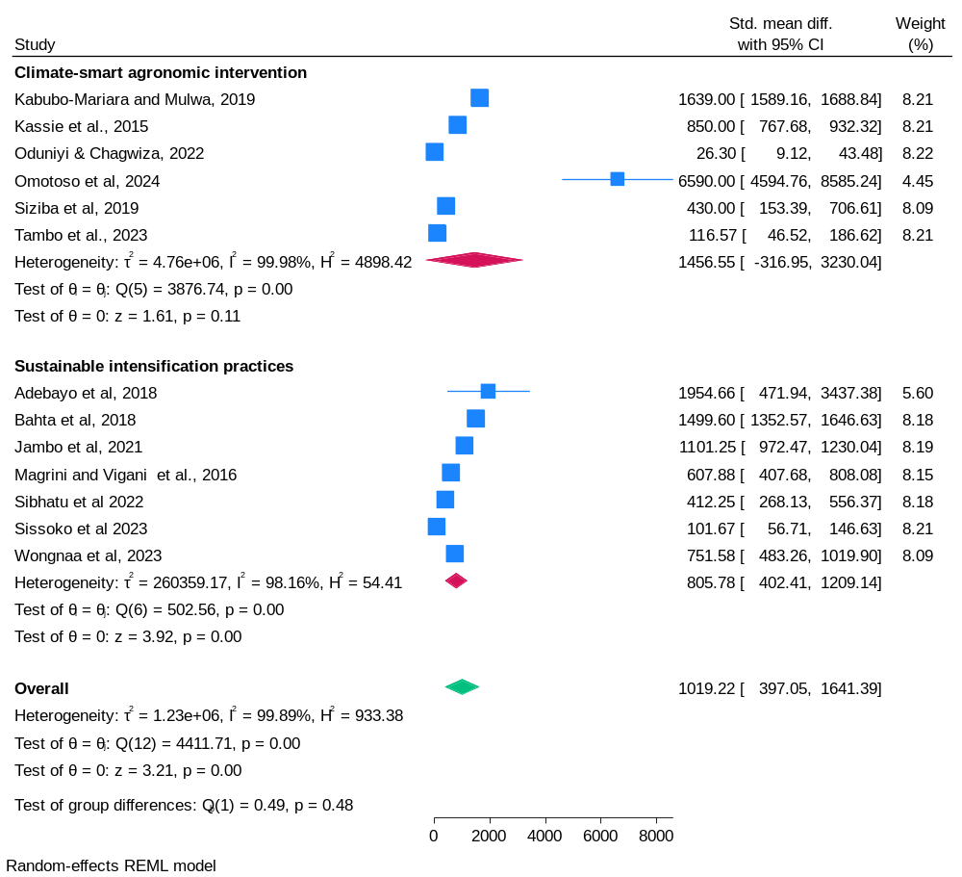

2B) Cereal yield equivalent in kg/ha by region
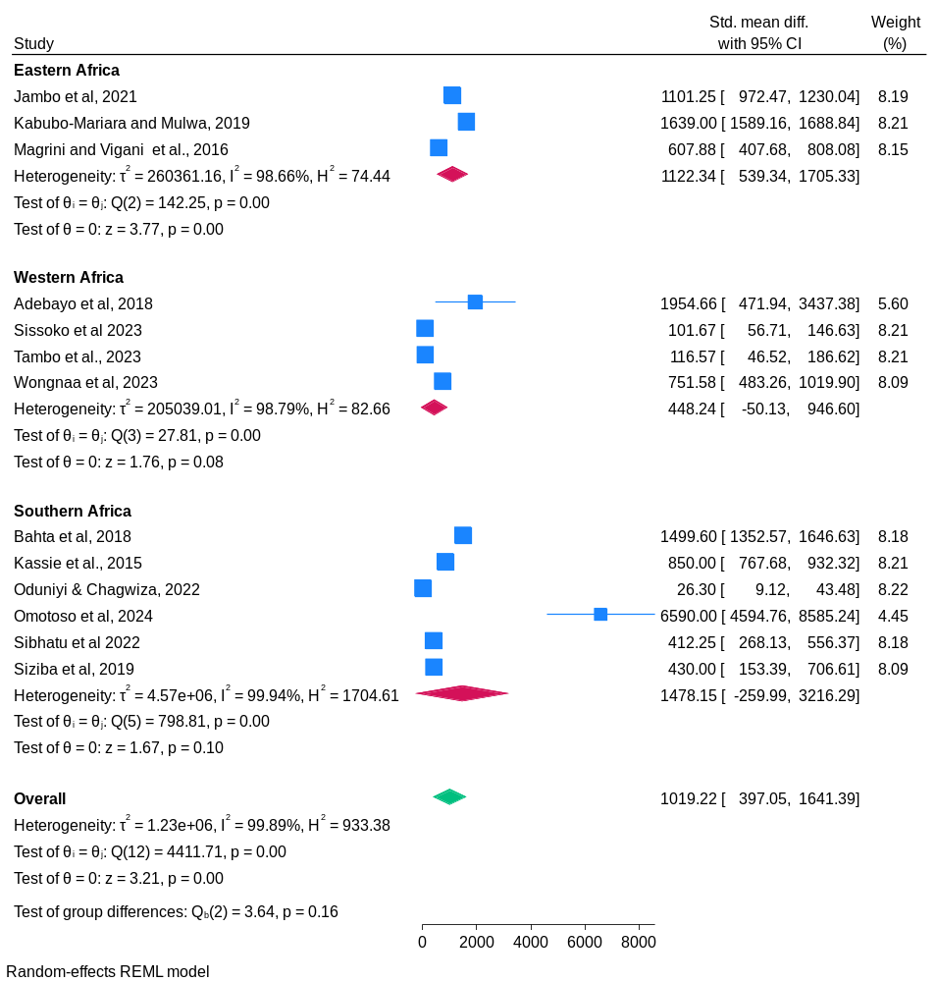

2C) Cereal yield equivalent in kg/ha by study design
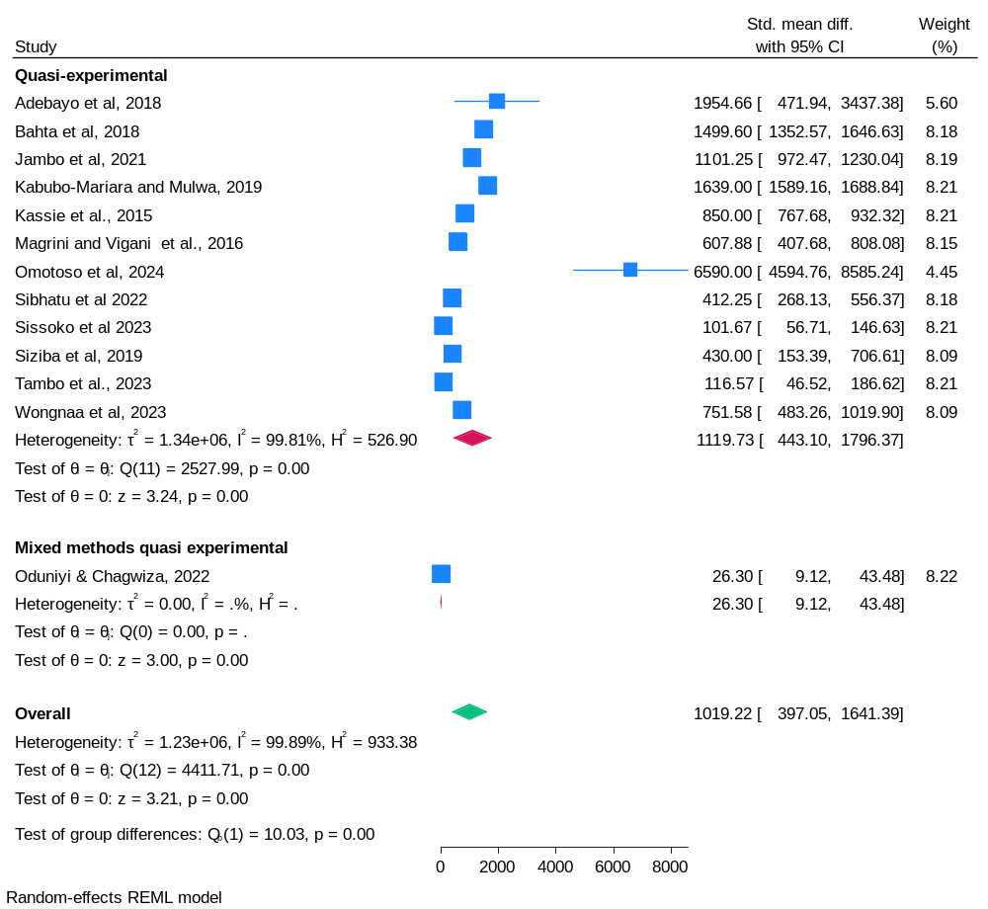
2D: Per capita farm food yield revenue by intervention type
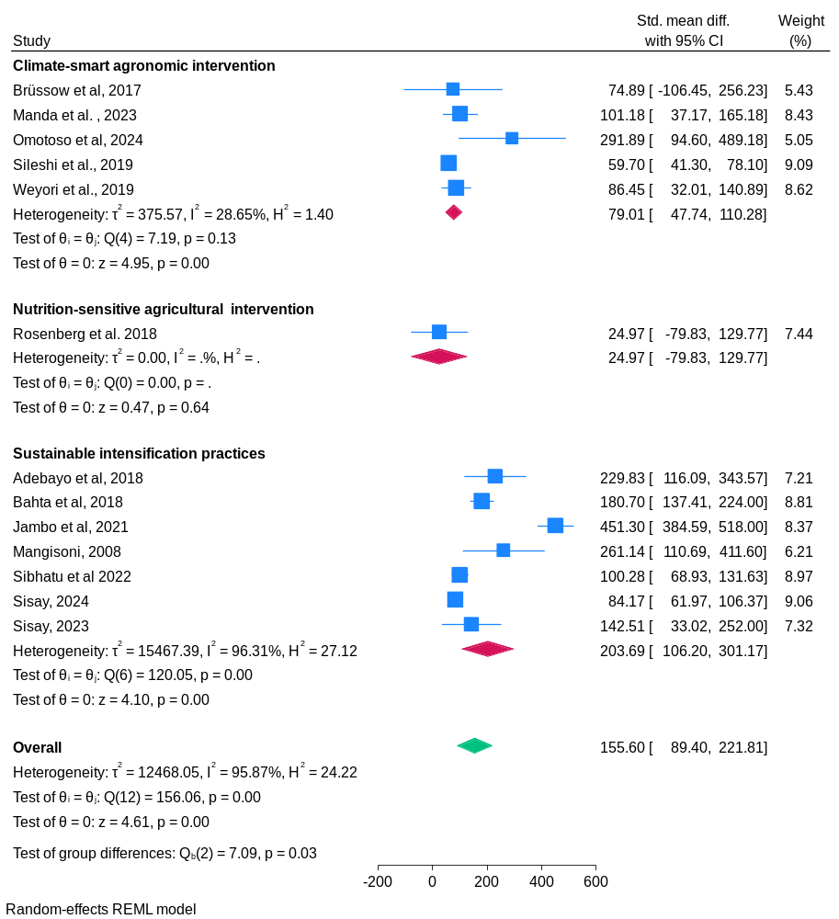

2E: Per capita farm food yield revenue by region
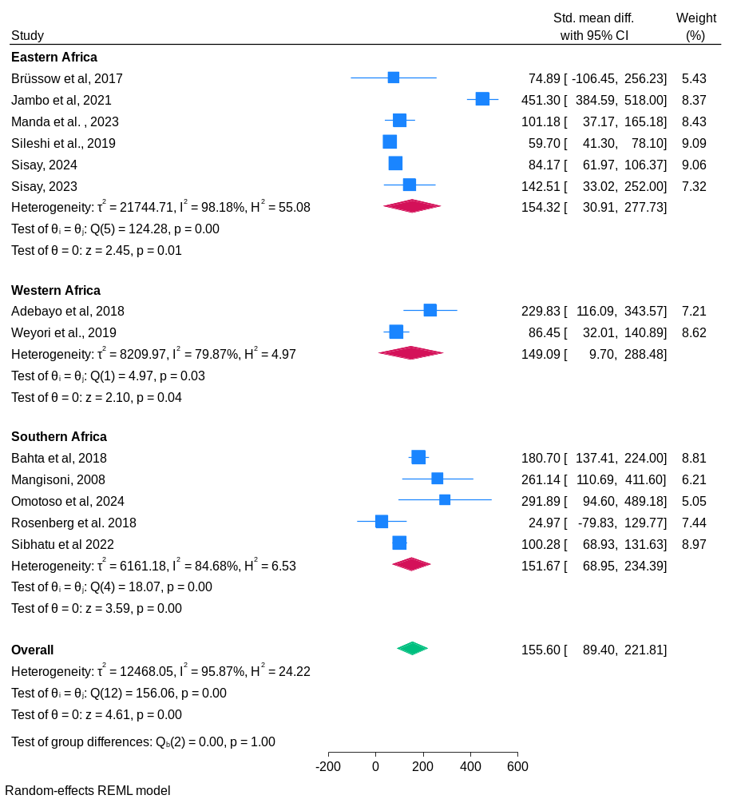

2F: Per capita farm food yield revenue by study design
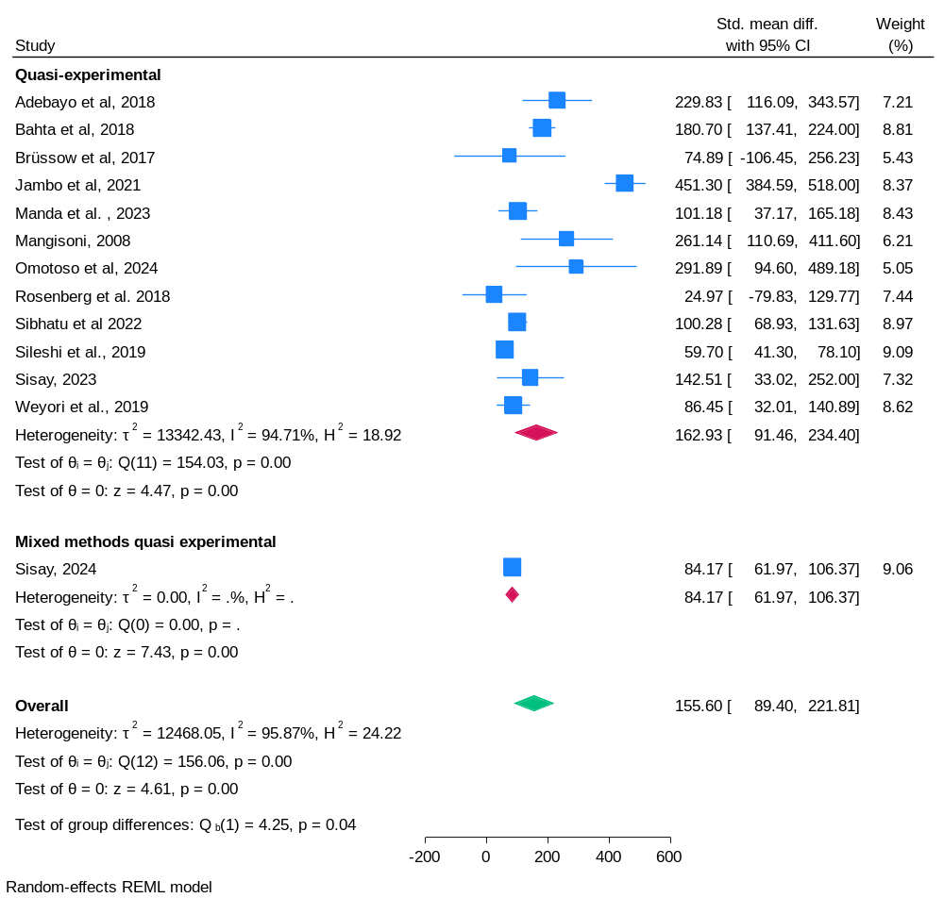

Supplemnatry figure 3: Impact of SOA on food access
3A: Impact on per capita household income
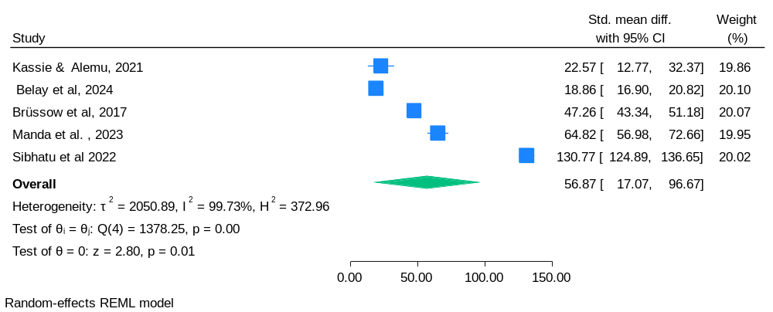

3B: Impact on per capita food consumption expenditure
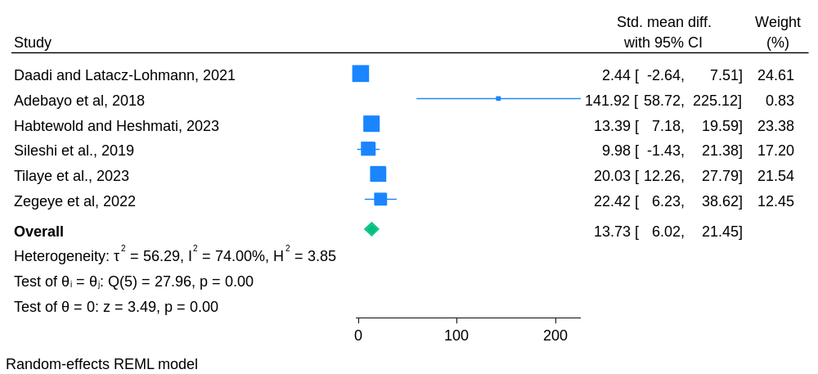

3C: Impact on household poverty
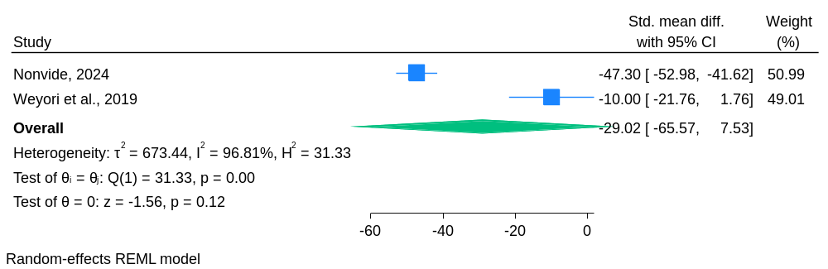

Supplemnatry figure 4: Impact of SOA on food utilisation

4A: Nutrient and food consumption by intervention type
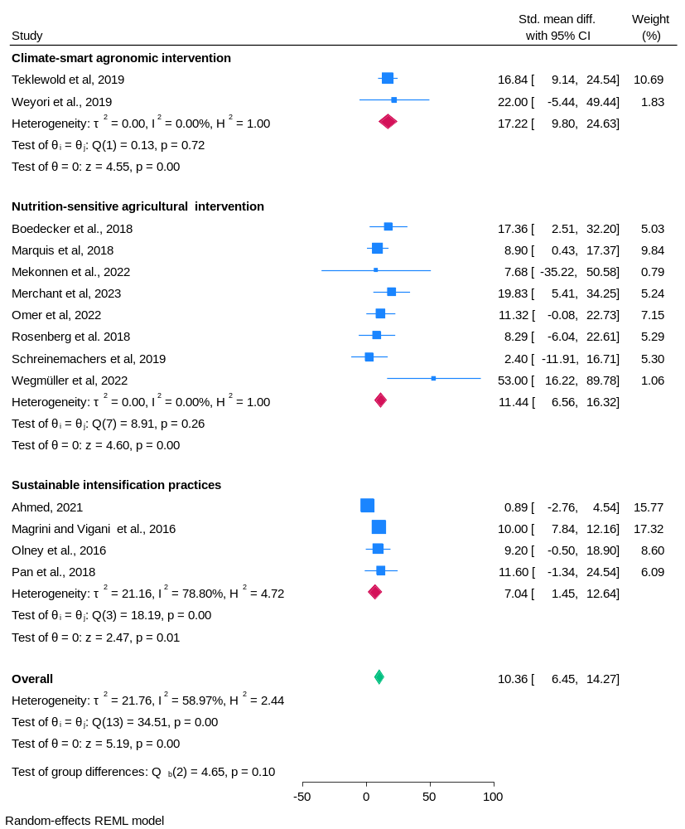

4B: Nutrient and food consumption by region
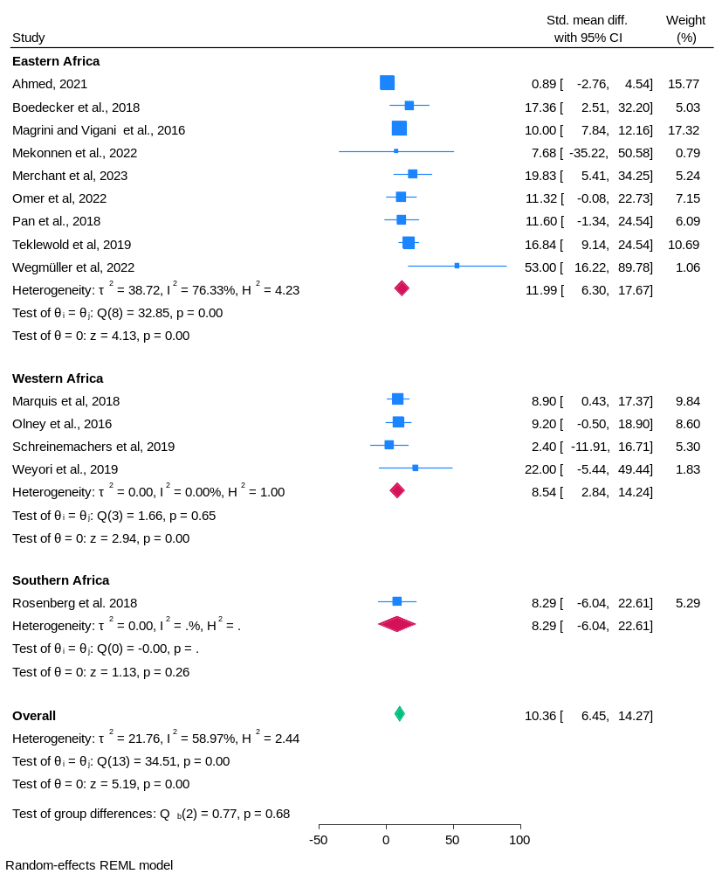

4C: Nutrient and food consumption by study design

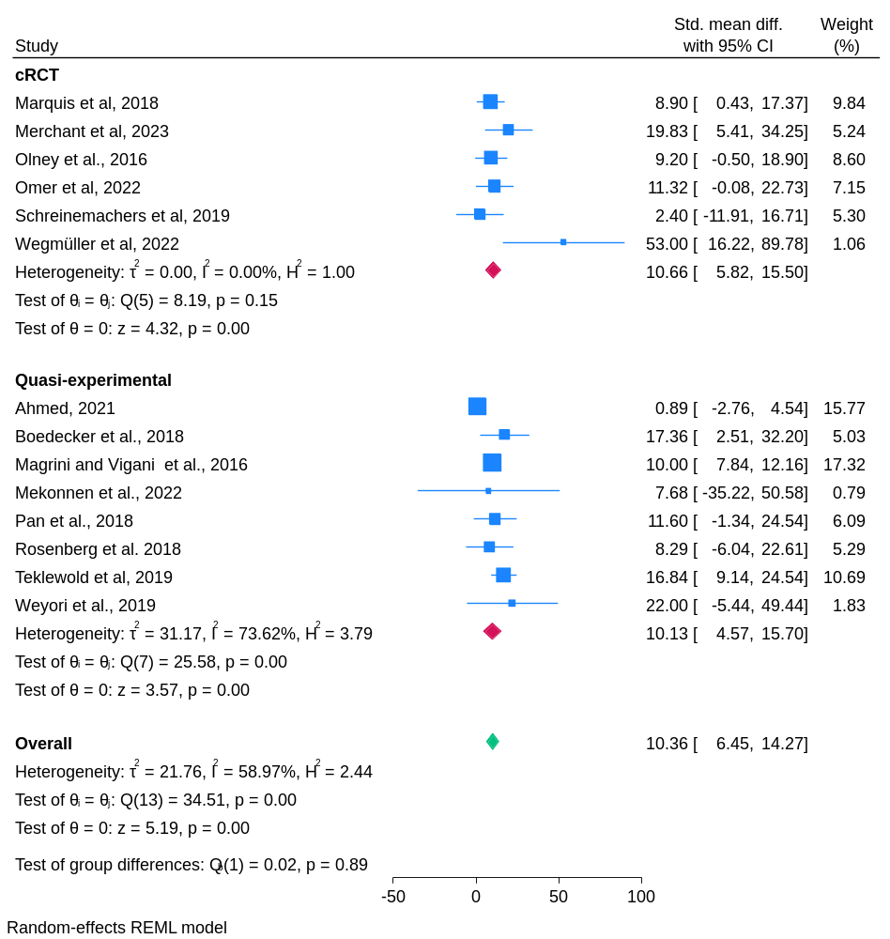

4D: Food composition scores by intervention type
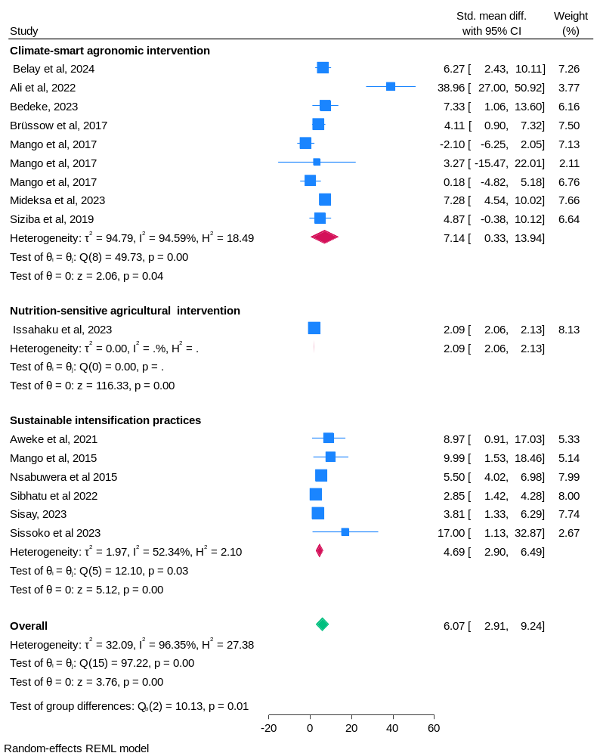

4E: Food composition scores by region

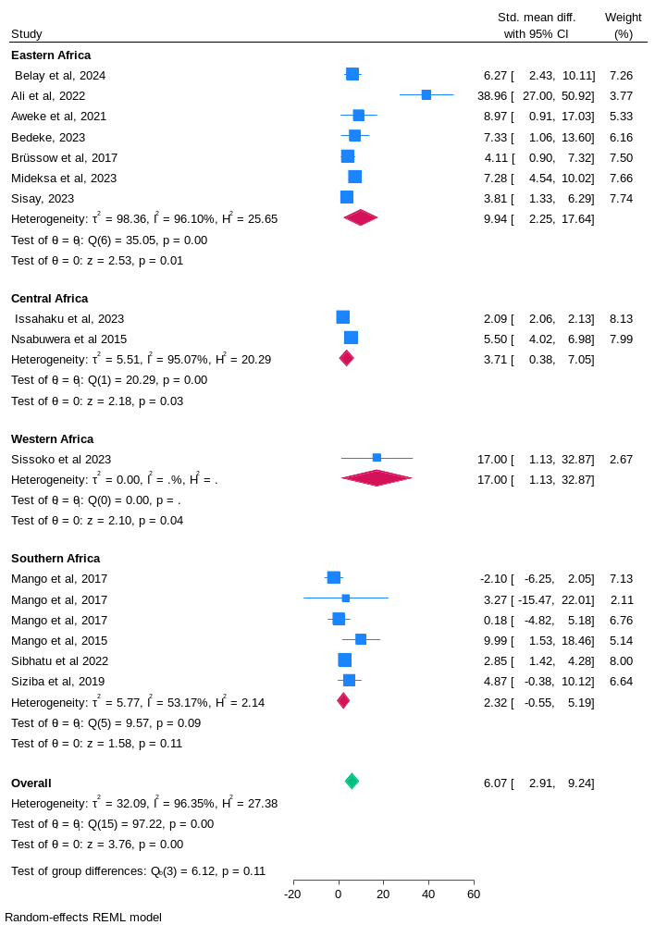
4F: Food composition scores by study design
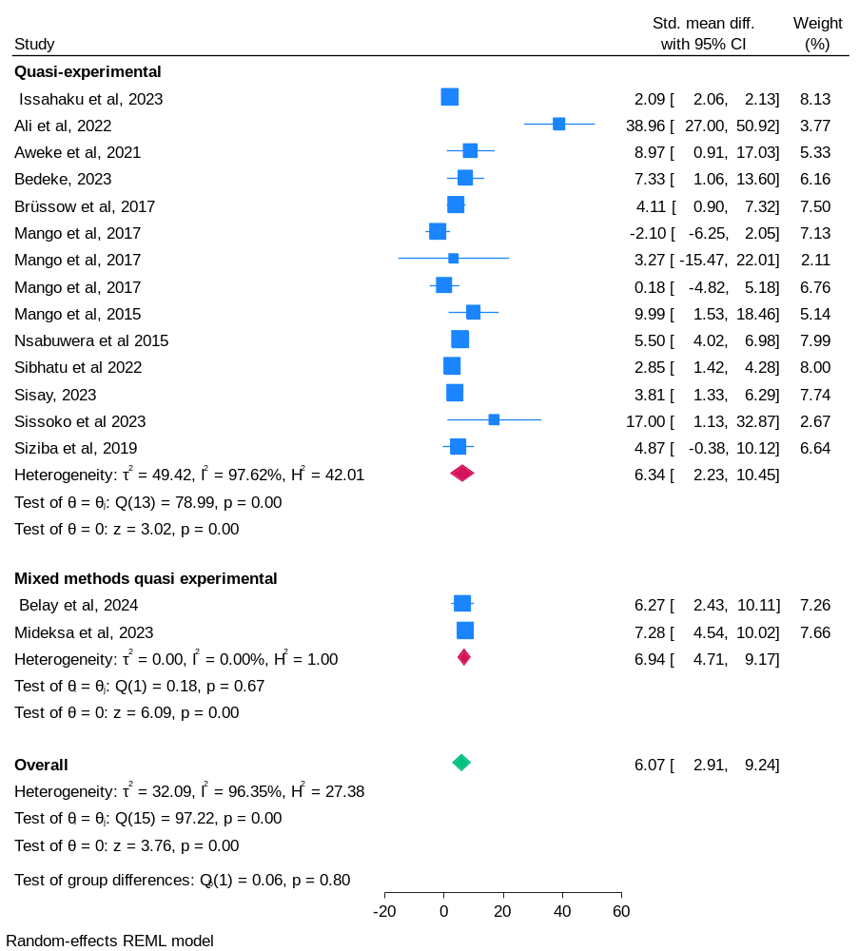

4G: Dietary diversity by intervention type
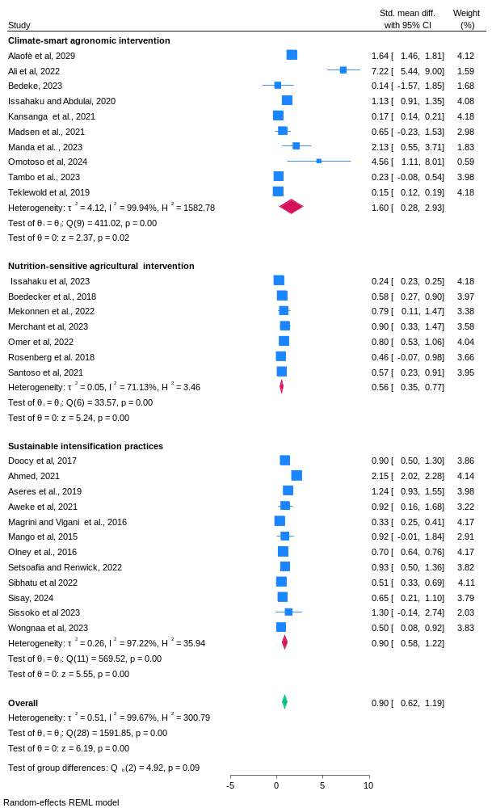
4H: Dietary diversity by region
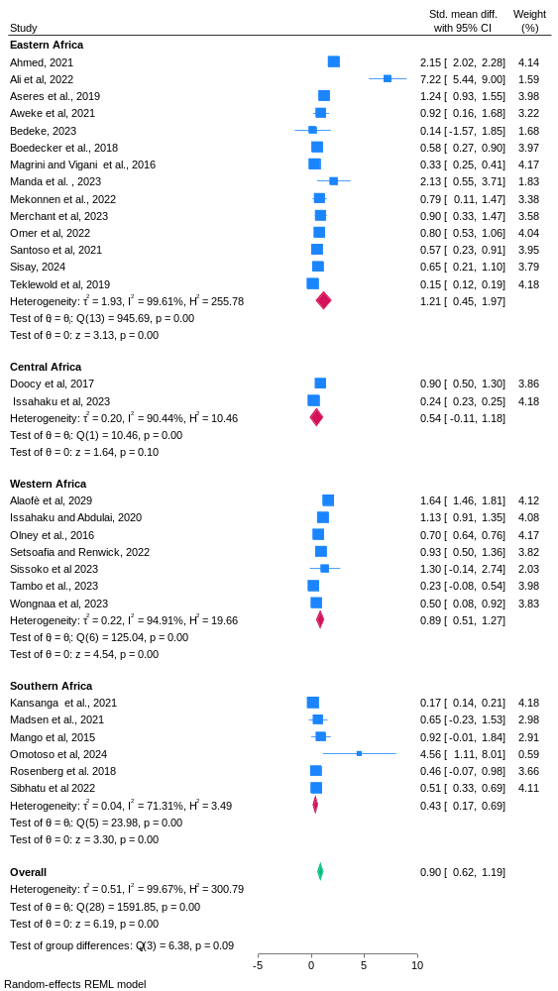

4I: Dietary diversity by study design
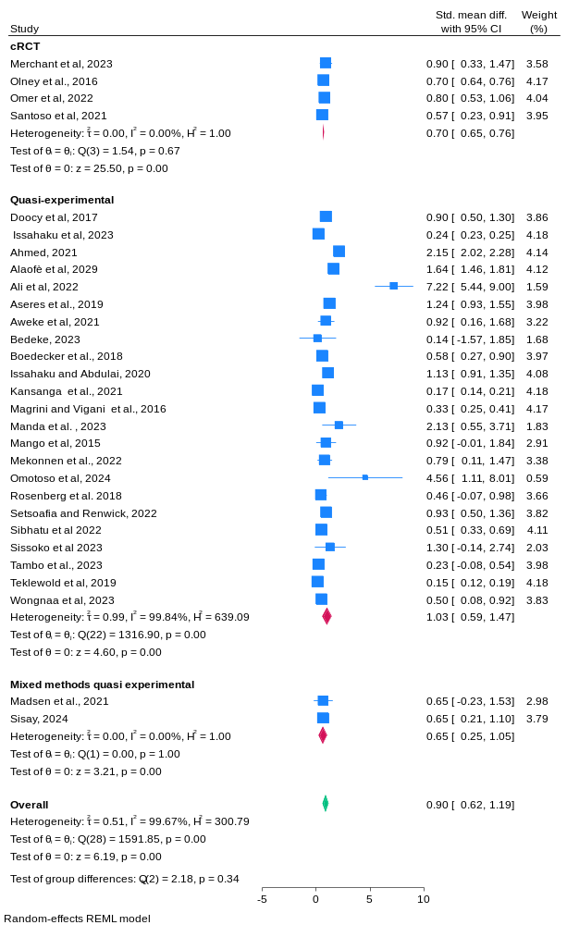

4J: Calorie intake by intervention type
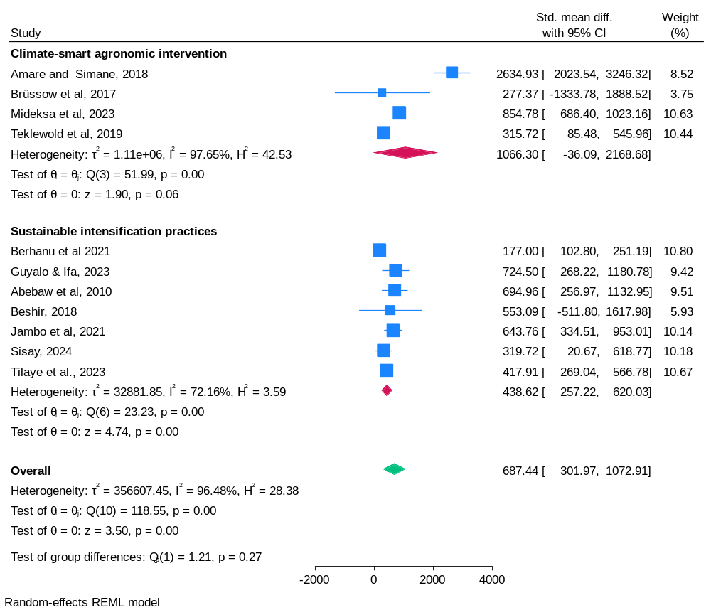

4K: Calorie intake by region
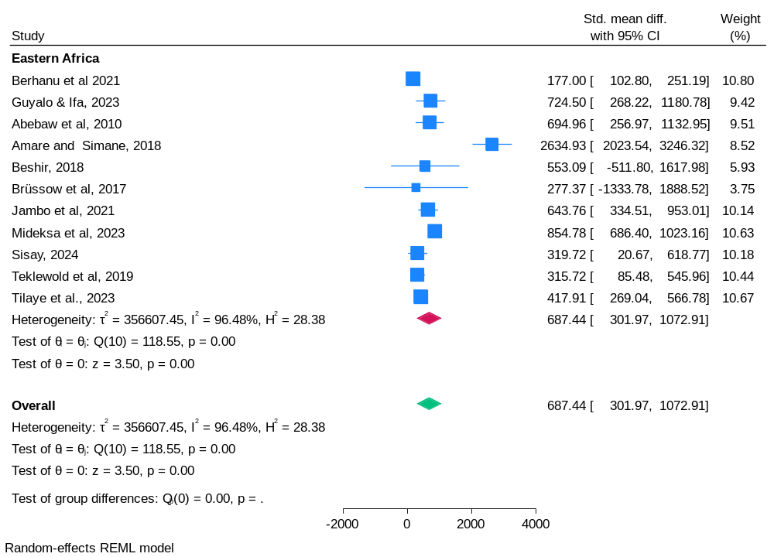

4L: Calorie intake by study design
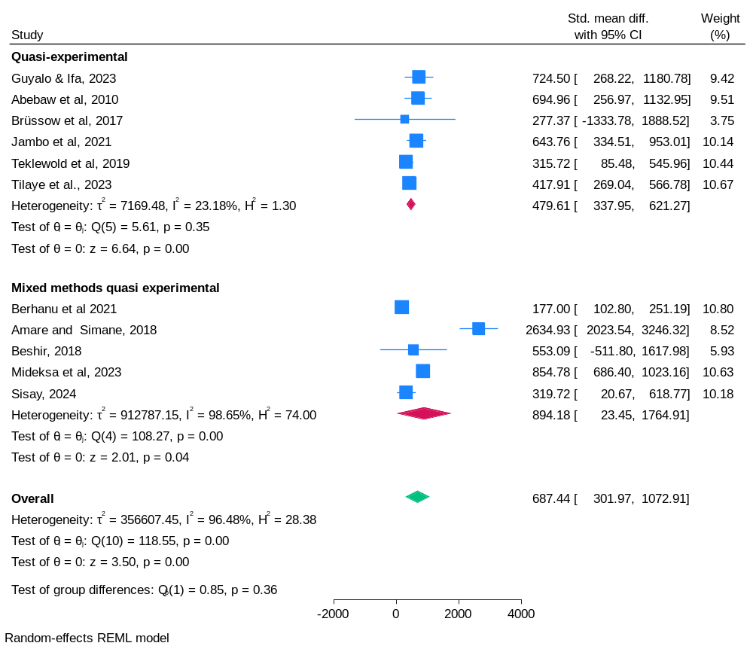

4M: Minimum dietary diversity
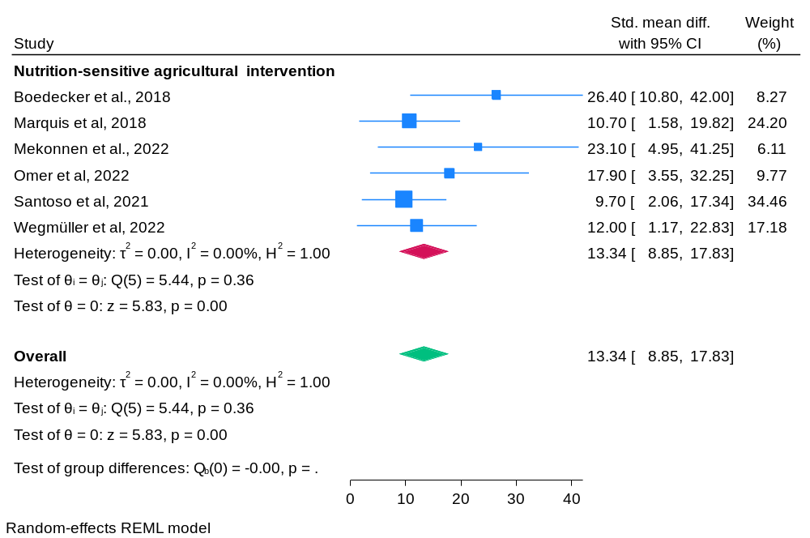

4N: HAZ
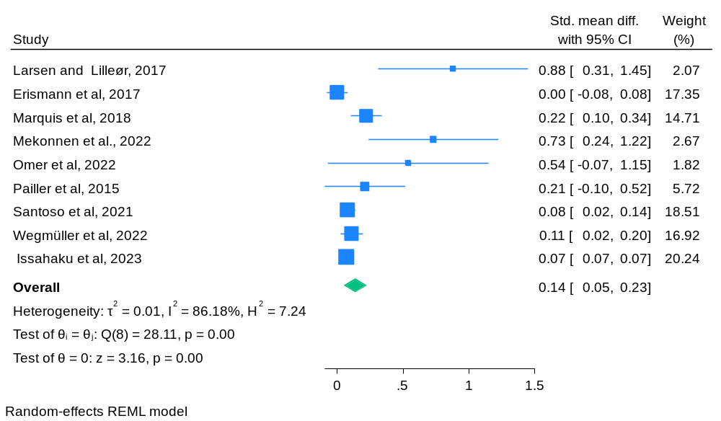

4O: WHZ
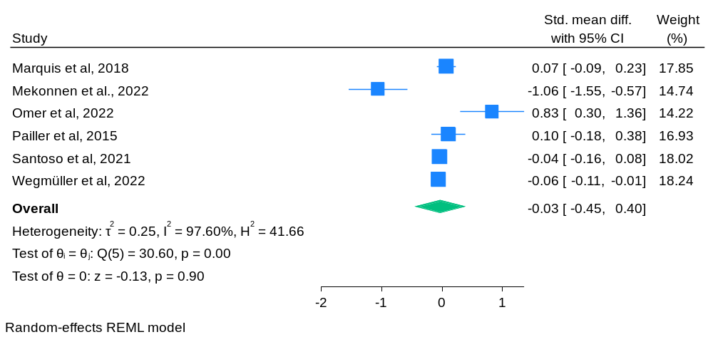

4P: WAZ
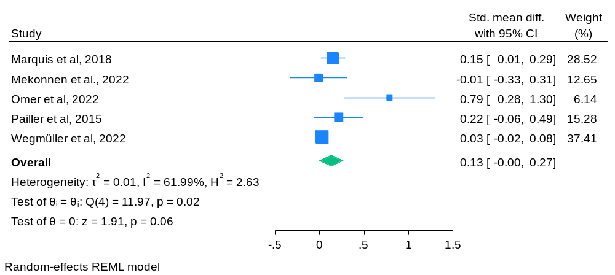

4R: Women’s BMI
