Enhancing Durum Wheat Grain Quality and Safety: The Role of Organic Foliar Fertilization and Selenium Biofortification in Mediterranean Farming Systems

Federica Carucciª, Giuseppe Gatta^{b}*, Massimo Blandino^{c}, Valentina Scarpino^{c}, Gustavo Moreno-Martín^{d}, Yolanda Madrid-Albarrán^{d}, Marcella Michela Giuliani^{b}

ª University of Tuscia, Dipartimento di Scienze Agrarie e Forestali (DAFNE), 01100 Viterbo, Italy. federica.carucci@unitus.it.
^{b} University of Foggia, Dipartimento di Scienze Agrarie, Alimenti, Risorse Naturali e Ingegneria (DAFNE), 71122 Foggia, FG, Italy. giuseppe.gatta@unifg.it, marcella.giuliani@unifg.it
^{c} University of Turin, Dipartimento di Scienze Agrarie, Forestali e Alimentari, Largo Paolo Braccini 2, 10095, Grugliasco, TO, Italy. massimo.blandino@unito.it, valentina.scarpino@unito.it
^{d} Universidad Complutense de Madrid, Departamento de Química Analítica, Facultad de Ciencias Químicas, 28040 Madrid, Spain. ymadrid@quim.ucm.es, gusmoren@ucm.es

*Corresponding author: giuseppe.gatta@unifg.it

This document provides more detailed information on the main paper mentioned above.
The following information is included:
 | Content
Table S1 | The main soil physical and chemical properties in the 2018 and 2019 growing seasons.
Table S2 | Details of the fertilizers used in the experimental trial, including active nutrient composition, application method, fertilizer and nutrient rates, spray volume, and crop growth stage (BBCH scale) for the 2018 and 2019 growing seasons. For fertilizers with foliar spray applications, meteorological conditions (wind speed, relative humidity, and air temperature) at the time of application are reported for the two growing seasons.
Table S3 | F-value and significance level of the effect of year (Y), cultivar (CV), foliar fertilization (F), selenium application (Se), and their interaction on protein fraction resulting from analysis of variance (ANOVA).
Table S4 | F-value and significance level of the effect of year (Y), cultivar (CV), foliar fertilization (F), selenium application (Se), and their interaction on macro and micro nutrient grain concentration resulting from analysis of variance (ANOVA).
Table S5 | F-value and significance level of the effect of year (Y), cultivar (V), foliar fertilization (F), selenium application (Se), and their interaction on the mycotoxin contamination in durum wheat grain resulting from analysis of variance (ANOVA).
Figure S1 | Experimental layout of the randomized complete block design arranged in a split-split-plot with three replicates, and the schematic representation of the net plot dimensions and buffer zones. CONT: control, dry blood meal in a single application at seeding; CONT+N: CONT plus N foliar application at BBCH stage 51; CONT+S: CONT plus foliar S application at BBCH stage 47; CONT+NS: CONT plus the combination of S (BBCH stage 47) and N (BBCH stage 47) foliar applications. Se0: control without selenium; Se60: application of sodium selenate (Na2SeO4), at booting stage BBCH 41.

Table S1. The main soil physical and chemical properties of the two growing seasons.
Soil proprieties |  | 2018 | 2019
Sand | % | 11.4 | 15.4
Silt | % | 39.6 | 34.9
Clay | % | 49 | 49.7
pH |  | 8.3 | 8.4
Total N (Dumas method) | ‰ | 1.3 | 1.1
Mineral N ‡ | mg kg^{–1} | 15.9 | 19.2
Total S (Dumas method) | ‰ | 0.49 | 0.46
Total Se (Mass spectrometry method) | mg kg^{–1} | 0.056 | 0.087
Available P (Olsen method) | mg kg^{–1} | 62 | 68
Exchangeable K (Ammonium acetate method) | mg kg^{–1} | 422 | 450
Organic matter (Walkley–Black method) | % | 2.5 | 2.6
‡ Mineral N was determined as the sum of nitrate and ammonium content (Keeney and Nelson 1982)

Table S2. Details of the fertilizers used in the experimental trial, including active nutrient composition, application method, fertilizer and nutrient rates, spray volume, and crop growth stage (BBCH scale) for the 2018 and 2019 growing seasons. For fertilizers with foliar spray applications, meteorological conditions (wind speed, relative humidity, and air temperature) at the time of application are reported for the two growing seasons.

Fertilizer applied | Active nutrient grade and form | Fertilizer Rate  (kg ha⁻¹) | Active Nutrient rate  (kg ha⁻¹) | Volume  (L ha⁻¹) | Growing season
 |  |  |  |  | 2018 |  |  |  |  | 2019
 |  |  |  |  | BBCH | Wind  (m s⁻¹) | RH (%) | T (°C) | BBCH |  | Wind  (m s⁻¹) | RH (%) | T (°C)
Dry Blood Meal (ORGAZOT®) | N 14.5%; Amino acid complex from dry blood meal. | 50 | 7.25 | - | 00 | - | - | - | 00 |  | - | - | -
Bio Sulphur (Fytofert®S) | S 50%; Elemental sulfur obtained by bacterial transformation (Thiobacillus spp.) from a plant-derived organic matrix. | 45 | 22.5 | 300 | 47 | 0.7 | 99 | 5 | 47 |  | 1.4 | 87 | 9
Selenium | Sodium selenate | 0.06 | 0.06 | 300 | 41 | 1.7 | 87 | 15 | 41 |  | 1.8 | 92 | 11
Liquid Blood Meal (EUTROFIT®) | N 4%; Amino acid complex from fluid blood meal. | 20 | 0.8 | 450 | 51 | 1.9 | 99 | 15 | 51 |  | 1.4 | 99 | 15

Table S3. F-value and significance level of the effect of year (Y), cultivar (CV), foliar fertilization (F), selenium application (Se), and their interaction on protein fraction resulting from analysis of variance (ANOVA).
Factor | DF | SLP | ILP | Polymeric protein fraction | Monomeric protein fraction | mon/pol | UPP | GI
Y | 1 | 426.99** | 37.475** | 1237.3** | 1237.3** | 1262.94** | 7.591** | 1679.68**
CV | 3 | 130.58** | 286.634** | 146.33** | 146.33** | 132.55** | 288.786** | 3883.98**
F | 3 | 17.22** | 25.901** | 1.61ns | 1.61ns | 1.57ns | 42.335** | 20.59**
Se | 1 | 0.00ns | 0.016ns | 0.35ns | 0.35ns | 0.22ns | 0.274ns | 1.95ns
YxCV | 3 | 11.56** | 84.65** | 72.64** | 72.64** | 59.61** | 40.1** | 10.35**
YxF | 3 | 11.36** | 15.101** | 0.48ns | 0.48ns | 0.57ns | 22.418** | 37.59**
CVxF | 9 | 3.2* | 6.842** | 1.86ns | 1.86ns | 1.73ns | 7.416** | 17.64**
YxSe | 1 | 0.17ns | 0.384ns | 0.08ns | 0.08ns | 0.12ns | 0.486ns | 105.12**
CVxSe | 3 | 2.05ns | 3.865* | 0.38ns | 0.38ns | 0.47ns | 4.514** | 35.62**
FxSe | 3 | 3.08* | 2.848* | 1.28 ns | 1.28ns | 1.12ns | 3.877* | 0.26ns
YxCVxF | 9 | 7.94** | 19.483** | 6.68** | 6.68** | 7.1** | 21.306** | 6.29**
YxCVxSe | 3 | 1.7ns | 1.911ns | 0.7ns | 0.7ns | 0.7ns | 2.118ns | 8.35**
YxFxSe | 3 | 2.17ns | 13.152** | 8.42** | 8.42** | 8.27** | 9.878** | 29.49**
VxFxSe | 9 | 2.59** | 9.905** | 4.77** | 4.77** | 5.73** | 10.49** | 16.35**
YxCVxFxSe | 9 | 6.64** | 19.485** | 2.85** | 2.85** | 3** | 21.723** | 11.35**
DF: degree of freedom; SLP: soluble large polymers; ILP: insoluble large polymers; mon/pol: monomeric/polymeric ratio; UPP: unextractable polymeric protein; GI: gluten index.
** p-value ≤ 0.01; * p-value ≤ 0.05; ns not significant.

Table S4. F-value and significance level of the effect of year (Y), cultivar (CV), foliar fertilization (F), selenium application (Se), and their interaction on macro and micro nutrient grain concentration resulting from analysis of variance (ANOVA).
Factor | DF | Grain [N] | Grain [S] | Grain [Se] | Grain [Fe] | Grain [Zn]
Y | 1 | 3815.25** | 2721.917** | 30.108** | 202.829** | 1599.287**
CV | 3 | 22.25** | 114.953** | 39.93** | 38.935** | 14.048**
F | 3 | 2.27ns | 8.866** | 40.913** | 11.311** | 4.66**
Se | 1 | 1.68ns | 0.16ns | 2924.688** | 0.453ns | 4.00ns
YxCV | 3 | 44.1** | 184.421** | 55.245** | 56.874** | 6.786**
YxF | 3 | 3.61* | 21.62** | 10.462** | 10.018** | 7.413**
CVxF | 9 | 10.77** | 6.541** | 7.095** | 5.871** | 4.727**
YxSe | 1 | 0.02ns | 0.445ns | 15.865** | 16.005** | 10.439**
CVxSe | 3 | 3.00* | 2.059ns | 15.213** | 1.79ns | 1.116ns
FxSe | 3 | 3.14* | 4.196** | 15.345** | 2.861* | 4.235**
YxCVxF | 9 | 16.2** | 14.372** | 4.707** | 12.024** | 5.064**
YxCVxSe | 3 | 1.28ns | 0.777ns | 8.299** | 2.631ns | 0.448ns
YxFxSe | 3 | 4.85** | 2.344ns | 1.272ns | 4.323** | 0.908ns
VxFxSe | 9 | 1.36ns | 1.284ns | 0.594ns | 4.17** | 1.448ns
YxCVxFxSe | 9 | 2.46** | 2.455* | 0.868ns | 2.879** | 1.886ns
DF: degree of freedom; grain [N], [S], [Se], [Fe] and [Zn]: nitrogen, sulphur, selenium, iron and zinc grain concentrations.
** p-value ≤ 0.01; * p-value ≤ 0.05; ns not significant.

Table S5. F-value and significance level of the effect of year (Y), cultivar (V), foliar fertilization (F), selenium application (Se), and their interaction on the mycotoxin contamination in durum wheat grain resulting from analysis of variance (ANOVA).
Factor | DF | DONtot | DON | DON-3-G | MON | ENNtot
Y | 1 | 45.8287** | 13.8618** | 205.3161** | 22.692** | 38.3567**
V | 1 | 1597.3811* | 1116.5985** | 629.9129** | 6.2776* | 1989.7170**
F | 1 | 59.9452** | 38.2226** | 20.5896** | 121.9709** | 161.8355**
Se | 1 | 247.3475** | 153.3908** | 203.8461** | 110.1052** | 541.9325**
YxV | 1 | 17.1765** | 12.8164** | 2.3538ns | 32.4134** | 1.3339ns
YxF | 1 | 1.7511ns | 1.2783ns | 0.1786ns | 10.0813** | 42.3342**
VxF | 1 | 16.1346** | 16.2995** | 0.7379ns | 14.3082** | 23.5756ns
YxSe | 1 | 0.4074ns | 0.7725ns | 0.0029ns | 0.7815ns | 4.0505**
VxSe | 1 | 1.1976ns | 0.4323ns | 2.9577ns | 2.0204ns | 12.1876**
FxSe | 1 | 1.9402ns | 1.4698ns | 1.9123ns | 21.1974** | 5.9767*
YxVxF | 1 | 2.4013ns | 2.0128ns | 0.2011ns | 0.0003ns | 20.2789**
YxVxSe | 1 | 2.1900ns | 1.7002ns | 1.4714ns | 6.8077* | 11.8672**
YxFxSe | 1 | 0.2642ns | 0.1944ns | 0.2408ns | 0.1764ns | 3.1567ns
VxFxSe | 1 | 0.6985ns | 0.5500ns | 0.051ns | 6.8898* | 0.0295ns
YxVxFxSe | 1 | 0.0763ns | 0.1375ns | 1.1455ns | 0.4175ns | 0.0374ns
DF: degree of freedom; DONtot: total deoxynivalenol forms, sum of DON, DON-3-G and 3-ADON; DON: deoxynivalenol; DON-3-G, deoxynivalenol-3-glucoside; MON: moniliformin; ENNtot, total enniatin forms, sum of ENN A, A₁, B and B_{1.}
** p-value ≤ 0.01; * p-value ≤ 0.05; ns not significant.

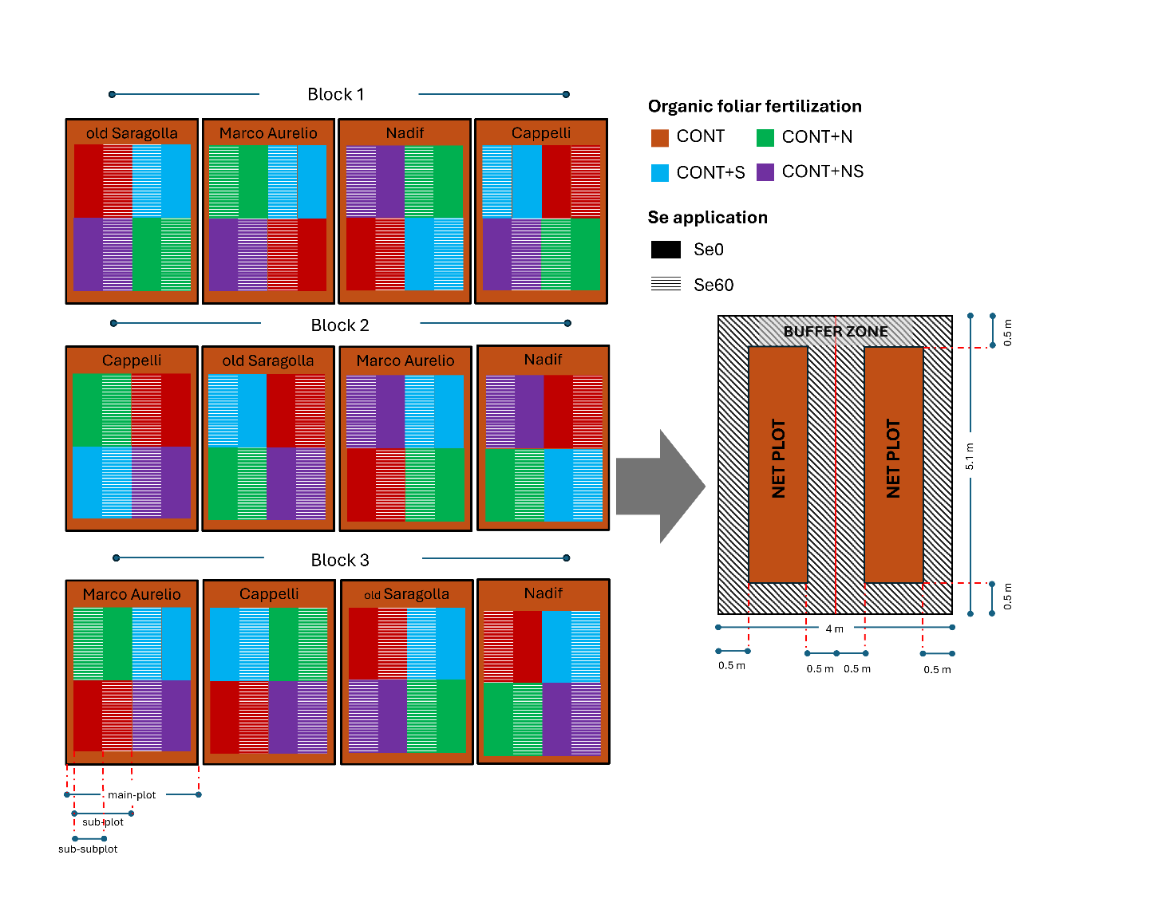
Figure S1. Experimental layout of the randomized complete block design arranged in a split-split-plot with three replicates, and the schematic representation of the net plot dimensions and buffer zones. CONT: control, dry blood meal in a single application at seeding; CONT+N: CONT plus N foliar application at BBCH stage 51; CONT+S: CONT plus foliar S application at BBCH stage 47; CONT+NS: CONT plus the combination of S (BBCH stage 47) and N (BBCH stage 47) foliar applications. Se0: control without selenium; Se60: application of sodium selenate (Na2SeO4), at booting stage BBCH 41.

