Appendix
Tables
Table a: Accuracy assessment of the 1985 classified image
 |  | Reference from Google earth (Date: 05 February, 1985) |  |  |  |  |  | User accuracy
 |  | Cultivated | Forest | Shrub land | Grassland | Built-up area | Row total | User accuracy
Classification  Result  (Date: 17 February, 1985) | Cultivated | 152 | 1 | 2 | 17 | 2 | 174 | 87.4
Classification  Result  (Date: 17 February, 1985) | Forest | 1 | 81 | 12 | 0 | 0 | 94 | 86.2
Classification  Result  (Date: 17 February, 1985) | Shrub land | 2 | 7 | 97 | 0 | 1 | 107 | 90.7
Classification  Result  (Date: 17 February, 1985) | Grassland | 11 | 0 | 2 | 63 | 0 | 76 | 82.9
Classification  Result  (Date: 17 February, 1985) | Built-up area | 3 | 0 | 0 | 2 | 24 | 29 | 82.8
Classification  Result  (Date: 17 February, 1985) | Column total | 169 | 89 | 113 | 82 | 27 | 480
Classification  Result  (Date: 17 February, 1985) | Producer accuracy | 89.9 | 91 | 85.8 | 76.8 | 88.9
Kappa coefficient= 0.83 Overall accuracy=86.9%

Table b: Accuracy assessment of the 2000 classified image
 |  | Reference from Google earth (21 February, 2000) |  |  |  |  |  | User accuracy
 |  | Cultivated | Forest | Shrub land | Grassland | Built-up area | Row total | User accuracy
Classification  Result  (Date: 03 February, 2000) | Cultivated | 158 | 4 | 7 | 6 | 7 | 182 | 86.8
Classification  Result  (Date: 03 February, 2000) | Forest | 3 | 67 | 6 | 1 | 0 | 77 | 87
Classification  Result  (Date: 03 February, 2000) | Shrubland | 6 | 3 | 89 | 5 | 0 | 103 | 86.4
Classification  Result  (Date: 03 February, 2000) | Grassland | 11 | 0 | 0 | 61 | 2 | 74 | 82.4
Classification  Result  (Date: 03 February, 2000) | Built-up area | 5 | 0 | 0 | 2 | 37 | 44 | 84.1
Classification  Result  (Date: 03 February, 2000) | Column total | 183 | 74 | 102 | 75 | 46 | 480
Classification  Result  (Date: 03 February, 2000) | Producer accuracy | 86.3 | 90.5 | 87.3 | 81.3 | 80.4
Kappa coefficient= 0.81 Overall accuracy=85.8 %

Table c: Accuracy assessment of the 2015 classified image
 |  | Reference from Google earth (Date: 28 February, 2015) |  |  |  |  |  | User accuracy
 |  | Cultivated | Forest | Shrub  land | Grassland | Built-up area | Row total | User accuracy
Classification  Result  (Date: 20 February, 2015) | Cultivated | 176 | 0 | 8 | 10 | 3 | 197 | 89.3
Classification  Result  (Date: 20 February, 2015) | Forest | 0 | 54 | 2 | 0 | 0 | 56 | 96.4
Classification  Result  (Date: 20 February, 2015) | Shrubland | 0 | 5 | 87 | 2 | 0 | 94 | 92.6
Classification  Result  (Date: 20 February, 2015) | Grassland | 6 | 0 | 5 | 60 | 2 | 73 | 82.2
Classification  Result  (Date: 20 February, 2015) | Built-up area | 8 | 0 | 0 | 3 | 49 | 60 | 81.7
Classification  Result  (Date: 20 February, 2015) | Column total | 190 | 59 | 102 | 75 | 54 | 480
Classification  Result  (Date: 20 February, 2015) | Producer accuracy | 92.6 | 91.5 | 85.3 | 80 | 90.7
Kappa coefficient= 0.85 Overall accuracy=88.8%

Figures

Figure a: Suitability areas for conversion to cultivated land (a), forest (b), shrubland (c), grassland (d) and built-up area (e) in the Andassa watershed

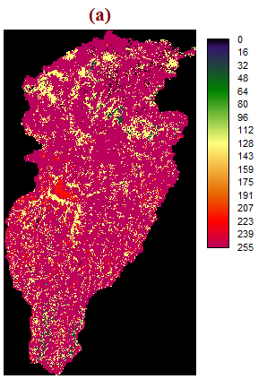

Figure b: Proximate to developed cultivated land (a), forest (b), shrubland (c), grassland (d) and built-up area (e) in the Andassa watershed

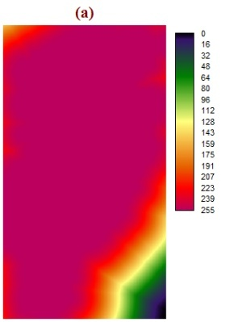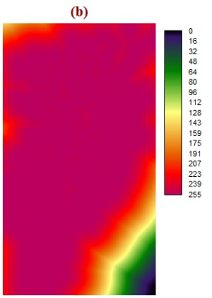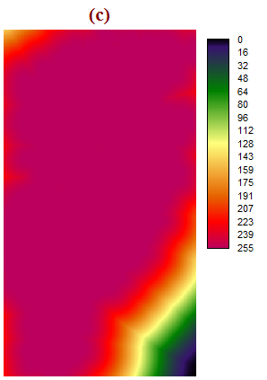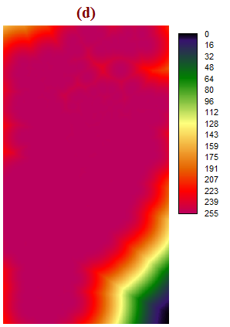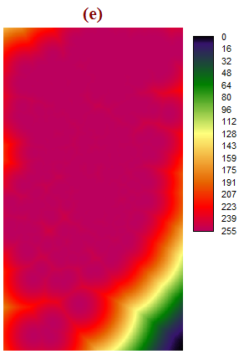

Figure c: Distance to rivers, towns and roads, and elevation factors considered in the Andassa watershed

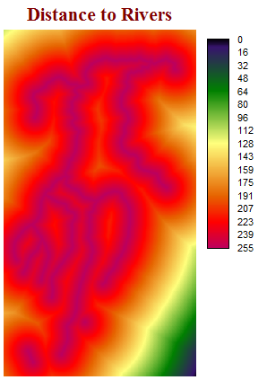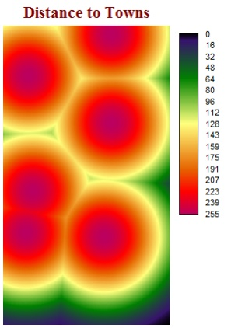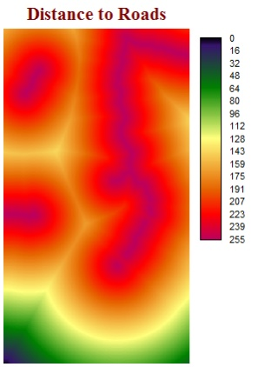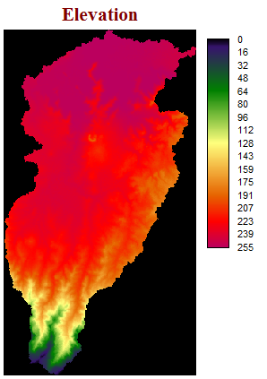

Figure d: Slope constraint map for cultivated land (a), built-up area (b), and forest, shrubland and grassland (c) in the Andassa watershed

