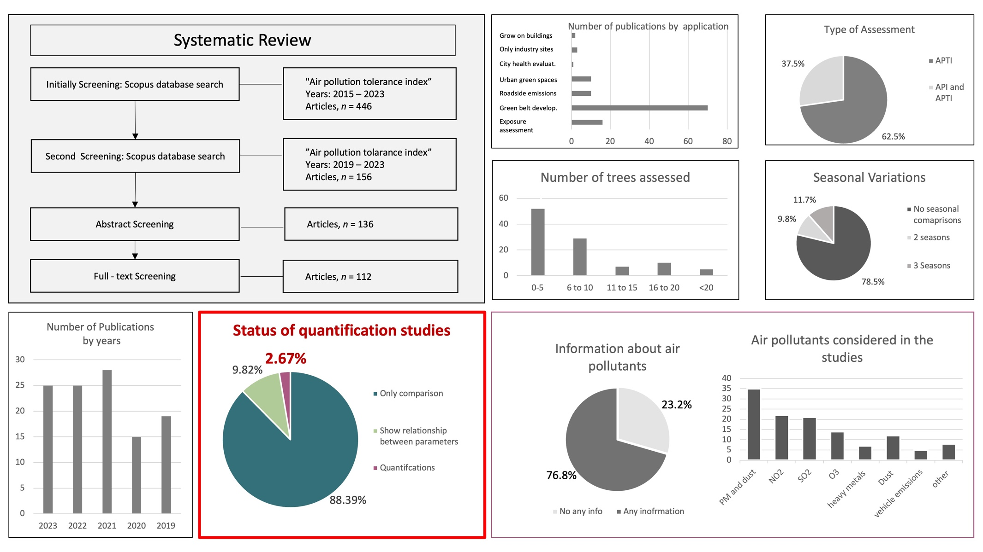 Supplementary Figure 1: Summary of the Systematic review of the study

Classification | Kingdom : Plantae  Phylum : Streptophyta  Class : Equisetopsida  Subclass : Magnoliidae  Order : Fabales  Family : Fabaceae  Genus : Pterocarpus  Species : Pterocarpus indicus
Common Name | Burmese rosewood, Andaman redwood
Landscape Uses | Roadside Tree, Coastal,  Shade Providing Tree
Remarks | Water Preference - Moderate Water  Plant Growth Rate - Fast to Moderate
Distribution of Pterocarpus indicus plant | 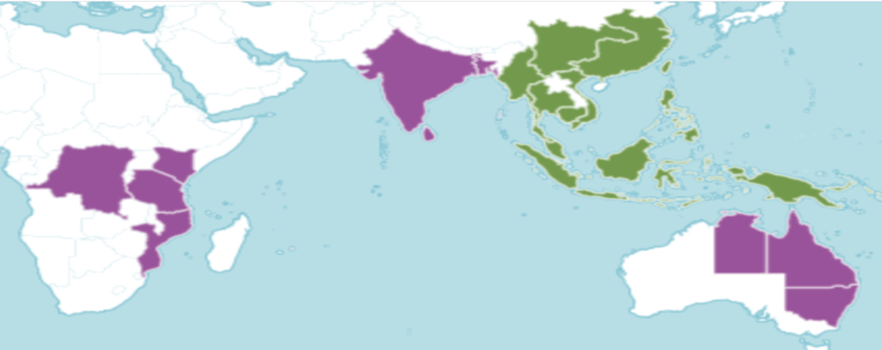  Green – native and purple- introduced regions
Sources | - the Royal Botanic Gardens, Kew, Plant of the world online https://powo.science.kew.org  Website: nparks.gov.sg,- Singapore
Supplementary Table 1. Information: Pterocarpus indicus plant
Location selection and criteria for selections
Supplementary Table 2. Location selection and criteria for selection
Code | Province | Air pollutants |  |  |  | Region | Meteorological
Code | Province | NO₂ | SO₂ | O₃ | PM2.5 | Region | Rainfall | Temp.
TH1 | Bangkok | H | H | H | M | C | M |  | H
TH2 | Chanthaburi | L | L | H | L | E | H |  | H
TH3 | Chiang Mai | M | M | L | H | N | L |  | L
TH4 | Kanchanaburi | L | H | M | M | W | M |  | M
TH5 | Khon Kaen | M | M | M | L | NE | M |  | M
TH6 | Nonthaburi | H | M | H | M | C | M |  | H
TH7 | Pathum Thani | M | H | H | M | C | M |  | H
TH8 | Rayong | M | M | M | L | E | M |  | H
TH9 | Saraburi | L | H | M | M | C | L |  | M
TH10 | Surat Thani | L | L | M | L | S | H |  | H
TH11 | Ubon Ratchahani | L | L | L | M | NE | M |  | H
TH12 | Udon Thani | M | L | M | M | NE | M |  | L
*Close locations/province to the University
Key : H- High, M- Medium, L-Low
Region- C-Central , E- Eastern, N- Northern, NE- Northeast, S-Southern, W-Western
Source: Arai et al., 2019; Khedari et al., 2002; Mahikul et al., 2022, climate.tmd.go.th

Supplementary Table 3. Hyperparameter search space and tuning ranges used for machine learning model optimization.
Models | Parameters | Range | Remarks | Pterocarpus indicus
RF | n_estimators | ( (100, 600) | Number of trees in ensemble | 198
 | max_depth | (3, 16) | Maximum tree depth | 11
 | min_samples_split | (2, 20) | Minimum samples to split a node | 11
 | min_samples_leaf | (1, 10) | Minimum samples per leaf | 2
 | max_features | ["sqrt", "log2", None, 0.7, 1.0] | Fraction or type of feature selection | Sqrt
 | bootstrap | [True, False] | Whether bootstrap samples are used | False
GBR | n_estimators | (80, 350) | Number of boosting stages (trees) | 221
 | learning_rate | uniform(0.01, 0.29) → (0.01–0.30) | Step-size shrinkage to prevent overfitting | 0.115
 | max_depth | (2, 8) | Depth of individual base trees | 5
 | min_samples_split | (2, 20) | Minimum samples to split an internal node | 9
 | min_samples_leaf | (1, 20) | Minimum samples required at a leaf node | 1
 | subsample | (0.6, 0.4) → (0.6–1.0) | Fraction of samples for each learner | 0.956
 | max_features | ["sqrt", 1.0, 0.7, 0.9] | Number of features considered per split | Sqrt
XGB | n_estimators | (150, 600) | Number of boosting rounds | 335
 | learning_rate | loguniform(1e-3, 3e-1) → (0.001–0.3) | Shrinkage rate (η) | 0.046
 | max_depth | (2, 10) | Maximum depth of a tree | 4
 | min_child_weight | (1, 10) | Minimum sum of instance weight in a child | 9
 | subsample | (0.6, 0.4) → (0.6–1.0) | Fraction of data per boosting round | 0.836
 | colsample_bytree | uniform(0.6, 0.4) → (0.6–1.0) | Fraction of features per tree | 0.8321
 | gamma | loguniform(1e-8, 1.0) | Minimum loss reduction to split | 0.000321
 | reg_alpha | loguniform(1e-8, 10.0) | L1 regularization term | 0.000765
 | reg_lambda | loguniform(1e-3, 10.0) | L2 regularization term | 0.014

Supplementary Table 4. The descriptive summary of data
variable | Unit | mean | sd | min | q1 | median | q3 | iqr | max
APTI | - | 14.65 | 2.90 | 8.26 | 12.41 | 14.97 | 16.60 | 4.19 | 21.52
RWC | % | 75.73 | 11.47 | 46.95 | 67.79 | 79.08 | 83.63 | 15.84 | 97.35
pH | - | 5.61 | 0.59 | 0.00 | 5.40 | 5.61 | 5.92 | 0.52 | 6.61
AA | mg/g | 4.12 | 1.20 | 0.21 | 3.84 | 4.17 | 4.92 | 1.08 | 6.65
TCC | mg/g | 10.47 | 4.22 | 0.00 | 7.87 | 10.72 | 13.48 | 5.61 | 18.95
N3 | µmol/ m² | 87.44 | 63.86 | 9.29 | 38.34 | 65.47 | 119.52 | 81.19 | 277.59
N4 | µmol/ m² | 83.81 | 58.70 | 9.68 | 36.19 | 65.81 | 117.09 | 80.90 | 256.09
N5 | µmol/ m² | 81.42 | 53.41 | 11.17 | 36.89 | 71.28 | 108.75 | 71.87 | 233.51
N6 | µmol/ m² | 81.13 | 46.64 | 10.40 | 43.86 | 89.53 | 106.86 | 63.00 | 203.36
S3 | µmol/ m² | 24.67 | 123.09 | -288.02 | -46.43 | 45.46 | 108.91 | 155.34 | 288.19
S4 | µmol/ m² | 14.13 | 109.44 | -247.53 | -53.73 | 28.93 | 89.72 | 143.45 | 239.87
S5 | µmol/ m² | -1.70 | 95.05 | -221.16 | -62.70 | 20.86 | 61.60 | 124.30 | 167.87
S6 | µmol/ m² | -11.14 | 63.10 | -191.80 | -53.43 | -3.25 | 31.67 | 85.10 | 138.52
O3 | µmol/ m² | 8936.90 | 2672.3 | 0.00 | 8921.41 | 9291.79 | 10641.81 | 1720.40 | 11515.6
O4 | µmol/ m² | 10144.25 | 1427.9 | 8533.7 | 9140.25 | 9954.60 | 10655.41 | 1515.17 | 14445.7
O5 | µmol/ m² | 10019.60 | 749.05 | 8827.2 | 9354.02 | 10001.31 | 10696.87 | 1342.85 | 11669.7
O6 | µmol/ m² | 10337.04 | 595.56 | 9193.5 | 10004.09 | 10224.18 | 10454.78 | 450.70 | 12101.8
P3 | µg/ m³ | 12.87 | 2.02 | 9.55 | 11.78 | 12.71 | 13.18 | 1.40 | 21.21
P4 | µg/ m³ | 12.89 | 2.02 | 9.73 | 11.44 | 12.69 | 13.88 | 2.44 | 20.03
P5 | µg/ m³ | 13.23 | 2.28 | 9.79 | 11.44 | 13.26 | 14.26 | 2.82 | 20.18
P6 | µg/ m³ | 14.63 | 3.01 | 9.96 | 11.88 | 13.75 | 17.57 | 5.69 | 20.32
R3 | mm | 4.18 | 4.22 | 0.00 | 0.17 | 2.17 | 8.18 | 8.01 | 12.15
R4 | mm | 4.85 | 3.65 | 0.04 | 0.68 | 4.92 | 7.94 | 7.25 | 11.79
R5 | mm | 5.13 | 3.12 | 0.22 | 2.23 | 5.74 | 7.72 | 5.49 | 9.86
R6 | mm | 4.90 | 1.42 | 0.31 | 3.56 | 5.22 | 5.81 | 2.26 | 7.85
T3 | K | 300.05 | 1.60 | 296.04 | 298.89 | 300.80 | 301.25 | 2.36 | 302.44
T4 | K | 300.19 | 1.63 | 295.79 | 299.34 | 300.75 | 301.43 | 2.09 | 303.14
T5 | K | 300.85 | 3.74 | 296.07 | 299.65 | 300.91 | 301.38 | 1.73 | 333.91
T6 | K | 301.17 | 1.43 | 297.48 | 300.39 | 301.22 | 302.57 | 2.18 | 303.06
H3 | % | 68.86 | 9.37 | 51.32 | 59.79 | 68.26 | 77.71 | 17.91 | 81.80
H4 | % | 70.71 | 8.68 | 54.54 | 62.26 | 72.60 | 77.66 | 15.40 | 86.16
H5 | % | 71.85 | 7.13 | 56.91 | 66.31 | 74.09 | 77.36 | 11.05 | 86.36
H6 | % | 71.79 | 4.37 | 56.83 | 69.87 | 72.88 | 74.41 | 4.54 | 83.55

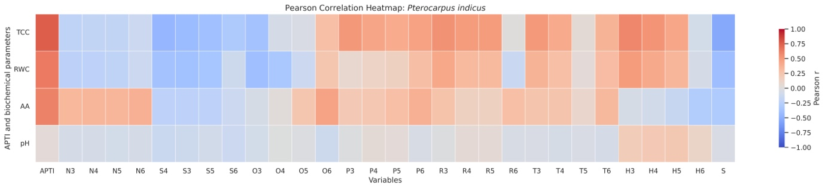
Supplementary Figure 2: The correlations among physio-biochemical parameters, APTI and the environmental predictor variables

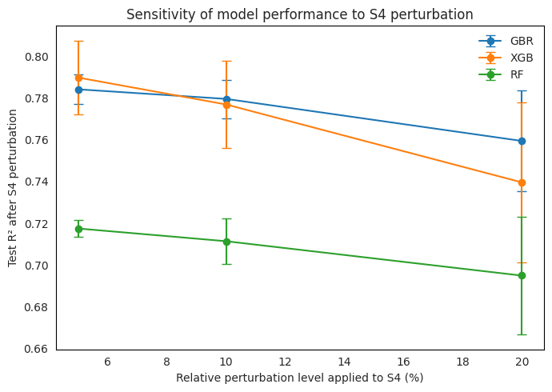
Supplementary Figure 3: Sensitivity of model performance to S4 perturbation

Supplementary Table 5. Sensitivity of model performance to S4 perturbation
model | feature | relative_noise | baseline_r2 | baseline_rmse | baseline_mae | mean_r2 | std_r2 | mean_rmse | std_rmse | mean_mae | std_mae | delta_r2 | delta_rmse | delta_mae
GBR | S4 | 0.050 | 0.794 | 1.063 | 0.834 | 0.784 | 0.007 | 1.087 | 0.018 | 0.865 | 0.019 | -0.009 | 0.024 | 0.031
GBR | S4 | 0.100 | 0.794 | 1.063 | 0.834 | 0.780 | 0.009 | 1.098 | 0.023 | 0.878 | 0.021 | -0.014 | 0.035 | 0.043
GBR | S4 | 0.200 | 0.794 | 1.063 | 0.834 | 0.760 | 0.024 | 1.146 | 0.057 | 0.910 | 0.041 | -0.034 | 0.083 | 0.076
XGB | S4 | 0.050 | 0.814 | 1.010 | 0.821 | 0.790 | 0.018 | 1.071 | 0.045 | 0.875 | 0.042 | -0.024 | 0.062 | 0.054
XGB | S4 | 0.100 | 0.814 | 1.010 | 0.821 | 0.777 | 0.021 | 1.104 | 0.052 | 0.896 | 0.044 | -0.037 | 0.094 | 0.076
XGB | S4 | 0.200 | 0.814 | 1.010 | 0.821 | 0.740 | 0.038 | 1.191 | 0.088 | 0.944 | 0.066 | -0.074 | 0.181 | 0.123
RF | S4 | 0.050 | 0.721 | 1.237 | 0.912 | 0.717 | 0.004 | 1.244 | 0.009 | 0.928 | 0.015 | -0.003 | 0.007 | 0.016
RF | S4 | 0.100 | 0.721 | 1.237 | 0.912 | 0.711 | 0.011 | 1.257 | 0.024 | 0.948 | 0.021 | -0.009 | 0.020 | 0.037
RF | S4 | 0.200 | 0.721 | 1.237 | 0.912 | 0.695 | 0.028 | 1.291 | 0.060 | 0.984 | 0.045 | -0.026 | 0.054 | 0.072

Supplementary Table 6. Province-holdout validation test results
Combination | RF_R2 | RF_RMSE | RF_MAE | GBR_R2 | GBR_RMSE | GBR_MAE | XGB_R2 | XGB_RMSE | XGB_MAE | SVR_R2 | SVR_RMSE | SVR_MAE
Set 1 | 0.671 | 1.448 | 1.110 | 0.721 | 1.374 | 1.060 | 0.605 | 1.633 | 1.367 | 0.272 | 2.218 | 1.592
Set 2 | 0.639 | 1.781 | 1.463 | 0.622 | 1.824 | 1.494 | 0.590 | 1.898 | 1.422 | -0.015 | 2.987 | 2.383
Set 3 | 0.547 | 2.122 | 1.537 | 0.603 | 1.987 | 1.435 | 0.664 | 1.828 | 1.316 | 0.400 | 2.364 | 2.202
Average | 0.619 | 1.784 | 1.370 | 0.648 | 1.728 | 1.330 | 0.620 | 1.787 | 1.368 | 0.219 | 2.523 | 2.059
Combination Set 1: Train- A,B,C,E,G,H,I,J,L Test- D,F,K
Combination Set 2: Train- A,B,E,G,H,I,J,K,L Test- C,D,F
Combination Set 3: Train- A,B,C,D,E,G,H,K,L Test -F,I,J

Supplementary Table 7. Sensitivity analyses of the deciduous-state indicator (S)- performances of the testing set

Model | R² | RMSE | MAE
RF | 0.592 | 1.495 | 1.040
GBR | 0.737 | 1.200 | 0.938
XGB | 0.769 | 1.056 | 0.895
SVR | 0.470 | 1.704 | 1.309

