Supplementary materials
Materials and methods
The version 1.5.0 of the PANDAS library in Python was the principal tool used to perform steps 1, 3, and 4 of the analysis.
First step (1): Trade data mining and cleaning
Annual imports (tonnes) of oil palm, oil of palm kernels, and cakes of palm kernels for Italy, Spain, Germany, and France from any Rest of the World (ROW) trade partners, between 2000 and 2020, were converted into primary crop equivalent – i.e. oil palm fruits eq. – through the equation 1 (Eq. 1) suggested by Cuypers (2013) and De Laurentis et al. (2022):
Q_{i,j} = Q_{i} /P_{i,j} * V_{i,j} [Eq. 1]
Where:
Q_{i,j}: Volume of the j^{th} primary crop equivalent needed to produce the i^{th} processed product (tonnes).
Q_{i}: Volume of the i^{th} processed product (tonnes).
P_{i,j}: Extraction rate, i.e. fraction of the volume of the processed i^{th} product needed to obtain the corresponding j^{th} primary crop equivalent (unitless).
V_{i,j}: Economic value fraction (i.e. value share) of the i^{th} processed product over the total economic value of all co-products that can be obtained from the j^{th} primary crop (unitless).

Eq. 1 represents a way to deal with the quantification of the land embodied in crop-processed products that are jointly produced – i.e. oil palm, oil of palm kernels, and cakes of palm kernels. Each of the three commodities has a specific technical extraction rate (FAO, 2011). The weighting by the economic value share avoids possible double counting of primary crop equivalents needed for joint production (see Annex C1 in Cuypers, 2013).
According to Cuypers (2013), Eq. 1 represents a straightforward solution, based on economic assumptions, to allocate primary crops into the complex production chains of jointly produced commodities. Nevertheless, it is worth specifying that while extraction rates tend to be country-dependent, values share are constant for each co-product, thus not reflecting the existing differences at country level regarding technological development or economic indices (e.g., relative prices). Concerning extraction rates, we have used country-level data when trade partners are also producing countries, while global averaged values were used when partners are just exporters. Regarding value share, we applied mean global values.
Furthermore, to convert the palm kernel equivalents, which represent the corresponding primary crop equivalents of the oil of palm kernel and the cakes of palm kernel, into oil palm fruits eq., we have used an additional conversion factor of 0.6 (FAO, 2011).

Step two (2): Consumption by economic sector and exporters ranking.
The second step of the analysis was carried out by using the trade statistics made available by the International Trade Center (ITC) via their online database TRADE MAP. This platform, while delivering COMTRADE data, can offer additional statistics like the allocation – in monetary values - of a traded commodity characterizing a specific bilateral trade (e.g. the monetary value of the Italian imports of crude palm oil from Indonesia destined to the food sector) by economic sector. Therefore, both for crude palm oil (CPO) and refined palm oil (RPO), and both for the crude palm kernel oil (CPKO) and refined palm kernel oil (RPKO), and the cakes of palm kernel we gathered the datasets of the annual economic values, of each bilateral trade, attributed respectively to the food (feed) sector, the energy (industrial) sector, and the oleochemicals (industrial) sector. Then, by summing all the annual economic values by sector for each product and exporting country, we quantified the share (%) of each sector over the total value of imports, differentiated per country of export. The latter represents an important aspect because of the considerable differences existing among the imports coming from different producing countries in terms of allocation per sector.
After scanning the literature regarding both palm oil production stages and final uses, and the share of the final consumption by sector at a global and EU level, we decided to allocate the different products to each sector, by using both the Harmonized System (HS) codes and nomenclatures characterizing the TRADEMAP datasets (See Table 1 below).
We made a few assumptions:
- The cakes of palm kernel are used as animal feed. Thus, this is indirectly part of the food sector for human consumption (i.e. Food-Feed).
- Crude palm oil and crude palm kernel oil are generally used for manufacture of foodstuffs, but what goes into the industrial sector manly serve the production of biofuels (i.e. Palm – Kernel - Fatty Acid Distillate). However, there is an undetectable part that goes to others industrial activities. This is why we used the term: Energy (Industrial).
- The solid part of refined palm oil (i.e. palm stearin) is almost only serving the oleochemicals sector, while the liquid (i.e. palm olein) fractions both the production of foodstuffs and energy.
- The solid part of refined palm kernel oil (i.e. palm kernel stearin) is almost only serving the food sector, while the liquid fractions both the production of foodstuffs and oleochemicals.
Table 1 Products allocation per sector
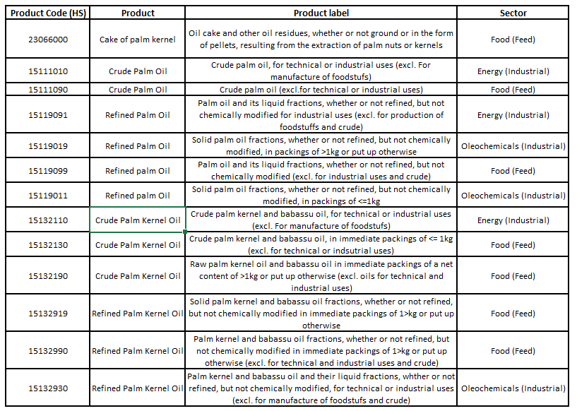

The steps and data inputs needed to develop Figures 5 and 6 reported within the article included:
- Data collection of the annual imports by product code (see Table 1), expressed in monetary values, for each bilateral trade (e.g. Italy-Indonesia).
- Total annual imports – in value - for each bilateral trade, of each product code assigned to the same sector (Table 1) (by summing data collected in step 1).
- Annual share (%) by sector and country of export (the proportion of the total annual imports in value by sector and country of export (step 2), over the total annual imports in value by country of export).
- Allocation of the imports – in volume – of primary crop equivalents to each sector differentiated by country of production (by means of the annual share calculated in step 3);
- Total annual imports of primary crop eq. by sector (by summing the annual volumes by sector imported from all the producing countries).
- Annual share (%) of imports of primary crop eq. by sector (the proportion of annual imports by sector over the total imports quantified in step 5).
- Annual imports – in volume - of primary crop equivalent by sector (by means of the annual share calculated in step 6) (Figure 5 in the paper).
- Mean share of imports, between 2004 and 2020, of primary crop equivalents by sector (Figure 6 in the paper).

Step three (3): Land Footprint estimation
Figures 1, 2, and 3 show an example of the difference between the raw data collected from Faostat (orange line) and the rolling mean (blue line) for the yield – t/ha - of oil palm fruits in, respectively, Indonesia, Malaysia, and Papua New Guinea between 2000 and 2020.

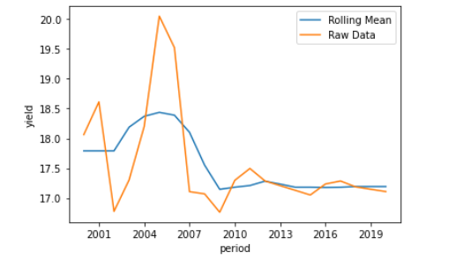
Figure 1: Comparison between Indonesia’s FAO yield (t/ha) data on oil palm fruits and their 5-year rolling mean.
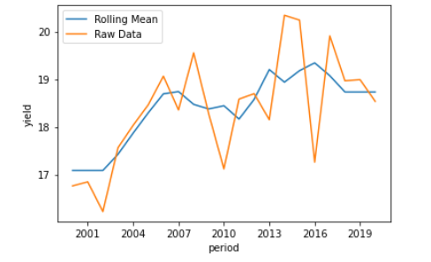
Figure 2: Comparison between Malaysia’s FAO yield (t/ha) data on oil palm fruits and their 5-year window rolling mean.
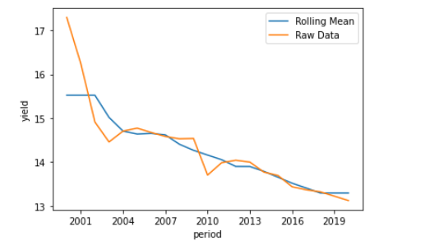
Figure 3: Comparison between Papua New Guinea’s FAO yield (t/ha) data on oil palm fruits and their 5-year window rolling mean.

At the end of step 3 we calculated the annual Land Footprint per country of direct export through Eq. 2:

LF_{dir,i,t} = Imp_{prim.eq,i,t} / Y_{smoothed,i,t} _{OR} Y_{smoothed,g,t} [Eq. 2]
Where:
LF_{dir,i,t}: Annual (t) hectares of palm oil plantations imported from direct trade partner (ha).
Imp_{prim.eq,i,t}: Annual (t) import of oil palm fruit eq. from the i^{th} direct partner (tonnes).
Y_{smoothed,i,t:} Annual (t) smoothed yield of the i^{th} country of direct export (if a producing country) (t/ha).
Y_{smoothed,g,t:} Annual (t) average global smoothed yield (if not a producing country) (t/ha).

Step four (4): Trade network analysis.
It is critical to assess if the annual Land Footprint (ha) per country of direct export was consistent with the annually harvested area reported by each country (Faostat, 2022). As already mentioned, indeed, the exporting country does not necessarily correspond to the producing country of the primary crop, therefore we decided to perform a test to detect the presence of intermediate trade partners - i.e. trade partners that annually exported a quantity of primary crop eq. greater than the quantity produced domestically in the same year.
To do so, we divided the dataset into two sub-sets: one for those partners where the annually harvested area is equal to or higher than the annual Land Footprint (positive test) and another one for those countries where the harvested area is lower than the annual Land Footprint (negative test). Then, while leaving aside the first subset, the second is further assessed.
Hence, from the subset of the negative test, to avoid losing data, we firstly selected all the rows (i.e. countries) that, even if having an annual harvested area lower than the Land Footprint, still presented positive values for the latter. These hectares of palm oil plantations were re-integrated within the dataset containing the positive test. These (very few) cases represent countries that, even if producing the primary crop domestically, have exported to the four EU importers some volumes of oil palm fruits eq. which were cultivated outside of their borders.
After reintegrating the area harvested, by modifying trade data on ROW imports of oil palm fruits eq., we quantified, for each of the intermediate trade partners (i), the total of the annual imports for the three commodities (x,y,z): (∑_{i}^{n =t} Imp_{(x,y,z)}).
Then through Eq. 3 and Eq. 4, we calculated respectively 1) the annual trade share of imports of each intermediate trade partners from each corresponding annual trade partner, and 2) the annual “extra Land Footprint” of each intermediate trade partner.

T_{%,i,p,t} = (Imp _{i,p,t} / ∑ ^{t}Imp_{i} _{(x,y,z)}) *100 [Eq. 3]
Where:
T_{%,i,p,t}: Annual (t) trade share of the i^{th} intermediate trade partner from the p^{th} trade partner (%).
Imp _{i,p,t}: Annual (n=t) import of the i^{th} intermediate trade partner from the p^{th} trade partner (tonnes).
∑^{t}Imp_{i(x,y,z)}: Total annual (t) imports of the i^{th} intermediate trade partner for the three commodities x, y, z (tonnes).

EF_{i,t} = LF_{dir,i,t} - AreaHarv_{i,t} [Eq. 4]
Where:
EF_{i,t}: Annual (t) extra Land Footprint of the i^{th} intermediate trade partner (ha).
LF_{dir,i,t}: Annual (t) hectares of palm oil plantations imported from the i^{th} intermediate (direct) trade partners (ha).
AreaHarv_{i,t}: Annual (t) area harvested of the i^{th} intermediate trade partner (ha).

In order to re-allocate the extra Land Footprint, through Eq. 5, we quantified the annual indirect Land Footprint via intermediate trade partners to indirect trade partners (i.e., producing country):

LF _{indi,j,t} = (EF_{i,t} * T_{%,i,p,t}) / 100 [Eq. 5]
Where:
LF_{ind i,j,t}: Annual (t) hectares of palm oil plantations imported via the i^{th} intermediate (direct) trade partners from the j^{th} indirect trade partners (ha).
EF_{i,t}: Annual (t) extra Land Footprint of the i^{th} intermediate trade partner (ha).
T_{%,i,p,t}: Annual (t) trade share of the i^{th} intermediate trade partner from the p^{th} trade partner (%).

Once all the LF^{t}_{ind i,j,t} values were re-integrated into the initial dataset (positive test), and the first Land Footprint re-allocation procedure was completed we performed a second test. The procedure was repeated until the extra land footprint reached a negligible value.

Hence, for each importing country, we obtained a final dataset with the total Land Footprint of imports of oil palm fruits eq, which includes the re-allocation of the Land Footprint from intermediate trade partners to the EU indirect trade partners (i.e. producing countries).

Step five (5): Embodied deforestation
Table 2 in the article reports estimates from five studies regarding the annual share of forest loss within palm oil plantations in the Borneo regions. Here we explain the procedure adopted to obtain annual forest loss values (%).
According to Meijaard et al., (2017), the average annual rate of forest loss within RSPO concessions between 2000 and 2015 was around 0.5% (Table 2 in Meijaard et al., 2017). Since, starting from 2005, a substantial reduction in deforestation rates has been detected, we arbitrarily lowered the average annual rate of forest loss to 0.4%. The same data for conventional plantations (i.e. NO-RSPO) is 0.9% (see Table 3 in Meijaard et al., 2017).
In order to quantify the annual rate of deforestation from Gunarso et al. (2013), we modified data on forest loss due to palm oil production between 2001 and 2015 for specific forest classes in Indonesia, Malaysia, and Papua New Guinea, as well as forest cover area in the year 2000 (Table 1).

Table 2 Forest cover and forest loss due to palm oil production, per forest type, in Indonesia, Malaysia and PNG
Indonesia | Forest cover (ha)  (2000) | Forest loss for palm oil production (ha)  (2001-2010)
Undisturbed Upland forest | 42,792,000 | 11,300
Disturbed Upland forest | 23,233,000 | 732,000
Undisturbed Swamp forest | 10,160,000 | 9,900
Disturbed Swamp forest | 6,267,000 | 366,000
Total | 82,452,000 | 1,119,200
Malaysia
Undisturbed Upland forest | 3,710,000 | 200
Disturbed Upland forest | 16,901,000 | 496,000
Undisturbed Swamp forest | 189,000 | 0
Disturbed Swamp forest | 928,000 | 89,000
Total | 21,728,000 | 585,200
Papua New Guinea
Undisturbed Upland forest | 23,452,000 | 4,934
Disturbed Upland forest | 7,588,000 | 61,944
Undisturbed Swamp forest | 1,533,000 | 0
Disturbed Swamp forest | 2,791,000 | 338
Total | 35,364,000 | 67,216

Data for forest cover in Indonesia reported in Table 2 were also used to quantify the annual rate of deforestation that occurred within the country between 2000 and 2015, by considering the deforestation area caused during the period for palm oil production (1,558,000 ha) as reported within the supplementary materials in Austin et al. (2017).
Regarding the RSPO and NO-RSPO annual deforestation rate (2001-2016) taken from the study of Cazzolla Gatti et al. (2019), we firstly quantified, from the supplementary information, the tree cover characterizing each assessed RSPO concessions in the year 2000 according to the following:
(Total tree cover loss ₍₂₀₀₁₋₂₀₁₆₎ *100) / % of tree cover loss ₍₂₀₀₁₋₂₀₁₆₎ Eq. [6]
Then, we quantified the tree cover still present in the year 2008 as follows:
Tree cover ₍₂₀₀₀₎ - ∑_{t} annual tree cover loss ₍₂₀₀₁₋₂₀₀₇₎ Eq. [7]
Hence, we quantified the annual rate of tree cover loss between 2008 and 2016 as follows:
[(∑ annual tree cover loss ₍₂₀₀₈₋₂₀₁₆₎ *100) / total tree cover ₍₂₀₀₈₎] / 9 _{(years)} Eq. [8]
Eq. 6 and Eq. 8 allowed the calculation of the tree cover in the year 2000 and the annual tree cover loss between 2000 and 2016 within NO-RSPO production areas.
Finally, the values from Carlson et al. (2018) were gathered directly from Table S1 in the supplementary information. We chose the results of the base matching scenarios since they are those discussed within the paper.
Step six (6): Per-capita deforestation footprint and per-capita embodied carbon dioxide emissions
Below are the four steps we have followed to estimate the annual carbon dioxide (CO₂) emissions per hectare of palm oil plantations. The data used for estimations have been derived from Agus et al. (2013a) and EUROSTAT (2022).

- Mean annual net emissions of CO₂ (Tg) from oil palm plantations resulting from changes in AGC due to LUC, peat fires and peat oxidation between 1990 and 2010.
- Mean annual palm oil plantations area expansion (480,000 ha), between 1990 and 2010, in Indonesia, Malaysia, and Papua New Guinea.
- Mean annual net CO₂ emissions (kg) per hectare of palm oil plantation in Indonesia, Malaysia, and Papua New Guinea.
- Annual per-capita embodied CO₂ emissions per country of import.

Annex references

Agus, F., Gunarso, P., Sahardjo, B.H., Harris, N., (2013)ª. Historical CO2 emissions from land use and land use change from the oil palm industry in Indonesia, Malaysia and Papua New Guinea.

Austin, K.G., Mosnier, A., Pirker, J., McCallum, I., Fritz, S., Kasibhatla, P.S., (2017) Shifting patterns of oil palm driven deforestation in Indonesia and implications for zero-deforestation commitments. Land Use Policy 69, 41–48. https://doi.org/10.1016/j.landusepol.2017.08.036

Carlson, K.M., Heilmayr, R., Gibbs, H.K., Noojipady, P., Burns, D.N., Morton, D.C., Walker, N.F., Paoli, G.D., Kremen, C., (2018) Effect of oil palm sustainability certification on deforestation and fire in Indonesia. Proc. Natl. Acad. Sci. U.S.A. 115, 121–126. https://doi.org/10.1073/pnas.1704728114

Cazzolla Gatti, R., Liang, J., Velichevskaya, A., Zhou, M., (2019) Sustainable palm oil may not be so sustainable. Science of The Total Environment 652, 48–51. https://doi.org/10.1016/j.scitotenv.2018.10.222

COMTRADE (2022) https://comtrade.un.org/

Cuypers, D., Lust, A., Geerken, T., Gorissen, L., Peters, G., Karstensen, J., Prieler, S., Fisher, G., Hizsnyik, E., Van Velthuizen, H., (2013) The impact of EU consumption on deforestation: comprehensive analysis of the impact of EU consumption on deforestation : final report. Publications Office, Luxembourg.

De Laurentiis, V., Galli, A., Sala, S., (2022) Modelling the land footprint of EU consumption. Publications Office of the European Union, Luxembourg.

EUROSTAT (2022) https://ec.europa.eu/eurostat/data/database

FAO (2011) Technical Conversion Factors for Agricultural Commodities. Available at: https://www.fao.org/economic/the-statistics-division-ess/methodology/methodology-systems/technical-conversion-factors-for-agricultural-commodities/en/

Faostat (2022) https://www.fao.org/faostat/en/

Gunarso, P., Hartoyo, M.E., Agus, F., Killeen, T.J., (2013) Oil Palm and Land Use Change in Indonesia, Malaysia and Papua New Guinea.

Meijaard, E., Morgans, C., Abram, N.K., Ancrenaz, M., (2017) An impact analysis of RSPO certification on Borneo forest cover and orangutan populations. A Borneo Futures report for the Orangutan Land Trust and Wilmar International Borneo Futures, Bandar Seri Begawan, Brunei Darussalam Doi: 10.13140/RG.2.2.35387.21287

Trade Map (2022) https://www.trademap.org/Index.aspx

