Supplementary Materials

Section 1: Overview, Design Concepts and Details (ODD)
This model is an agent-based model (ABM) designed to simulate and analyze the preferences of Flemish farmers regarding the adoption of bio-based fertilizers. This model can be applied to various settings and countries, making it highly adaptable. Developed within the Julia Programming environment (Bezanson et al., 2017), it utilizes the Agent.jl package (Vahdati, 2019) for efficient simulation.
In this document, we provide a detailed model description using an ODD protocol (Grimm et al., 2013, 2020; Müller et al., 2013). This protocol is widely recognized and employed within the social simulation community, promoting effective knowledge exchange, transparency, and replication of results. By adhering to this framework, we ensure that our research contributes to the overall advancement of the field of the agricultural economics.

Purpose and Patterns
The model aims to simulate an agricultural environment where multiple heterogeneous farms coexist and decide to use certain types of fertilizers with different application rates. The fertilizers can be of various kinds, including urea, certified compost, pig slurry, crop residue compost after a composting process, and crop residue compost from AD after anaerobic digestion (AD). When making the decision, farmers may consider different aspects, such as nitrogen requirements, to ensure that their choice of fertilizers satisfies their needs. The decision-making process of the farmers will also depend on their preferred strategies stylized through the FARMIND adjusted framework (Huber et al., 2022).
Furthermore, the model focuses on leek farmers, as their on-farm residues are considered to have a high potential for conversion into compost from AD and compost, which are bio-based fertilizers. Two different business model scenarios are considered: 1) a waste-treatment plant performs the conversion (functionality), or 2) a group of farmers performs the conversion (stewardship). In each scenario, costs related to both compost from AD and compost will be calculated, and a final price for the compost from AD will be estimated. The model reveals four main patterns that can be observed.
- Application of different fertilizers: urea, certified compost, pig slurry, crop residue compost, and crop residue compost from AD, or leaving crop residues on the field
- Preferred business model scenario for fertilizer use: composting stewardship, composting functionality, compost from AD stewardship, and compost from AD functionality
- Strategies chosen by the farmers: imitation, repetition, optimization, inquiry
Additionally, the model is parametrized in a way that the effect of different factors on emerging patterns can be observed. The factors that are chosen to illustrate such effects are:
- Change in the energy prices: changing the production and fertilizer prices
- Change in the radius: changing the cooperation level among farmers
- Change in the profit margin charged by the waste-treatment plants: changing the prices of crop residue compost from compost and AD by the waste-treatment plants
- Change in the tolerance to activity and paid-cost dissimilarity compared with the social environment: changing the inclination towards socially-oriented strategies

Entities, State Variables, and Scales
The main agents (i.e. entities) in the model are farmers facing the decision of fertilizer use. There are multiple parameters that could influence the farmers' decision, ranging from farm size, crop residues, costs, energy, and fertilizer prices to logistics and transportation, nitrogen, phosphorous, carbon, investments, farmers' memory, radius which allows access to other farms, and evaluation of success and similarity of neighbors. Below we provide a table that shows the parameters used in our model.
Table 1- parameters, notations, ranges, values, description
Parameter | Notations | Range | Value | Description
Id | id | [1,n] | [1,2077] | The identifier number of the agent
Position | Pos | (x_cor, y_cor) | (x_cor, y_cor) | The agents coordinates
Kind | K | (1,2) | (1,2) | Agents kinds with regards to fresh or industrial leek
social_orientation | SO | (0,1) | (0,1) | A calculated value based on the agents’ threshold for perceiving dissimilarities and disparities
activity_dis | A_{d} | (0,1) | (0,1) | Agents’ dissimilarity based on the performed activities (i.e., applied fertilizers in this case) with regards to the agent’s neighbors
group_digestate | G_{D} | (0,n) | (0,n) | An identifier showing whether the agent is in a group (labeled with a number) with regards to the stewardship compost from AD scenarios
group_compost | G_{C} | (0,n) | (0,n) | An identifier showing whether the agent is in a group that has a number with regards to the stewardship composting scenarios
size | SZ | (0,n) | (0,n) | Agents’ cultivation area
residues | RS | (0,n) | (0,n) | Agents’ produced residues that varies linearly based on kind
n_co_investors | N_{ci} | (0,n) | (0,n) | Agents’ number of potential co-investors based on radius
perfect_pos | PP_{j} | (x_cor, y_cor) | (x_cor, y_cor) | The position in the middle of a group (stewardship) that is ideal for j fertilizer (= compost from AD or compost)
distance_to_  conversion_unit | D_{fs} | [0,n] | [0,n] | Distance calculated in kilometers from the agent’s position to the perfect position regarding f fertilizer (compost or compost from AD) under s scenario (stewardship or functionality)
total_fertilizer_costs | TC_{s} | [0,n] | [0,n] | Total fertilizer costs calculated in euro under s scenario (stewardship or functionality)
average_cost | AC_{fs} | [0,n] | [0,n] | Calculated average costs of fertilizer f (crop residue compost, compost from AD), in euro, under scenario s (stewardship or functionality)
app_rate_calculated | APC_{fs} | [0,n] | [0,n] | Calculated application rate of fertilizer f (urea, certified compost, pig slurry, crop residue, crop residue compost, compost from AD), under scenario s (stewardship or functionality)
adoption_digestate | AD_{fs} | (0,1) | (0,1) | A binary value (true/false) indicating whether the agent preferred the adoption of fertilizer f (crop residue compost, compost from AD), under scenario s (stewardship or functionality)
app_rate | AP_{fs} | [0,n] | [0,n] | Application rate of fertilizer f (urea, certified compost, pig slurry, crop residue, crop residue compost, compost from AD) under scenario s (stewardship or functionality) after the adoption
cost_trend | CT | [0,1] | [0,1] | Growth trend of costs associated with applied fertilizers calculated based on the memory length
cost_trend_disparity | CT_{d} | [0,1] | [0,1] | An averaged value indicating the difference between the growth trend of costs of an agent and its neighbors
ave_costs_paid | C_{a} | [0,n] | [0,n] | Average costs paid by the agent for its fertilizers use
costs_paid | C_{p} | [0,n] | [0,n] | A list of all the paid costs for the fertilizers by the agent over the simulation runs
cost_gain | x⁺ | [0,n] | [0,n] | A list of values indicating the farmers gains (i.e. lower costs paid with respect to the average costs over the length of the farmers’ memory)
cost_loss | x⁻ | [0,n] | [0,n] | A list of values indicating the farmers losses (i.e. higher costs paid with respect to the average costs over the length of the farmers’ memory)
w_pos | w⁺ | [0,1] | [0,1] | Probability weight function in the gain domain
w_neg | w⁻ | [0,1] | [0,1] | Probability weight function in the loss domain
alpha_pos | α⁺ | [0,1] | [0,1] | The scale of value in the gain domain
alpha_neg | α⁻ | [0,1] | [0,1] | The scale of value in the loss domain
phi_pos | φ⁺ | [0,1] | [0,1] | Probability weight function in gains used in the decision weight function
phi_neg | φ⁻ | [0,1] | [0,1] | Probability weight function in gains in the decision weight function
lambda | λ | [0,n] | [1.5,3] | Loss aversion level (a uniform distribution)
g_tol | g^{tol} | [0,1] | [0,1] | The tolerance level of the agents towards cost growth disparity
d_tol | d^{tol} | [0,1] | [0,1] | The tolerance level of the agents towards dissimilarity perceived with the neighbors
v_pos | ν⁺ | [0,n] | [0,n] | Value functions for the gain domains
v_neg | ν⁻ | [0,n) | [0,n] | Value functions for the loss domains
decision_w_pos | Φ⁺ | [-1,1] | [-1,1] | The decision weight calculated for each gain
decision_w_neg | Φ⁻ | [-1,1] | [-1,1] | The decision weight calculated for each loss
pros_value | V | [-n,n] | [-n,n] | The prospect value calculated for each farm by summing up the prospect values for gains and losses
satisfaction | S | (0,1) | (0,1) | A binary value indicating whether an agent is satisfied or not (i.e. If an agent’s pros_value is zero or positive, then the agent is satisfied otherwise the agent is not satisfied)
memory | M | (0,n] | 3 | A value indicating the memory length of the agents
strategy | ST | (“optimization”,  “imitation”,  “repetition”,  “inquiry”) | (“optimization”,  “imitation”,  “repetition”,  “inquiry”) | The strategy that agents take based on their satisfaction and social orientation values
energy_price_increase | EP | [0,1] | [0,1] | A value defining to which degree the energy prices can increase
profit_margin | P_{m} | [0,1] | [0,1] | A value defining to the profit margins that can be applied under the functionality scenario
radius | R | [0,n] | [0,n] | A parameters defining in kilometers, how far agents can search for other agents relevant in stewardship scenario
electricity_price | EL | [0,n] | 0.297 | A parameter defining the average electricity price for the production of bio-based fertilizers
electrical_energy_  process_production | ELPP_{i} | [0,n] | ELPP_{s}=0.29×119.33  ELPP_{f} = 0.29×220 | Electricity production per ton of waste due to the process of bio-based fertilizer production depending on the business model scenario (stewardship or functionality) used for the production and processing.
electrical_energy_  side_production | ELSP_{i} | [0,n] | ELSP_{s}=119.33  ELSP_{f} = 220 | Electricity production per ton of waste due to the process of bio-based fertilizer production depending on the business model scenario (stewardship or functionality) that can be sold.
maintenance_cost | MC_{fs} | [0,n] | MC_{dg,stew}= 8.44  MC_{dg,fun}= 8.44 | Maintenance cost associated with the production of bio-based fertilizer investment. The fertilizer f can be crop residue compost or compost from AD under s scenario (stewardship or functionality)
transport_cost | T | [0,n] | 0.28 | Transport cost for each kilometer and ton of waste/fertilizer
composting_processing_costs | CPC | [0,n] | 1.33 | Compost processing cost for each ton of waste being processed to be converted to compost
total_investment_costs | TIC_{fs} | [0,n] | TIC_{ofc,stew}= 3.32  TIC_{ofc,func}= 3.32  TIC_{dg,stew}= depending on the neighbors  TIC_{dg,func}= 23.58 | Total investment costs associated with the investment in fertilizer f (crop residue compost or compost from AD) under scenario s (stewardship or functionality)
Investment_costs | IC_{fs} |  | IC_{dg,stew}= 1.07 | Investment costs associated with the investment in fertilizer f (compost from AD) under scenario s (stewardship)
price_fertilizer | P_{f,f} | [0,n] | P_{f,urea}=316 euro  P_{f,cc}=15 euro | A dynamic variable defining average prices assigned to urea and certified compost. Pig slurry and crop residues are considered to be free. Crop residue compost and compost from AD are calculated through investments, maintenance, transport, etc. costs.
nitrogen_content | NC_{fs} | [0,n] | NC_{urea}= 460  NC_{cr}= 2.5  NC_{cc}= 12  NC_{ps}=6.4  NC_{ofc}= 3.7  NC_{dg}= 2.5 | Nitrogen content for each fertilizer varying from zero to 460 kg/ton. For compost from AD and crop residue compost the contents could vary based on the business model scenario (i.e. stewardship and functionality)
phosphorus_content | PP_{fs} | [0,n] | PP_{urea}= 0  PP_{cr}= 0.36  PP_{cc}= 2.61  PP_{ps}=1.53  PP_{ofc}= 0.62  PP_{dg}= 2.78 | Phosphorus content for each fertilizer varying from zero to 2.78 kg/ton. For compost from AD and crop residue compost the contents could vary based on the business model scenario (i.e. stewardship and functionality)
potassium_content | PT_{f} | [0,n] | PT_{urea}= 0  PT_{cr}= 0.06  PT_{cc}= 10  PT_{ps}=4.4  PT_{ofc}= 0  PT_{dg}= 0 | Potassium content for each fertilizer varying from zero to 10 kg/ton. For compost from AD and crop residue compost the contents could vary based on the business model scenario (i.e. stewardship and functionality)
eoc_content | CB_{f} | [0,n] | CB_{urea}= 0  CB_{cr}= 8.24  CB_{cc}= 123  CB_{ps}=12  CB_{ofc}= 64.35  CB_{dg}= 7.42 | Carbon content for each fertilizer varying from zero to 10 kg/ton. For compost from AD and crop residue compost the contents could vary based on the business model scenario (i.e. stewardship and functionality)
conversion_rate | CRT_{f} | [0,n] | CRT_{urea} = 0  CRT_{cr} = 1  CRT_{cc} = 0.4  CRT_{ps} = 0  CRT_{ofc} = 0.375  CRT_{dg,untreated} = 0.9  CRT_{dg,composted} = 0.4 | Conversion rates (to make compost) for each fertilizer varying from zero to 1. For compost from AD and crop residue compost the contents could vary based on the business model scenario (i.e. stewardship and functionality)
pan | PN_{f} | [0,n] | PN_{urea}= 1  PN_{cr}= 0  PN_{cc}= 0.15  PN_{ps}=0.6  PN_{ofc}= 0.15  PN_{dg}= 0.6 | Plant available nitrogen for each fertilizer varying from zero to 1. For compost from AD and crop residue compost the contents could vary based on the business model scenario (i.e. stewardship and functionality)
Note: cr stands for crop residue, cc stands for certified compost, ps stands for pig slurry, ofc stands for on-farm-composing, dg stands for compost driven from AD

Process Overview and Scheduling
The model has two main components: (1) Initialize, (2) Step.
Initialize: Firstly, the model creates a virtual environment to identify farming leek plots based on their coordinates. Additionally, the model locates seven waste-treatment plants that have the potential to invest in anaerobic digestion technology for compost from AD conversion and three waste-treatment plants potential to expand their composting facilities, if needed, to treat the waste received from the farms. Next, the model treats each leek plot as a farmer and assigns various attributes (see Table 1) to them, including size, type, crop residues, strategy, etc. Data is utilized to determine some of these attributes. Further information on the initialization procedure is provided in the subsequent subsections (refer to the subsection on Initialization under the section Details).
Step: At a global level, fertilizer prices will be updated in each round based on assumptions regarding energy prices and available data. At the individual agent level, farmers, undergo several procedures to determine which fertilizers to use and at what rates, considering various conditions and behaviors. Initially, they calculate the costs associated with different scenarios. To do so, they first calculate distances relevant to different scenarios, such as distances to composting and AD facilities, while taking into account stewardship and functionality scenarios. Subsequently, they assess the costs associated with different fertilizer scenarios. Based on these cost calculations and behavioral conditions (utilizing the FARMIND adjusted framework), farmers make decisions regarding fertilizer use, drawing upon pre-selected strategies (randomly assigned during the initial step, which will change in the later rounds). Following these decisions and choices, farmers evaluate the associated costs and, in accordance with the FARMIND adjusted framework, calculate their satisfaction and social dissimilarity, which inform their future strategies. Consequently, a farmer selects a future strategy that will influence subsequent decisions regarding fertilizer use in the next simulation round. This phase is designed as a loop, with each time step representing a round of simulation equivalent to one year. Figure 1 depicts all the model procedures.
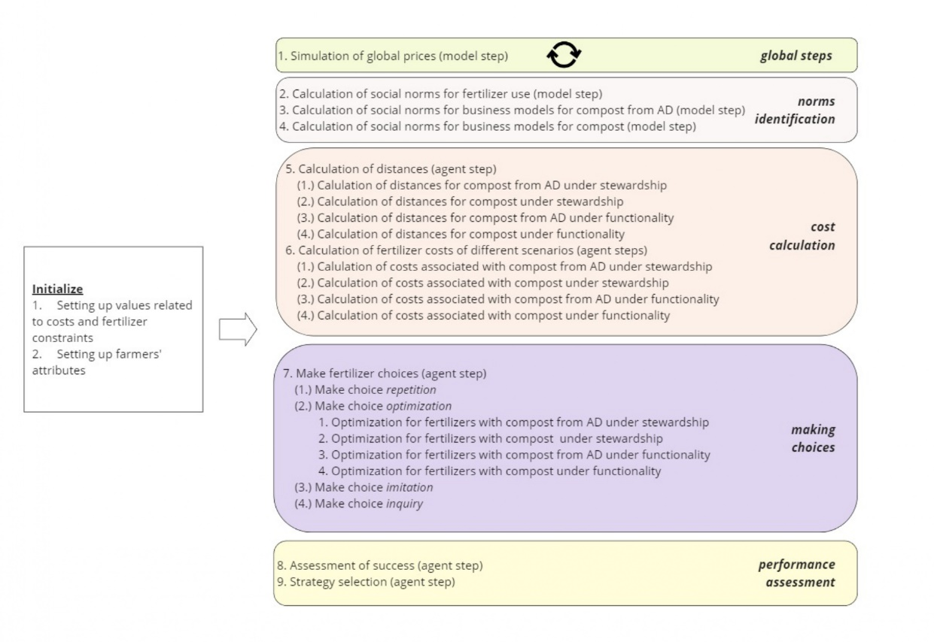
Figure 1- Procedures and schedule

Design Concepts

Basic principles
The model focuses on the decision-making process of farms using FARMIND adjusted framework. The core element of the model that defines the preferences of the agents is the four strategies of optimization, repetition, imitation, and inquiry. Social orientation and satisfaction serve as the primary factors for selecting these strategies. If a farm is both satisfied and individually oriented, it will repeat its behavior. However, if the farm is individually oriented but not satisfied, it will opt for optimization. Conversely, if a farm is satisfied and socially oriented, it will imitate a neighboring farm. Similarly, if the farm is not satisfied while being socially oriented, it will inquire the norms with regards to application rates of different fertilizers and used business models at the population level. Moreover, when the strategy is to optimize, a linear programming model will be employed to enable farmers to make optimal decisions regarding fertilizer use in different scenarios, such as stewardship versus functionality..
Therefore, the model incorporates both social and economic aspects into the farm's decision-making process. Regarding social aspects, the model includes social orientation and neighbor choice as key factors. As for economic aspects, in addition to the linear programming model, various cost-related parameters are considered. In this regard, two primary loops are implemented: (1) the impact of farms' choices on their satisfaction, and (2) the influence of neighboring farms' choices on socially oriented farms.

Emergence
Based on the model principle and the problem of fertilizer use under stewardship and functionality scenarios, the following patterns are identified as emerging.
- Application of different fertilizers: urea, certified compost, pig slurry, crop residue compost, and crop residue compost from AD
- Preferred business model scenario for fertilizers use: composting stewardship, composting functionality, compost from AD stewardship, and compost from AD functionality
- Strategies chosen by the farmers: imitation, repetition, optimization, inquiry
At the agent level, two behavioral values - satisfaction and social orientation - undergo changes that can be considered emerging as well. More precisely, agents’ satisfaction values change based on the costs incurred due to the choices they make. Similarly, agents’ social orientation could change as a result of the performance and activity comparisons they make with other agents, stemming from the choices they have made (see section 7.2).

Decision-making
Agents' primary decision-making regarding business model scenarios and fertilizer use is based on their selected strategies - repetition, optimization, imitation, inquiry - driven by their social orientation and satisfaction. In this context, agents first calculate their satisfaction by taking into account their gains and losses (compared with a reference value) through a prospect value, which indicates whether the probability of gaining is higher than losing. The agent also calculates the differences it has with its social environment (defined by a radius). In this case, the difference represents the agent's disparity in cost growth and dissimilarity in activity compared to its neighbors. Therefore, based on the agent's satisfaction level and dissimilarity with its neighbors, the agent selects a strategy.
Specifically, if an agent feels satisfied and is not dissimilar from its neighbors, it will choose a repetition strategy. If the agent feels satisfied but is very dissimilar to its neighbors, it will opt for an imitation strategy. On the other hand, if the agent feels unsatisfied but is not dissimilar to its neighbors, it will choose an optimization strategy. Lastly, if the agent is unsatisfied and dissimilar to its neighbors, it will select an inquiry strategy.
In the optimization strategy, the agent employs a linear programming model that considers its fertilizer requirements (e.g., nitrogen, phosphorous, carbon, etc.) along with the business model scenario (stewardship and functionality) with the objective of minimizing its costs.

Interaction
There are two main levels of interactions (and feedback loops) designed within the model:
  - Interactions with neighbors:
    - Agents define their dissimilarity and, ultimately, their social orientation by comparing themselves to their neighbors.
    - Agents who choose imitation as a strategy replicate one of their neighbors' choices.
  - Interactions with social norms:
    - Agents' choices, at a collective level, define the norms regarding fertilizer application rates and business models.
    - Agents with the inquire strategy internalize the social norms by adopting the most preferred fertilizer application rates and business models.
Figure 2 depicts the interactions between agents' choices, neighbors' choices, and social norms.
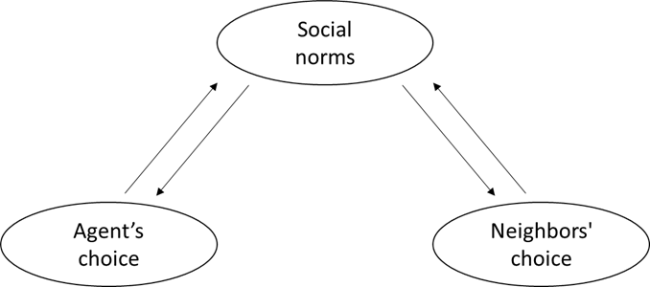
Figure 2- Overview of interactions in the model

Stochasticity
In addition to the random uniform distribution of various parameters during the initialization stage (see Section X), there are several stochastic processes contributing to uncertainty and non-linear behaviors. At a global level, the prices of urea (P_{f,urea}) and certified compost (P_{f,cc}) change at each time step of the simulation following a beta distribution, which can generate values perceived as shocks. At the agent level, numerous stochastic parameters are designed to influence the calculation of satisfaction and the social orientation of the agents. Concerning the satisfaction, the parameters of α⁺, α⁻, φ⁺, φ⁻, and λ change in every simulation time-step following uniform distributions. Additionally, calculated probability parameters related to decision weights for both gains and losses can change as they are drawn from the cumulative normal distribution. Similarly, regarding social orientation, g^{tol} and d^{tol} vary at each simulation step following a uniform distribution. With this approach, the model includes changes in the agents’ perception of success and dissimilarity ultimately leading to different strategies.
Observation
The model is implemented in the Julia Programming Language environment utilizing the Agent.jl package. Although there is no interactive interface defined, the code is written in such a way that one can change the parameters using a dictionary and run the model. Five parameters have been identified as the most effective ones, and by changing them, one can observe different outcome trajectories. These parameters are: (a) profit margin, (b) increase in energy prices, (c) radius, (d) dissimilarity tolerance, and (e) cost growth disparity tolerance.

Details

Initialization
The initial values are indicated in Table 1. The model is initialized by first defining the population of the agents (n=2077) in their predefined positions based on data, varying based on different parameters, including size, type, strategy (randomly assigned), social orientation (random uniform distribution), residue (size-dependent), and fertilizer application rates (random uniform distribution, assuming values for urea, pig slurry, and crop residue, while assigning 0 for crop residue compost and compost from AD).

Input Data
The model includes various sources of data. In particular, at the agent-level, the agents and their sizes within their types are assigned based on geographical data and leek farm typologies. Cost, price and business models related parameters are also sourced based on data (De Keyser et al., 2023). Where the data were missed, assumptions based the literature were made. For example, the weighting probability parameters come from the work of Huber et al. (2022).

Submodels
- Initialize
  - Setting up the values related to the costs and fertilizers constraints
The model will establish values for all costs and fertilizer constraints listed in Table 1. Specifically, this stage defines values related to investment costs, the location of waste-treatment plants, conversion rates, maintenance, transportation, and electricity. Similarly, other values related to fertilizers, such as nitrogen, phosphorus and carbon constraints, as well as average prices, are set at this stage. Further details can be found in the codes at the end of this document.
  - Setting up farmers attributes
The model configures all fixed variables related to the farmers, as indicated in Table 1. This includes the kind (fresh or industrial), location, size, initial strategy (randomly assigned), residues (dependent on the type), and initial fertilizers application rates for urea (randomly uniform between 0.05 and 0.175), pig slurry (randomly uniform between 13 and 17), and crop residues (randomly uniform between 20 and 35). All the other agent values are set at zero initially.

- Global steps
  - Simulation of global prices
For the prices of urea and certified compost fertilizers, the model employs a beta distribution at each step (i.e., year), repeated 100 times, to encompass all possible variations of values. More precisely,
$$P_{f,urea }=C_{f,urea } ×Beta(α, β)$$ | (1)
$$P_{f,cc }=C_{f,cc} ×Beta(α, β)$$ | (2)
where $α=10,$ $β=15$, and $C_{f,urea }$is a constant value for urea equal to 790 and $C_{f,urea }$is a constant value for certified compost equal to 38. The outcome of these two equations provides the average prices associated with these two fertilizers.

- Norm identification
  - Calculation of social norms for fertilizers use
The model goes on with the calculation of the average rates for the fertilizers use as well as the price paid by the user farmers.
${Norm}_{APC,i,f}= \frac{\sum_{1}^{i=n}{{APC}_{i,j}}}{n}$ | (4)
where APC is the application rate of the fertilizer j and i is the farmer that is the user of fertilizer f, and n is the number of farms that are using the certain fertilizers.
Moreover, for the case crop residue compost and compost from AD, normative prices are calculated as follows.
${Norm}_{P,i,f,s}= \frac{\sum_{1}^{i=n}{P_{f,i,j,s}}}{n}$ | (5)
Where P is the price/cost of the fertilizer f (i.e. crop residue compost and compost from AD) and i is the farmer that is the user of the fertilizer, s is the scenario (i.e. stewardship and functionality) under which the price was calculated, and n is the number of farms that are using the certain fertilizers in that scenario.
  - Calculation of social norms for business models used for compost from AD
The model continues by identifying the most chosen business model (i.e. stewardship vs functionality) for the case of compost from AD.
$${Mode}_{BM,dg}=mode({BM}_{dg,s,i=1},…,{BM}_{dg,s,i=n})$$ | (6)
where BM_{dg,s} is the business model chosen for compost from AD under s scenario (stewardship or functionality) by agent i.
  - Calculation of social norms for business models used for composting
The model continues by identifying the most chosen business model (i.e. stewardship vs functionality) for the case of composting.
$${Mode}_{BM,ofc}=mode({BM}_{ofc,s,i=1},…,{BM}_{ofc,s,i=n})$$ | (7)
where BM_{ofc,s} is the business model chosen for composting under s scenario (stewardship or functionality) by agent i.
- Cost calculations: Distances
  - Calculation of distances for compost from AD under stewardship scenario
The model proceeds by instructing the agents to calculate distances to determine an optimal position relative to their neighbors, serving as a proxy for the AD facility location. In this regard, agents first identify neighbors within their radius (r) using a haversine function. Subsequently, they compute an average of their x and y coordinates to determine the optimal location between themselves.
  - Calculation of distances for composting under stewardship scenario
Here too, the model proceeds by instructing the agents to calculate distances to determine an optimal position relative to their neighbors, serving as a proxy for the composting facility location. The main difference here is that the agents will look for only three neighbors. In this regard, agents first identify the three neighbors within their radius (r) using a haversine function. Subsequently, they compute an average of their x and y coordinates to determine the optimal location between themselves.
  - Calculation of distances for compost from AD under functionality scenario
The model continues by instructing the agents to calculate distances to identify the closest AD facility from a list of seven potential waste-treatment plants. The distance, in this respect, is calculated using a haversine function.
  - Calculation of distances for composting under functionality scenario
Here as well, the model continues by instructing the agents to calculate distances to identify the closest composting facility from a list of three potential waste-treatment plants. The distance, similarly, is calculated using a haversine function.
- Cost calculations: Fertilizers
  - Calculation of costs associated with crop residue composting in a stewardship scenario
Agents continue by calculating how much it would cost for them to engage in crop residue composting while collaborating with three other farmers in their neighborhood. Having already determined the distances and identified the optimal location for the potential composting facility, they proceed to calculate the associated average costs (AC), per ton of waste, for the compost produced in this scenario via,
$${AC}_{ofc,s}={TIC}_{ofc,s}+{MC}_{ofc,s}+\frac{D_{ofc,s} ×T ×{(1+ CRT}_{ofc})}{{CRT}_{ofc}}$$ | (8)
where TIC represents the total investment cost per ton of waste for crop residue compost (ofc) under stewardship (s) scenario, D is the distance to the facility, T is the transport cost per kilometer, and CRT is the conversion rate from waste to compost. ${MC}_{ofc,s}$ is the maintenance cost (which can be assumed as a processing cost as well) under scenario s. Moreover, the transport’s logic is as follows. It is assumed that two drives will take place in which one is with a full load and the return’s volume is based on the conversion-rate (CRT).
  - Calculation of costs associated with crop residue composting in a functionality scenario
Agents continue by calculating how much it would cost for them to engage in crop residue compost while collaborating with an existing waste-treatment plant with composting facility. Having already determined the distance the potential composting facility of the waste-treatment plant, they proceed to calculate the associated average costs (AC), per ton of waste, for the compost produced in this scenario via,
$${AC}_{ofc,f}={((TIC}_{ofc,f}+{MC}_{ofc,f})+\frac{D_{ofc,f} ×T ×{(1+ CRT}_{ofc})}{{CRT}_{ofc}} )×(1+P_{m})$$ | (9)
where TIC represents the total investment cost per ton of waste for crop residue compost (ofc) under stewardship (s) scenario, P_{m} is the profit margin targeted by the waste-treatment plant, D is the distance to the facility, T is the transport cost per kilometer, and CRT is the conversion rate from waste to compost.
  - Calculation of costs associated with compost from AD in a stewardship scenario
Agents continue by calculating how much it would cost for them to engage in a compost from AD production while collaborating with other farmers in their neighborhood. Having already determined the distances and identified the optimal location for the potential AD facility, they proceed to calculate the associated average costs (AC), per ton of waste, for the compost produced in this scenario. In this regard, agents first calculate the total cost of investment (TIC) as follows,

$${TIC}_{dg,s}={\frac{{IC}_{dg,s }}{15 ×{SZ}_{i}× {RS}_{i}×N_{ci,i} } ×(\frac{{SZ}_{i}× {RS}_{i}×N_{ci,i} }{4190})}^{0.6}$$ | (10)

where IC represents the investment cost per ton of waste for compost from AD (dg) under stewardship (s) scenario, SZ is the size of the farm i, RS is the residue of the farm i, and N_{ci} is the number of co-investors in this scenario for the farm i. Having the TIC calculated, the AC is computed as follows. The 4190 denominator is based on pocket digestion economic analysis carried out by De Dobbelaere et al. (2015).
$${AC}_{dg,s}=\frac{{TIC}_{dg,s}+{MC}_{dg,s}+{(D}_{dg,s} ×T ×{(1+ CRT}_{dg,untreated}))+\left(EE{ ×ELPP}_{s}×EL\right) }{{CRT}_{dg,untreated}}$$  $$- \frac{({ELSP}_{s} ×EL)}{{CRT}_{dg,untreated}}$$ | (11)
where TIC represents the total cost of investment, MC is the maintenance cost, D is the distance to the AD facility, under the stewardship for scenario (s) for compost from AD (dg), T denotes the transport cost, CRT signifies the conversion rate used for compost from AD in an untreated setting, ELPP stands for electrical energy production used for the production of the fertilizer, ELSP is the side production of electricity that can be sold, and EL represents the electricity price.
  - Calculation of costs associated with compost from AD in a functionality scenario
Agents continue by calculating how much it would cost for them to engage in a compost from AD production while collaborating with the closest AD facility of a waste-treatment plant. Having already determined the distance to the potential AD facility, they proceed to calculate the associated average costs (AC), per ton of waste, for the compost from AD produced in this scenario.
$${AC}_{dg,s}=\frac{{TIC}_{dg,f}+{MC}_{dg,f}+{(D}_{dg,f} ×T ×{(1+ CRT}_{dg,composted}))+(EE{ ×ELPP}_{f}×EL) }{{CRT}_{dg,composted}}× \left(1+P_{m}\right)- \frac{{(ELSP}_{f}× EL)}{{CRT}_{dg,composted}}$$ | (12)
where TIC represents the total cost of investment, MC is the maintenance cost, D is the distance to the AD facility, under the functionality for scenario (f) for compost from AD (dg), T denotes the transport cost, CRT signifies the conversion rate used for compost from AD in an untreated setting, ELPP stands for electrical energy production used for the production of the fertilizer, ELSP stands for electrical energy production that can be sold, EL represents the electricity price, and P_{m} refers to the targeted profit margin by the waste-treatment plant for the production of compost from AD.
- Make fertilizers choices
  - Make choice repetition
At this step, agents who have chosen the “repetition” strategy will maintain their approach by retaining their fertilizer application rate without any changes. Based on the fertilizer application rates, they then calculate the costs they have to pay (CP).
$${CP}_{if}=\sum_{\begin{aligned}f=1 \\ \end{aligned}}^{f=6}{{AP}_{i,f}} × P_{f}$$ | (13)
where f is the fertilizer (6 choices), AP is the application rate of the fertilizer f, and accordingly P is the price of the fertilizer f .
  - Make choice optimization
At this step, agents who chose the “optimization” strategy, will optimize with a cost-minimization approach, for different k configurations (explained below), coming up with application rates for different fertilizers, given different constraints following De Keyser et al. (2023),
$$Min {CP}_{k}= \sum_{f}{{CP}_{f,k}}{AP}_{f,k}+ \sum_{b}{{CP}_{b,k}}{AP}_{b,k}$$ | (14)
subject to constraints:
$$N_{min} ≤ \sum_{f}{{pan}_{f,k}N_{f}}{AP}_{f,k}+ \sum_{b}{{{pan}_{b,k}N}_{b}}{AP}_{b,k} ≤ N_{max}$$ | (15)
$$\sum_{f}{{PP}_{f,k}}{AP}_{f,k}+ \sum_{b}{{PP}_{f,b}}{AP}_{f,b} ≤ {PP}_{max}$$ | (16)
$$\sum_{f}{{CB}_{f,k}}{AP}_{f,k}+ \sum_{b}{{CB}_{b,k}}{AP}_{b,k} ≤ {CB}_{min}$$ | (17)
$$\sum_{f}{\frac{{AP}_{b,k}}{{CRT}_{b,k}}} = \sum_{b}{{RC}_{b,k}}= RS$$ | (18)
where CP represents costs associated with fertilizer f (urea, pig slurry, crop residue, certified compost) and fertilizer b (crop residue compost, compost from AD), with AP representing the application rate for the fertilizer. In the constraints area, N denotes the nitrogen content, pan is the plant-available nitrogen, PP is the phosphorus content, CB is the carbon content, CRT is the conversion rate, and RS is the total residues of the farm. Moreover, k represents a configuration that determines the business model scenario (stewardship vs functionality) and the choice of bio-based fertilizer (b = crop residue compost vs b = compost from AD) taken into the optimization model. This configuration results in four distinct scenarios.
After identifying the most optimal configuration, the agent will adjust its fertilizer applications based on the solution derived from configuration k. It will use Equation 13 to map the costs. Furthermore, the agent assesses whether fertilizer b has been utilized in that configuration. If the configuration includes a specific application rate for fertilizer b within configuration k, then the agent sets its preference (i.e., adoption) for that k configuration to true.
  - Make choice imitation
The agent, whose strategy is set to "imitation”, will identify neighbors who incur lower fertilizer costs, on average, compared to the agent's average costs. If any neighbor exhibits such characteristics, the agent will internalize those characteristics, including fertilizer application rates and the choice of the business model scenario. The agent will then update its fertilizer costs using Equation 13.
  - Make choice inquiry
The agent, whose strategy is set to “inquiry”, will identify norms related to fertilizer application rates, the average price paid for different fertilizers, and the choice of the business model scenario. Subsequently, the agent will internalize these norms and update its fertilizer costs accordingly using Equation 13.
- Performance assessments
  - Assessment of success and changing strategies
    - Satisfaction assessments
The agents, after deciding on fertilizer choices and scenarios, proceed to assess their satisfaction with the chosen options. In this context, utilizing a FARMIND framework (Huber et al., 2022), they calculate a prospect value to determine whether the probability of gaining is higher than that of losing. Gain, in this context, is defined by whether the agent has incurred lower costs for fertilizer choices compared to the previous time. Similarly, a loss is associated with higher costs spent on fertilizer choices compared to the previous time step. Furthermore, from a behavioral perspective, the sensation of loss is more pronounced (utilizing a scaling factor as a proxy for loss aversion) than the sensation of gain. The probability of gaining being higher than losing is calculated through a decision function that incorporates the likelihood (using a cumulative distribution function) of a specific cost and its corresponding gain/loss occurring. The assessment process of the prospect value (S) follows the equation below;
$$S_{i}= \sum_{i=1}^{m}{ν{(x}_{i})}{ϕ(x}_{i})$$ | (20)

where m is the memory, $ν{(x}_{i})$ is the value function for the gains and losses domains, calculated as follows;
$$ν^{+}\left(x\right)= x_{t}^{α^{+}}$$ | (21)
$$ν^{-}\left(x\right)= λx_{t}^{α^{-}}$$ | (22)

where $α^{+}$ and $α^{-}$ are the scale for the losses and gains (based on a reference value) and $λ$ is the loss aversion value.
The corresponding decision weights ${ϕ(x}_{i})$ in Equation 20 are calculated as follows,
$$ϕ_{x_{t}}^{+}= w^{+}\left[1-F\left(x_{t}\right)\right]- w^{+}[1-F(x_{t}+ Δ)]$$ | (23)
$$ϕ_{x_{t}}^{-}= w^{-}\left[1-F\left(x_{t}\right)\right]- w^{-}[1-F(x_{t}+ Δ)]$$ | (24)

where $F\left(x_{t}\right)$ is the cumulative normal distribution of paid costs, $w^{+}$ and $w^{-}$ are the probability wight functions for, respectively, gains and loss domains, and the $Δ$ is relative change between the cost reported in time t and t-1. Furthermore, the $w^{+}$ and $w^{-}$ functions are calculated as follows.
$$w^{+}(p)=\frac{p^{φ^{+}}}{{(p^{φ^{+}}+{(1-p)}^{φ^{+}})}^{1/φ^{+}}}$$ | (25)
$$w^{-}(p)=\frac{p^{φ^{-}}}{{(p^{φ^{-}}+{(1-p)}^{φ^{-}})}^{1/φ^{-}}}$$ | (26)

where $φ^{+}$ and $φ^{-}$ are probability weighting for gains and losses respectively,
    - Satisfaction assessments
Cost trends disparity analysis; Agents will continue by assessing first a cost paid disparity with respect to their neighbors, identified in their r radius. The disparity function is as follow.
$${CT}_{d,i}={CT}_{i,t}-\overline{{CT}_{t}}$$ | (27)
where ${CT}_{i,t}$ represents the cost paid change for farmer i for year t and the $\overline{{CT}_{t}}$ is the cost paid change trend for the whole population within the radius r (i.e. identified neighbors).
Activity dissimilarity analysis; agents after will continue to see how dissimilar they are with their neighbors in radius r, within a FARMIND framework. In this respect, they look into their neighbors and calculate which portion of their neighbors are performing a dissimilar activity. Accordingly, based on the ratio of dissimilar activities to the total activities, they come up with a activity dissimilarity value. The process can be stylized as follows.
$$d_{i}=\frac{1}{a}\sum_{j=1}^{a}{\frac{\# neighbors with activity A_{j}}{n}} (1-P\left(A_{j}^{i}\right))$$ | (28)

Where, a is the number of total activities, and $P\left(A_{j}^{i}\right)$ represents the status of whether agent i is performing activity j. The activities considered include the application rates (as farming practices) for fertilizers such as urea, pig slurry, crop residue, crop residue compost, and compost from AD. For example, if a neighbor uses compost from AD (in form of a compost) and the agent does not, then $P\left(A_{j}^{i}\right)$ value will be zero.
  - Take strategy
After evaluating satisfaction, cost-paid disparities, and activity dissimilarities, the agents proceed to select a strategy within the (adjusted) framework of FARMIND, as demonstrated in the table below.
Table 2- Strategic decisions
Satisfaction
Prospect value with reference cost as threshold to determine gains and losses
 |  | >0: Satisfied | <0: dissatisfied
Information seeking behavior  Threshold for cost trends and fertilizer dissimilarity | <tolerance level: individually oriented | Repetition  The decision of the last period is repeated | Optimization  The decision is represented by solving the cost-optimization sub-model
 | >tolerance level: socially oriented | Imitation  The decision of a peer is imitated | Inquiry  The decision of the population-level norm to be internalized

Following Table 2, if an agent's satisfaction value is below zero, it means that the agent is not satisfied and will adopt either an “optimization” or “inquiry” strategy. The final decision will depend on how dissimilar the agent feels compared to its neighbors in terms of cost-paid disparity or activity dissimilarity. If the agent perceives itself as different from its social environment, it will choose an “inquiry” strategy; otherwise, it will opt for an “optimization” strategy. The same reasoning can be applied if the agent's satisfaction value is positive. In this case, a satisfied agent that feels similar to its social environment will adopt a "repetition” strategy, while a dissimilar agent will choose an “imitation” strategy.

Section 2: Sensitivity Analysis
We conducted a sensitivity analysis (Richiardi et al., 2006) to understand the model dependency on the initial conditions, particularly concerning the parameters of “energy-price-increase”, “radius”, “profit-margin”, “tolerance to activity dissimilarity”, “tolerance to cost paid disparity”.
More precisely, we, first, expect an increase in the “energy-price-increase” parameter to have cascading effects across multiple areas. These effects include higher costs for waste-treatment processes, increased logistics expenses, and higher revenues from electricity production. As a result, this parameter introduces a trade-off situation for both the stewardship and functionality business models. Another notable impact is on mineral fertilizers, such as urea, whose price is directly correlated with rising energy costs. This increase could initially result in reduced preference for urea. However, considering the model’s optimization sub-model, which accounts for cost optimization alongside the required nutrients, farmers might still choose the more expensive urea. Given this context, it becomes particularly interesting to examine the multidimensional effects of the “energy-price-increase” parameter on the model's final outcomes.
Second, based on the model’s logic and processes, we expect the effect of “radius” to be most visible in the uptake of the stewardship business model. A higher radius means greater access to neighboring farmers, and therefore, more opportunities to acquire the necessary inputs for BBF production. Moreover, radius can influence transport costs, especially if the optimal location of the waste-treatment facility in the stewardship business model is far from the farmers. The distance to the facility could increase, potentially affecting the overall feasibility of the model. Radius can also impact peer pressure. As the radius increases, a farmer is exposed to more neighboring farmers and may be more influenced by their choices. Therefore, while radius has significant implications for the model's processes, its exact effect on the overall trend remains to be seen.
Third, regarding the “profit-margin” parameter, we expect a more linear effect. Specifically, when it is set higher, there may be less preference for the functionality business model, as profit margins play a role in its feasibility. It is worth noting that a less feasible functionality business model does not necessarily translate to a preference for the stewardship business model; it could also result in zero preference for BBFs altogether. Overall, we still need to observe its exact effect, particularly when considering interactions with changes in other parameters.
Lastly, regarding the “tolerance to activity dissimilarity” and “tolerance to cost paid disparity” parameters, we expect these to have a direct effect on farmers' decision-making, as described in the model. Reducing the values of these two threshold-based parameters will make farmers less socially resistant, leading them to adopt more socially oriented strategies (such as imitation or inquiry). In this scenario, farmers will be more influenced by their neighbors and the overall population. In this setting, the feasibility of the business models can act as a moderating factor. This means that if BBF adoption is not feasible, it will not spread throughout the population, even in a less socially resistant group. Altogether, it will be interesting to observe the effects of these parameters, particularly when co-varying them with other factors that influence the feasibility of BBF business model.
With this context, and knowing our interest to see the effect of the above mentioned parameters, we co-vary these parameters, and we kept all the other parameters at fixed values indicated in Table 1. Given the defined ranges, the experiment included 72 configurations and each configuration was repeated 20 times . Accordingly, 47854080 observations were obtained, and we present the resulting patterns (averages), including preferred business models, fertilizers’ application rates, and strategies taken, for different configurations in the following sections. Moreover, we selected the according to the model processes and logics the parameters

Business model preferences
Figure 3 represents the preferred business models over time. Following these results, when the radius is set to 1, there is no configuration in which the agents prefer business models of “compost from AD stewardship”, “composting stewardship”, and “composting functionality”.
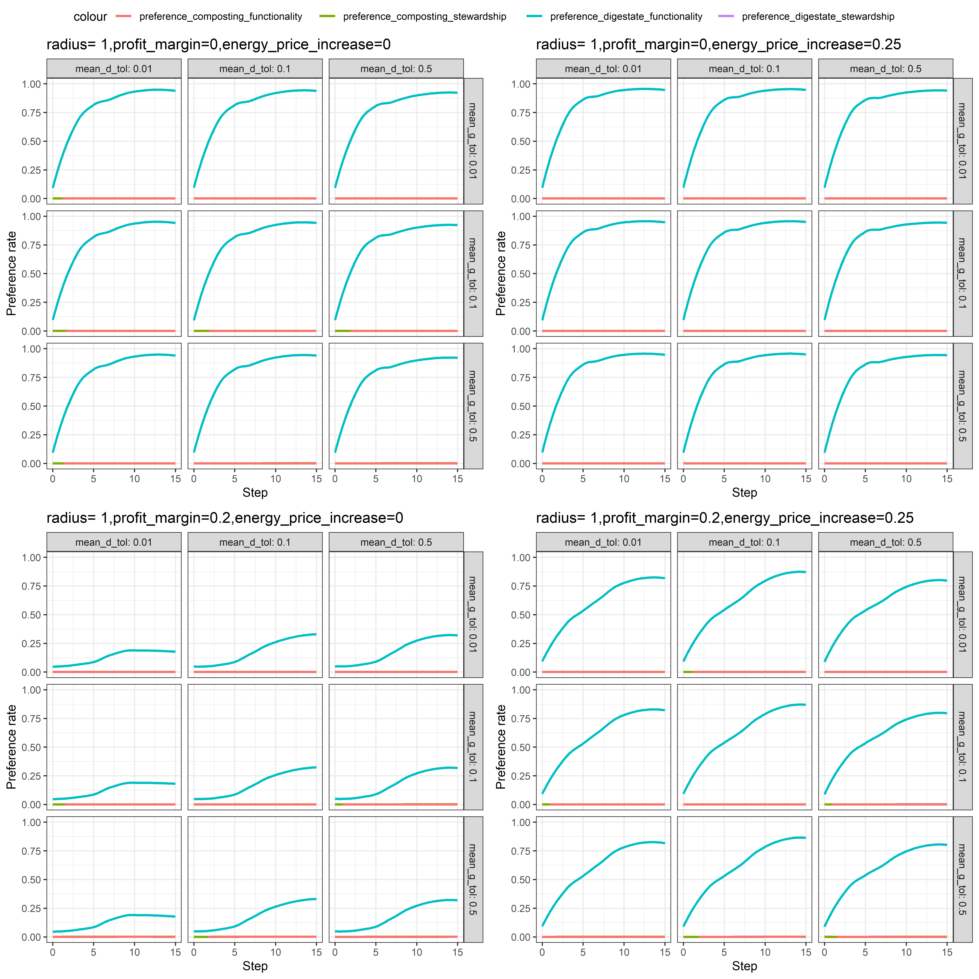
(a) Buiness models chosen in the configuration of radius = 1
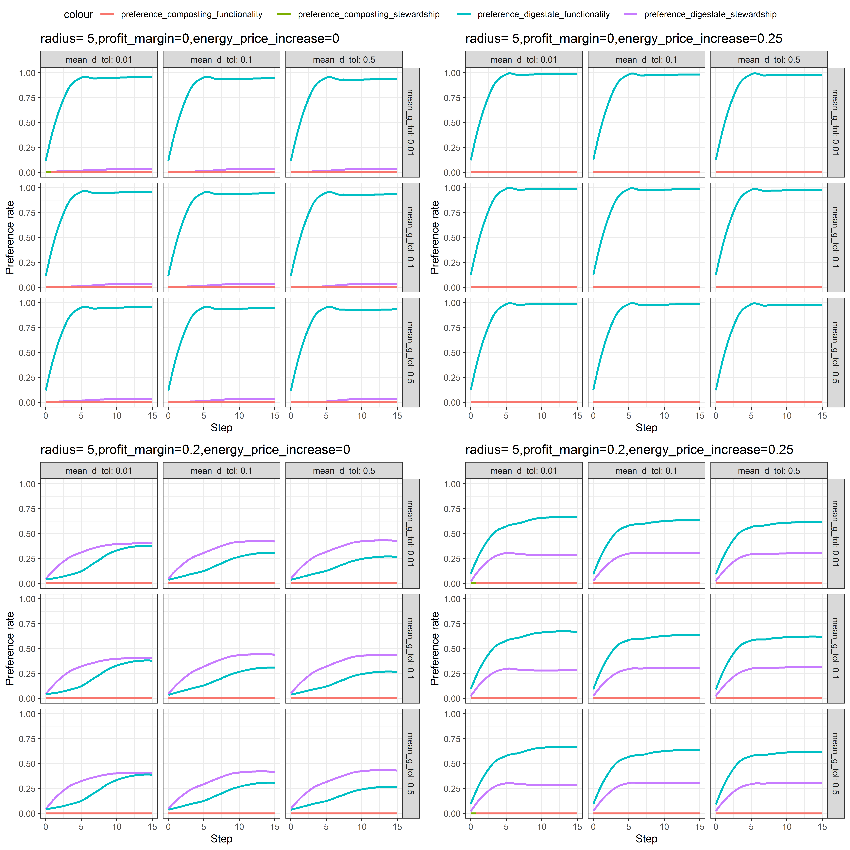
(b) Buiness models chosen in the configuration of radius = 5

Figure 3- Business models preferences
Interestingly, on the one hand, when examining Figure 3.a, where the radius is set at 1, an increase in profit margin reduces the preference for the compost from AD under functionality scenario. On the other hand, an increase in energy prices enhances the preference for the compost from AD under functionality scenario. This behavior aligns with the model logic, wherein an increase in energy prices affects the price of urea and partially favors the compost from AD functionality scenario, given its electricity and energy production component as a source of revenue.
Moreover, when the radius is increased to 5, a preference towards the compost from AD under stewardship scenario emerges, indicating that agents will find more co-investors for their business models. The compost from AD stewardship scenario is even more preferred than its functionality counterpart, especially when the profit margin charged by the waste-treatment plant increases to 0.2. Nevertheless, this attractiveness decreases when energy prices are increased. This suggests that the compost from AD stewardship scenario is highly sensitive to changes in energy prices.

Regarding the effect of tolerance to activity dissimilarity (mean_d_tol) and cost disparity (mean_g_tol), they have marginal effects, as the choices of fertilizers and application rates may not differ substantially from each other. However, when examining configurations where the tolerances are set at their lowest values (i.e., more socially oriented agents), the preferences towards the business models follow a slower pace and have lower values compared to configurations where these parameters are set at their highest values (i.e., more individually oriented agents).
This implies that when agents are more socially oriented (i.e., more inclined to imitate or adhere to social norms), they are less likely to prefer business models designed at earlier stages. This is attributed to the model logic where business models are initially outcomes of the optimization strategy and later diffuse into the social environment. In this regard, tolerance to activity dissimilarity (mean_d_tol) and cost disparity (mean_g_tol) exhibit a delaying effect on the emergence of preferences towards the business models designed in the model.

Fertilizer application rates
With respect to fertilizer application rates, Figures 4 and 5, in different configurations, show which fertilizer and at what application rates were chosen by farms over time. Here too, it is important to note that the choice of compost from AD use comes firstly from the optimization strategy and is then introduced into the social environment. Hence, the explanations previously made regarding the effect of tolerance to activity dissimilarity (mean_d_tol) and cost disparity (mean_g_tol) hold true here as well.
Moreover, in general, an increase in the radius results in more use of compost from AD, which could be in the form of either a functionality or a stewardship scenario. Regarding the effect of an increase in the profit margin charged by waste-treatment plants, it decreases the choice of compost from AD, especially when the increase in energy prices is set at zero. However, when energy prices increase, due to the revenue related to energy and electricity production, the choice of compost from AD becomes more favorable. With respect to the effect of the radius, an increase in this parameter enhances the preference towards compost from AD and stabilizes the choice of fertilizers more quickly.
Considering interactions between fertilizers, when compost from AD is chosen, the use of crop residue and pig slurry will decrease. In the same line of argumentation as for compost from AD, an increase in radius reduces the preference for pig slurry, crop residue, and urea. Moreover, an increase in the profit margin charged by waste-treatment plants favors the use of pig slurry, crop residues. Lastly, an increase in energy prices negatively affects the use of these fertilizers, especially urea as its price interacts with energy prices.

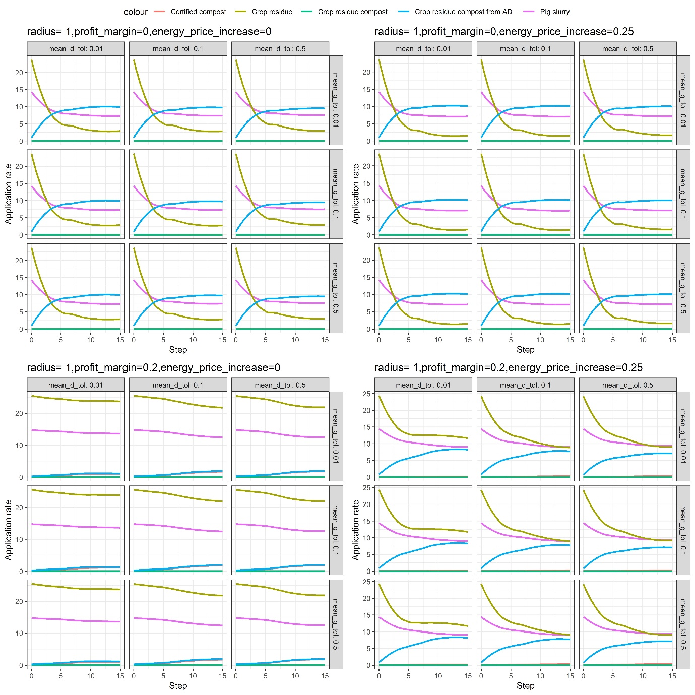
(a) Application rates of pig-slurry, certified compost, crop residue compost, and compost from AD over time when radius = 1
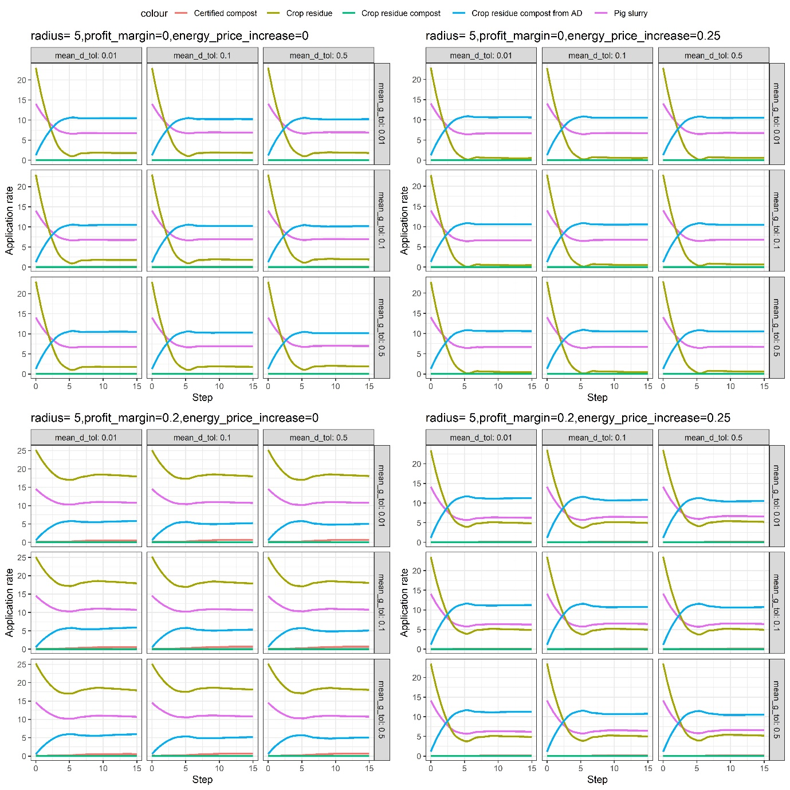
(b) Application rates of pig-slurry, certified compost, crop residue compost, and compost from AD over time when radius = 5

Figure 4- Application rates of pig-slurry, certified compost, crop residue compost, and compost from AD over time

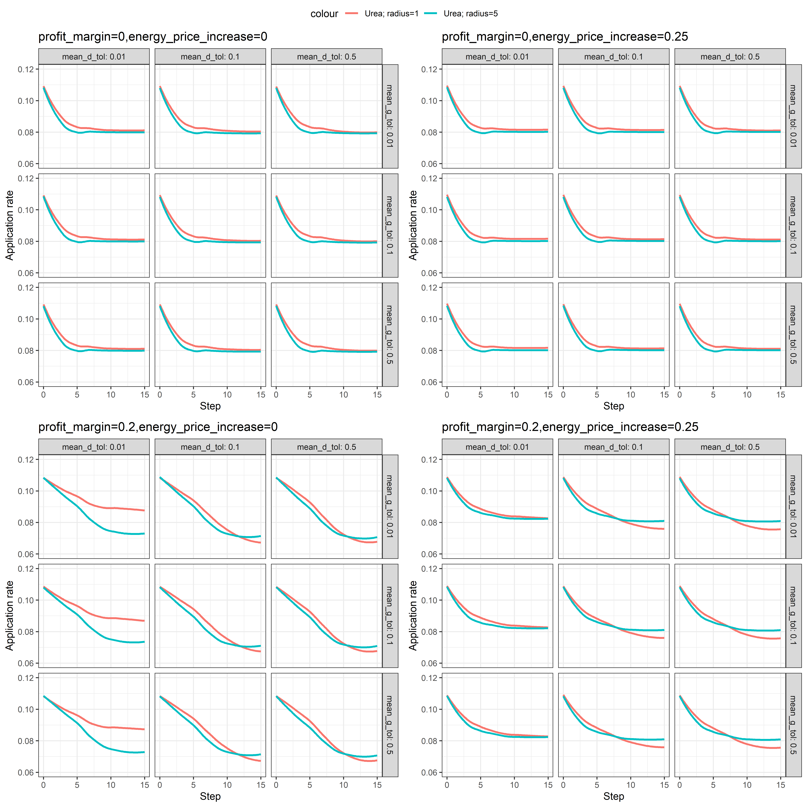
Figure 5- Fertilizer application rate urea overtime

Strategies
Regarding the strategies implemented over time, the results can be observed in Figure 6. In general, repetition and optimization are the most commonly chosen strategies, indicating that agents do not significantly differ from each other. However, more socially-oriented strategies (i.e., imitation and inquiry) are noticeable in configurations where the tolerance to activity dissimilarity (mean_d_tol) and cost disparity (mean_g_tol) are set at lower values. This is evident in the model as these parameters, when set to lower values, result in a higher number of socially-oriented agents.
Furthermore, socially-oriented strategies are also influenced by parameters such as an increase in energy prices and profit margin. In these cases, an increase in such parameters creates a more volatile environment, prompting some agents to immediately change their fertilizer choices and thereby generating a dissimilar social environment. This, in turn, puts pressure on neighboring agents to adopt a socially-oriented strategy.
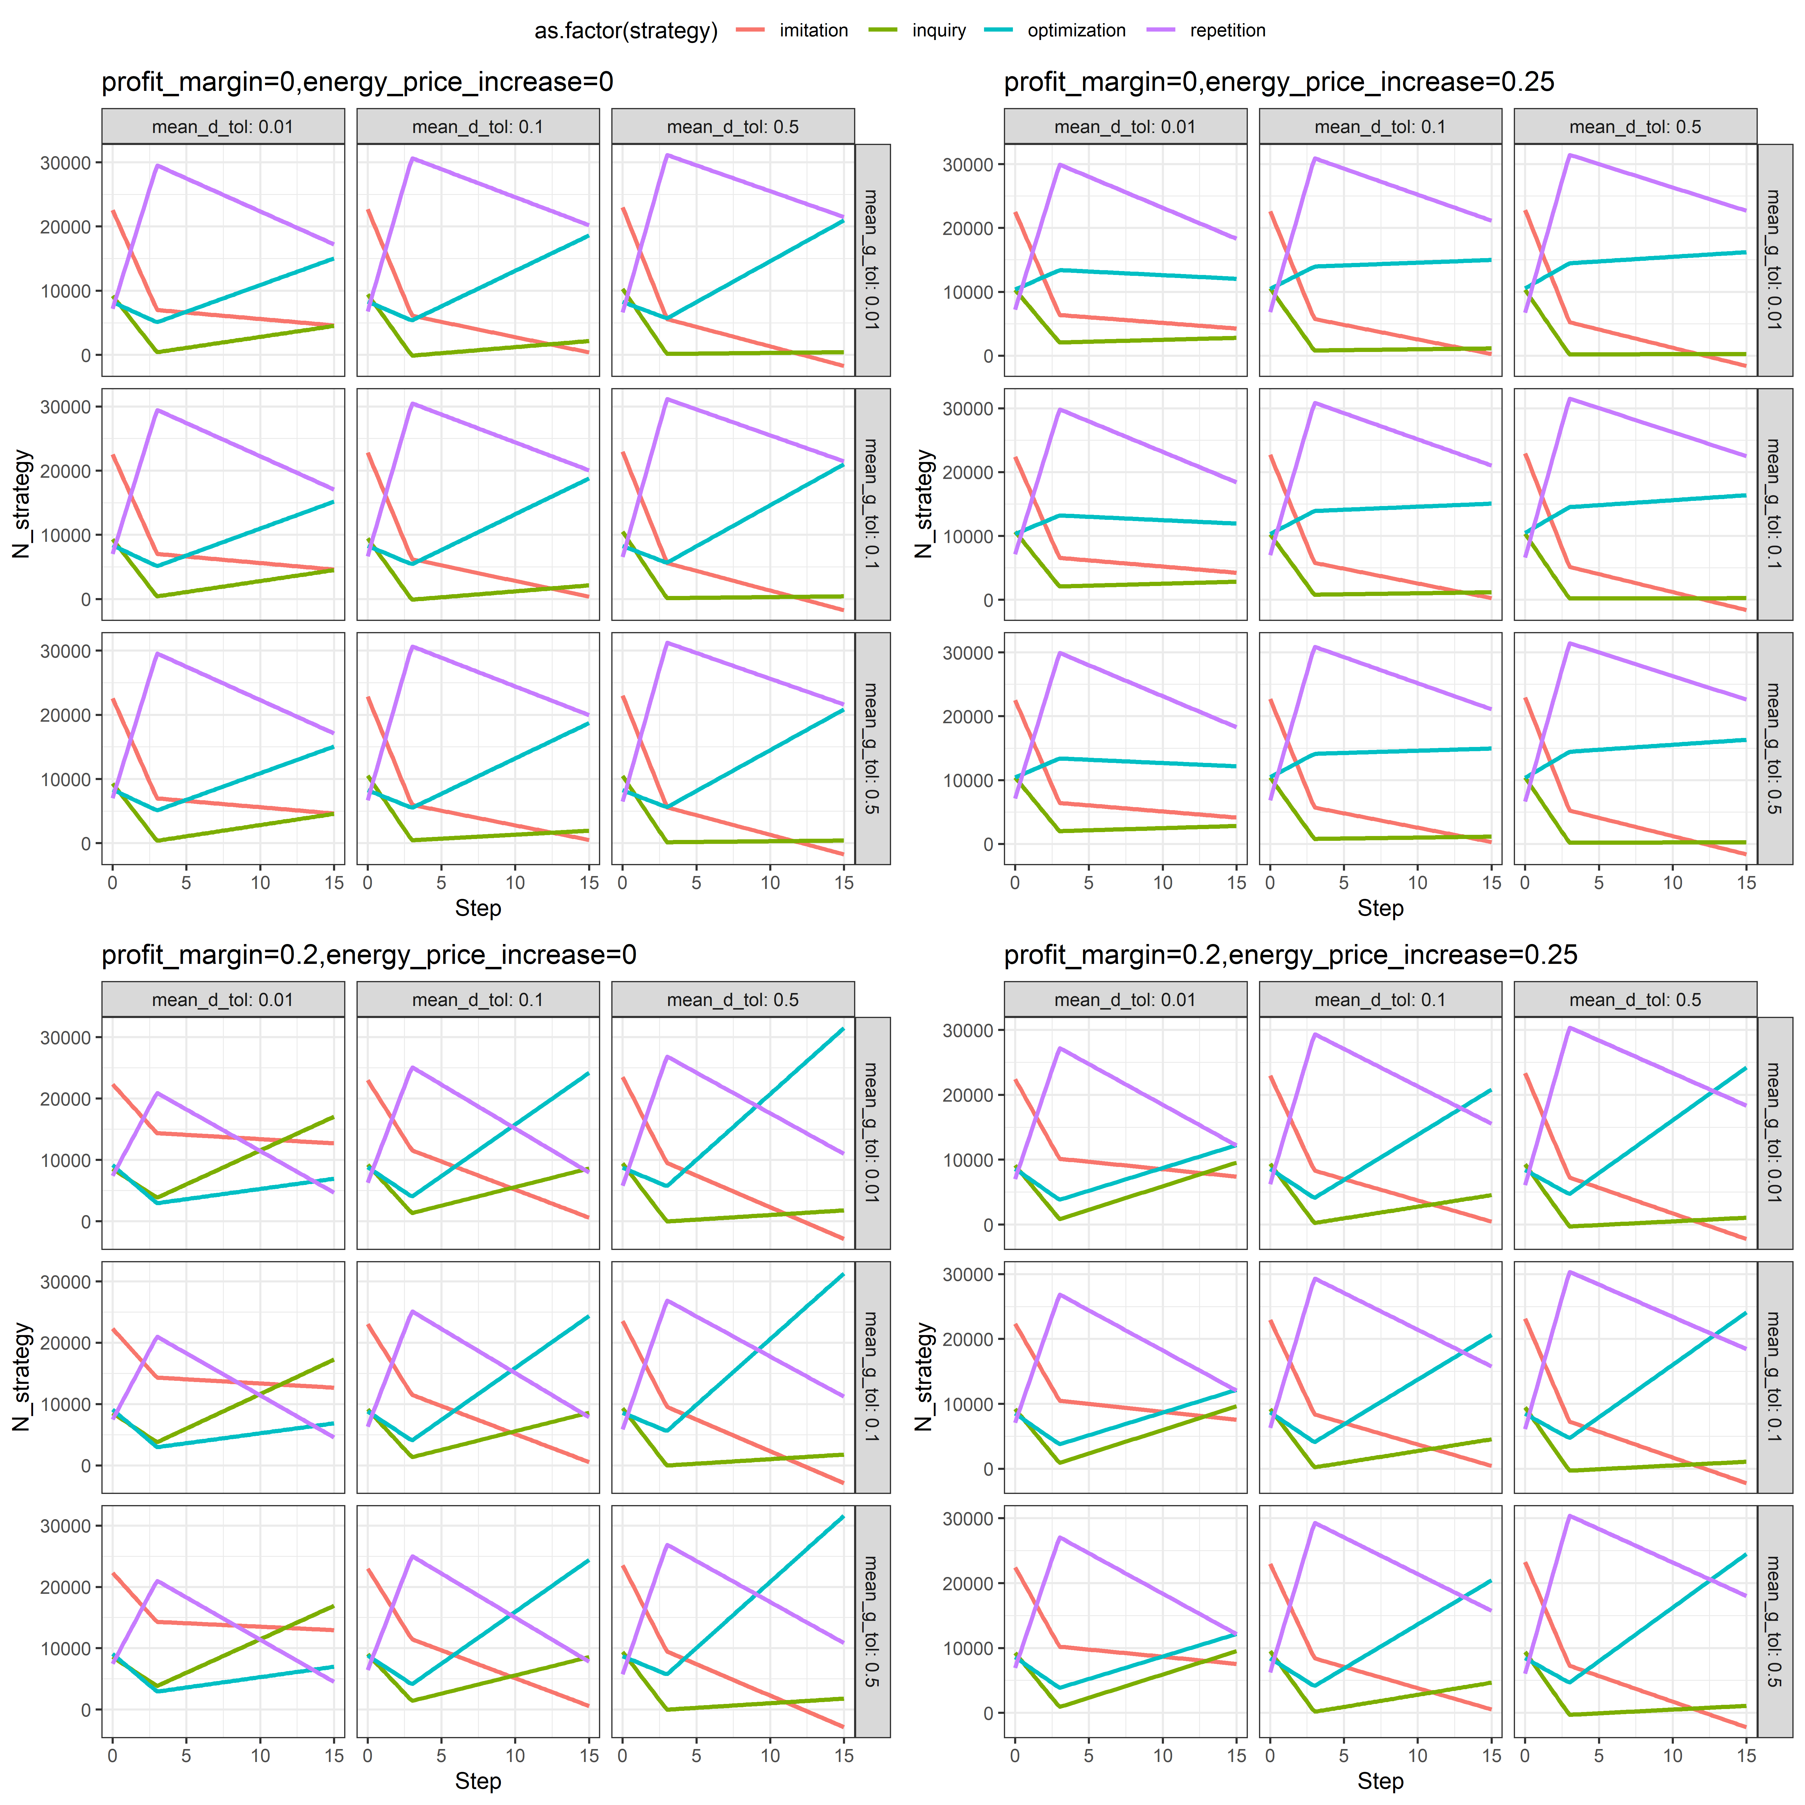
(a) Stratgeies taken over time when radius = 1
(a) Stratgeies taken over time when radius = 5

Figure 6-Strategies taken over time

References
Bezanson, J., Edelman, A., Karpinski, S., & Shah, V. B. (2017). Julia: A fresh approach to numerical computing. SIAM {R}eview, 59(1), 65–98. https://doi.org/10.1137/141000671
De Dobbelaere, A., De Keulenaere, B., De Mey, J., Lebuf, V., Meers, E., Ryckaert, B., Schollier, C., Van Driessche, J., & {{eng}}, L. =. (2015). Small-scale anaerobic digestion : case studies in Western Europe (p. 19). Inagro.
De Keyser, E., De Dobbelaere, A., Leenknegt, J., Meers, E., Mathijs, E., & Vranken, L. (2023). An optimization model minimizing costs of fertilizer application in Flemish horticulture. International Journal of Agricultural Sustainability, 21(1), 2184572. https://doi.org/10.1080/14735903.2023.2184572
Grimm, V., Polhill, G., & Touza, J. (2013). Documenting Social Simulation Models: The ODD Protocol as a Standard. 117–133. https://doi.org/10.1007/978-3-540-93813-2_7
Grimm, V., Railsback, S. F., Vincenot, C. E., Berger, U., Gallagher, C., Deangelis, D. L., Edmonds, B., Ge, J., Giske, J., Groeneveld, J., Johnston, A. S. A., Milles, A., Nabe-Nielsen, J., Polhill, J. G., Radchuk, V., Rohwäder, M. S., Stillman, R. A., Thiele, J. C., & Ayllón, D. (2020). The ODD protocol for describing agent-based and other simulation models: A second update to improve clarity, replication, and structural realism. Jasss, 23(2). https://doi.org/10.18564/jasss.4259
Huber, R., Xiong, H., Keller, K., & Finger, R. (2022). Bridging behavioural factors and standard bio-economic modelling in an agent-based modelling framework. Journal of Agricultural Economics, 73(1), 35–63. https://doi.org/https://doi.org/10.1111/1477-9552.12447
Müller, B., Bohn, F., Dreßler, G., Groeneveld, J., Klassert, C., Martin, R., Schlüter, M., Schulze, J., Weise, H., & Schwarz, N. (2013). Describing human decisions in agent-based models - ODD+D, an extension of the ODD protocol. Environmental Modelling and Software, 48, 37–48. https://doi.org/10.1016/j.envsoft.2013.06.003
Richiardi, M., Leombruni, R., Saam, N. J., & Sonnessa, M. (2006). A Common Protocol for Agent-Based Social Simulation. Journal of Artificial Societies and Social Simulation, 9(1), 15. https://doi.org/10.1017/S0068245400017846
Vahdati, A. (2019). Agents.jl: agent-based modeling framework in Julia. Journal of Open Source Software, 4(42), 1611. https://doi.org/10.21105/joss.01611

In case of functionality composting or digestion, the composition of the resulting compost is equal to the composition of certified compost. Further detains can be found in the code section.
The reason for treating each plot as a farmer is the absence of detailed data regarding the exact sizes and locations of farms in Flanders. Instead, we have access to information about the plots and parcels, which can serve as a proxy for farms. Another approach could have involved simulating different farms on the plots using available size distribution data. While this approach could be useful, it introduces additional assumptions and granularity that we chose not to pursue.
This procedure is coded in four sub-procedures.
Average paid costs given the memory of the farmers
The decision to repeat only 20 times was made due to the computational resources available to us at the time.

