Supplementary information C

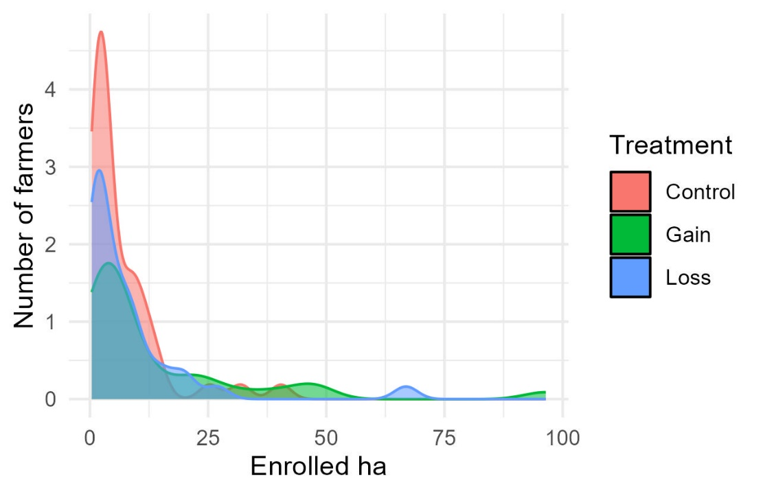
Figure 1: Density plot of the number of farmers that enrolled a given amount of land in 2023 by treatment.
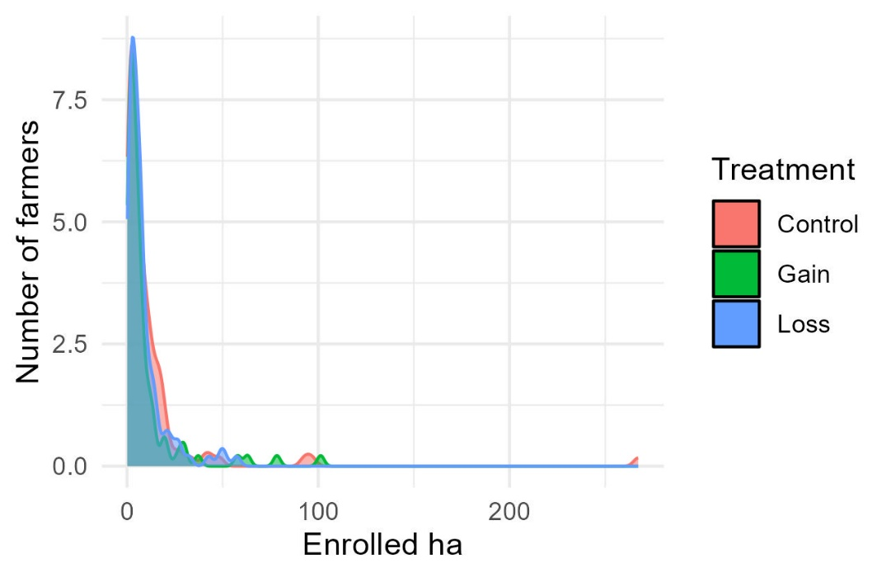
Figure 2: Density plot of the number of farmers that enrolled a given amount of land in 2024 by treatment.

