APPENDIX
APPENDIX A
Table A.1: Comparative baseline store and socio-demographic characteristics of control and intervention stores, stratified by store size.
 |  |  |  | HYPERMARKT |  |  |  | MARKET
 |  |  |  | Control | Intervention | p-value |  | Control | Intervention | p-value
Store Characteristics
 | Store size (m²) |  |  | 8261 | 6873 | >0,1 |  | 1980 | 2280 | >0,1
 | Weekly sales of meal kits |  |  | 7,5 | 7,8 | >0,1 |  | 6,9 | 7,1 | >0,1
Socio-demographic Characteristics
 | Household size |  |  | 2,3 | 2,3 | >0,1 |  | 2,2 | 2,2 | >0,1
 | Yearly household income (€) |  |  |  |  | <0,05 |  |  |  | <0,05
 |  | 0 - 18.000 |  | 2,8% | 5,1% |  |  | 1,1% | 0,6%
 |  | 18.001 - 20.500 |  | 5,6% | 6,3% |  |  | 2,5% | 2,0%
 |  | 20.501 - 23.000 |  | 12,4% | 10,6% |  |  | 15,7% | 6,9%
 |  | 23.001 - 25.000 |  | 20,0% | 14,2% |  |  | 13,8% | 21,8%
 |  | 25.501 - 28.000 |  | 22,1% | 18,1% |  |  | 12,9% | 20,3%
 |  | 28.001 - 30.500 |  | 16,6% | 14,7% |  |  | 20,1% | 24,1%
 |  | 30.501 - 33.000 |  | 10,4% | 12,5% |  |  | 20,8% | 13,8%
 |  | > 33.000 |  | 8,2% | 15,9% |  |  | 12,2% | 8,5%
 | Age
 |  | [0-25] |  | 1,4% | 1,5% | >0,1 |  | 1,0% | 1,1% | >0,1
 |  | ]25-35] |  | 9,4% | 9,9% |  |  | 7,1% | 7,0%
 |  | ]35-45] |  | 16,0% | 15,9% |  |  | 11,6% | 11,2%
 |  | ]45-55] |  | 19,6% | 20,1% |  |  | 15,2% | 16,7%
 |  | ]55-65] |  | 22,4% | 22,0% |  |  | 22,0% | 22,4%
 |  | ]65+] |  | 31,1% | 30,6% |  |  | 43,1% | 41,7%
NOTE: Data were obtained directly from the retailer’s internal databases. These baseline covariates are presented to assess parity between the control and intervention groups across both hypermarket and market segments prior to the intervention period. Store characteristics: Values represents the mean of store-level metrics (size in m² and average weekly meal kit sales). Socio-demographic characteristics were calculated for the population residing within a 10-minute walking distance of each store. Specifically, "Household size" denotes the average number of persons per household, while "Yearly household income" and "Age" reflect the distribution (in percentages) of the resident population within the specified area. Statistical significance was assessed using one-way ANOVA (to compare means for continuous variables: Store size, weekly sales of meal kits and household size) and Pearson’s Chi-squared test (to compare distributions for age and income demographics). Analyses were stratified by store size.

Table A.2: Combination of selected meal kits and plant-based protein sources, with price.
Protein type | Protein product | Protein unit price (€) | Qty needed | Meal kit | Meal kit price (€) | Total meal cost (€)
Analogue | PB mince meat | 3.19 | 2 | Burrito from Sonora | 5.99 | 12.37
Analogue | PB mince meat | 3.19 | 2 | Lasagna with Vegetables | 5.49 | 11.87
Analogue | PB chicken | 3.95 | 2 | Japanese Teriyaki* | 6.99 | 14.89
Analogue | PB chicken | 3.95 | 2 | Indian Tikka Masala | 5.99 | 13.89
Non-Analogue | Tofu | 1.69 | 1 | Green Curry with Tofu | 5.49 | 7.18
Non-Analogue | Lentils | 2.49 | 1 | Goulash Soup with Lentils* | 5.99 | 8.48
Note: PB = plant-based.
*Implies the meal kit was newly introduced for the intervention.

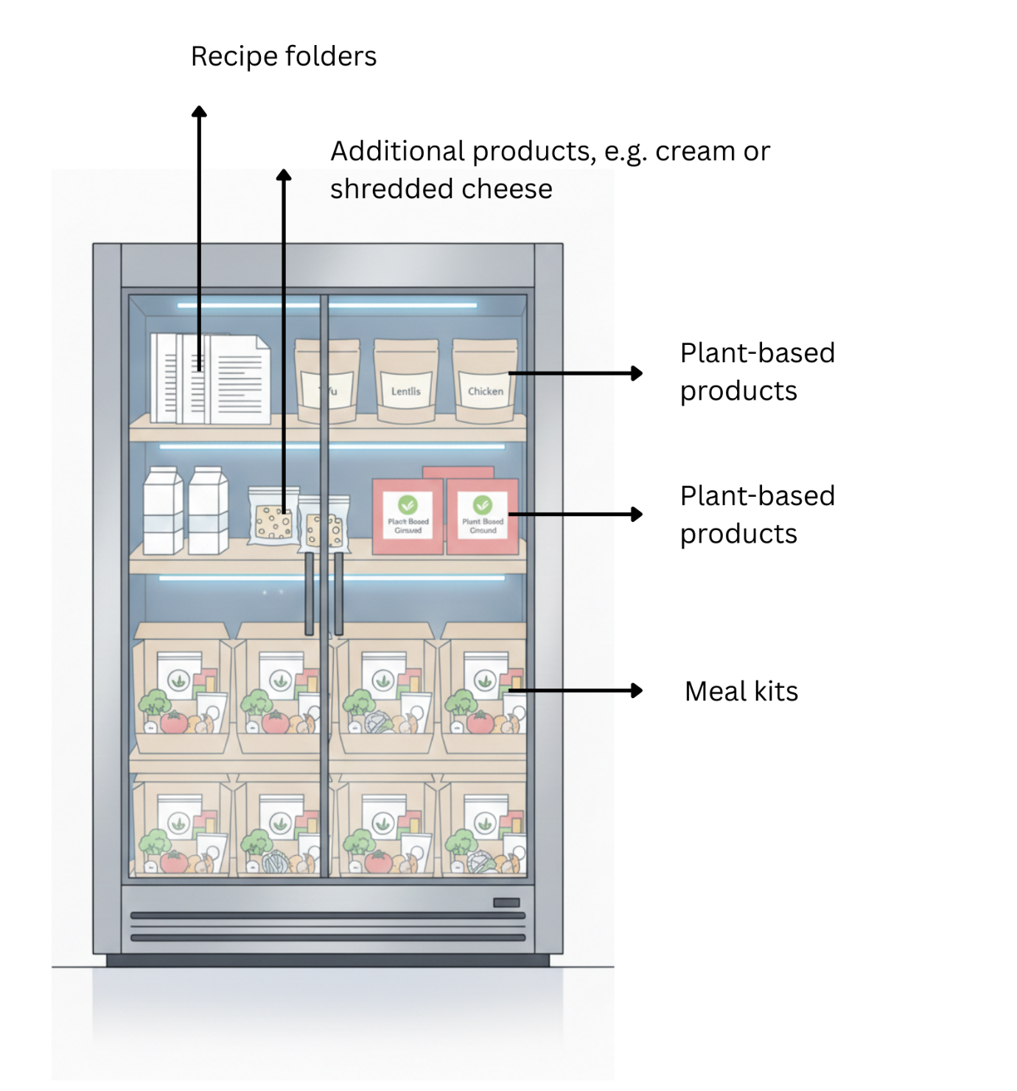
Figure 1. Presentation of the intervention implementation. Image created with AI

