Appendix A
Table A1
Measurement Summary
Construct | Item Example | Source | Scale
Attitude | Use imperfect bananas for smoothies | Ajzen (1991) adapted | 1–5 Likert
Subjective Norm | Discuss sustainability with family | Ajzen (1991) adapted | 1–5 Likert
PBC | Turn off tap to save water | Ajzen (1991) adapted | 1–5 Likert
Environmental Value | Protect environment | Stern et al. (1999) adapted | 1–5 Likert
Personal Norm | Reduce food waste | Stern et al. (1999) adapted | 1–5 Likert
WTP | Prefer imperfect bananas | Behavioural stated preference | Ordinal 3-point

Table A2
Association Between Preference for Imperfect Bananas and Water Saving Practices
 |  |  | Turn off tap |  |  |  |  | Total
 |  |  | 1.00 | 2.00 | 3.00 | 4.00 | 5.00
WTP | 1.00 | % within Prefer imperfect banana | 1.7% | 4.0% | 11.1% | 20.5% | 62.8% | 100.0%
WTP | 1.00 | % within Turn off tap | 64.0% | 65.5% | 68.4% | 78.4% | 84.3% | 79.7%
WTP | 2.00 | % within Prefer imperfect banana | 3.7% | 9.3% | 21.5% | 26.2% | 39.3% | 100.0%
WTP | 2.00 | % within Turn off tap | 16.0% | 17.2% | 14.8% | 11.2% | 5.9% | 8.9%
WTP | 3.00 | % within Prefer imperfect banana | 3.6% | 7.3% | 19.0% | 19.0% | 51.1% | 100.0%
WTP | 3.00 | % within Turn off tap | 20.0% | 17.2% | 16.8% | 10.4% | 9.8% | 11.4%
Total |  | % within Prefer imperfect banana | 2.1% | 4.8% | 12.9% | 20.8% | 59.4% | 100.0%
 |  | % within Turn off tap | 100.0% | 100.0% | 100.0% | 100.0% | 100.0% | 100.0%

Table A3

Linking Preference for Imperfect Bananas with Environmental Protection Engagement

 |  |  | Protect environment |  |  |  |  | Total
 |  |  | 1.00 | 2.00 | 3.00 | 4.00 | 5.00 | Total
WTP | 1.00 | % within Prefer imperfect banana | 1.3% | 2.7% | 18.0% | 43.6% | 34.4% | 100.0%
WTP | 1.00 | % within protect environment | 66.7% | 60.5% | 64.9% | 83.8% | 87.5% | 79.7%
WTP | 2.00 | % within Prefer imperfect banana | 3.7% | 8.4% | 29.0% | 38.3% | 20.6% | 100.0%
WTP | 2.00 | % within protect environment | 22.2% | 20.9% | 11.7% | 8.2% | 5.8% | 8.9%
WTP | 3.00 | % within Prefer imperfect banana | 1.5% | 5.8% | 45.3% | 29.2% | 18.2% | 100.0%
WTP | 3.00 | % within protect environment | 11.1% | 18.6% | 23.4% | 8.0% | 6.6% | 11.4%
Total |  | % within Prefer imperfect banana | 1.5% | 3.6% | 22.0% | 41.5% | 31.4% | 100.0%
 |  | % within protect environment | 100.0% | 100.0% | 100.0% | 100.0% | 100.0% | 100.0%

Table A4
Linking Preferences for Imperfect Bananas with Support for Locally Produced Food
 |  |  | Buy locally produced food |  |  |  |  | Total
 |  |  | 1.00 | 2.00 | 3.00 | 4.00 | 5.00 | Total
WTP | 1.00 | % within Prefer imperfect banana | 0.8% | 9.3% | 37.7% | 43.3% | 8.9% | 100.0%
WTP | 1.00 | % within buy locally produced food | 57.1% | 78.8% | 73.2% | 85.7% | 86.7% | 79.7%
WTP | 2.00 | % within Prefer imperfect banana | 5.6% | 10.3% | 53.3% | 22.4% | 8.4% | 100.0%
WTP | 2.00 | % within buy locally produced food | 42.9% | 9.7% | 11.6% | 5.0% | 9.2% | 8.9%
WTP | 3.00 | % within Prefer imperfect banana |  | 9.5% | 54.7% | 32.8% | 2.9% | 100.0%
WTP | 3.00 | % within buy locally produced food |  | 11.5% | 15.2% | 9.3% | 4.1% | 11.4%
Total |  | % within Prefer imperfect banana | 1.2% | 9.4% | 41.0% | 40.3% | 8.2% | 100.0%
 |  | % within buy locally produced food | 100.0% | 100.0% | 100.0% | 100.0% | 100.0% | 100.0%

Table A5
Cross-tabulation of Imperfect Banana Preferences and Support for Minimal Packaging Products
 |  |  | minimal packaging products |  |  |  |  | Total
 |  |  | 1.00 | 2.00 | 3.00 | 4.00 | 5.00 | Total
WTP | 1.00 | % within Prefer imperfect banana | 2.1% | 11.1% | 44.6% | 33.9% | 8.4% | 100.0%
WTP | 1.00 | % within minimal packaging products | 71.4% | 72.1% | 76.1% | 86.4% | 88.9% | 79.7%
WTP | 2.00 | % within Prefer imperfect banana | 4.7% | 20.6% | 45.8% | 22.4% | 6.5% | 100.0%
WTP | 2.00 | % within minimal packaging products | 17.9% | 15.0% | 8.7% | 6.4% | 7.8% | 8.9%
WTP | 3.00 | % within Prefer imperfect banana | 2.2% | 13.9% | 62.0% | 19.7% | 2.2% | 100.0%
WTP | 3.00 | % within minimal packaging products | 10.7% | 12.9% | 15.2% | 7.2% | 3.3% | 11.4%
Total |  | % within Prefer imperfect banana | 2.3% | 12.2% | 46.7% | 31.3% | 7.5% | 100.0%
 |  | % within minimal packaging products | 100.0% | 100.0% | 100.0% | 100.0% | 100.0% | 100.0%

Table A6
Cross-tabulation of Imperfect Banana Preferences and Food Waste Reduction Behaviours
 |  |  | Reduce food waste |  |  |  |  | Total
 |  |  | 1.00 | 2.00 | 3.00 | 4.00 | 5.00 | Total
WTP | 1.00 | % within Prefer imperfect banana | 0.7% | 6.3% | 25.2% | 45.3% | 22.5% | 100.0%
WTP | 1.00 | % within reduce food waste | 53.8% | 63.2% | 71.9% | 84.1% | 88.9% | 79.7%
WTP | 2.00 | % within Prefer imperfect banana | 4.7% | 15.0% | 29.0% | 37.4% | 14.0% | 100.0%
WTP | 2.00 | % within reduce food waste | 38.5% | 16.8% | 9.3% | 7.8% | 6.2% | 8.9%
WTP | 3.00 | % within Prefer imperfect banana | 0.7% | 13.9% | 46.0% | 30.7% | 8.8% | 100.0%
WTP | 3.00 | % within reduce food waste | 7.7% | 20.0% | 18.8% | 8.1% | 4.9% | 11.4%
Total |  | % within Prefer imperfect banana | 1.1% | 7.9% | 27.9% | 42.9% | 20.2% | 100.0%
 |  | % within reduce food waste | 100.0% | 100.0% | 100.0% | 100.0% | 100.0% | 100.0%

Table A7
Association Between Preference for Imperfect Bananas and Discussions with Social Circles
 |  |  | Discuss friends-family-colleagues |  |  |  |  | Total
 |  |  | 1.00 | 2.00 | 3.00 | 4.00 | 5.00 | Total
WTP | 1.00 | % within Prefer imperfect banana | 6.7% | 26.2% | 38.2% | 21.7% | 7.2% | 100.0%
WTP | 1.00 | % within discuss friends family colleagues | 59.3% | 78.9% | 81.2% | 86.0% | 83.1% | 79.7%
WTP | 2.00 | % within Prefer imperfect banana | 19.6% | 24.3% | 29.0% | 19.6% | 7.5% | 100.0%
WTP | 2.00 | % within discuss friends-family-colleagues | 19.4% | 8.2% | 6.9% | 8.7% | 9.6% | 8.9%
WTP | 3.00 | % within Prefer imperfect banana | 16.8% | 29.9% | 39.4% | 9.5% | 4.4% | 100.0%
WTP | 3.00 | % within discuss friends-family-colleagues | 21.3% | 12.9% | 12.0% | 5.4% | 7.2% | 11.4%
Total |  | % within Prefer imperfect banana | 9.0% | 26.5% | 37.5% | 20.1% | 6.9% | 100.0%
 |  | % within discuss friends-family-colleagues | 100.0% | 100.0% | 100.0% | 100.0% | 100.0% | 100.0%

Table A8
Association Between Imperfect Banana Preference and Acceptance of Processed Banana Forms (e.g., Powder, Smoothies)
 |  |  | Process food-banana powder, smoothies |  |  |  |  | Total
 |  |  | 1.00 | 2.00 | 3.00 | 4.00 | 5.00 | Total
WTP | 1.00 | % within Prefer imperfect banana | 7.2% | 14.0% | 28.8% | 33.0% | 17.0% | 100.0%
WTP | 1.00 | % within process food-banana powder, smoothies | 56.6% | 74.4% | 76.5% | 88.0% | 90.6% | 79.7%
WTP | 2.00 | % within Prefer imperfect banana | 15.9% | 16.8% | 32.7% | 22.4% | 12.1% | 100.0%
WTP | 2.00 | % within process food-banana powder, smoothies | 13.9% | 10.0% | 9.7% | 6.7% | 7.2% | 8.9%
WTP | 3.00 | % within Prefer imperfect banana | 26.3% | 20.4% | 36.5% | 13.9% | 2.9% | 100.0%
WTP | 3.00 | % within process food-banana powder, smoothies | 29.5% | 15.6% | 13.9% | 5.3% | 2.2% | 11.4%
Total |  | % within Prefer imperfect banana | 10.1% | 15.0% | 30.0% | 29.9% | 15.0% | 100.0%
 |  | % within process food-banana powder, smoothies | 100.0% | 100.0% | 100.0% | 100.0% | 100.0% | 100.0%

Appendix B
Figure B1
Crosstab Charts of Willingness to Purchase for Imperfect Produce and Pro-environmental Behavioural Factors
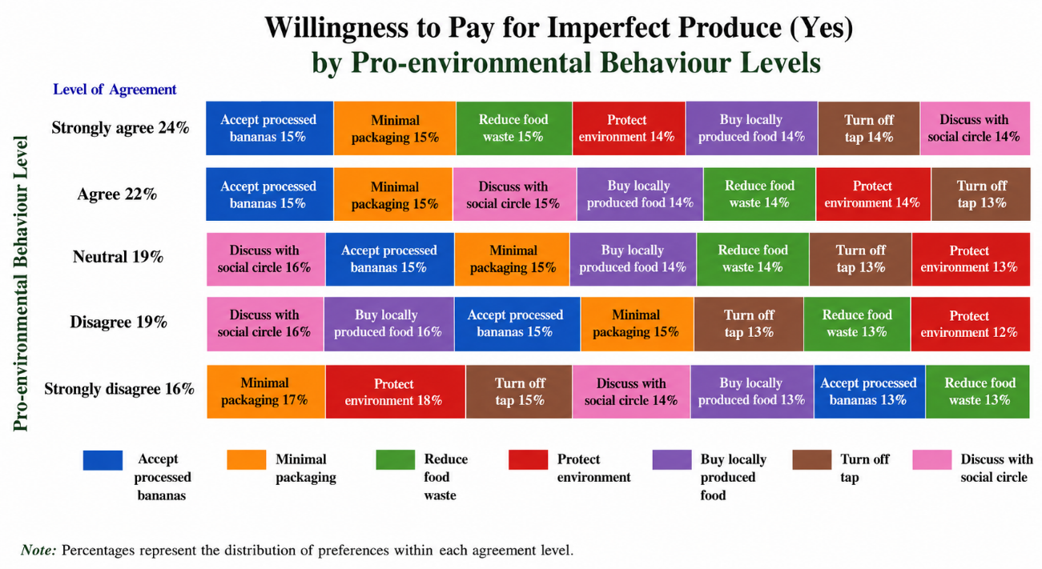
Crosstab Chart (a)

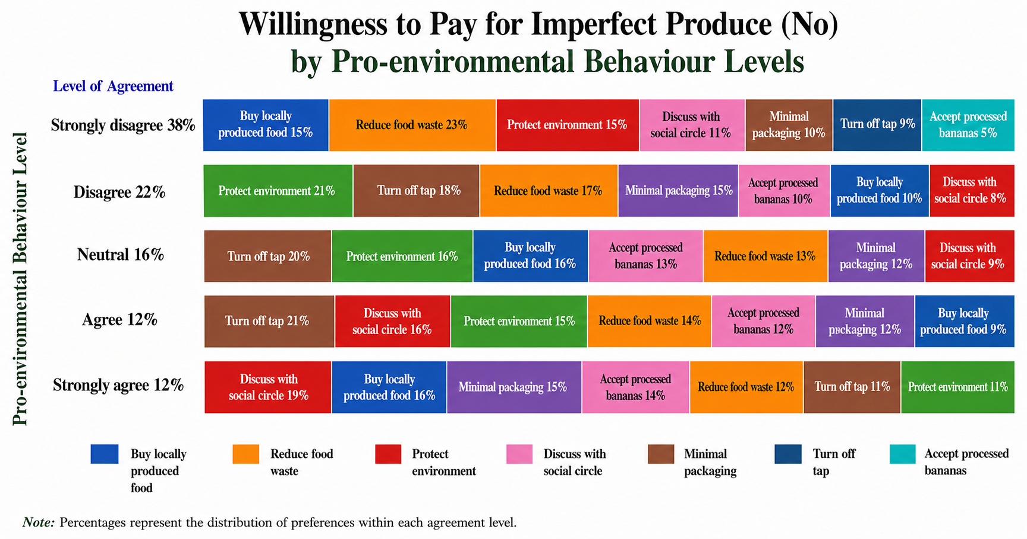
Crosstab Chart (b)
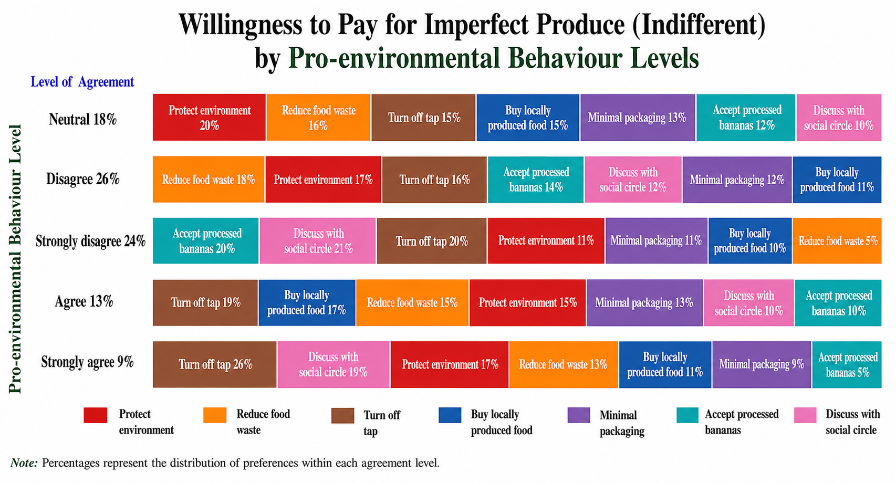
Crosstab Chart (c)

Appendix C
Figure C1
Relationship between Pro-Environmental Behaviour Index (PEBI) and Willingness to Purchase (WTP) for Imperfect Bananas

