Association between thermogenic brown fat and genes under positive natural selection in circumpolar populations

Authors
Yuka Ishida¹, Mami Matsushita², Takeshi Yoneshiro ³, Masayuki Saito^{2,４}, Kazuhiro Nakayama¹

Affiliations
¹ Department of Integrated Biosciences, Graduate School of Frontier Sciences, The University of Tokyo, Kashiwa, Chiba 277-8562, Japan
² Department of Nutrition, School of Nursing and Nutrition, Tenshi College, Sapporo, Hokkaido 065-0013, Japan
³ Department of Molecular Metabolism and Physiology, Tohoku University Graduate School of Medicine, Sendai, Miyagi 980-8575, Japan
⁴ Laboratory of Biochemistry, Faculty of Veterinary Medicine, Hokkaido University, Sapporo, Hokkaido 060-0818, Japan

Correspondence
Kazuhiro Nakayama
Laboratory of Evolutionary Anthropology, Department of Integrated Biosciences, Graduate School of Frontier Sciences, The University of Tokyo
5-1-5 Kashiwanoha, Kashiwa, Chiba 277-8562, Japan,
TEL: +81-4-7136-3686
FAX: +81-4-7136-3687
Email: knakayama@edu.k.u-tokyo.ac.jp

Abstract
Background
Adaptation to cold was essential for human migration across Eurasia. Non-shivering thermogenesis through brown adipose tissue (BAT) participates in cold adaptation because some genes involved in the differentiation and function of BAT exhibit signatures of positive natural selection in populations at high latitudes. Whether these genes are associated with the inter-individual variability in BAT thermogenesis remains unclear. In this study, we evaluated the potential associations between BAT activity and single nucleotide polymorphisms (SNPs) in candidate gene regions in East Asian populations.

Methods
BAT activity induced by mild cold exposure was measured in 399 healthy Japanese men and women using fluorodeoxyglucose positron emission tomography and computed tomography (FDG-PET/CT). The capacity for cold-induced thermogenesis and fat oxidation was measured in 56 men. Association analyses with physiological traits were performed for 11 SNPs at six loci (LEPR, ANGPTL8, PLA2G2A, PLIN1, TBX15-WARS2, and FADS1) reported to be under positive natural selection. Associations found in the FDG-PET/CT population were further validated in 84 healthy East Asian men and women, in whom BAT activity was measured using infrared thermography. Associations between the SNP genotypes and BAT activity or other related traits were tested using multiple logistic and linear regression models.

Results
Of the 11 putative adaptive alleles of the six genes, two intronic SNPs in LEPR (rs1022981 and rs12405556) tended to be associated with higher BAT activity. However, these did not survive multiple test comparisons. Associations with lower body fat percentage, plasma triglyceride, insulin, and HOMA-IR levels were observed in the FDG-PET/CT population (P < 0.05). Other loci, including TBX15-WARS2, which is speculated to mediate cold adaptation in Greenland Inuits, did not show significant differences in BAT thermogenesis.

Conclusions
Our results suggest a marginal but significant association between LEPR SNPs. However, robust supporting evidence was not established for the involvement of other loci under positive natural selection in cold adaptation through BAT thermogenesis in East Asian adults. Given the pleiotropic function of these genes, factors other than cold adaptation through BAT thermogenesis, such as diet adaptation, may contribute to positive natural selection at these loci.

Keywords
cold adaptation, brown adipose tissue, single nucleotide polymorphism, metabolism, positive natural selection

Background
Homeothermic mammals need to maintain their body temperature at a nearly constant level to ensure proper functioning of their vital organs. Most mammals have developed strategies to maintain stable body temperatures, such as shivering or non-shivering thermogenesis and insulation provided by fur and subcutaneous fat (1). Natural selection plays an important role in the evolution of these traits in mammalian species living in cold environments. Modern humans have long been believed to have evolved cold-adaptive phenotypes during their migration from Africa during the last glacial period. Compared to other mammals, humans have less body hair, a trait that is expected to make a limited contribution to insulation. The high capability for adaptive thermogenesis observed in human populations in cold climates, such as the Greenland Inuit, is regarded as a phenotype for coping with cold environments (2). Non-shivering thermogenesis is primarily mediated by the brown adipose tissue (BAT). In cold environments, shivering thermogenesis produces heat and increases energy expenditure; however, after prolonged exposure to cold, shivering decreases gradually, and non-shivering thermogenesis mechanisms take over (3). In humans, high BAT activity during cold exposure has been associated with reduced reliance on shivering and higher rectal temperatures (4). Thus, non-shivering thermogenesis may play a more significant role in cold adaptation than shivering thermogenesis.
The general understanding regarding the genetic basis of cold adaptation via non-shivering thermogenesis remains fragmented, and only a few candidate loci have been reported to date. The gene encoding the mitochondrial uncoupling protein 1 (UCP1), which acts as a part of the thermogenic machinery in BAT, is involved in cold adaptation in modern humans. Single nucleotide polymorphisms (SNP) in UCP1 have been linked to adaptive thermogenesis and the development of obesity (5-7). This SNP has a specific geographical distribution, with a putative adaptive allele involved in high BAT thermogenesis and obesity resistance that is more frequent in high-latitude populations (6, 8). SNPs in the adrenoceptor beta 2 and 3 genes are significantly associated with cold-induced activity in BAT (5, 9), although no firm evidence is available to reject their selective neutrality.
Several other candidate genes for cold adaptation in humans have been reported, mainly from population genetic studies (10-13). Greenland Inuits have a genomic signature of natural selection related to adaptation to extreme conditions: a locus containing the T-box transcription factor 15 (TBX15) and tryptophanyl tRNA synthetase 2 (WARS2) genes and a cluster of genes encoding fatty acid desaturases (FADS1–3) (14-16). In indigenous Siberian and Central and East Asian (EAs) living in cold climates, a specific variant that may be under positive natural selection was found in the phospholipase A2 group 2A gene (PLA2G2A). Angiopoietin-like-8 (ANGPTL8) and perilipin1 (PLIN1) also exhibit signatures of positive selection in these populations (17). The allele frequencies of SNPs in the leptin receptor (LEPR), especially rs1137100 (Lys109Arg), are correlated with principal components representing winter in populations worldwide (11, 18). Moreover, haplotypes consisting of rs1137100 and tightly linked SNPs exhibit increased homozygosity in EAs, implying recent positive selection at this locus (19, 20). Although the products of these genes have been identified as molecules that participate in BAT differentiation and function in rodents (12, 17, 21, 22), it remains unclear whether these genes play a similar role in humans and whether the adaptive allele indeed renders cold tolerance in humans. We recently conducted an association study on BAT activity and successfully identified an SNP in the adrenoceptor beta 2 gene significantly associated with variability in cold-induced thermogenesis (9). The set of genomic DNA and phenotypic data used in this study can help test putative cold-adaptive genes in humans. In this study, we evaluated the association between putative adaptive alleles of these genes and BAT activity to determine whether these polymorphisms are associated with cold adaptation in humans. In this study, we focused on EAs because the SNPs of interest are polymorphic in this population. In addition, the close genetic relationship with Arctic people and variability in their capability for adaptive thermogenesis (23) suggest that testing the association between these genes and cold adaptation in EAs is an appropriate strategy.

Methods
Study participants
BAT activity was assessed in two independent populations using two measurement methods, fluorodeoxyglucose-positron emission tomography and computed tomography (FDG-PET/CT) or infrared thermography (IRT), respectively. Details of the participants and the methods for measuring BAT activity have been described previously (5, 9, 24). The FDG-PET/CT population included 399 healthy Japanese men and women (age: 27.1 ± 7.6, body–mass index [BMI; kg/m²]: 21.9 ± 2.9, Tables 1 and S1) who were living in or near Sapporo City, Hokkaido, Japan. The IRT population comprised 84 healthy men and women (age: 26.7 ± 7.0, BMI [kg/m²]: 21.5 ± 3.0, Tables 2 and S2) who lived in or near Kashiwa City, Chiba, Japan, and included individuals of Japanese, Chinese, Korean, and Taiwanese origin. Their ethnic origins were Japanese (46), Chinese (35), Korean (2), and Taiwanese (1) (Table S3). The study design complied with the principles of the Declaration of Helsinki and was approved by the Ethics Committees of the authors’ institutions. All participants provided written informed consent prior to inclusion in these studies.

Table 1. Characteristics of participants in the FDG-PET/CT population
 | All | BAT-positive | BAT-negative | P-value
n (Men/Women) | 399 (343/56) | 247 (225/22) | 152 (118/34) | < 0.001
Age (years) | 27.1 ± 7.6 | 25.6 ± 6.3 | 29.6 ± 9.0 | < 0.001
Height (cm) | 170.5 ± 7.3 | 171.0 ± 7.2 | 169.6 ± 7.3 | 0.759 ^{b}
Weight (kg) | 63.7 ± 10.5 | 63.0 ± 9.5 | 64.8 ± 11.8 | 0.006 ^{b}
BMI (kg/m²) | 21.9 ± 2.9 | 21.5 ± 2.6 | 22.5 ± 3.2 | 0.003 ^{b}
BFP (%) | 19.0 ± 6.4 | 17.8 ± 5.5 | 20.8 ± 7.1 | 0.189 ^{b}
SUV_{max} ª | 6.1 ± 6.3 | 7.9 ± 6.4 | 0.9 ± 0.4 | < 0.001

P-values between BAT-positive and BAT-negative phenotypes were calculated as follows: men-to-women ratio, Pearson’s chi-square test; age and SUV_{max}, Mann–Whitney U test; other traits, multiple linear regression model adjusted for age and sex. Continuous variables are presented as means ± standard deviation. ª Data from 325 participants is shown (BAT-positive: n=242; BAT-negative: n=83). ^{b} P-value shows the effect of BAT-positive or BAT-negative groups. BAT, brown adipose tissue; BFP, body fat percentage; BMI, body mass index; FDG-PET/CT, fluorodeoxyglucose positron emission tomography and computed tomography; SUV_{max}, maximum standardized uptake value.

Table 2. Body characteristics of the participants in the IRT population
 | All (n=84)
Age (years) | 26.7 ± 7.0
Height (cm) | 168.1 ± 8.4
Weight (kg) | 60.7 ± 9.8
BMI (kg/m²) | 21.5 ± 3.0
BFP (%) | 23.9 ± 8.0
∆Temp (°C) | 1.9 ± 0.9

Continuous variables are presented as means ± standard deviation. BFP: body fat percentage; BMI: body–mass index; ΔTemp: BAT activity calculated by subtracting the skin surface temperature in the control chest region from that in the supraclavicular fossa region.; IRT: infrared thermography.

BAT measurements using FDG-PET/CT
BAT activity was measured during the winter season (from December to March) using a methodology established and utilized in previous studies. The participants wore light clothes (a T-shirt and underwear or a disposable lightweight gown) and stayed in a 19°C room for 1 h after fasting for 6 to 12 h. Subsequently, they were administered ¹⁸F-fluoro-2-deoxyglucose (1.66–5.18 MBq/kg body weight) intravenously and exposed to the same cold condition for another hour. FDG-PET/CT examinations using a PET/CT system (Aquiduo; Toshiba Medical Systems, Ohtawara, Japan) were performed in a room at 24°C. BAT activity in a region of interest was quantified by calculating the maximum standardized uptake value (SUV_{max}). An SUV_{max} of 2.0 or greater was considered to indicate high BAT activity (BAT-positive), while an SUV_{max} of less than 2.0 indicated low activity (BAT-negative) (24, 25). In 74 samples, BAT-positive/BAT-negative status was duly documented, but the raw-SUV_{max} value was absent.

Measurements of cold-induced thermogenesis (CIT) and fat oxidation (FO)
CIT and FO were measured in a 56-men subset of the FDG-PET/CT population in our previous studies (26, 27). Whole-body energy expenditure was measured using a respiratory gas analyzer connected to a ventilated hood (AR-1; Arco System, Kashiwa, Japan). Energy expenditure adjusted for free fat mass (kg) was used to calculate the CIT values. The CIT and FO values were calculated as previously described (26, 27). ΔFat oxidation was calculated by subtracting the fat oxidation value of pre-cold exposure from that of post-cold exposure.

BAT measurements using IRT
Measurements were conducted during the winter and summer (December–March and June–September, respectively). The participants abstained from excessive drinking, staying up late, and exercising on the previous day. On the day of the experiment, the participants skipped breakfast and participated in the experiment in the morning (9:00–12:00). After a 30-minute rest in a 27°C room, the participants were asked to wear light clothing (thin disposable gowns) and rest in a sitting position for 90 min in a 19°C air-conditioned room. Thermal images were acquired using a FLIR-E6-XT thermal imaging camera (Teledyne FLIR, Wilsonville, Oregon, USA). Infrared thermal images of the upper body were acquired at the beginning of and during cold exposure (10, 30, 60, and 90 min). The captured images were analyzed using FLIR tools (Teledyne FLIR). We used ∆Temp at 90 min of cold exposure as an indicator of BAT activity. ΔTemp was calculated by subtracting the skin surface temperature in the control chest region from that in the BAT-rich supraclavicular fossa region (28).

SNP genotyping
In the FDG-PET/CT population, genomic DNA was prepared from buccal swab cells using the QIAamp DNA Mini kit (QIAGEN, Hilden, Germany), followed by ethanol precipitation using a Dr. GenTLE precipitation carrier (TAKARA BIO, Kusatsu, Japan). Genomic DNA was obtained from the saliva of the IRT population using the OraGene DNA kit (DNA Genotek, Ontario, Canada) and QIAamp DNA Midi kit (QIAGEN, Hilden, Germany).
SNP genotyping was performed using TaqMan SNP Genotyping Assays (Thermo Fisher Scientific K.K., Tokyo, Japan), a Light Cycler Probe Master, and a Light Cycler 96 instrument (Roche Diagnostics K.K., Tokyo, Japan). Eleven candidate SNPs of six gene regions—rs1137100, rs1892535, rs1022981, rs12405556, and rs4655518 (LEPR); rs2278426 (ANGPTL8); rs11573162 (PLA2G2A); rs6496589 (PLIN1); rs2298080 (TBX15-WARS2) and rs3790553 (WARS2); and rs174547 (FADS1)—were selected based on the literature (Table S4) (11, 12, 14-18); these were reported as being under positive natural selection in high-latitude populations or populations living in cold climates. LEPR SNPs have strong linkage disequilibrium (29, 30). We analyzed all the SNPs because they were inconclusive which were truly important.

Statistical analysis
Agreement with the Hardy–Weinberg equilibrium was assessed using the χ² goodness-of-fit test, and the significance level was set at 0.0045, considering the number of SNPs tested. Associations between SNP genotypes and BAT activity were evaluated using logistic or multiple linear regression models adjusted for age, sex, test month, or test season, interactions of age and sex, and ethnicity as appropriate, following a previous study (9). In the FDG-PET/CT population, three genetic models were tested for each SNP, additive, dominant, and recessive, for the putatively selected allele (Table S4). Dependent variables without a normal distribution were log-transformed. P-values of less than 0.05 were considered to indicate statistical significance in the analyses of CIT, FO, and the IRT validation study. All statistical tests were two-sided. SPSS software (IBM, Tokyo, Japan) was used for all statistical analyses.

Results
Association analyses were performed on data from two independent populations, collectively comprising 483 individuals in whom BAT activity was measured using FDG-PET/CT (n=399) or IRT (n=84). The characteristics of the participants in each population are summarized in Tables 1, 2, S1, S2, S3, and S5. For the association test, we selected factors other than SNPs involved in BAT activity. In the FDG-PET/CT population, the BAT-positive group was younger than the BAT-negative group (25.6 ± 6.3 vs 29.6 ± 9.0, Mann–Whitney U test, P< 0.001, Table 1). It comprised a higher percentage of men (91.1% vs 77.6%, respectively, P< 0.001, Table 1). In the IRT population, women had a higher ∆Temp than men (Student’s t-test, P< 0.001; Table 2). Age was higher in the Japanese population than that for the other population (Mann-Whitney U test, P= 0.014, Table S3). Furthermore, body characteristics differed between sexes (Tables S1, S2, and S5). We performed association tests, including age and sex, with clear causal relationships with BAT activity as covariates. Based on the literature, we selected 11 SNPs from six genomic regions: LEPR, ANGPTL8, PLA2G2A, PLIN1, TBX15-WARS2, and FADS1 (Table S4). These SNPs have been reported to be under positive selection in indigenous circumpolar populations, and the annotated genes are involved in BAT function in cellular and animal studies (11, 12, 14, 15, 17, 18, 21, 22, 31-33). There was no deviation from Hardy–Weinberg equilibrium in the genotype frequencies of any SNPs (P > 0.05, Tables S4 and S6). First, we analyzed whether these SNPs affected BAT activity in the FDG-PET/CT population. No significant association was observed between genotype and BAT positivity (P> 0.1, Figure 1). Considering that binarization might reduce the statistical power to detect the effect of SNPs on a quantitative trait, we tested the associations between these SNPs and the log-transformed SUV_{max} in 325 participants, excluding 74 for whom raw SUV_{max} data had not been recorded. Of the 11 SNPs, differences in the additive models were noted for two intronic SNPs of LEPR, rs1022981 and rs12405556 (P= 0.041, β= -0.108 and P= 0.036, β= -0.11, respectively; Figure 2 and Table S7), although the association did not survive multiple testing correction. Carriers of the putative adaptive T allele at rs12405556, which showed a trend toward a higher SUV_{max}, had significantly lower body fat percentage (BFP), plasma triglyceride levels, insulin levels, and HOMA-IR levels (Table 3). BAT metabolic activity uses lipids as substrates, and CIT and FO are auxiliary indicators of BAT activity (26, 27). We performed association analyses using an additive model for CIT and FO in 56 male participants for two SNPs with different SUV_{max} values between the alleles. We failed to find any association between the two LEPR SNPs and CIT or FO (Figure 3). Further association analyses were performed using data from an independent IRT cohort. There were no differences in BAT activity based on the presence of the allele (Figure 4).
[Insert Table 3 here]

Discussion
Of the six loci tested, LEPR showed a tendency for carriers of adaptive alleles to have higher BAT activity in the FDG-PET/CT test (Figure 2 and Table S7). Notably, the slight associations with BFP, plasma triglyceride, insulin, and HOMA-IR levels (Table 3) were consistent with the negative correlation between BAT activity and body fat (23, 24). Leptin is produced in adipose tissues and has pleiotropic functions such as controlling appetite and regulating energy balance via interactions with the sympathetic nervous system (34-36). It has also been reported to mediate sympathetic activation of BAT (34) or the induction of beige adipocytes (37). The lower BFP observed in carriers of the putative adaptive alleles contrasts with a report that high BFP is associated with increased levels of insulation (38), indicating a requirement for thermogenesis in cold environments. The healthier body composition and blood biochemical parameters observed in carriers of this allele could be attributed to enhanced energy expenditure by leptin-mediated BAT activation (34, 37).
Both LEPR SNPs have been identified as quantitative expression trait loci (eQTL) in peripheral blood cells (39). Rs12405556 is an enhancer of LEPR in the liver, and rs1022981 has strong linkage disequilibrium with the promoter and enhancer SNPs of LEPR in some tissues (30). Other SNPs in strong linkage disequilibrium with these positively associated SNPs could be genuinely effective SNPs. Moreover, increased transcript levels of adaptive alleles have been observed in several tissues (40). Thus, it is a potential contributor to the maintenance of deep body temperature by promoting LEPR transcript expression. In contrast, LEPR alleles were not associated with significant differences in CIT, FO, or BAT activity as assessed using IRT. These apparently conflicting results may be explained, in part, by the limited number of participants, which likely restricts the statistical power. The thermal images acquired by IRT may be affected by focal fat thickness and blood flow; thus, these factors need to be controlled in future studies. The BFP differed between the sexes in terms of insulation properties. Given these findings, LEPR may be involved in cold adaptation through BAT activity. However, further studies with larger sample sizes are required.
Another notable finding of the present study was the locus involving TBX15 and WARS2, which has been associated with a wide range of traits and is thought to be involved in cold adaptation in the Greenland Inuit (15). The putative adaptive allele at this locus was likely introgressed from Denisovan hominins, who were already distributed in high latitudes in East Eurasia before the arrival of modern humans (14, 15). Tbx15 and Wars2 participate in the differentiation of brown adipocytes in mice (21, 41); however, no association was observed between the capacity for BAT thermogenesis and these SNPs in the present study. This locus was previously found to be significantly associated with facial and body morphology, such as lip thickness, height, and waist-to-hip ratio (32, 42). Facial morphology appears to play an important role in cold adaptation in humans (43, 44), and a previous study has suggested that body temperature is regulated by insulation when the BFP is high (38). Thus, natural selection at this locus in the Greenland Inuit may target phenotypes related to insulation, such as body fat distribution and facial morphology.
ANGPTL8 plays a role in the production of very low-density lipoproteins by regulating lipolysis and lipid accumulation in the liver (17, 45). PLIN1 is expressed in the adipocytes and plays essential roles in lipolysis and lipogenesis (46). The positive selection in these genes may predate human dispersal into subarctic regions. Furthermore, the putative adaptive alleles were detected at a low frequency in Africa, suggesting that variations arose long before selection began. Thus, the involvement of ecological factors other than low temperature is a reasonable consideration (12, 17). PLA2G2A participates in the generation of free fatty acids by hydrolyzing phospholipids and influences circulating lipid levels. FADS1 is involved in fatty acid metabolism modulation. This gene is likely linked to adaptation to animal-rich diets, which are tied to the encoding of delta-5 desaturase enzymes that increase unsaturation of polyunsaturated fatty acids more efficiently, as evidenced by observations in the Inuit, who relied on diets based on nutrients sourced from marine mammals (14). Based on these reports, aspects beyond adaptation to cold conditions, such as adaptation to unique diets and efficient energy storage in scenarios where food is not readily accessible, may explain the natural selection of these genes.
It should be clarified whether the loci tested here interact with other factors that influence BAT activity. Previous studies have reported sex-based differences in BAT activity and the CIT (47, 48). Sex also has a substantial impact on body fat deposition, which can be influenced by the energy-dissipating nature of BAT and possibly affects BAT activity by altering the insulation properties of the body (49). In particular, LEPR may need to be examined in detail since LEPR participates in the regulation of food intake, energy expenditure, and the function of gonadal glands, all of which showed sex differences (50). The sex-specific effects of variants at the LEPR on the development of obesity have been reported (51). Although our association analysis was adjusted for sex, further association analyses with larger sample sizes are required to address these issues.
This study had some limitations. This study was based exclusively on SNPs documented in previous population genetics studies. The SNPs tested may not have adequately captured the variant that was the actual target of natural positive selection. Moreover, how variations in BAT activity are inherited in modern humans remains unclear. If this trait is highly polygenic, our analysis may have limited statistical power because of the relatively small sample size. In particular, the CIT and FO measurements and association analyses were conducted only in 56 males. Further studies of data from larger populations are required. Increasing the sample size is indispensable for assessing the interactions between SNPs and factors of interest, such as sex, tested season, and ethnicity. Differences in dietary behavior may affect BAT activity (52); however, dietary surveys were not conducted in this study. The inclusion of dietary information is essential for clarifying the effects of LEPR SNPs on BAT activity. Finally, variants specific to circumpolar populations could not be analyzed.

Conclusions
The present study demonstrates that LEPR may play a role in cold adaptation. In contrast, we did not find robust evidence for the involvement of other previously identified “cold-adaptive” genes, including TBX15, in the variability of thermogenic phenotypes. If there are traces of natural selection in high-latitude and low-temperature regions and the genomic regions are involved in BAT differentiation and function, it does not necessarily mean that they are directly involved in the diversity of human thermogenesis. We substantiated the importance of verifying the results of genomic analyses using actual human physiological information. This study deepens our understanding of the genomic basis of cold adaptation in humans and provides intriguing insights into human adaptation and the evolution of thermogenetic diversity.

Abbreviations
95% CI: 95% confidence interval
ANGPTL8: angiopoietin-like-8 gene
BAT: brown adipose tissues
BFP: body fat percentage
BMI: body–mass index
CIT: cold-induced thermogenesis
EAs: East Asians
eQTL: quantitative expression trait loci
FADS1: fatty acid desaturase 1 gene
FDG-PET/CT: fluorodeoxyglucose-positron emission tomography and computed tomography
FO: fat oxidation
HDL: high-density lipoprotein
IRT: infrared thermography
MAF: minor allele frequency
Models: A: additive; D: dominant; R: recessive
N.S.: not significant
OR: odds ratio
PLA2G2A: phospholipase A2 group 2A gene
PLIN1: perilipin1 gene
SNP: single nucleotide polymorphism
SUV_{max}: maximum standardized uptake value
TBX15: T-box transcription factor 15 gene
T-Cho: total cholesterol
TG: triglyceride level
UCP1: uncoupling protein 1 gene
WARS2: Tryptophanyl tRNA synthetase 2 gene

Declarations
Ethics declarations
Ethics approval and consent to participate
The study design complied with the principles of the Declaration of Helsinki and was approved by the ethics committees of the authors’ institutions (T2019-0028, SH3957, 22-6, and 22-133). All participants provided written informed consent prior to inclusion in the study.

Consent for publication
All participants agreed with the publication by documentation.

Availability of data and material
The data analyzed during the current study are not publicly available owing to ethical regulations but will be available from the corresponding author upon reasonable request.

Competing interests
The authors declare that they have no competing interests.

Funding
This work was partly supported by JSPS KAKENHI Grant Numbers JP22H04446, JP21H02571, and JP23KJ0705.

Authors’ contributions
KN conceived the study. YI, MM, TY, and MS collected data. YI and KN wrote the manuscript. All the authors have read and approved the final manuscript.

Acknowledgments
We want to thank all the study participants. We thank Minami Ogawa for assistance with the acquisition of the IRT data.

References
1. Blix AS. Adaptations to polar life in mammals and birds. J Exp Biol. 2016;219:1093-105.
2. Castellani JW, Young AJ. Human physiological responses to cold exposure: Acute responses and acclimatization to prolonged exposure. Auton Neurosci. 2016;196:63-74.
3. van der Lans AA, Hoeks J, Brans B, Vijgen GH, Visser MG, Vosselman MJ, et al. Cold acclimation recruits human brown fat and increases nonshivering thermogenesis. J Clin Invest. 2013;123:3395-403.
4. Wakabayashi H, Matsumoto K, Kobori Y, Ebara T, Matsushita M, Kameya T, et al. Multiorgan contribution to non-shivering and shivering thermogenesis and vascular responses during gradual cold exposure in humans. Eur J Appl Physiol. 2020;120:2737-47.
5. Yoneshiro T, Ogawa T, Okamoto N, Matsushita M, Aita S, Kameya T, et al. Impact of UCP1 and beta3AR gene polymorphisms on age-related changes in brown adipose tissue and adiposity in humans. Int J Obes. 2013;37:993-8.
6. Nishimura T, Katsumura T, Motoi M, Oota H, Watanuki S. Experimental evidence reveals the UCP1 genotype changes the oxygen consumption attributed to non-shivering thermogenesis in humans. Sci Rep. 2017;7:5570.
7. Nakayama K, Miyashita H, Yanagisawa Y, Iwamoto S. Seasonal effects of UCP1 gene polymorphism on visceral fat accumulation in Japanese adults. PLoS One. 2013;8:e74720.
8. Hancock AM, Clark VJ, Qian Y, Di Rienzo A. Population genetic analysis of the uncoupling proteins supports a role for UCP3 in human cold resistance. Mol Biol Evol. 2011;28:601-14.
9. Ishida Y, Matsushita M, Yoneshiro T, Saito M, Fuse S, Hamaoka T, et al. Genetic evidence for involvement of β2-adrenergic receptor in brown adipose tissue thermogenesis in humans. Int J Obes. 2024.
10. Cardona A, Pagani L, Antao T, Lawson DJ, Eichstaedt CA, Yngvadottir B, et al. Genome-wide analysis of cold adaptation in indigenous Siberian populations. PLoS One. 2014;9:e98076.
11. Hancock AM, Witonsky DB, Gordon AS, Eshel G, Pritchard JK, Coop G, et al. Adaptations to climate in candidate genes for common metabolic disorders. PLoS Genet. 2008;4:e32.
12. Levy SB, Leonard WR. The evolutionary significance of human brown adipose tissue: Integrating the timescales of adaptation. Evol Anthropol. 2022;31:75-91.
13. Nakayama K, Ogawa A, Miyashita H, Tabara Y, Igase M, Kohara K, et al. Positive natural selection of TRIB2, a novel gene that influences visceral fat accumulation, in East Asia. Hum Genet. 2013;132:201-17.
14. Fumagalli M, Moltke I, Grarup N, Racimo F, Bjerregaard P, Jørgensen ME, et al. Greenlandic Inuit show genetic signatures of diet and climate adaptation. Science. 2015;349:1343-7.
15. Racimo F, Gokhman D, Fumagalli M, Ko A, Hansen T, Moltke I, et al. Archaic adaptive introgression in TBX15/WARS2. Mol Biol Evol. 2017;34:509-24.
16. Tobler R, Souilmi Y, Huber CD, Bean N, Turney CSM, Grey ST, et al. The role of genetic selection and climatic factors in the dispersal of anatomically modern humans out of Africa. Proc Natl Acad Sci U S A. 2023;120:e2213061120.
17. Hallmark B, Karafet TM, Hsieh P, Osipova LP, Watkins JC, Hammer MF. Genomic evidence of local adaptation to climate and diet in indigenous siberians. Mol Biol Evol. 2018;36:315-27.
18. Brown EA. Genetic explorations of recent human metabolic adaptations: hypotheses and evidence. Biol Rev Camb Philos Soc. 2012;87:838-55.
19. Sazzini M, Schiavo G, De Fanti S, Martelli PL, Casadio R, Luiselli D. Searching for signatures of cold adaptations in modern and archaic humans: hints from the brown adipose tissue genes. Heredity. 2014;113:259-67.
20. Voight BF, Kudaravalli S, Wen X, Pritchard JK. A map of recent positive selection in the human genome. PLoS Biol. 2006;4:e72.
21. Gburcik V, Cawthorn WP, Nedergaard J, Timmons JA, Cannon B. An essential role for Tbx15 in the differentiation of brown and "brite" but not white adipocytes. Am J Physiol Endocrinol Metab. 2012;303:E1053-60.
22. Kuefner MS, Pham K, Redd JR, Stephenson EJ, Harvey I, Deng X, et al. Secretory phospholipase A(2) group IIA modulates insulin sensitivity and metabolism. J Lipid Res. 2017;58:1822-33.
23. Yoneshiro T, Aita S, Matsushita M, Okamatsu-Ogura Y, Kameya T, Kawai Y, et al. Age-related decrease in cold-activated brown adipose tissue and accumulation of body fat in healthy humans. Obesity. 2011;19:1755-60.
24. Saito M, Okamatsu-Ogura Y, Matsushita M, Watanabe K, Yoneshiro T, Nio-Kobayashi J, et al. High incidence of metabolically active brown adipose tissue in healthy adult humans: effects of cold exposure and adiposity. Diabetes. 2009;58:1526-31.
25. Pfannenberg C, Werner MK, Ripkens S, Stef I, Deckert A, Schmadl M, et al. Impact of age on the relationships of brown adipose tissue with sex and adiposity in humans. Diabetes. 2010;59:1789-93.
26. Yoneshiro T, Matsushita M, Nakae S, Kameya T, Sugie H, Tanaka S, et al. Brown adipose tissue is involved in the seasonal variation of cold-induced thermogenesis in humans. Am J Physiol Regul Integr Comp Physiol. 2016;310:R999-R1009.
27. Matsushita M, Nirengi S, Hibi M, Wakabayashi H, Lee S-i, Domichi M, et al. Diurnal variations of brown fat thermogenesis and fat oxidation in humans. Int J Obes. 2021;45:2499-505.
28. Nirengi S, Wakabayashi H, Matsushita M, Domichi M, Suzuki S, Sukino S, et al. An optimal condition for the evaluation of human brown adipose tissue by infrared thermography. PLoS One. 2019;14:e0220574.
29. Kagawa Y, Nishijima C, Nakayama K, Iwamoto S, Tanaka A, Kamachi K, et al. Nutrigenetics of Japanese vegetarians with polymorphism in the fatty acid desaturase. J Nutr Food Sci. 2016;6:498.
30. Ward LD, Kellis M. HaploReg: a resource for exploring chromatin states, conservation, and regulatory motif alterations within sets of genetically linked variants. Nucleic Acids Res. 2011;40:D930-D4.
31. Souza SC, Christoffolete MA, Ribeiro MO, Miyoshi H, Strissel KJ, Stancheva ZS, et al. Perilipin regulates the thermogenic actions of norepinephrine in brown adipose tissue. J Lipid Res. 2007;48:1273-9.
32. Bonfante B, Faux P, Navarro N, Mendoza-Revilla J, Dubied M, Montillot C, et al. A GWAS in Latin Americans identifies novel face shape loci, implicating VPS13B and a Denisovan introgressed region in facial variation. Sci Adv. 2021;7:eabc6160.
33. Hale N. Inuit metabolism revisited: what drove the selective sweep of CPT1a L479? Mol Genet Metab. 2020;129:255-71.
34. Haynes WG, Morgan DA, Walsh SA, Mark AL, Sivitz WI. Receptor-mediated regional sympathetic nerve activation by leptin. J Clin Invest. 1997;100:270-8.
35. Dhillon H, Zigman JM, Ye C, Lee CE, McGovern RA, Tang V, et al. Leptin directly activates SF1 neurons in the VMH, and this action by leptin is required for normal body-weight homeostasis. Neuron. 2006;49:191-203.
36. Barrios-Correa AA, Estrada JA, Contreras I. Leptin signaling in the control of metabolism and appetite: lessons from animal models. J Mol Neurosci. 2018;66:390-402.
37. Okamatsu-Ogura Y, Nio-Kobayashi J, Iwanaga T, Terao A, Kimura K, Saito M. Possible involvement of uncoupling protein 1 in appetite control by leptin. Experimental Biology and Medicine. 2011;236:1274-81.
38. Wijers SL, Saris WH, van Marken Lichtenbelt WD. Cold-induced adaptive thermogenesis in lean and obese. Obesity. 2010;18:1092-9.
39. Westra H-J, Peters MJ, Esko T, Yaghootkar H, Schurmann C, Kettunen J, et al. Systematic identification of trans eQTLs as putative drivers of known disease associations. Nat Genet. 2013;45:1238-43.
40. The GTEx Consortium. The GTEx Consortium atlas of genetic regulatory effects across human tissues. Science. 2020;369:1318-30.
41. Mušo M, Bentley L, Vizor L, Yon M, Burling K, Barker P, et al. A Wars2 mutant mouse shows a sex and diet specific change in fat distribution, reduced food intake and depot-specific upregulation of WAT browning. Front Physiol. 2022;13:953199.
42. Heid IM, Jackson AU, Randall JC, Winkler TW, Qi L, Steinthorsdottir V, et al. Meta-analysis identifies 13 new loci associated with waist-hip ratio and reveals sexual dimorphism in the genetic basis of fat distribution. Nat Genet. 2010;42:949-60.
43. Noback ML, Harvati K, Spoor F. Climate-related variation of the human nasal cavity. Am J Phys Anthropol. 2011;145:599-614.
44. Lacruz RS, Stringer CB, Kimbel WH, Wood B, Harvati K, O’Higgins P, et al. The evolutionary history of the human face. Nat Ecol Evol. 2019;3:726-36.
45. von Loeffelholz C, Pfeiffer AFH, Lock JF, Lieske S, Döcke S, Murahovschi V, et al. ANGPTL8 (Betatrophin) is expressed in visceral adipose tissue and relates to human hepatic steatosis in two independent clinical collectives. Horm Metab Res. 2017;49:343-9.
46. Brasaemle DL, Subramanian V, Garcia A, Marcinkiewicz A, Rothenberg A. Perilipin A and the control of triacylglycerol metabolism. Mol Cell Biochem. 2009;326:15-21.
47. Fuller-Jackson J-P, Dordevic AL, Clarke IJ, Henry BA. Effect of sex and sex steroids on brown adipose tissue heat production in humans. European Journal of Endocrinology. 2020;183:343-55.
48. Fletcher LA, Kim K, Leitner BP, Cassimatis TM, O’Mara AE, Johnson JW, et al. Sexual Dimorphisms in Adult Human Brown Adipose Tissue. Obesity. 2020;28:241-6.
49. Brychta RJ, McGehee S, Huang S, Leitner BP, Duckworth CJ, Fletcher LA, et al. The thermoneutral zone in women takes an “arctic” shift compared to men. Proceedings of the National Academy of Sciences. 2024;121:e2311116121.
50. Picó C, Palou M, Pomar CA, Rodríguez AM, Palou A. Leptin as a key regulator of the adipose organ. Reviews in Endocrine and Metabolic Disorders. 2022;23:13-30.
51. Riestra P, García-Anguita A, Schoppen S, López-Simón L, De Oya M, Garcés C. Sex-specific association between leptin receptor polymorphisms and leptin levels and BMI in healthy adolescents. Acta Paediatr. 2010;99:1527-30.
52. Jurado-Fasoli L, Merchan-Ramirez E, Martinez-Tellez B, Acosta FM, Sanchez-Delgado G, Amaro-Gahete FJ, et al. Association between dietary factors and brown adipose tissue volume/18F-FDG uptake in young adults. Clin Nutr. 2021;40:1997-2008.

Figure legends
Figure 1. Results of the logistic regression analysis of BAT positive/negative and SNP genotypes.
The forest plot shows the association between genotype groups and BAT prevalence in the FDG-PET/CT population (n=399). Binary variables representing BAT-negative or BAT-positive statuses were coded as 0 or 1, respectively. Sex (0= female, 1= male), the interaction term between age and sex (female: 0 × age, male: 1 × age), a dummy variable representing the study month (0=December and March, 1=January and February), and the genotype were included as independent variables. To consider multiple tests of the number of SNPs and genetic models, the significance level for the genotypes was set at P= 0.0015. ¹: Identifiers in the Single Nucleotide Polymorphism Database at the National Center for Biotechnology Information are shown. ²: Putatively selected alleles of each SNP are indicated. ³: The tested genetic models were as follows: A, additive model; D, dominant model; and R, recessive model for the putatively selected allele. SNP, single nucleotide polymorphism; OR, odds ratio; 95% CI: 95% confidence interval. Black dots and horizontal bars represent ORs in each model and their 95% confidence intervals (CIs), respectively.

Figure 2. Results of the association study between SUV_{max} and SNP genotypes.
Box plots show the distribution of log₁₀SUV_{max} in the genotype groups of the FDG-PET/CT population (n=325). In each box plot, genotypes are shown in the following order: homozygotes of the putatively selected alleles (right), heterozygotes (middle), and homozygotes of the counter allele (left). Sex (0= female, 1= male), the interaction term between age and sex (female: 0 × age, male: 1 × age), a dummy variable representing the study month (0=December and March, 1=January and February), and the genotype were included as independent variables. Box plots show median values (central line), mean values (cross mark), and 75th and 25th percentiles (upper and lower boundaries, respectively). The largest and smallest values are represented as whiskers drawn from the box ends. Outliers are indicated by dots. P-values of genotypes in multiple linear regression models are shown. N.S.: not significant.

Figure 3. Results of the association study between genotypes and CIT and FO.
In each box plot, genotypes are shown in the following order: homozygotes of the putatively selected alleles (right), heterozygotes (middle), and homozygotes of the counter allele (left). The box plot shows the median values (central line), mean values (cross marks), and 75th and 25th percentiles (upper and lower boundaries, respectively). The largest and smallest values are represented as whiskers drawn from the box ends. Outliers are indicated by dots. CIT, cold-induced thermogenesis; FO, fat oxidation. ΔFat oxidation was calculated by subtracting the fat oxidation value of pre-cold exposure from that of post-cold exposure. P-values of genotypes in multiple linear regression models are shown. N.S.: not significant.

Figure 4. Results of the association study between BAT activity and rs1022981 and rs12405556 genotypes.
The box plot shows the distribution of the ΔTemp (BAT temperature) values in the genotype groups at the end of the experiment. Age, sex (0= female, 1= male), season (summer= 0, winter= 1), ethnicity (Japanese= 0, other= 1), and genotype were included as independent variables. In each box plot, genotypes are shown in the following order: homozygotes of the putatively selected alleles (right), heterozygotes (middle), and homozygotes of the counter allele (left). The box plot shows the median values (central line), mean values (cross marks), and 75th and 25th percentiles (upper and lower boundaries, respectively). The largest and smallest values are represented as whiskers drawn from the box ends. Outliers are indicated by dots. ΔTemp was calculated by subtracting the skin surface temperature in the control chest region from that of the supraclavicular fossa region. P-values of genotypes in multiple linear regression models are shown.

Supplemental Information
Table S1. Sex differences of participants in the FDG-PET/CT population
Table S2. Sex differences of participants in the IRT population
Table S3. Nations differences among participants in the IRT population
Table S4. SNP genotyping results in the FDG-PET/CT population (n= 399)
Table S5. Sex differences of biochemical parameters in the FDG-PET/CT population (n=325)
Table S6. SNP genotyping results for rs1022981 and rs12405556 (LEPR) in the IRT population (n= 84)
Table S7. Results of the association study in the FDG-PET/CT population (n= 325)
Figure S1. Summary of the tested LEPR SNPs

Table 3. Association of rs1022981 and rs12405556 (LEPR) and biochemical and anthropometric parameters in the FDG-PET/CT population

 | All (n= 325) | rs1022981 |  |  |  | rs12405556
 | All (n= 325) | AA (n= 11) | AG (n= 111) | GG (n= 203) | P-value | GG (n= 11) | GT (n= 111) | TT (n= 203) | P-value
Age (years) | 26.0±6.9 | 22.8±3.6 | 26.8±7.6 | 25.9±6.7 | 0.126 | 22.9±3.8 | 26.7±7.7 | 25.9±6.6 | 0.201
Height (cm) | 171.3±6.8 | 171.1±7.7 | 171.7±6.9 | 171.1±6.7 | 0.638 | 170.9±8.8 | 171.7±6.7 | 171.1±6.7 | 0.535
Weight (kg) | 64.0±10.1 | 63.5±9.2 | 64.9±11.1 | 63.6±9.5 | 0.471 | 65.5±10.6 | 64.8±11.0 | 63.6±9.5 | 0.217
BMI (kg/m²) | 21.7±2.8 | 21.7±2.6 | 21.9±2.9 | 21.7±2.7 | 0.576 | 22.4±2.6 | 21.9±3.0 | 21.7±2.7 | 0.290
BFP (%) | 17.9±5.6 | 18.9±5.8 | 18.4±5.8 | 17.5±5.4 | 0.086 | 19.1±5.4 | 18.6±5.8 | 17.4±5.5 | 0.034
T-Cho (mg/dl) | 182.0±29.3 | 187.3±29.8 | 183.7±32.5 | 179.9±30.1 | 0.312 | 192.5±26.7 | 184.6±32.5 | 179.2±30.1 | 0.175
HDL (mg/dl) | 63.1±12.3 | 59.0±11.1 | 62.0±11.7 | 63.7±12.7 | 0.144 | 57.7±8.5 | 62.4±11.9 | 63.6±12.7 | 0.142
TG (mg/dl) | 74.2±38.5 | 95.6±64.7 | 77.0±40.7 | 72.3±37.0 | 0.081 | 112.0±76.2 | 76.9±37.7 | 71.5±36.8 | 0.006
Glucose (mg/dl) | 82.4±6.4 | 81.3±6.6 | 82.5±6.0 | 82.6±6.6 | 0.668 | 81.3±6.3 | 82.4±5.9 | 82.7±6.7 | 0.504
HbA1cNGSP (%) | 5.1±0.3 | 5.0±0.4 | 5.1±0.2 | 5.1±0.3 | 0.519 | 5.1±0.4 | 5.1±0.2 | 5.1±0.3 | 0.803
Insulin (µIU/ml) | 4.6±2.7 | 5.5±2.5 | 4.8±2.8 | 4.4±2.6 | 0.150 | 5.7±2.7 | 5.0±2.9 | 4.3±2.5 | 0.024
HOMA-IR | 0.9±0.6 | 1.1±0.6 | 1.0±0.6 | 0.9±0.6 | 0.179 | 1.2±0.6 | 1.0±0.6 | 0.9±0.6 | 0.035

The analysis included data from 325 participants in the FDG-PET/CT population. Continuous data are expressed as the mean ± standard deviation. HOMA-IR was calculated from fasting glucose×fasting insulin/405. P-values were calculated from statistical tests as follows: age, Kruskal–Wallis test; other traits, multiple linear regression models adjusted for sex and age (non-normally distributed trait values were log-transformed before the tests). BMI, body mass index; BFP, body fat percentage; T-Cho, total cholesterol; HDL, high-density lipoprotein; TG, triglyceride.
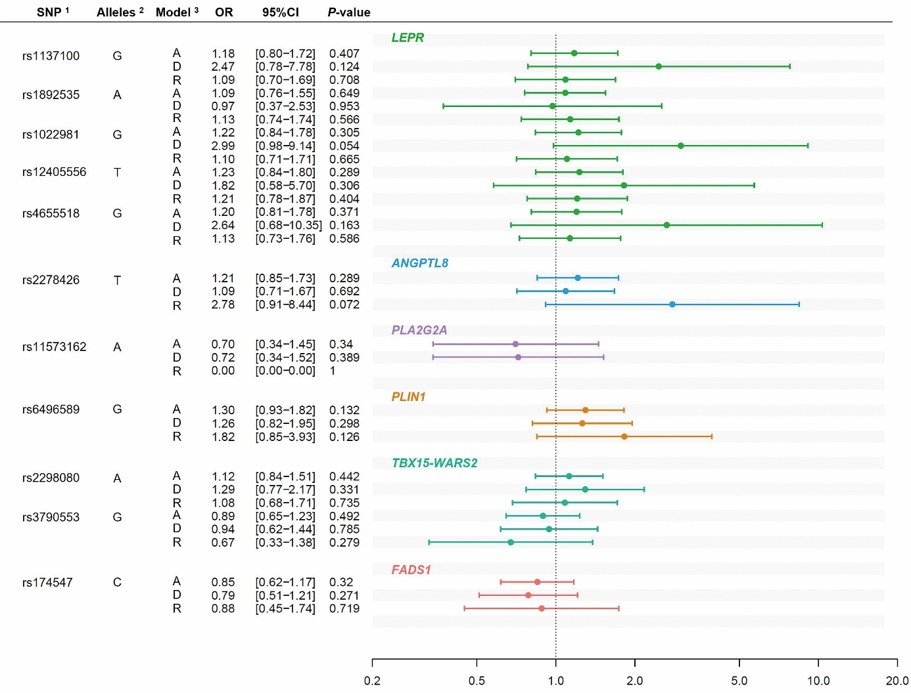
Figure 1

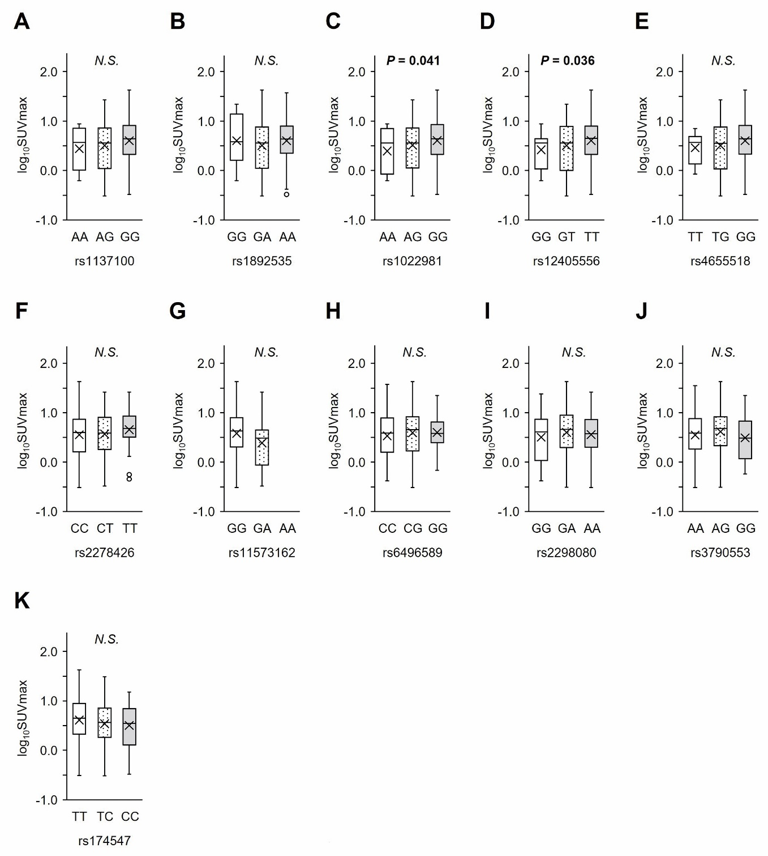
Figure 2
(A–E) SNPs of LEPR; (F) SNP of ANGPTL8; (G) SNP of PLA2G2A Note the absence of AA homozygotes in this population due to low minor allele frequency. (H) SNP of PLIN1; (I–J) SNPs of TBX15 and WARS2; and (K) SNP of FADS1.

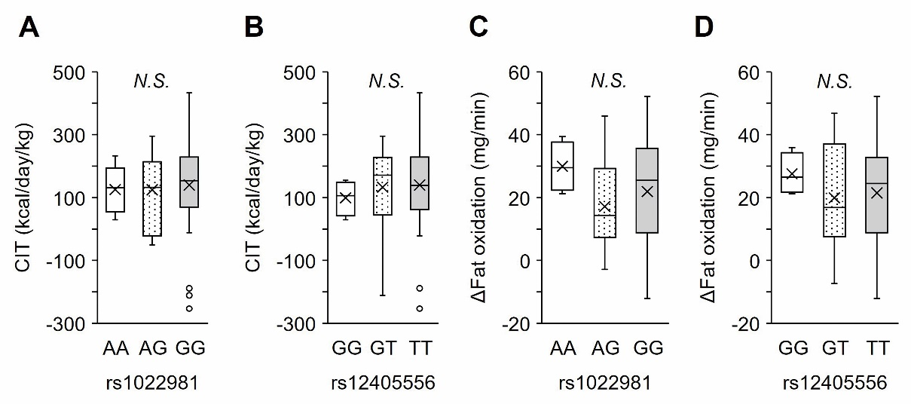
Figure 3
The box plots show the distribution of values for capacity for CIT (kcal/day/kg) (A, B) and ∆Fat oxidation (mg/min) (C, D) in the genotype groups. Associations are shown for rs1022981 (LEPR) (A, C) and rs12405556 (LEPR) (B, D).

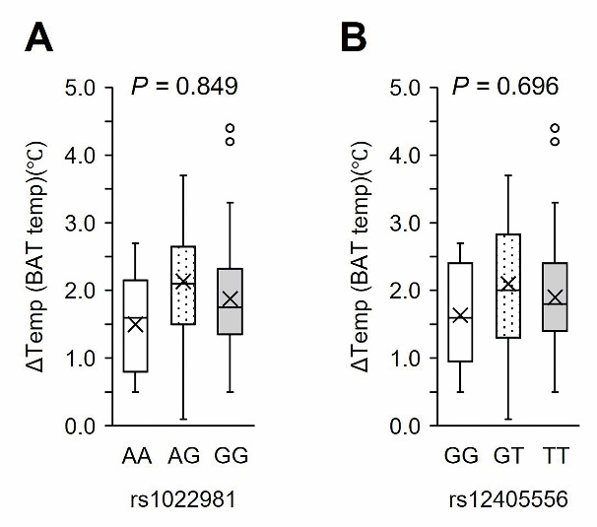
Figure 4
Results are shown for rs1022981 (A) and rs12405556 (B) (LEPR).

