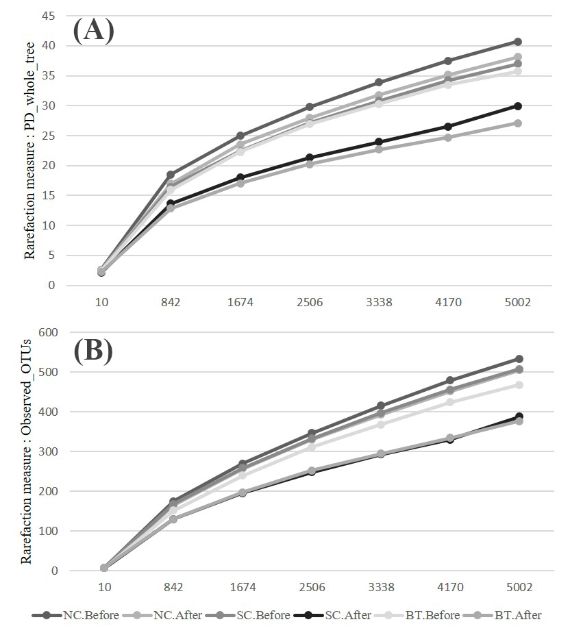
Fig. S1 Rarefaction curves measuring bacterial diversity among broiler communities. Alpha-diversity measured by (A) PD_whole_tree and (B) Observed OTUs before and after Salmonella infection in control (NC), Salmonella-challenged (SC), and Bacillus-treated (BT) groups.

