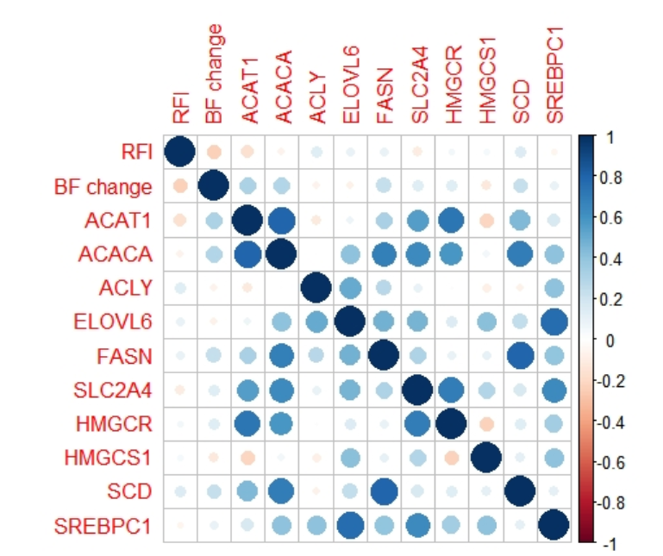
Correlogram highlighting the correlation between all adipose tissue candidate genes, Backfat measurements and RFI. Visual representation of the correlation matrix between RFI, Backfat change and all genes measured. Blue circles (correlation value 1) indicate a positive correlation while red (correlation value -1) indicate a negative correlation.

