Electronic Supplementay Material of Journal of Animal Science and Biotechnology
Differential expression, molecular cloning, and characterization of porcine beta defensin 114
Guoqi Su^{1, 2}, Kunhong Xie^{1, 2}, Daiwen Chen^{1, 2}, Bing Yu^{1, 2}, Zhiqing Huang^{1, 2}, Yuheng Luo^{1, 2}, Xiangbing Mao^{1, 2}, Ping Zheng^{1, 2}, Jie Yu^{1, 2}, Junqiu Luo^{1, 2}, Jun He^{1, 2}

¹Institute of Animal Nutrition, Sichuan Agricultural University, Chengdu, Sichuan 611130, People’s Republic of China
²Key Laboratory for Animal Disease-Resistance Nutrition of China Ministry of Education, Sichuan Agricultural University, Chengdu, Sichuan 625014, People’s Republic of China

SFig 1 Agarose gel electrophoresis of PBD114 cloning PCR
M, 2000 bp DNA marker; 1, clone PCR products of PBD114 from TP pigs; 2, clone PCR products of PBD114 from DLY pigs

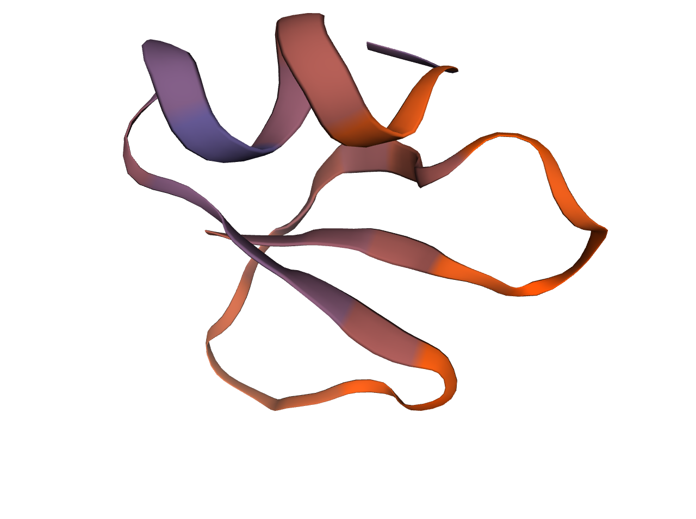
SFig 2 Predictive spatial structure of rPBD114.
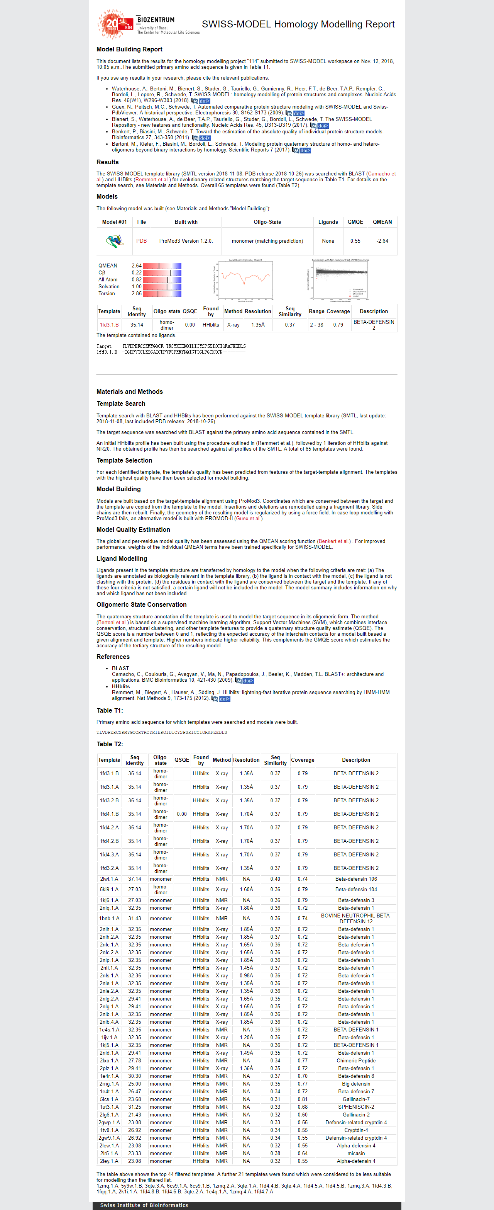
SFig 3 Workspace of rPBD114 analyzed on SWISS-MODEL.

Second structure of rPBD114 was predicted on SWISS-MODEL (https://swissmodel.expasy.org/). Briefly, the amino acids of rPBD114 were input, clicked “Build Model” and run.

Corresponding author: Institute of Animal Nutrition, Sichuan Agricultural University, Chengdu, Sichuan 611130, People’s Republic of China; Tel: 86-835-2885065; Fax: 86-835-2885065; E-mail: hejun8067@163.com

