A novel apidaecin Api-PR19 synergizes with the gut microbial community to maintain intestinal health and promote growth performance of broilers
Shengru Wu^{*，1}, Jian Wang*, Liqin Zhu*, Hao Ren*, Xiaojun Yang^{*, 1}
* College of Animal Science and Technology, Northwest A&F University, Yangling, Shaanxi, China

Running Head: Apidaecin and gut microbiota

¹ Corresponding author:
Shengru Wu, email: wushengru2013@163.com (S.R. Wu);
Xiaojun Yang, email: yangxj@nwsuaf.edu.cn (X. J. Yang); fax +86 29 87092164; Tel.: +86 13319284469.
Email addresses of other authors:
Shengru Wu: wushengru2013@163.com, Jian Wang: poultrywang@nwafu.edu.cn, Liqin Zhu: 954208918@qq.com, Hao Ren: 18729502782@163.com.
Supplementary information
Figure S1 The differential bacteria among CON, AGP, and ABP identified using the linear discriminant analysis and effect size (LEfSe) analysis. Note: CON indicates control group; ABP indicates Api-PR19 group; AGP indicates enramycin (antibiotic) group. The differential microbiota at each level (including phylum, class, family, genus and species) were analyzed and the first letter before the bacteria represents the level of the identified bacteria: p: phylum, c: class, f: family, g: genus, s: species.
Table S1 Physical and chemical parameters of apidaecin-HbIb, apidaecin-Hb1C-20, and api-PR19.
Table S2 Composition and nutrient level of the basal diet (air-dry basis).
Table S3 Broiler immunization program used in the present study.
Table S4 Primers used in the relative real-time quantitative PCR for gene expression in broilers.
Table S5 Primers used in the absolute real-time quantitative PCR for caecal bacteria in broilers.
Table S6 The effect of Api-PR19 on villus height, crypt depth and villus height/crypt depth ratio in the duodenum, jejunum, and ileum of broiler chickens.

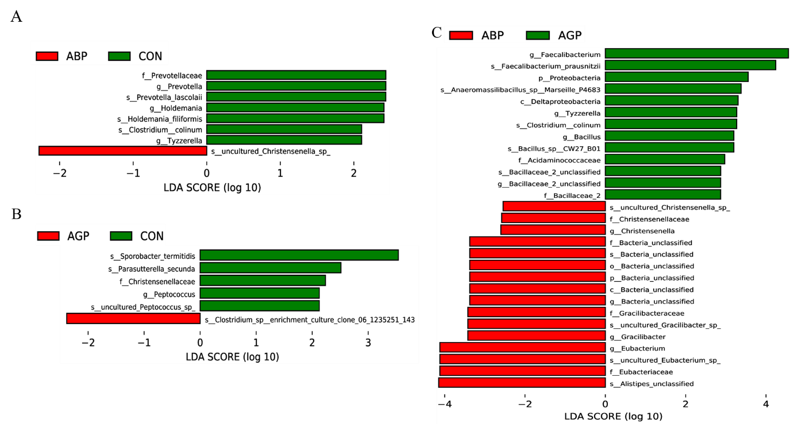
Figure S1 The differential bacteria among CON, AGP, and ABP identified using the linear discriminant analysis (LDA) and effect size (LEfSe) analysis.

Table S1 Physical and chemical parameters of apidaecin-HbIb, apidaecin-Hb1C-20, and api-PR19.
Item | Apidaecin
Item | Apidaecin-HbIb | Apidaecin-Hb1C-20 | Api-PR19
Amino acid composition | GNNRPVYIPQPRPPHPRL | PRVRRPVYIPQPRPPHPRL | PRVRRPVYIPQPRPPHPRL
Isoelectric point | 11.71 | 12.18 | 12.18
Charge number (+) | 4 | 5 | 5
Total hydrophilic index | -1.444 | -1.300 | -1.316
Coefficient of fat | 59.44 | 75.56 | 71.58
Beaumont index, kcal/mol | 2.97 | 3.72 | 3.52
Antibacterial activity score | 1.174 | 0.692 | 0.802

Table S2 Composition and nutrient level of the basal diet (air-dry basis).
Ingredients, % | 1 to 3 weeks | 4 to 6 weeks |  | Nutrient levels² | 1 to 3 weeks |  | 4 to 6 weeks
Corn | 53.61 | 59.80 |  | ME, MJ/kg | 12.24 |  | 12.87
Soybean meal | 22.82 | 15.52 |  | CP, % | 21.20 |  | 19.30
DDGS | 5.00 | 6.00 |  | EE, % | 2.61 |  | 6.39
Flour | 2.00 | 2.50 |  | Ca, % | 0.85 |  | 0.85
Corn gluten meal | 4.00 | 4.00 |  | Total P, % | 0.68 |  | 0.62
Lard | 2.30 | 3.20 |  | Available P, % | 0.43 |  | 0.35
Corn germ meal | 3.00 | — |  | Lys, % | 1.29 |  | 1.27
Peanut meal | 2.50 | 4.00 |  | Met, % | 0.60 |  | 0.65
CaHCO₃ | 1.76 | 1.30
Ca power | 0.90 | 1.21
L-Lysine sulphate | 0.75 | 1.01
Salt | 0.25 | 0.25
DL-Met | 0.28 | 0.36
Thr | 0.15 | 0.26
Limestone | 0.20 | 0.20
Choline chloride | 0.08 | 0.10
Premix | 0.19 | 0.19
Tryptophan | 0.01 | —
Sodium bicarbonate | 0.20 | 0.10
Total | 100.00 | 100.00

Table S3 Broiler immunization program used in the present study.
Age | Type of vaccine | Method
1 d | Chicken marek's disease vaccine | Cervical subcutaneous injection
3 d, extra vaccine for immunization | Avian influenza (H5N1 Re-5+H9N2 Re-2 bivalent inactivated vaccine) | Intramuscular injection
7 d | New city disease + infectious bronchitis | Eye droppings, nasal inhalation
14 d | Chicken marek's disease vaccine | Drinking water
21 d | New city disease + avian influenza | Intramuscular injection

Table S4 Primers used in the relative real-time quantitative PCR for gene expression in broilers.
Gene | Sequence of Primers from 5’ to 3’
β-actin | F: ACTCCTACGGGAGGCAGCAGT  R: ATTACCGCGGCTGCTGGC
SGLT1 | F: AGCATTTCAGCATGGTGTGTCTTC  R: GATGCTCCTATCTCAGGGCAGTTC
GLUT2 | F: CACACTATGGGCGCATGCT  R: ATTGTCCCTGGAGGTGTTGGTG
rBAT | F: CCCGCCGTTCAACAAGAG  R: AATTAAATCCATCGACTCCTTTGC
y⁺LAT2 | F: GCCCTGTCAGTAAATCAGACAAGA  R: TTCAGTTGCATTGTGTTTTGGTT
CAT1 | F: CAAGAGGAAAACTCCAGTAATTGCA  R: AAGTCGAAGAGGAAGGCCATAA

Table S5 Primers used in the absolute real-time quantitative PCR for caecal bacteria in broilers.
Item | Size, bp | Primers Sequence from 5’ to 3’
Total bcateria | 172 | F: ACTCCTACGGGAGGCAGCAGT  R: ATTACCGCGGCTGCTGGC
Escherichia coil | 96 | F: CATGCCGCGTGTATGAAGAA  R: CGGGTAACGTCAATGAGCAAA
Bifidobacterium bifidum | 290 | F: GGAAGAACACCGATGGCGAAG  R: ATGTCAAGCCCAGGTAAGG
Salmonella gallinarum | 236 | F: GGGTGAGTAATGTCTGGGAAAC  R: CGTAGGAGTCTGGACCGTGT
Campylobacter jejuni | 251 | F: AGACACGGTCCAGACTCCTA  R: GACTTGATAATCCGCCTACG

Table S6 The effect of Api-PR19 on villus height, crypt depth and villus height/crypt depth ratio in the duodenum, jejunum, and ileum of broiler chickens.
Intestine | Age |  | Item | CON | AGP | Api-PR19, mg/kg |  |  | SEM | P-value
 |  |  |  |  |  | 100 | 200 | 300 | SEM | P-value
Duodenum | 21 d | villus height, μm |  | 1715.41 | 1683.06 | 1864.59 | 1909.45 | 2010.36 | 59.37 | 0.398
Duodenum | 21 d | crypt depth, μm |  | 146.16 | 142.41 | 127.47 | 112.55 | 123.38 | 6.11 | 0.414
Duodenum | 21 d | villus height/crypt depth |  | 11.81 | 12.44 | 15.18 | 18.04 | 17.68 | 1.01 | 0.160
Duodenum | 42 d | villus height, μm |  | 1560.16^{b} | 1549.5^{b} | 1868.29^{ab} | 1929.30ª | 1709.98^{ab} | 47.08 | 0.013
Duodenum | 42 d | crypt depth, μm |  | 240.24 | 142.35 | 140.10 | 148.99 | 138.70 | 13.80 | 0.072
Duodenum | 42 d | villus height/crypt depth |  | 7.87^{b} | 10.87^{ab} | 13.37^{ab} | 13.97ª | 13.25^{ab} | 0.76 | 0.050
Jejunum | 21 d | villus height, μm |  | 1227.66^{ab} | 944.83^{b} | 1297.13^{ab} | 1597.23ª | 1636.92ª | 68.37 | 0.002
Jejunum | 21 d | crypt depth, μm |  | 143.67 | 123.07 | 127.21 | 130.31 | 134.83 | 4.00 | 0.571
Jejunum | 21 d | villus height/crypt depth |  | 8.59^{bc} | 7.70^{c} | 10.23^{ab} | 12.25ª | 12.14ª | 0.47 | 0.002
Jejunum | 42 d | villus height, μm |  | 1627.17 | 1673.86 | 1570.89 | 1669.34 | 1776.98 | 38.54 | 0.577
Jejunum | 42 d | crypt depth, μm |  | 119.45 | 120.87 | 129.16 | 122.08 | 103.75 | 4.31 | 0.467
Jejunum | 42 d | villus height/crypt depth |  | 13.90 | 14.13 | 12.60 | 14.01 | 17.74 | 0.67 | 0.148
Ileum | 21 d | villus height, μm |  | 1274.82 | 1104.87 | 1098.65 | 1181.91 | 1394.98 | 53.00 | 0.366
Ileum | 21 d | crypt depth, μm |  | 136.60 | 144.41 | 144.04 | 136.52 | 132.68 | 3.86 | 0.185
Ileum | 21 d | villus height/crypt depth |  | 9.36 | 7.99 | 7.69 | 8.89 | 10.53 | 0.46 | 0.864
Ileum | 42 d | villus height, μm |  | 691.62 | 789.05 | 772.24 | 874.12 | 749.47 | 35.62 | 0.630
Ileum | 42 d | crypt depth, μm |  | 125.07 | 120.92 | 116.66 | 135.24 | 114.39 | 4.95 | 0.854
Ileum | 42 d | villus height/crypt depth |  | 5.96 | 6.57 | 6.67 | 6.63 | 6.75 | 0.36 | 0.968

