Intrauterine growth restriction alters growth performance, plasma hormones, and small intestinal microbiota communities in growing-finishing pigs
Liang Xiong^{1,2}, Jinming You², Wanghong Zhang¹, Qian Zhu¹, Francois Blachier³, Yulong Yin¹, Xiangfeng Kong¹
¹ CAS Key Laboratory of Agro-ecological Processes in Subtropical Regions, Hunan Provincial Key Laboratory of Animal Nutritional Physiology and Metabolic Process, National Engineering Laboratory for Pollution Control and Waste Utilization in Livestock and Poultry Production, Institute of Subtropical Agriculture, Chinese Academy of Sciences, Changsha, Hunan 410125, China
² Key Laboratory of Animal Nutrition in Jiangxi Province, College of Animal Science and Technology, Jiangxi Agricultural University, Nanchang, Jiangxi 440000, China
³ Université Paris-Saclay, AgroParisTech, INRAE, UMR PNCA, 75005, Paris, France
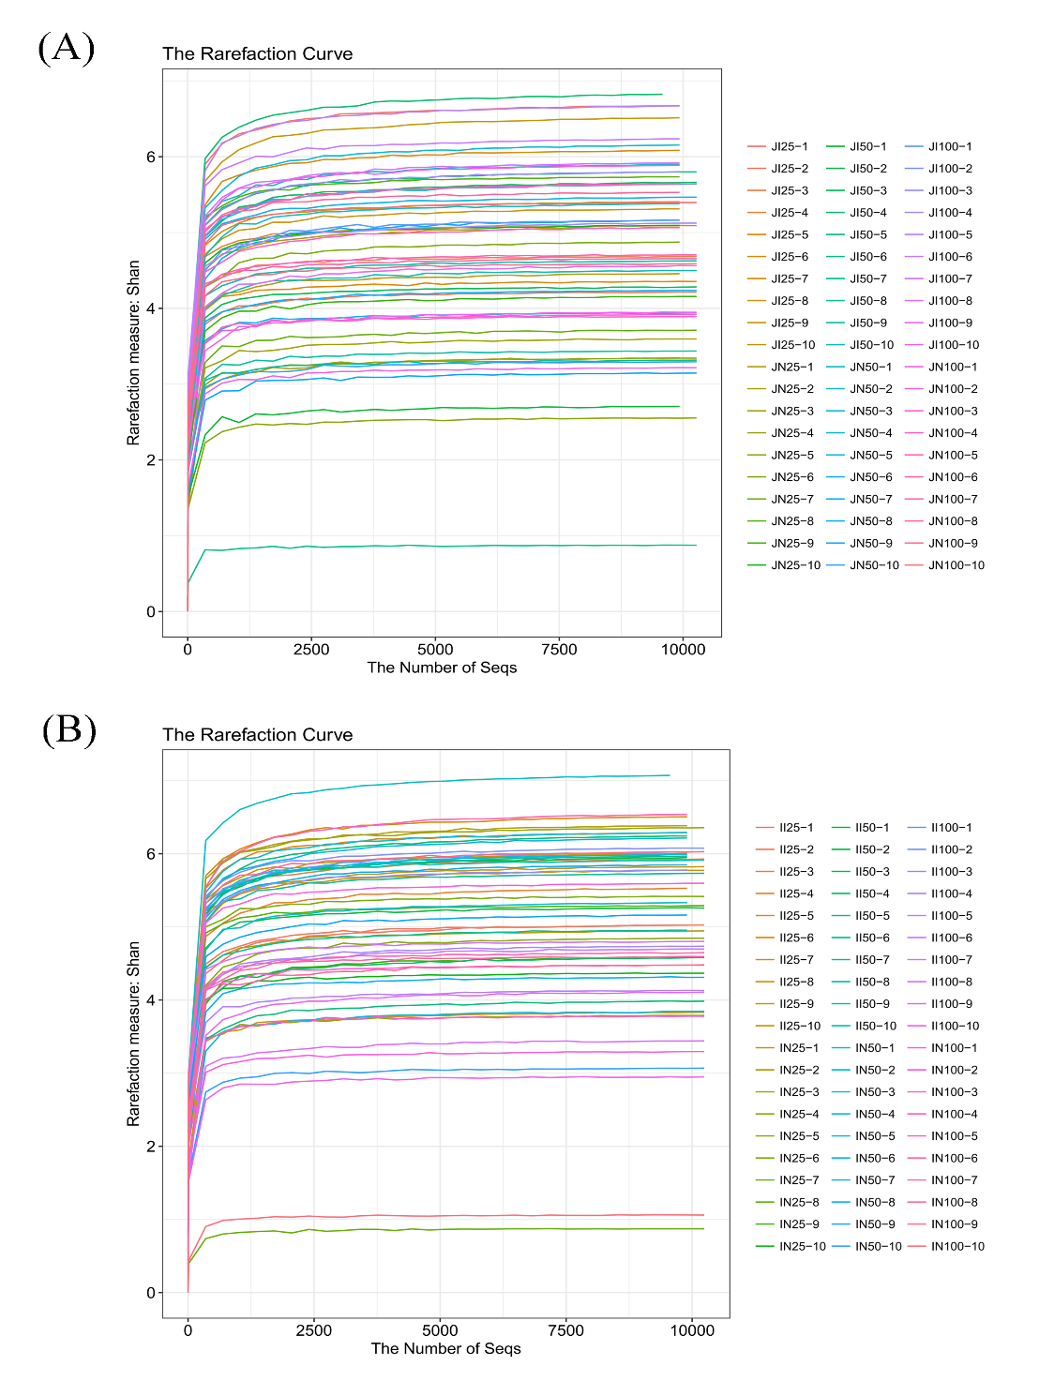
Supplementary Figure 1 Differences in microbial community structures in the jejunum (A) and ileum (B) between intrauterine growth retardation (IUGR) pigs and normal birth weight (NBW) pigs throughout the trial. The data presented are obtained from 10 animals in each group (n=10). Rarefaction curve analysis was used to evaluate whether further sequencing would likely detect additional taxa. JI and JN represent samples obtained from the jejunum of IUGR pigs and NBW pigs, respectively; II and IN represent samples obtained from the ileum of IUGR pigs and NBW pigs, respectively. 25, 50, and 100 represent 25, 50, and 100 kg BW groups.

Corresponding author: Professor Xiangfeng Kong, E-mail: nnkxf@isa.ac.cn

