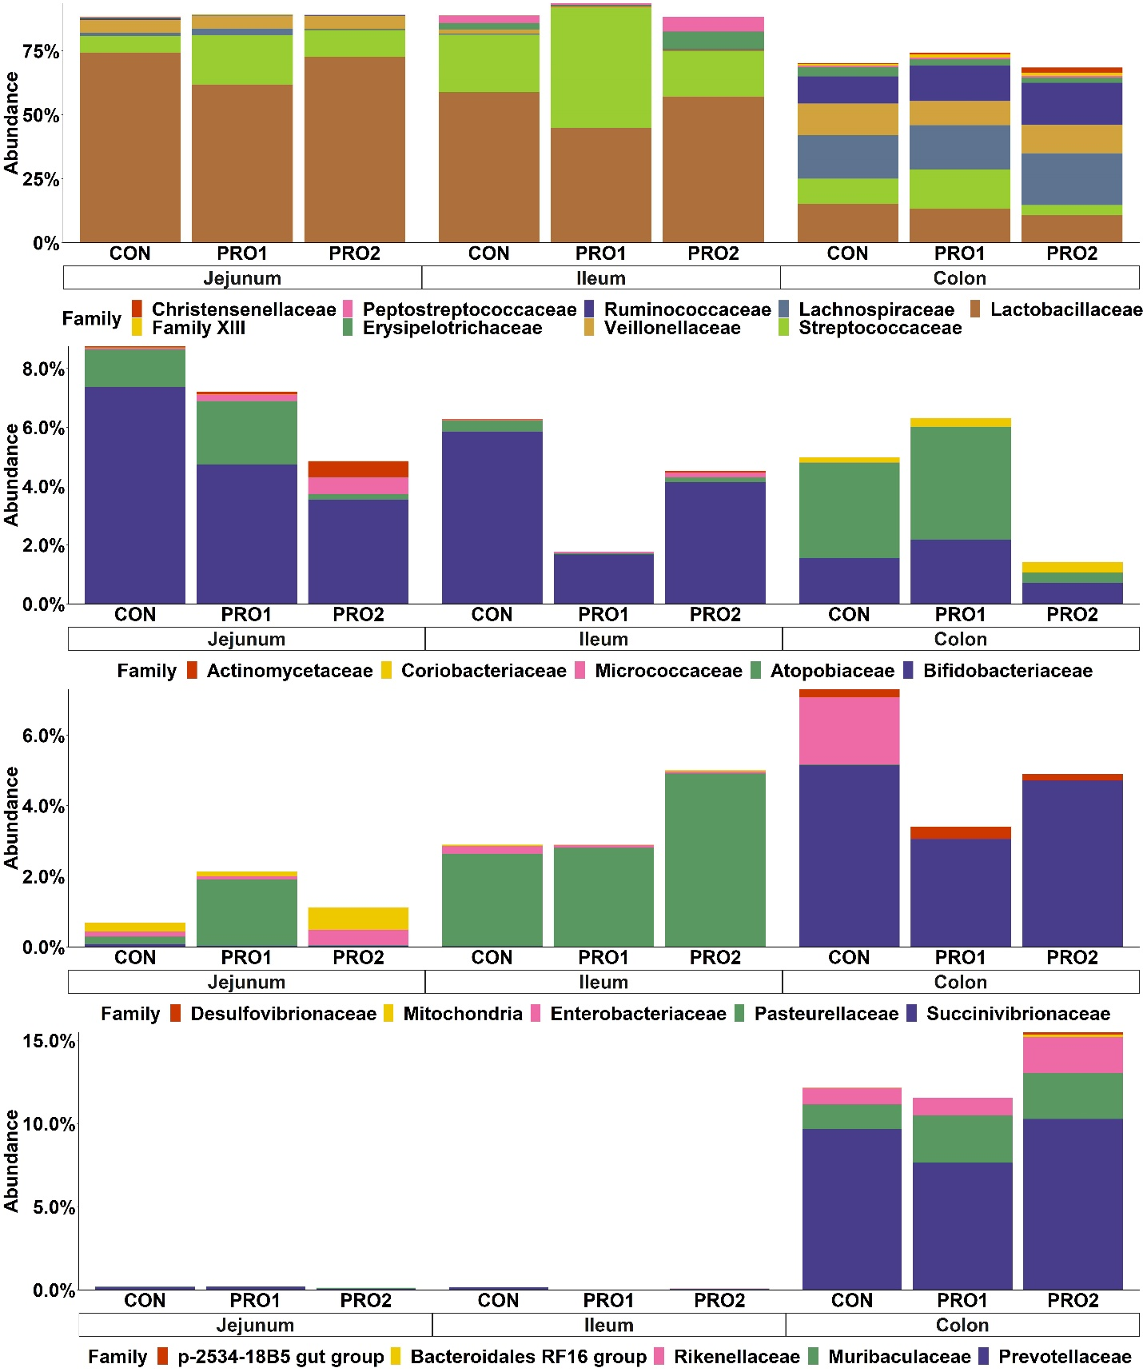
Supplementary Figure 1. Stacked bar plot showing the relative abundance of the family of Firmicutes (A), Actinobacteria (B), Proteobacteria (C), and Bacteroidetes (D) in the jejunum, ileum, and distal colon of enterotoxigenic E. coli F18 challenged pigs fed diets supplemented with probiotics on d 21 post inoculation. Each least squares mean represents 7-10 observations. PRO1 = Bacillus subtilis DSM 32540; PRO2 = Bacillus pumilus DSM 32539.
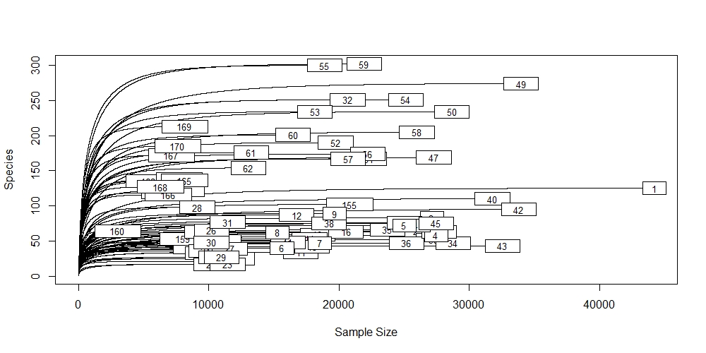
Supplementary Figure 2. The rarefaction curves of 16S rRNA sequence data.

