Figure S1. Electrophoresis of PCR products of Juno gene

Figure S2. Clone and RACE results of Juno and Izumo1 genes of Small Tail Han sheep. (A) Juno gene partial CDS Clone of Small Tail Han sheep. (B) Juno gene 3' RACE results of Small Tail Han sheep. (C) Juno gene 5' RACE results of Small Tail Han sheep. (D) Izumo1 gene partial CDS Clone of Small Tail Han sheep. (E) Izumo1 gene 3 'RACE results of Small Tail Han sheep. (F) Izumo1 gene 5' RACE results of Small Tail Han sheep. Note: M: DL2000 DNA Marker.

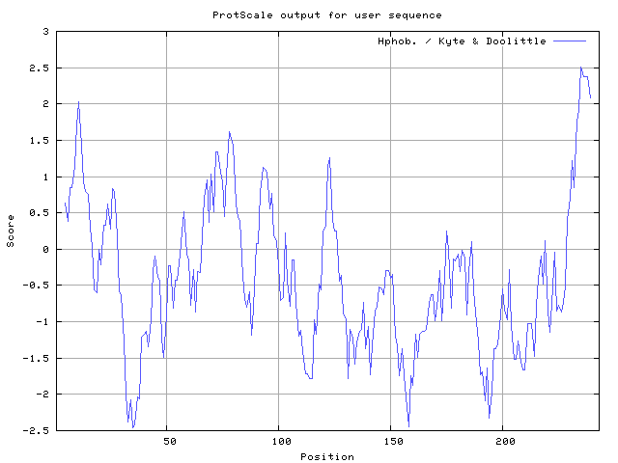
A
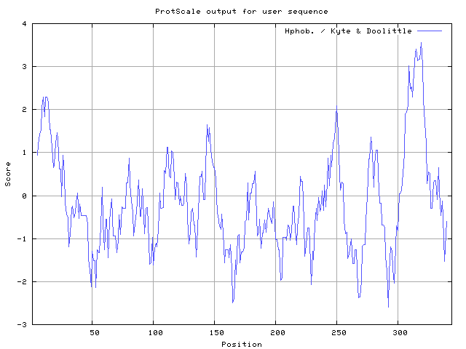
B

Figure S3. The hydrophobic prediction in Small Tail Han sheep JUNO and IZUMO1 proteins.
Table S1. Primers used for amplifying DNA of the Juno gene in sheep
Primer name | Usage | Primer sequence (5′ to 3′) | Product size, bp | Annealing temperature, ℃
JP1 | Primer 1 for DNA segment amplification of Juno gene | F：TGTGGAGTGAGGGGTTCTGC | 1074 | 66
JP1 | Primer 1 for DNA segment amplification of Juno gene | R：CAGCAGGCGTTGTCCTTCCA | 1074 | 66
JP2 | Primer 2 for DNA segment amplification of Juno gene | F：ACACCGGCCTATCCCACTTGCA | 1153 | 66
JP2 | Primer 2 for DNA segment amplification of Juno gene | R：AACCACTTCTGCAGACACCGCC | 1153 | 66
JP3 | Primer 3 for DNA segment amplification of Juno gene | F：TTGTGTGAGCGGATCTGGAGC | 1500 | 66
JP3 | Primer 3 for DNA segment amplification of Juno gene | R：TAGTTCATGCCTTGGGGATCTGG | 1500 | 66
Note: F means forward primer, R means reverse primer.

Table S2. Primers used for amplifying cDNA and real-time PCR of the Juno and Izumo1 genes in sheep
Primer Name | Primer sequence (5' to 3' ) | Length, bp | Annealing temperature, ℃
Juno-CDS | F：GAATGCCAAGCCCCACAAG | 484 | 62
Juno-CDS | R：GATCCGCTCACACAAGTTGG | 484 | 62
Juno-RT | F：CACTGCGGACTAATGATGCC | 227 | 60
Juno-RT | R：CAGTTGGACTTGCAGGTGTG | 227 | 60
UPM | CTAATACGACTCACTATAGGGCAAGCAGTGGTATCAACGCAGAGT |  | 68
Juno-3' GSP | CTACTTCCCCACGCCCGCCAACTTGT |  | 68
Juno-5' GSP | GCCGCTCCAGATCCGCTCACACAAGT |  | 68
β-actin | F：CCAACCGTGAGAAGATGACC | 97 | 60
β-actin | R：CCCGAGGCGTACAGGGACAG | 97 | 60
Izumo1-CDS | F：GGGTTCTACGACTCCGCTTC | 895 | 58-62
Izumo1-CDS | R：GGTTACTTTCAGGCCCATCAT | 895 | 58-62
Izumo1-RT | F：ATGCAGGTACCTATCGCTGC | 84 | 60
Izumo1-RT | R：TGGGCAATACTGTGACGTGA | 84 | 60
Izumo1-3' GSP | TGCTGAGAAGACGCCTGTTCCGAGTGC |  | 68
Izumo1-5' GSP | TGATGGACCTTGACTTCGCGCTCTCC |  | 68

Table S3. SNP loci screening
SNP | Variant type
g.844598A>G | 5' UTR | A/G transition
g.846206C>T | synonymous SNV | T/C transition
g.846268A>G | nonsynonymous SNV | A/G transition
g.847219G>C | nonsynonymous SNV | G/C transversion
g.847810C>G | nonsynonymous SNV | G/C transversion
g.847814C>T | nonsynonymous SNV | T/C transition
g.847830T>C | synonymous SNV | T/C transition
g.847927A>C | synonymous SNV | C/A transversion
g.848253C>A | nonsynonymous SNV | C/A transversion

