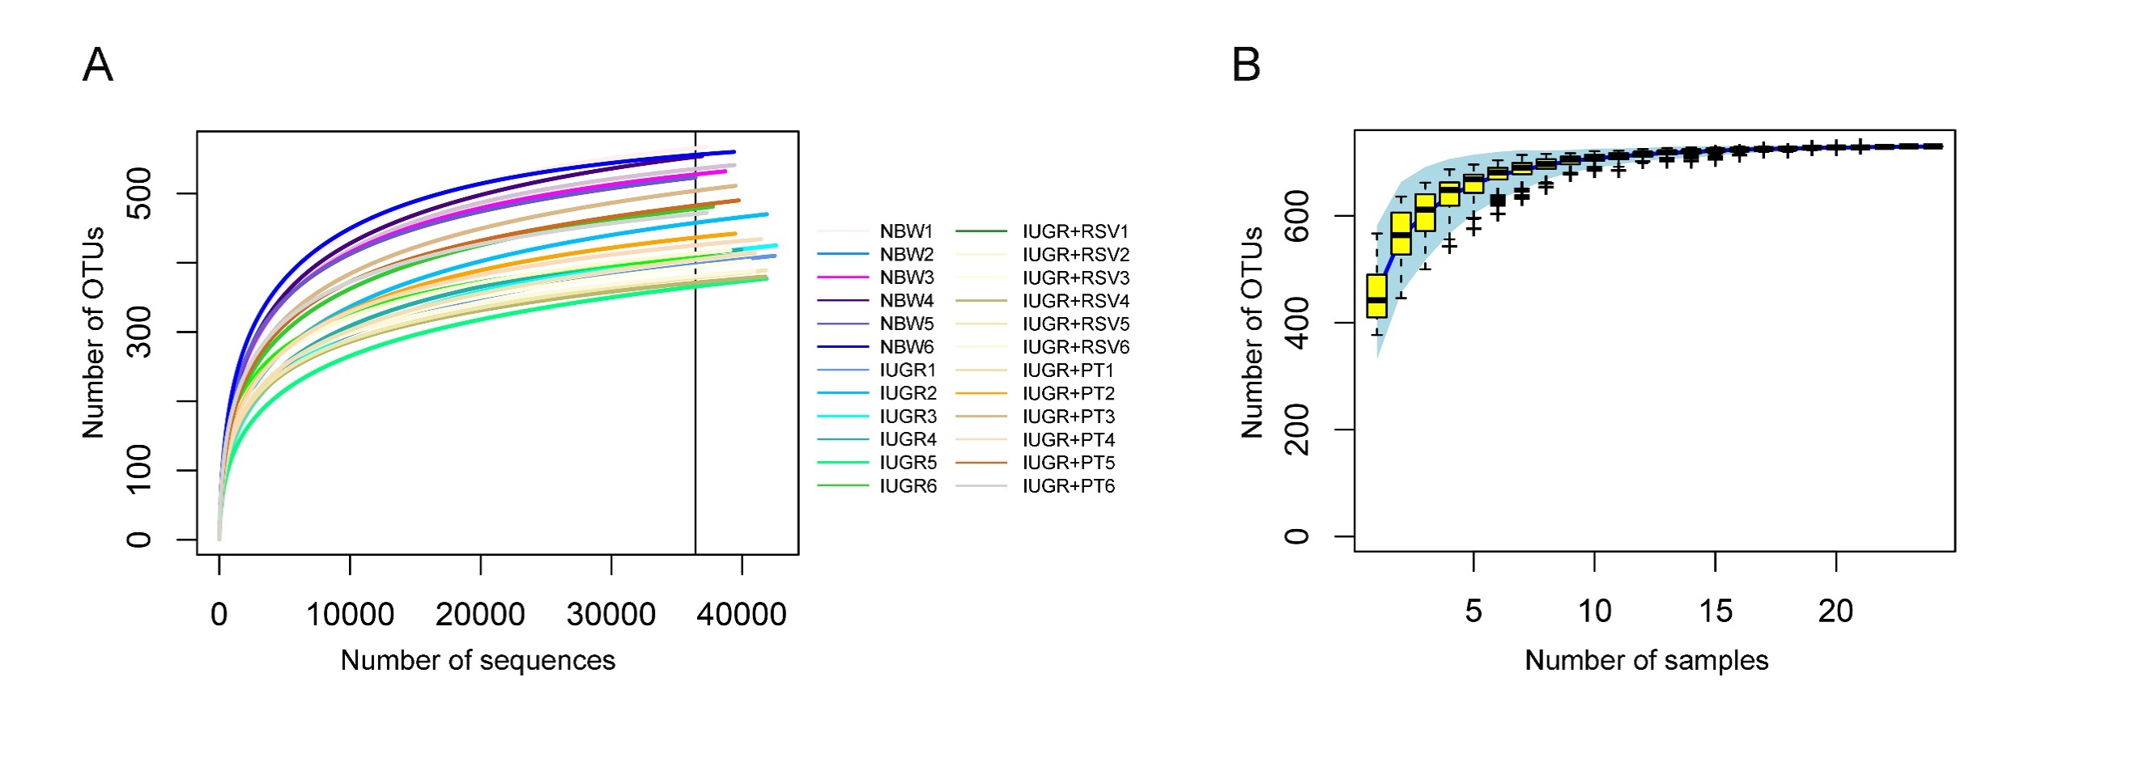
Figure S1. Rarefaction curve (A) and species accumulation curve (B) of the cecal microbiota based on operational taxonomic units (OTUs).

