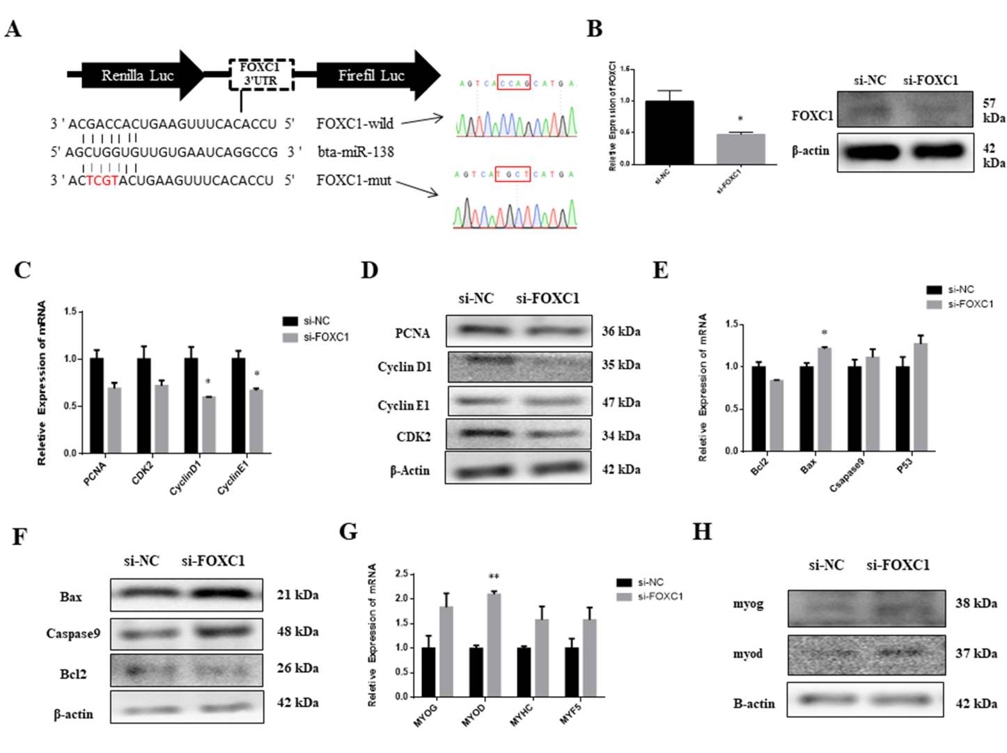
Fig S3. Effect of FOXC1 knockdown on proliferation，apoptosis and differentiation of myoblasts. (A) The illustration shows the construct of FOXC1 3´ UTR containing wild-type miR-138 binding sites or mutated sites. (B) The interference efficiency of the siRNAs to FOXC1 was detected by qRT-PCR and western blot. (C and D) The mRNA and protein level of proliferative marker genes was detected by qRT-PCR and western blot after transfection with si-FOXC1. (E and F) The expression of apoptotic marker genes was detected by real-time qPCR and western blots after transfection with si-FOXC1. (G and H) The mRNA and protein level of differentiated marker genes was detected by qRT-PCR and western blot after transfection with si-FOXC1. Values are means ± SEM for three individuals. P < 0.05, P < 0.01.

