Supplementary material

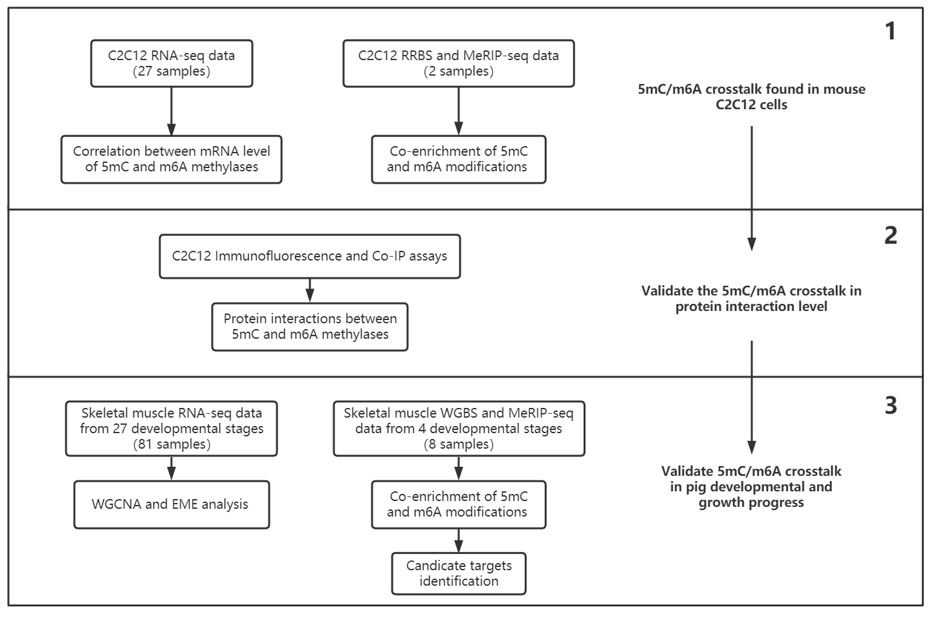
Fig. S1 The whole design of this study

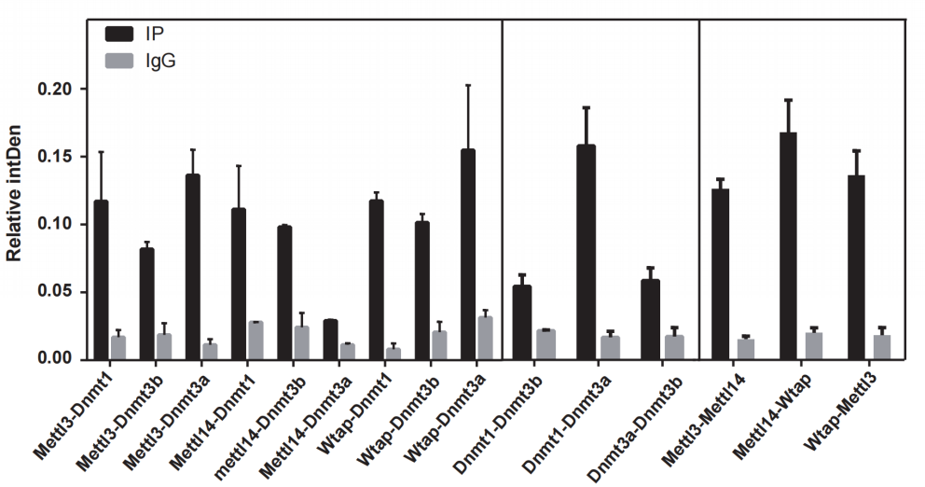
Fig. S2 Relative interaction intensities between the 5mC and m6A writer protein pairs based on the western blot images from co-IP assays
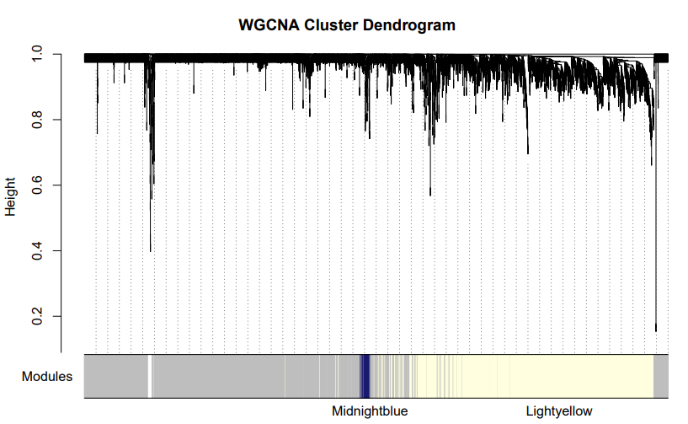
Fig. S3 Identification of WGCNA co-expression modules based on the top 25% expressing variant genes from the 27 prenatal and postnatal skeletal muscle development stages
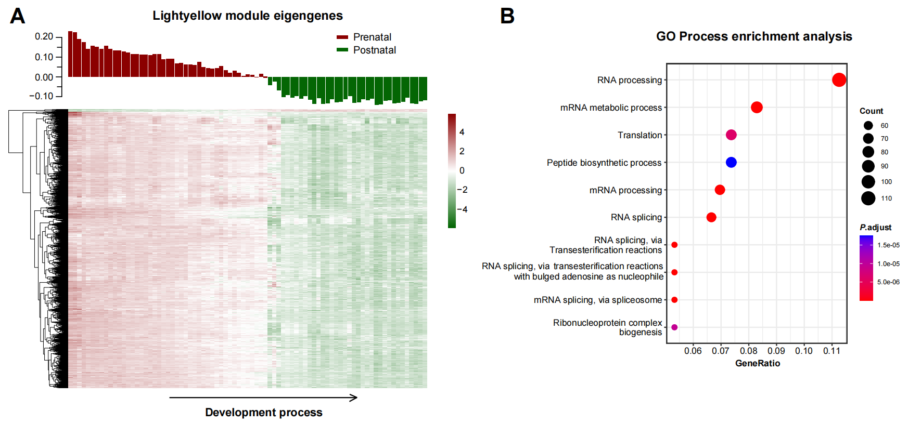
Fig. S4 Potential regulation role of 5mC/m⁶A EMEs on prenatal myogenesis of pigs. (A) EME positive correlated Lightyellow module and its gene expression heatmap. (B) GO process enrichment analysis of Midnightblue module genes
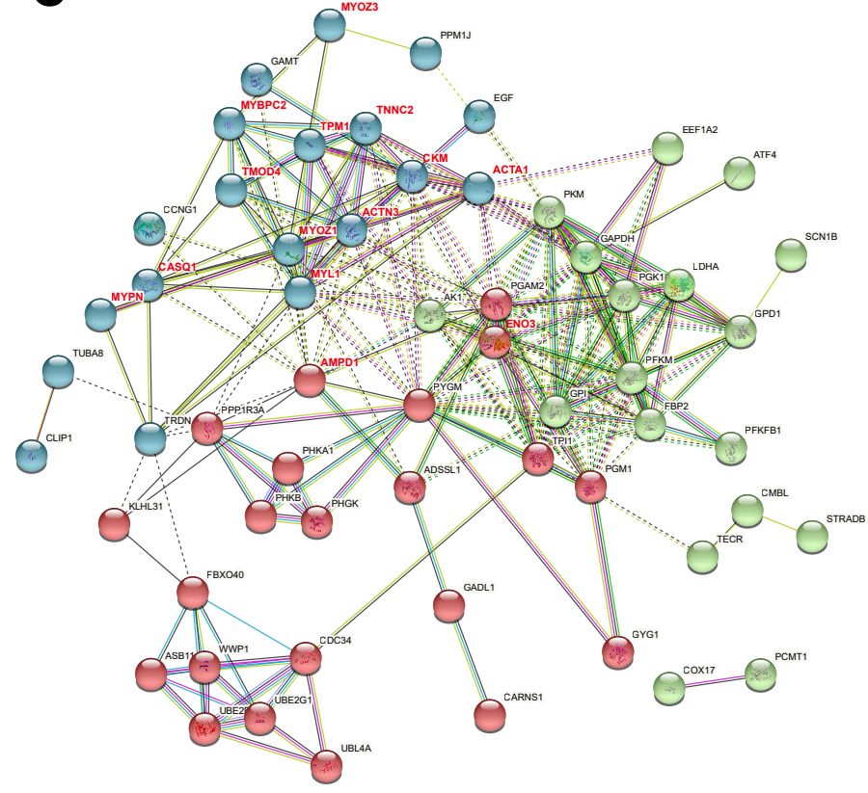
Fig. S5 Protein-Protein Interaction network among the Midnightblue module genes
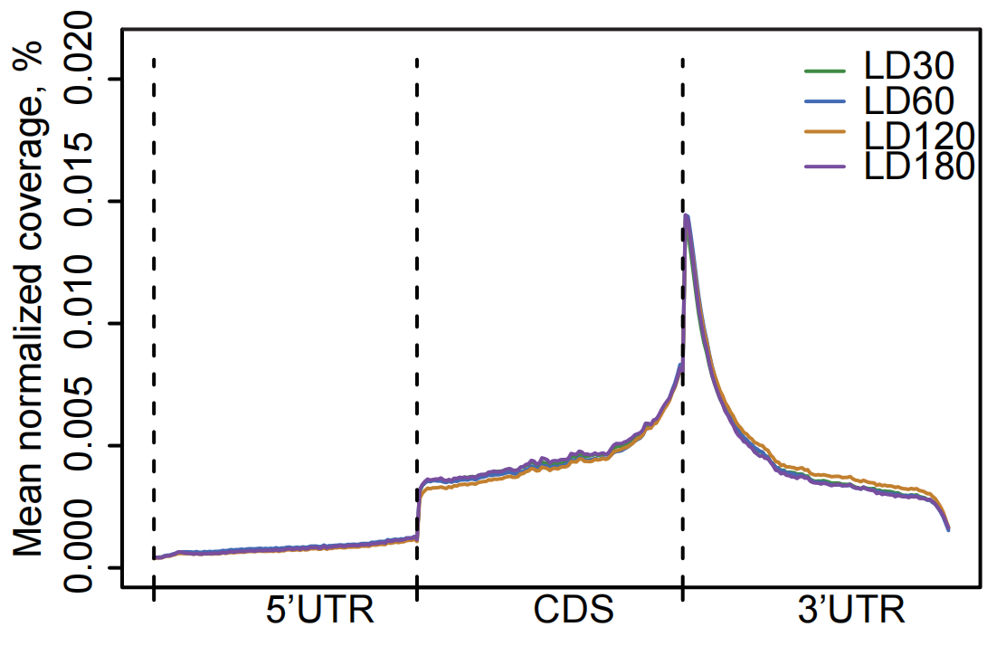
Fig. S6 Distribution of m⁶A peaks across the whole transcript
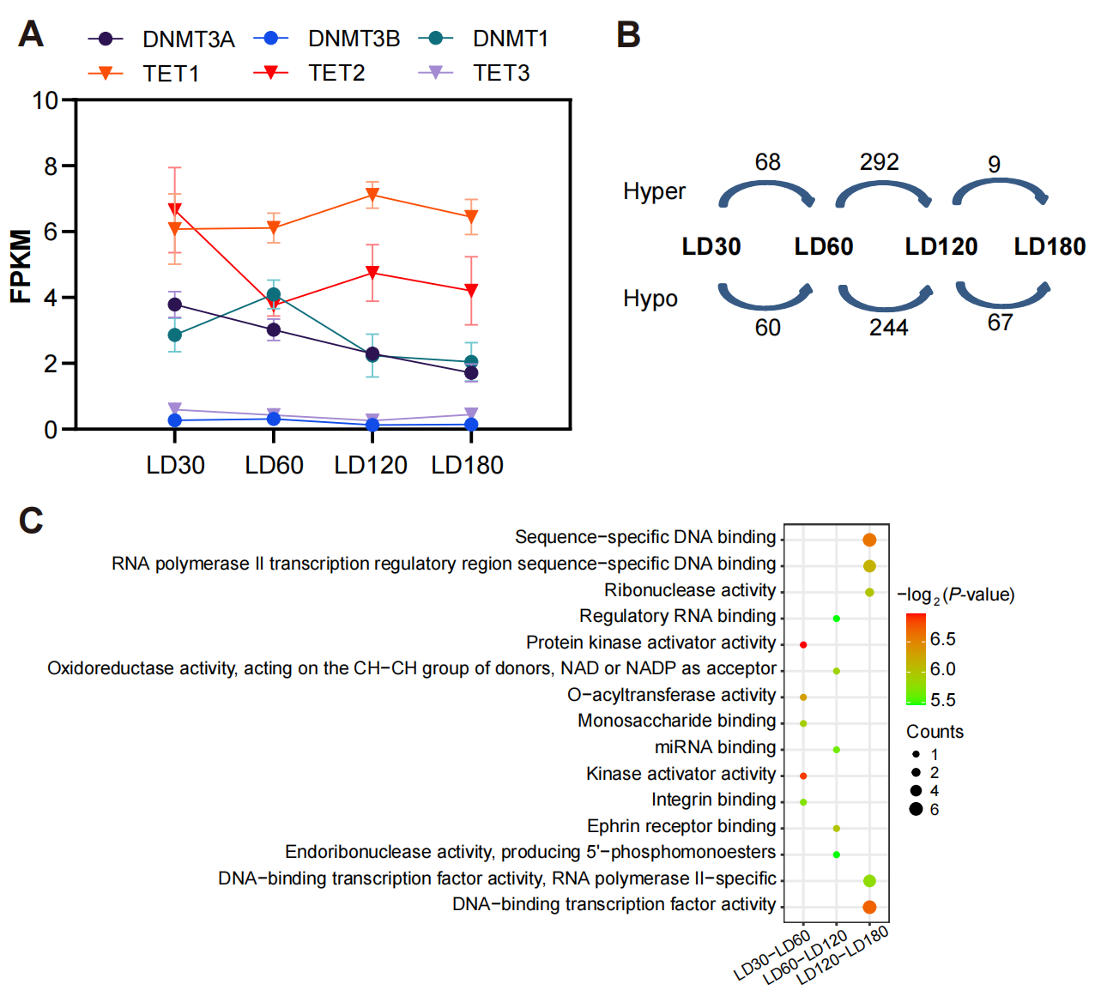
Fig. S7 Dynamics of the DNA methylation during postnatal skeletal muscle development. (A) mRNA expression profiles of 5mC writers (DNMT1/DNMT3A/DNMT3B) and erasers (TET1/TET2/TET3). (B) Numbers of 5mC hypermethylated or hypomethylated genes from inter-stage comparisons (C) Top 5 GO terms enriched by the inter-stage differentially 5mC modification genes

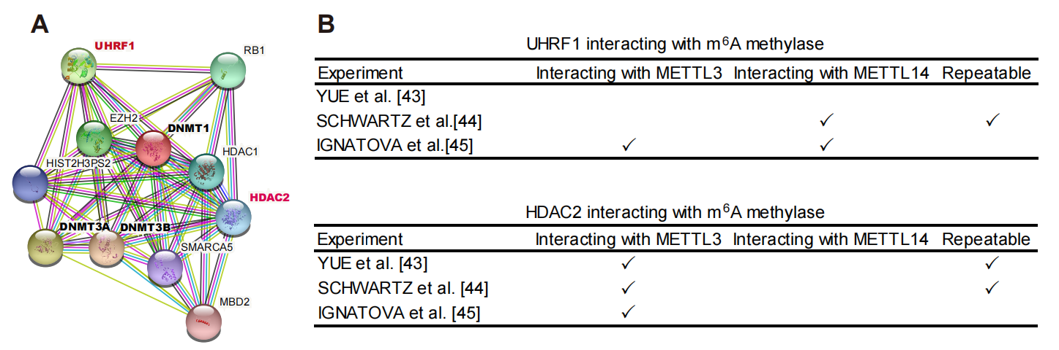
Fig. S8 Possible indirect interactions between 5mC writers and m⁶A writers. (A) Protein-protein interaction network shows the proteins interacted with 5mC writers (DNMT1/3A/3B) in human beings. (B) Experiment evidence found in the published documents indicated the linker protein (UHRF1 and HDAC1) could interact with the m⁶A methyltransferase complex (MTC) proteins

