The raw western blot images are shown below:
Fig. 2 Isorhamnetin inhibited ZEA-caused apoptosis
- Protein is Bcl-2. The different treatments from left to right are Control, ZEA, ZEA+5 μmol/L ISO, ZEA+10 μmol/L ISO and ZEA+20 μmol/L ISO, respectively.
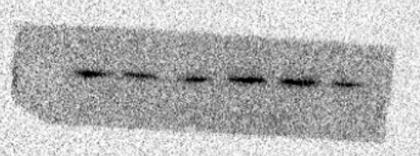
- Protein is Bax. The different treatments from left to right are Control, ZEA, ZEA+5 μmol/L ISO, ZEA+10 μmol/L ISO and ZEA+20 μmol/L ISO, respectively.
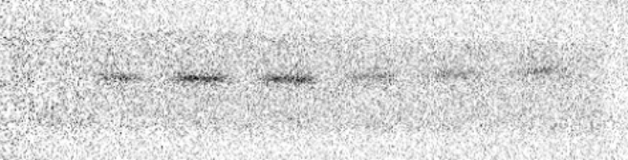
- Protein is C-Casp3. The different treatments from left to right are Control, ZEA, ZEA+5 μmol/L ISO, ZEA+10 μmol/L ISO and ZEA+20 μmol/L ISO, respectively.
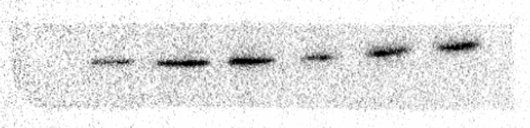
- Protein is GAPDH. The different treatments from left to right are Control, ZEA, ZEA+5 μmol/L ISO, ZEA+10 μmol/L ISO and ZEA+20 μmol/L ISO, respectively.
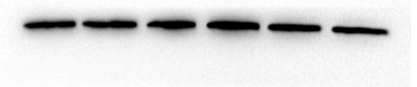
Fig. 3 Isorhamnetin relieved oxidative stress caused by ZEA
1. Protein is SOD2. The different treatments from left to right are Control, ZEA and ZEA+ISO, respectively.
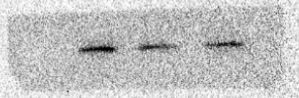
2. Protein is GAPDH. The different treatments from left to right are Control, ZEA and ZEA+ISO, respectively.
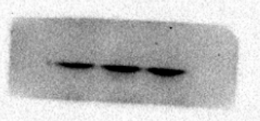
Fig. 6 Isorhamnetin suppressed ZEA-induced ER stress in porcine oocytes
1. Protein is CHOP. The different treatments from left to right are Control, ZEA and ZEA+ISO, respectively.
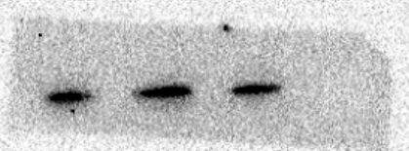
2. Protein is GRP78. The different treatments from left to right are Control, ZEA and ZEA+ISO, respectively.
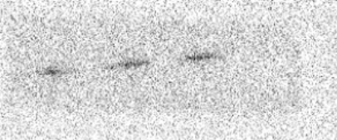
3. Protein is GAPDH. The different treatments from left to right are Control, ZEA and ZEA+ISO, respectively.
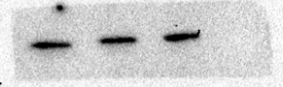
Fig. 7 Isorhamnetin activated PI3K/Akt pathway in response to ZEA-induced meiosis arrest
1. Protein is PI3K. The different treatments from left to right are Control, ZEA and ZEA+ISO, respectively.
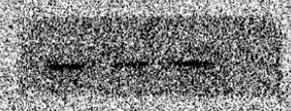
2. Protein is P-Akt. The different treatments from left to right are Control, ZEA and ZEA+ISO, respectively.
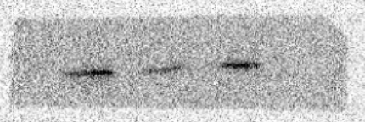
3. Protein is Akt. The different treatments from left to right are Control, ZEA and ZEA+ISO, respectively.
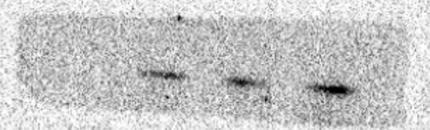
4. Protein is GAPDH. The different treatments from left to right are Control, ZEA, ZEA+ISO and ZEA+ISO+LY294002, respectively.
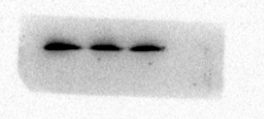
Fig. 9 Isorhamnetin inhibited ZEA-caused apoptosis through the PI3K/Akt signaling pathway
1. Protein is Bcl-2. The different treatments from left to right are Control, ZEA, ZEA+ISO and ZEA+ISO+LY294002, respectively.
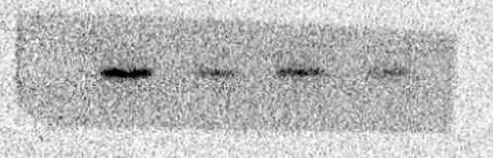
2. Protein is Bax. The different treatments from left to right are Control, ZEA, ZEA+ISO and ZEA+ISO+LY294002, respectively.
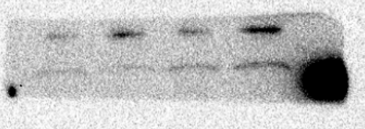
3. Protein is GAPDH. The different treatments from left to right are Control, ZEA, ZEA+ISO and ZEA+ISO+LY294002, respectively.
