A cold tolerance  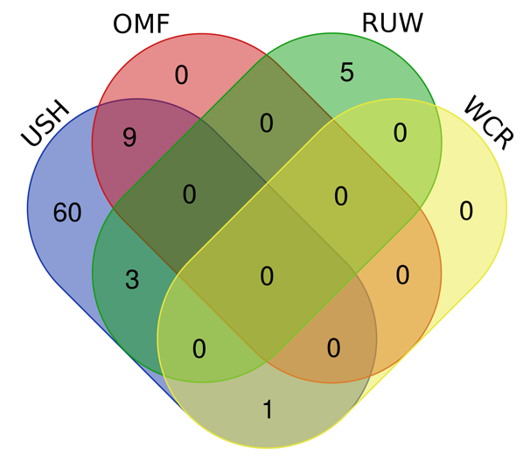 | G immunity  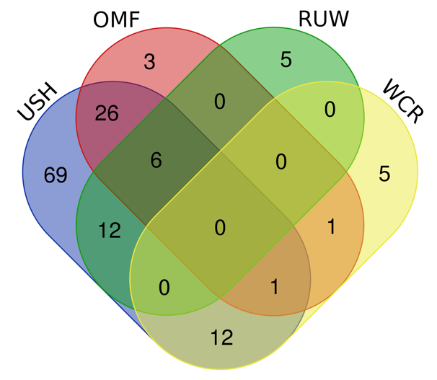
B domestication  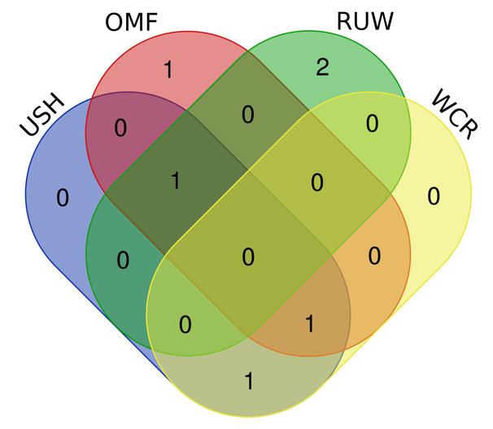 | H reproduction  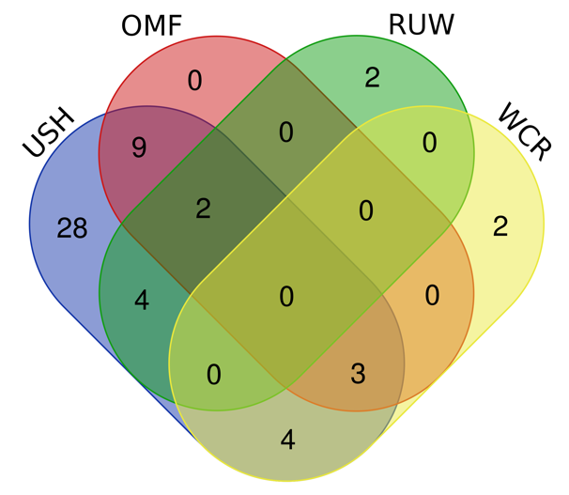
B egg traits  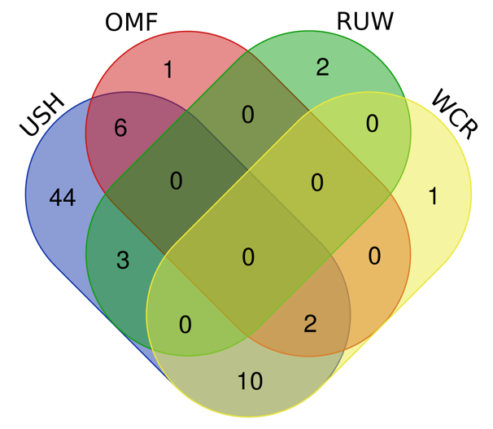 | I response to heat  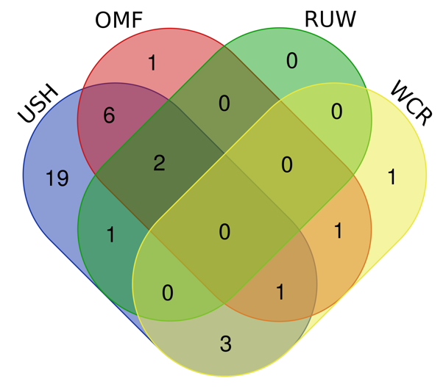

D energy and feed intake  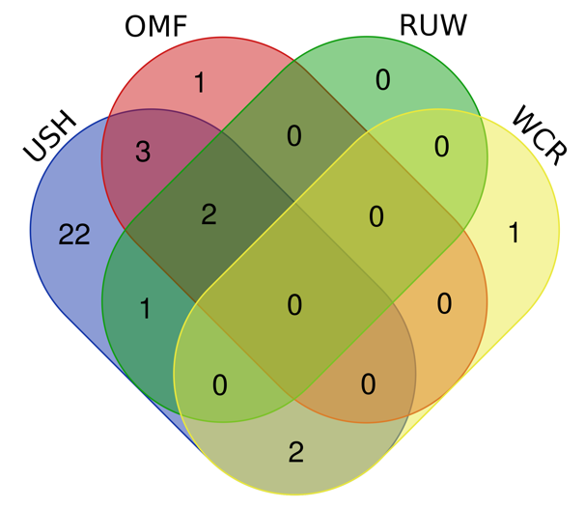 | J skin, feather, skin other appendages  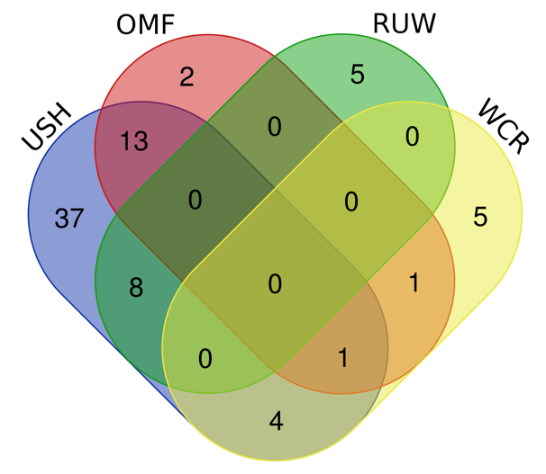
E fat metabolism  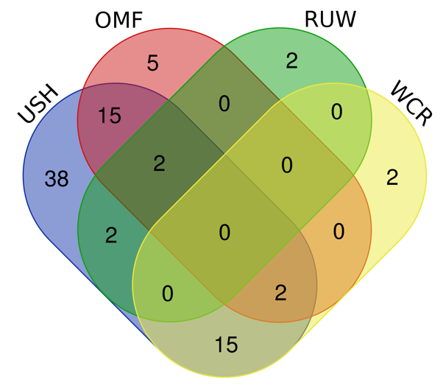 | K stress and adaptation  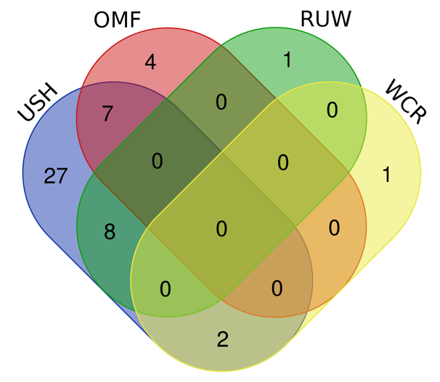
F growth, meat, carcass  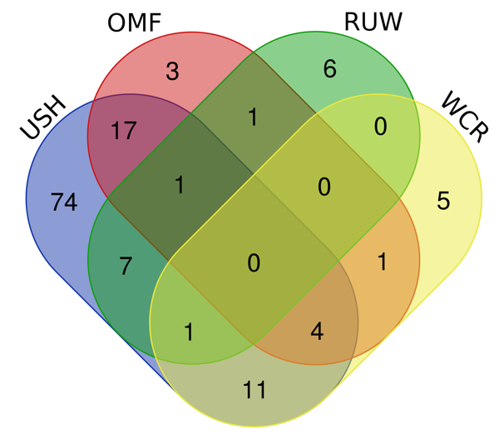 | L thermosensation  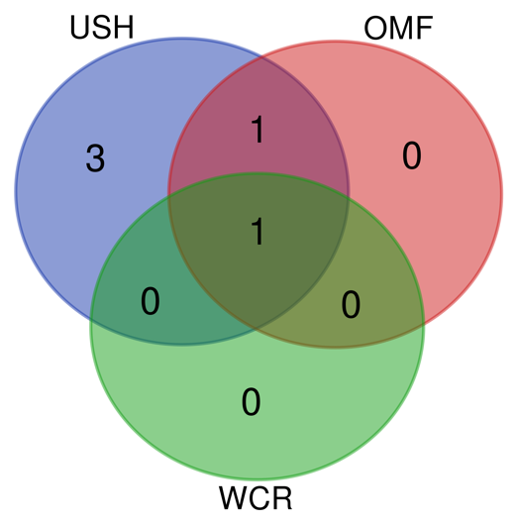
Additional file 11: Fig. S5 Venn diagrams representing distribution of 540 prioritized genes between the four studied breeds by phenotypic categories (A to L). Breeds: OMF, Orloff Mille Fleur; RUW, Russian White; USH, Ushanka; WCR, White Cornish

