Supplementary Information
Rumen microbial-driven metabolite from grazing lambs potentially regulates body fatty acid metabolism by lipid-related genes in liver
Zhen Li, Xingang Zhao, Luyang Jian, Bing Wang, Hailing Luo*
State Key Laboratory of Animal Nutrition, College of Animal Science and Technology, China Agricultural University, Beijing 100193, P. R. China
*Corresponding author: luohailing@cau.edu.cn
Zhen Li: lizhen6394@126.com
Xingang Zhao: 1404010216@cau.edu.cn
Luyang Jian: jianluyang@cau.edu.cn
Bing Wang: wangb@cau.edu.cn
Hailing Luo: luohailing@cau.edu.cn

Additional file 1
Table S1 Composition and nutrient level of the experimental diet (dry-matter basis)
Ingredients | Content, % | Components | Content, %
Pellets
Corn | 25.24 | Dry matter | 93.17
Alfalfa powder | 25.00 | Crude protein | 13.96
Wheat bran | 7.76 | Crude fiber | 22.74
Rapeseed cake | 6.00 | Ether extract | 3.32
Soybean meal | 8.00 | Crude ash | 9.55
NaHCO₃ | 1.00 | Calcium | 0.60
Salt | 1.00 | Phosphorus | 0.35
Premix¹ | 1.00 | Metabolizable energy, MJ/kg² | 9.39
Hay
Alfalfa hay  Corn straw  Total | 10.00  15.00  100.00
¹ Each 1 kg premix contained 320,000 IU vitamin A, 10,000 IU vitamin E, 300 mg copper, 5,000 mg iron, 5,000 mg zinc, 1,000 mg manganese, 40 mg iodine, 10 mg cobalt, and 10 mg selenium
² The metabolizable energy was calculated value

Table S2 Good's coverage of rumen microbial diversity of sheep under different feeding regimes
Simple | Good’s_coverage
F-2 | 0.9998
F-3 | 0.99986
F-4 | 0.999778
F-5 | 0.999856
F-6 | 0.999834
F-7 | 0.999748
F-8 | 0.999936
G-1 | 0.999829
G-2 | 0.999819
G-3 | 0.999848
G-4 | 0.99991
G-5 | 0.999834
G-6 | 0.999908
G-7 | 0.99979
G-8 | 0.99976
“F” means indoor feeding group; “G” means grazing group

Table S3 Results of Pearson correlation analysis between microorganisms and VFA in rumen^{1,2,3}
Items |  | Acetate | Propionate | Isobutyrate | Butyrate | Isovalerate | Valerate | Acetate/  propionate | Total VFA
Tenericutes | r | 0.345 | 0.475 | 0.264 | 0.374 | 0.088 | 0.688 | -0.241 | 0.544
Tenericutes | P | 0.655 | 0.525 | 0.736 | 0.626 | 0.912 | 0.312 | 0.565 | 0.163
Succiniclasticum | r | 0.287 | 0.973* | 0.170 | 0.042 | 0.503 | 0.647 | -0.515 | 0.762*
Succiniclasticum | P | 0.713 | 0.027 | 0.830 | 0.958 | 0.497 | 0.353 | 0.192 | 0.028
Butyrivibrio_sp_AC2005 | r | -0.821 | -0.295 | -0.790 | -0.866 | -0.567 | -0.842 | 0.191 | -0.300
Butyrivibrio_sp_AC2005 | P | 0.179 | 0.705 | 0.210 | 0.134 | 0.433 | 0.158 | 0.651 | 0.471
Acidaminococcales | r | 0.289 | 0.974* | 0.172 | 0.045 | 0.504 | 0.650 | -0.522 | 0.754*
Acidaminococcales | P | 0.711 | 0.026 | 0.828 | 0.955 | 0.496 | 0.350 | 0.184 | 0.031
Candidatus_Saccharimonas | r | 0.648 | 0.762 | 0.549 | 0.568 | 0.531 | 0.950* | -0.540 | 0.752*
Candidatus_Saccharimonas | P | 0.352 | 0.238 | 0.451 | 0.432 | 0.469 | 0.050 | 0.167 | 0.031
Coprobacillus | r | 0.308 | 0.681 | 0.201 | 0.269 | 0.137 | 0.740 | -0.504 | 0.284
Coprobacillus | P | 0.692 | 0.319 | 0.799 | 0.731 | 0.863 | 0.260 | 0.203 | 0.495
¹ r: correlation coefficient; P: significance (probability)
² Significant correlation was considered at P < 0.05 and marked with “*”
³ VFA volatile fatty acid

Table S4 Results of Pearson correlation analysis between ruminal VFAs and lipid-related metabolites in liver^{1,2}
Items³ |  | Acetate | Propionate | Isobutyrate | Butyrate | Isovalerate | Valerate
ETA | r | -0.142 | -0.192 | 0.077 | -0.054 | 0.025 | -0.284
ETA | P | 0.660 | 0.551 | 0.811 | 0.867 | 0.940 | 0.371
EPA | r | 0.613* | 0.698* | 0.349 | 0.459 | 0.593* | 0.691*
EPA | P | 0.034 | 0.012 | 0.266 | 0.133 | 0.042 | 0.013
DHA | r | -0.637* | -0.573 | -0.215 | -0.661* | -0.281 | -0.607*
DHA | P | 0.026 | 0.051 | 0.502 | 0.019 | 0.377 | 0.036
3-hydroxypropanoate | r | 0.633* | 0.617* | 0.646* | 0.751** | 0.728** | 0.724**
3-hydroxypropanoate | P | 0.027 | 0.033 | 0.023 | 0.005 | 0.007 | 0.008
¹ r: correlation coefficient; P: significance (probability)
² Significant correlation was considered at P < 0.05 and marked with “*”
³ ETA Icosatrienoic acid, DHA Docosahexaenoic acid, EPA Icosapentaenoic acid

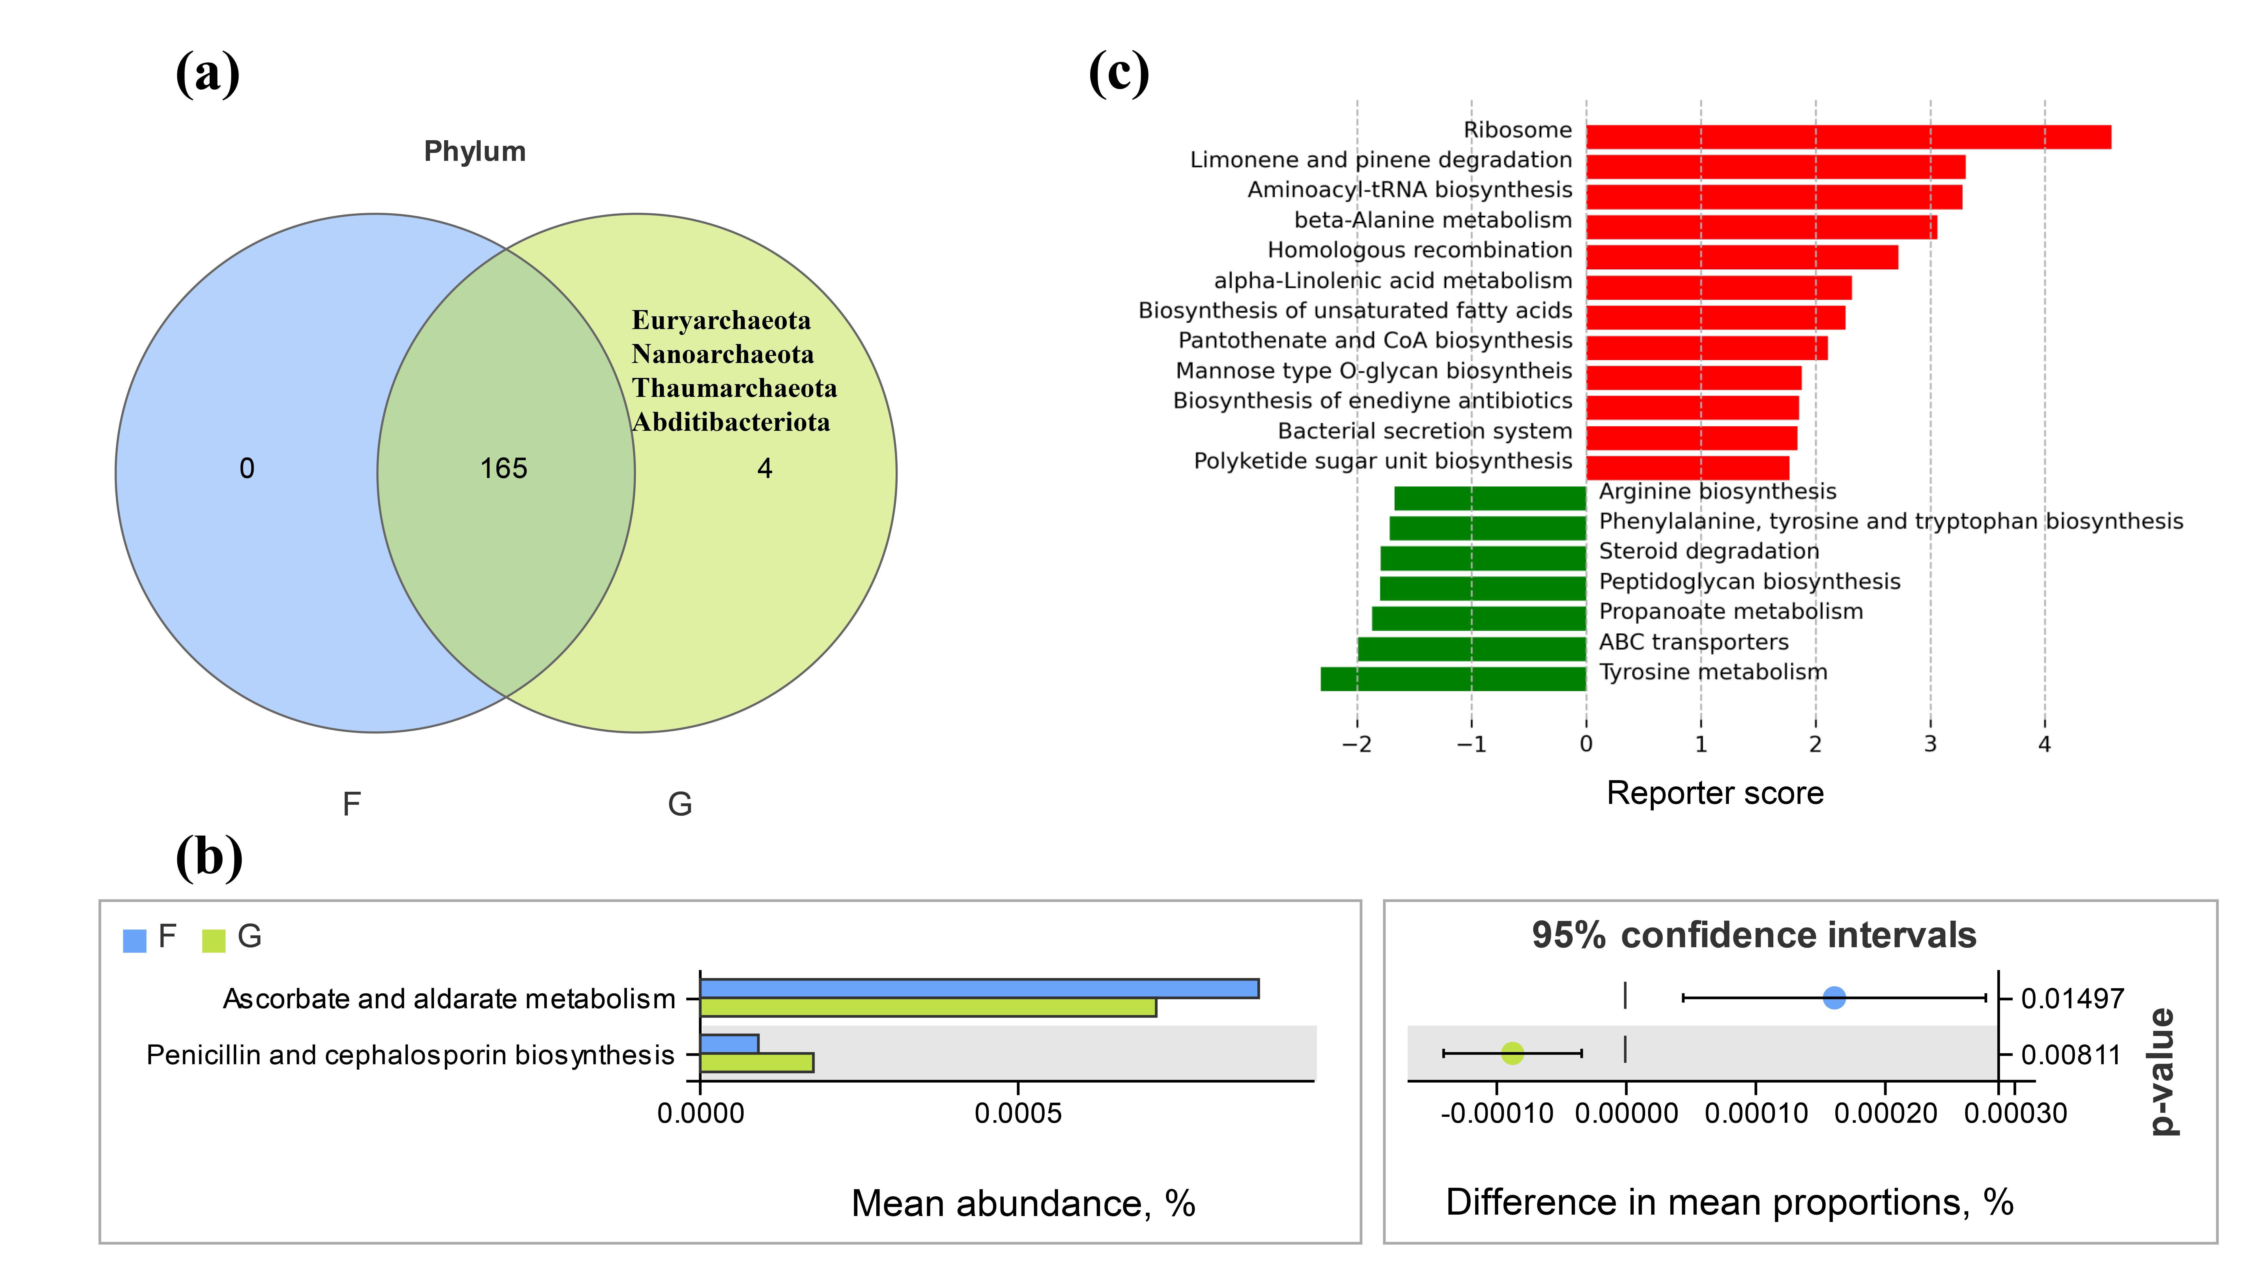
Fig. S1 Venn diagram illustrating the overlap of microbial phyla between the two groups in metagenomic sequencing (a). Comparisons of the pathway annotation based on the KEGG database of rumen microbiomes in the F and G groups by the Welch's t-test (b). Metabolic pathway enrichment score in metagenomic sequencing (c). Positive/negative values indicate a significant increase/decrease of abundance in the grazing group, respectively, and larger absolute values indicate more significant enrichment
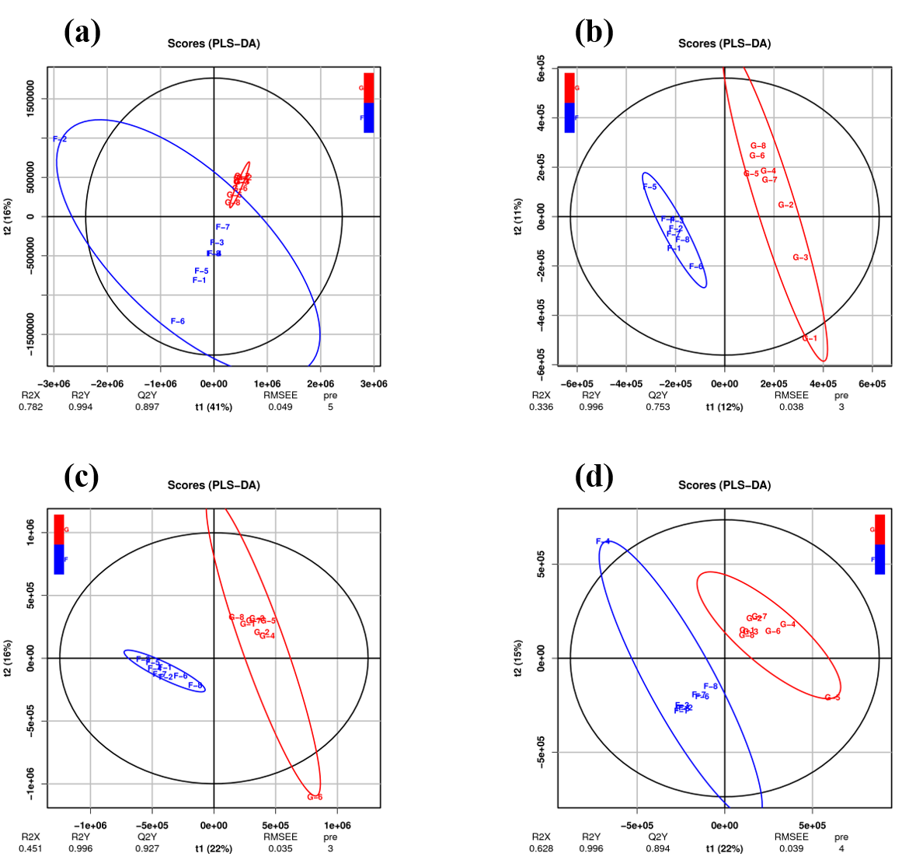
Fig. S2 Score plot of partial least squares discriminant analysis (PLS-DA) model obtained in positive (a) and negative mode (b) of rumen metabolism. Score plot of PLS-DA model obtained in positive (c) and negative mode (d) of liver metabolism
Fig. S3 Functional enrichment analysis of differential metabolites in rumen (a) and liver (b)

