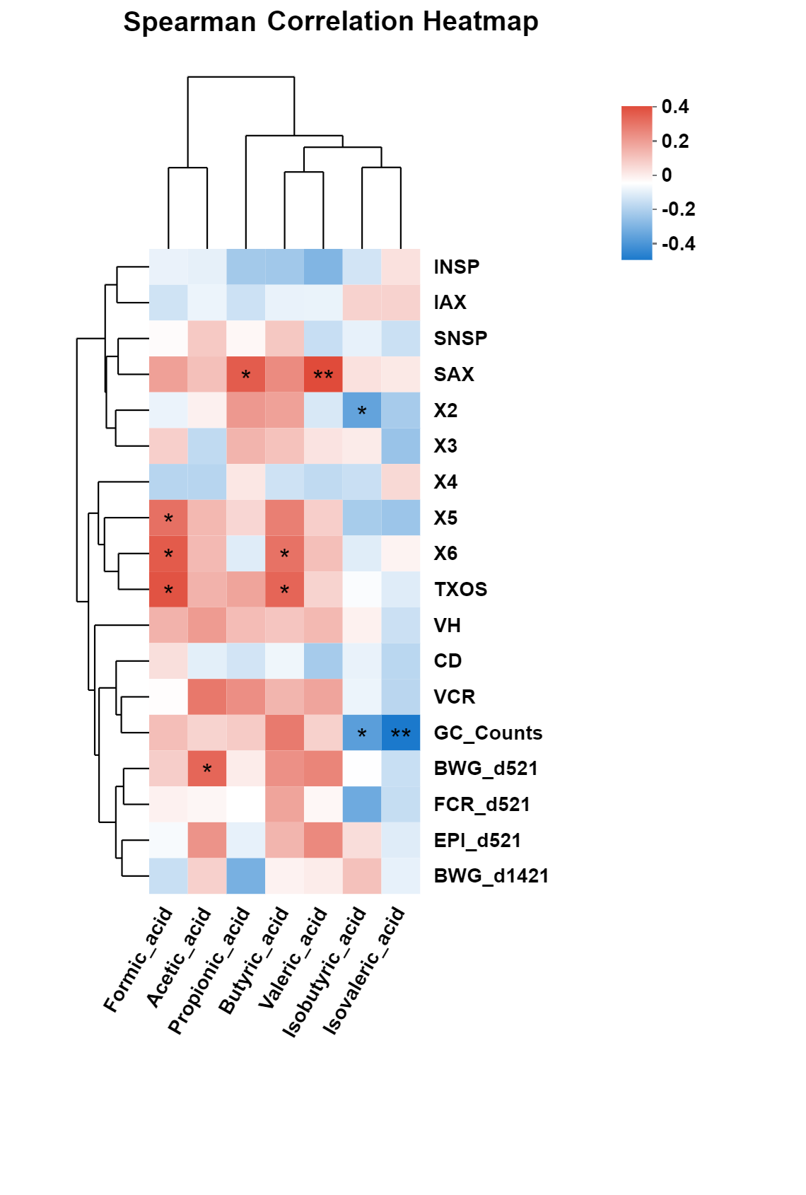
Fig. S4 Correlation of SCFA components in the hindgut of broiler chickens with multiple indicators. The intensity of the colors represents the degree of association based on spearman’s correlation coefficients (red, positive correlation; blue, negative correlation; *P < 0.05, **P < 0.01)

