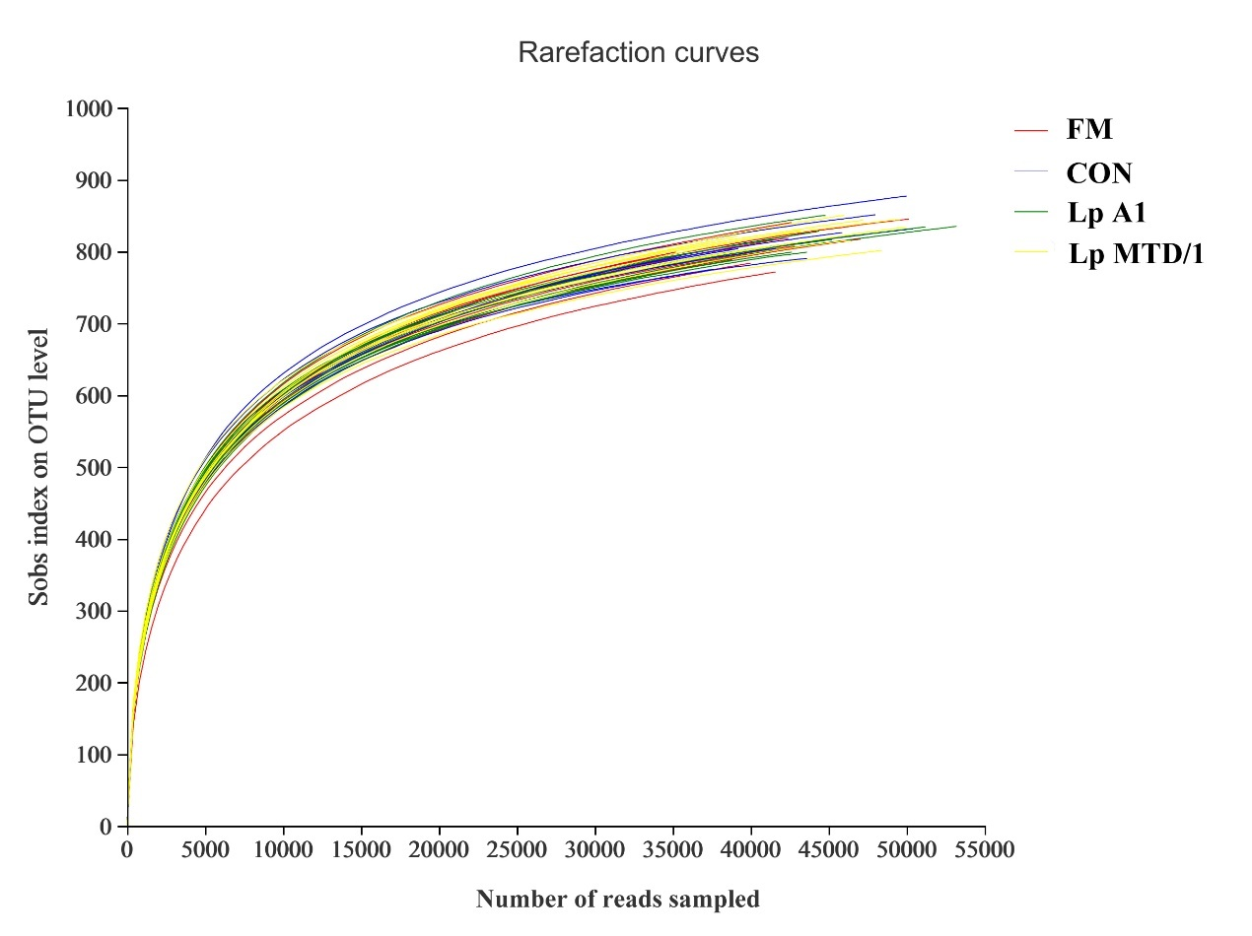
Fig. S1. Rarefaction of four treatments. Treatment: FM = fresh material; CON = control (no additives); Lp A1 = silage inoculated with L. plantarum A1; Lp MTD/1 = silage inoculated with L. plantarum MTD/1

