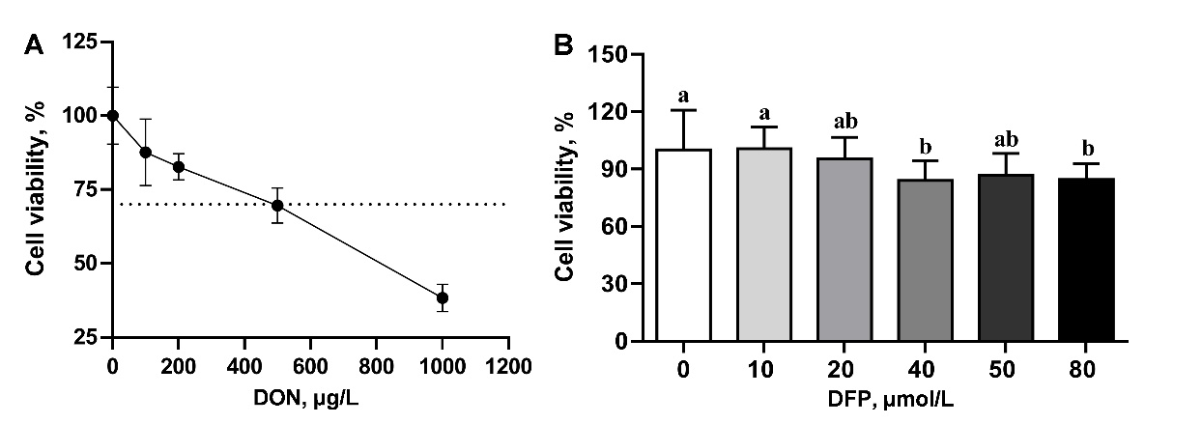
Fig. S1 The cell viability of IPEC-J2 after 24h treatment with DON (A) and DFP (B). DON, μg/L; DFP, μmol/L. Values are expressed as means ± SD, n = 6. Labeled means without a common letter differ, P < 0.05

