Supplementary Information
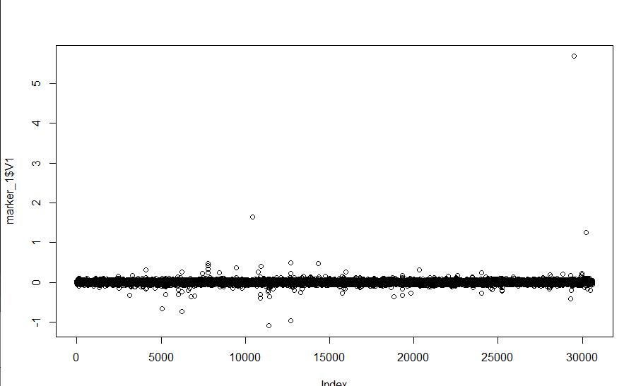
Fig. S1 SNP effects cross the whole genome at the heritability of 0.1
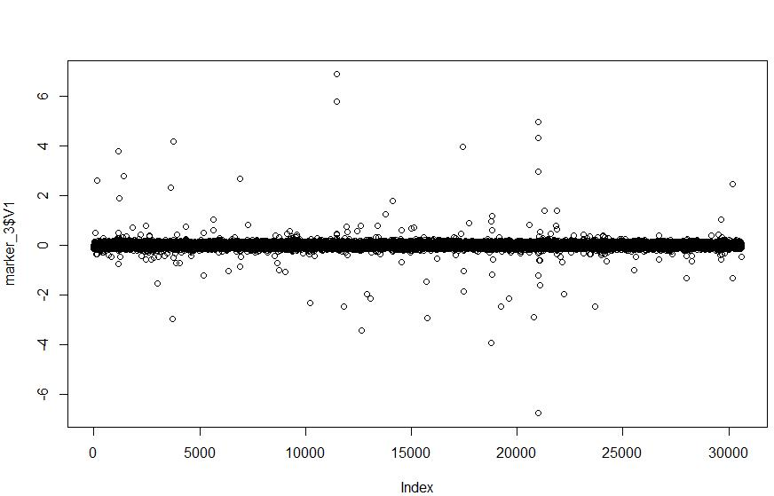
Fig. S2 SNP effects cross the whole genome at the heritability of 0.3

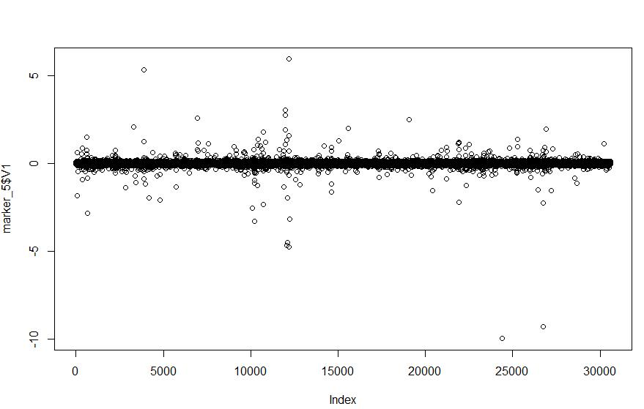
Fig. S3 SNP effects cross the whole genome at the heritability of 0.5

