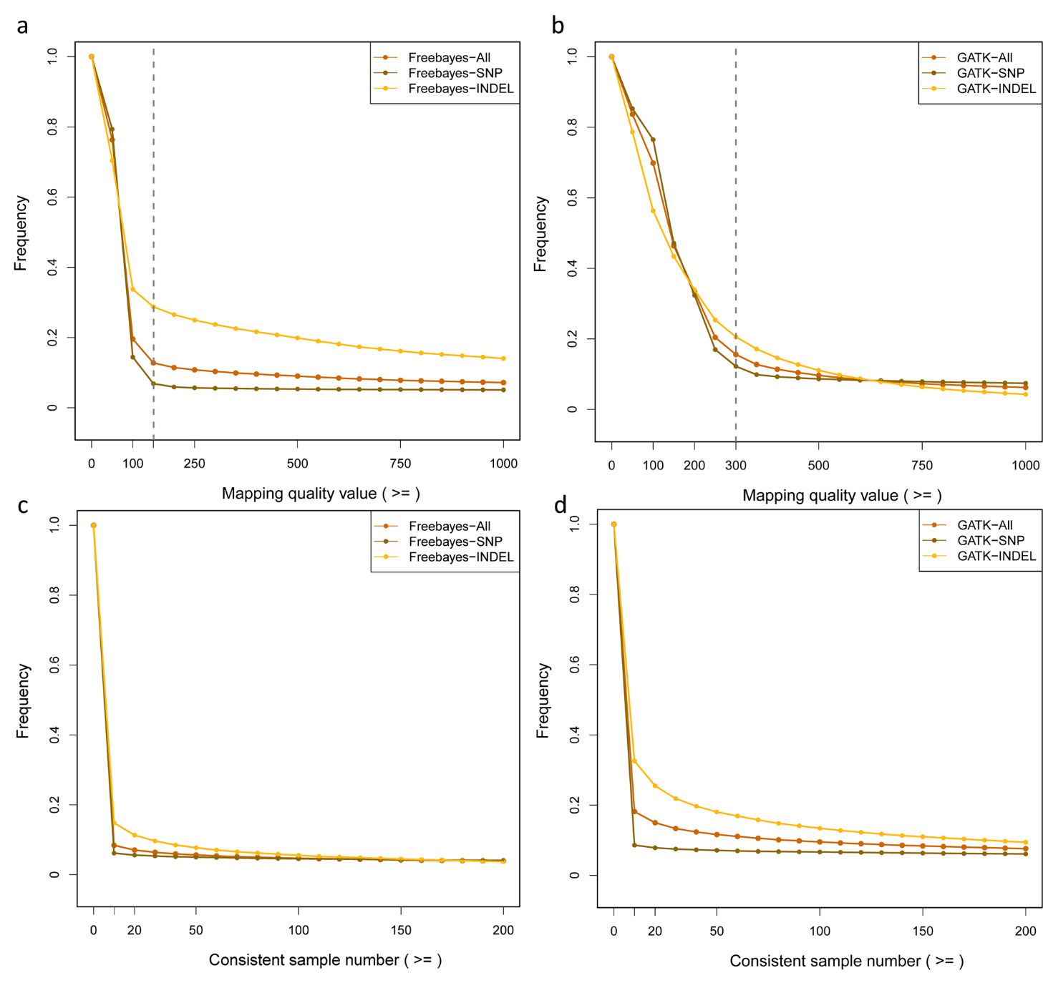
Fig. S1 The distributions of mapping qualities and consistent sample number in GATK and Freebayes. a Mapping quality in Freebayes; b mapping quality in GATK; c consistent sample number in Freebayes; d consistent sample number in GATK

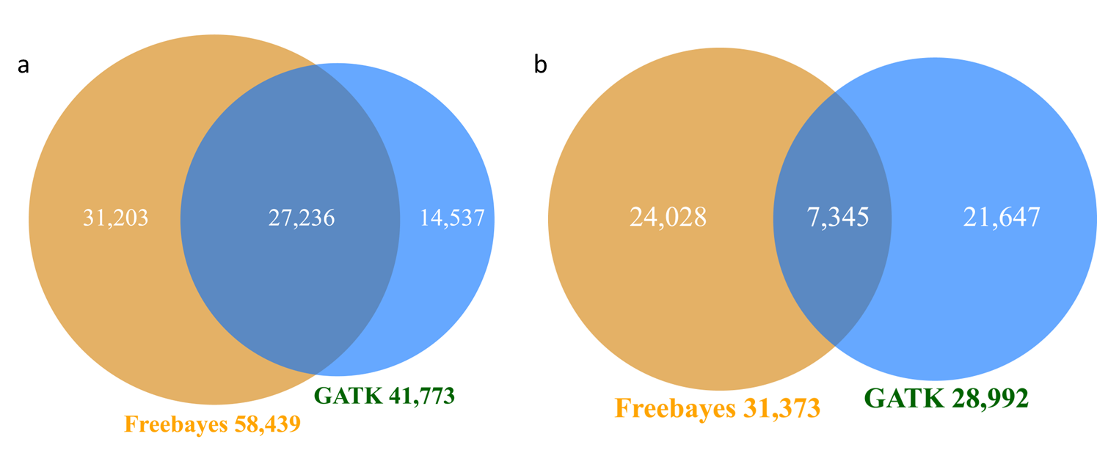
Fig. S2 The concordance of raw variants in SNP and Indel from FreeBayes and GATK. a SNP; b Indel

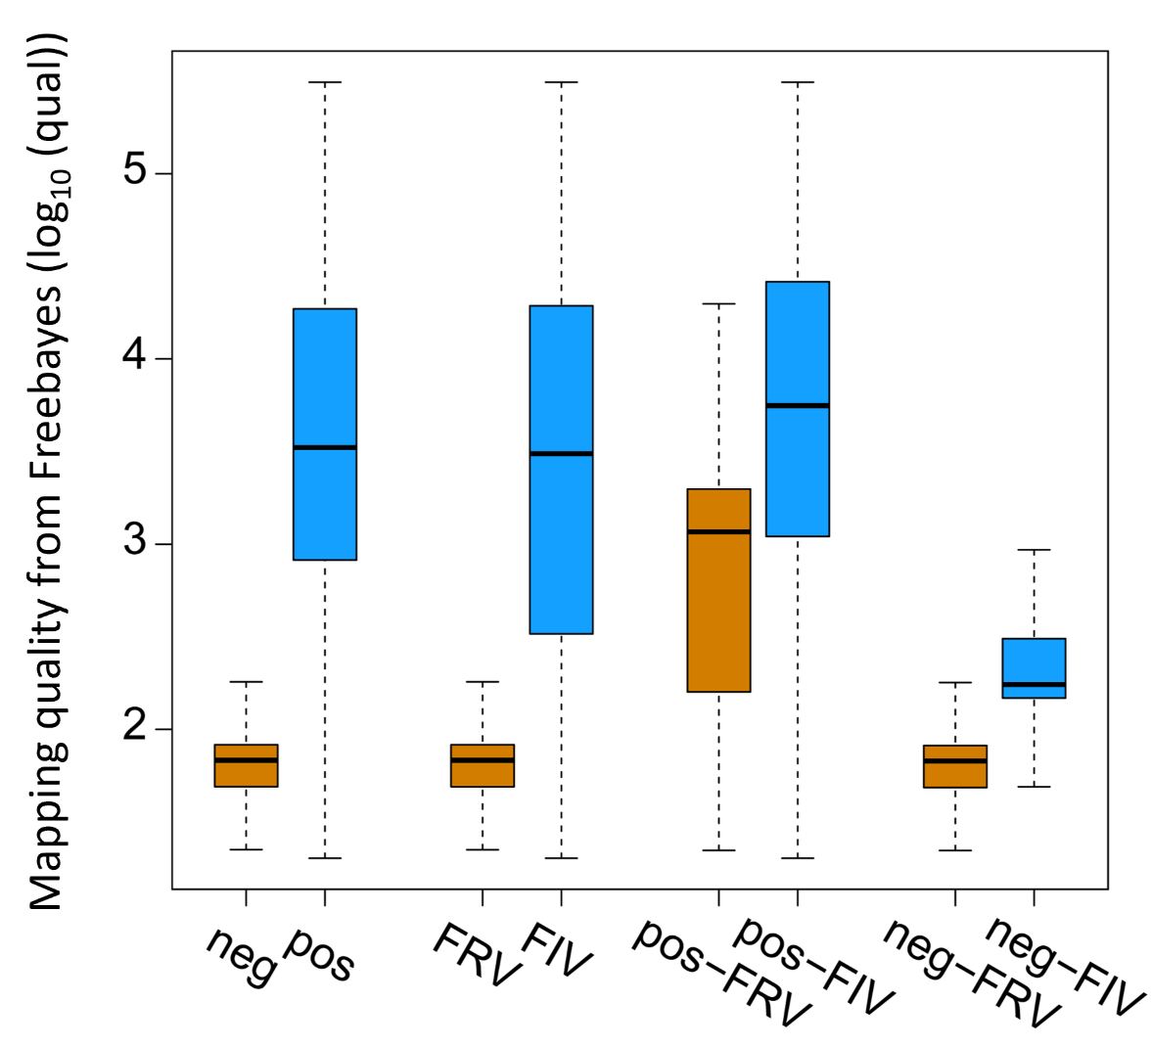
Fig. S3 Comparison of mapping qualities at pre- and post-FDR in Freebayes

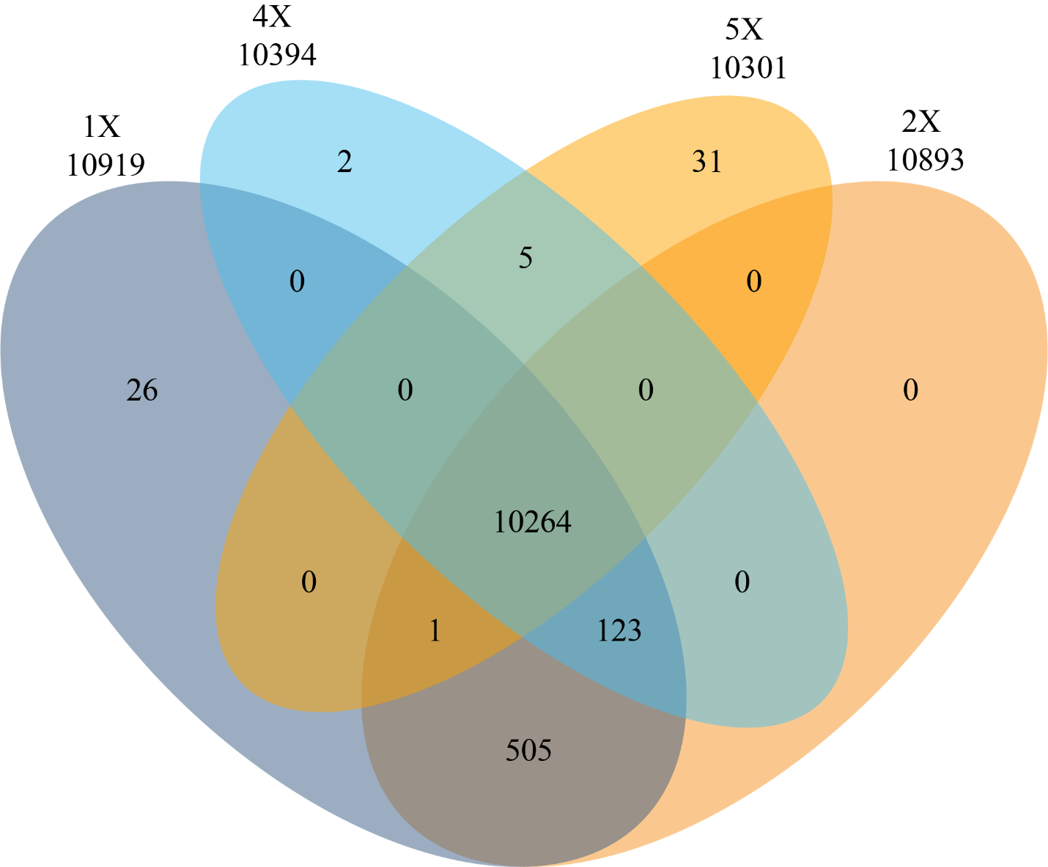
Fig. S4 Comparison of variants with at least 1×, 2×, 4× and 5× read coverage in 5,061 sheep

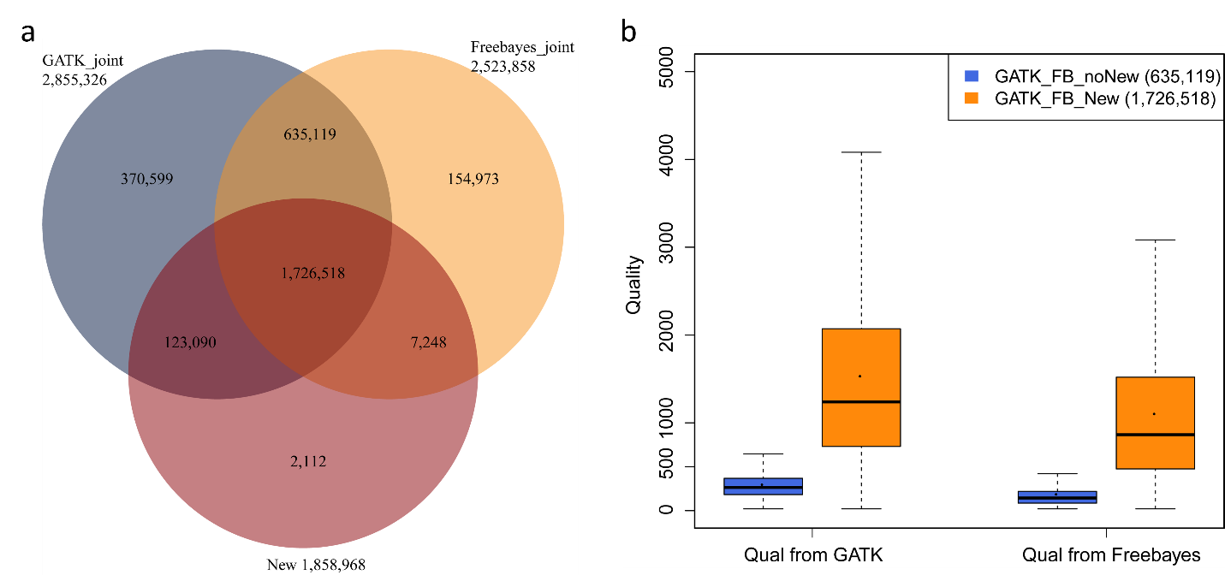
Fig. S5 Comparison of new strategy with GATK and Freebayes joint variant identification in chr1 of WGS data. a Identified variants in three strategies; b comparison between the unique overlap from GATK and Freebayes and the overlap of all three strategies

