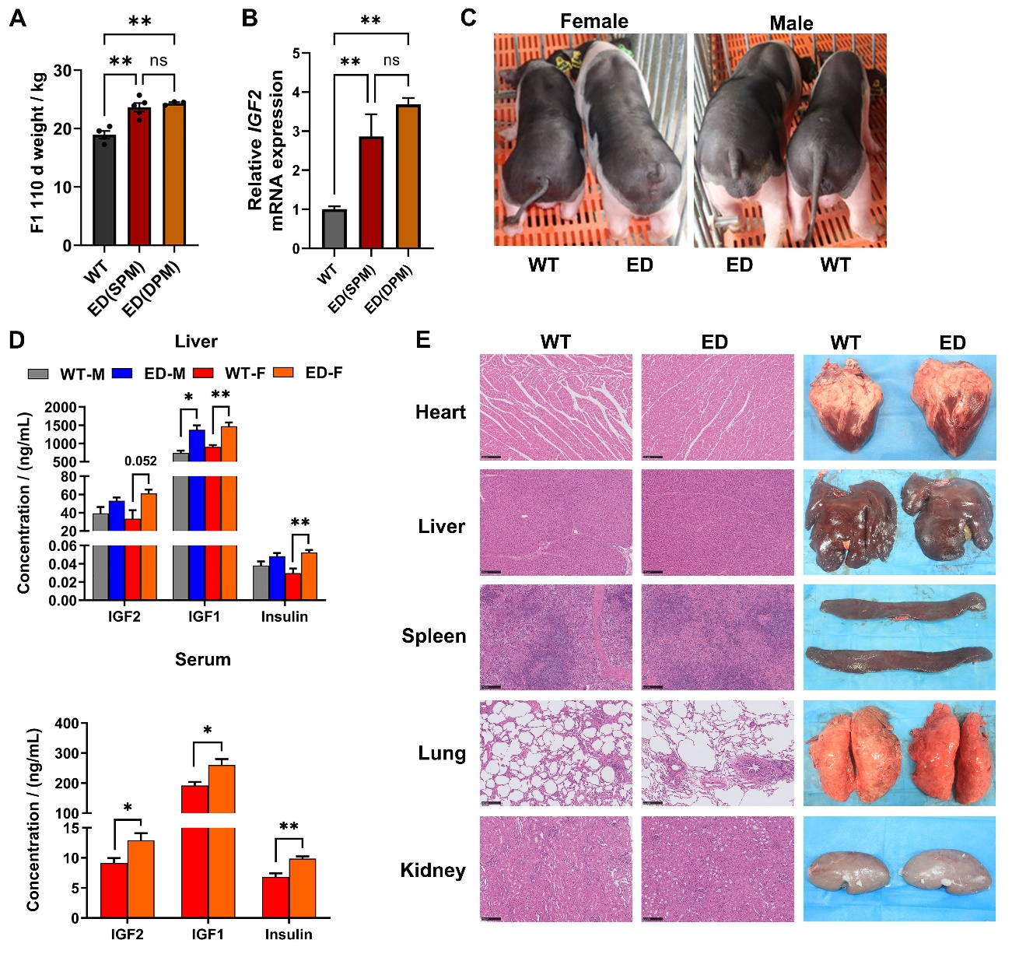
Fig. S4 Growth phenotype and health detection of IGF2^{C/T} F1 generation pigs. A The body weight and (B) the mRNA expression level of IGF2 of WT, single point mutation (SPM) and double point mutation (DPM) pigs at 110-day-old, with black points representing actual data. C Representative photos of WT and IGF2^{C/T} pigs at age of 3 months, indicating more developed rump of IGF2^{C/T} pigs. D The levels of IGF2, IGF1 and insulin in liver and serum of 370-day-old WT and IGF2^{C/T} pigs were determined by ELISA (Liver: n = 3 per group; Serum: n = 4 per group). (E) H&E staining of internal organs including heart, liver, spleen, lung, and kidney of 370-day-old WT and IGF2^{C/T} pigs (Scale bar = 250 μm, n = 3 per group). All data were presented as means ± SEM. *P < 0.05, **P < 0.01, ns P > 0.05, student’s t test

