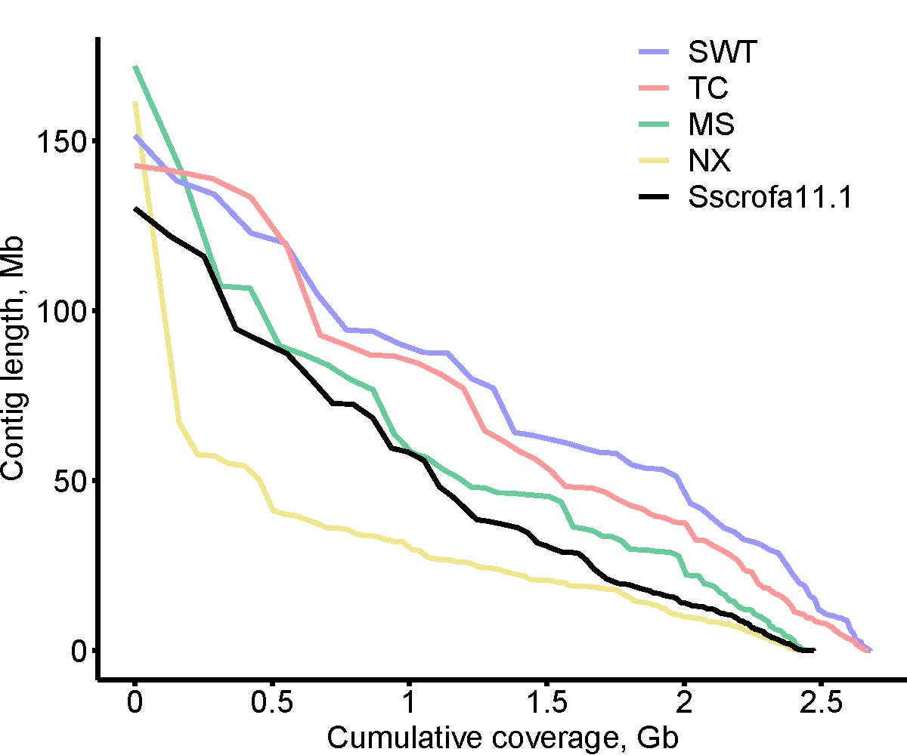
Fig. S1 Assembly contiguity shown as a NGx plot. Contigs of Meishan (MS) pig and Ningxiang(NX) pig are included for comparison

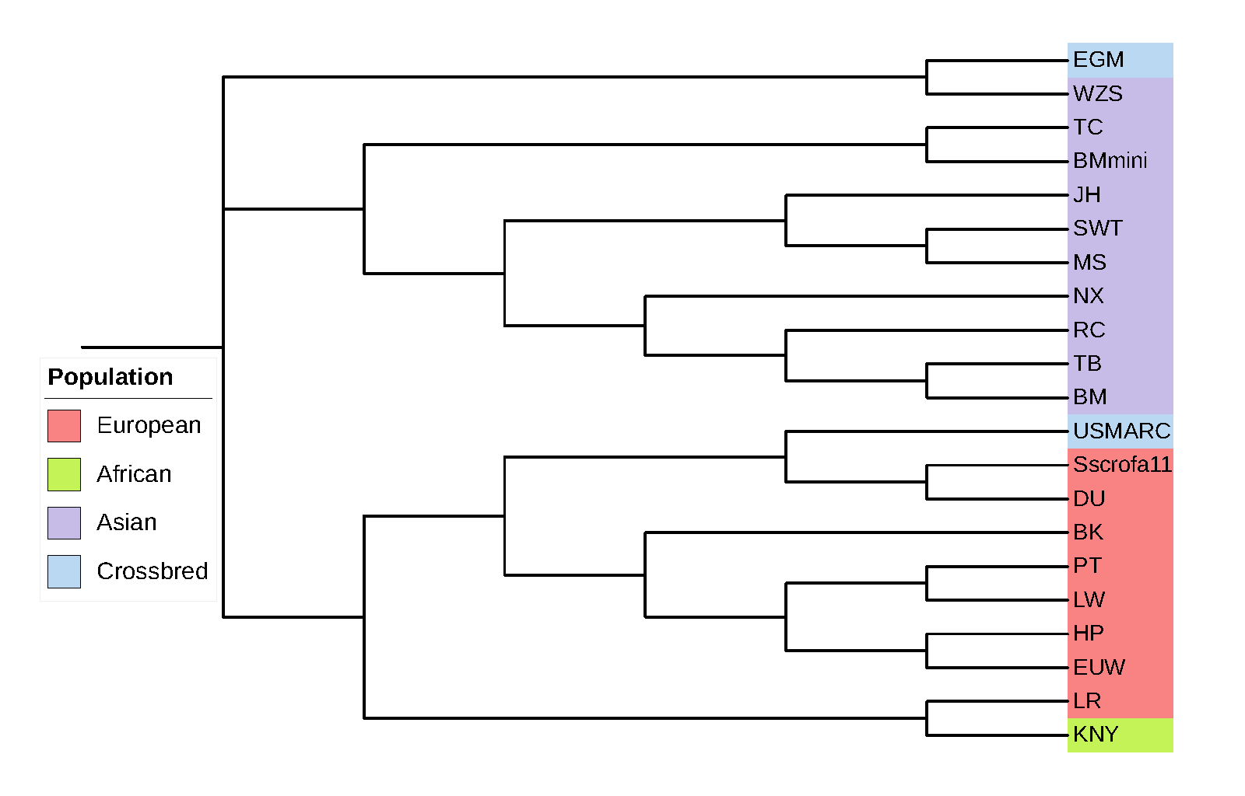
Fig. S2 Phylogenetic tree of the Sus scrofa 11.1 assembly and 20 other pig assemblies
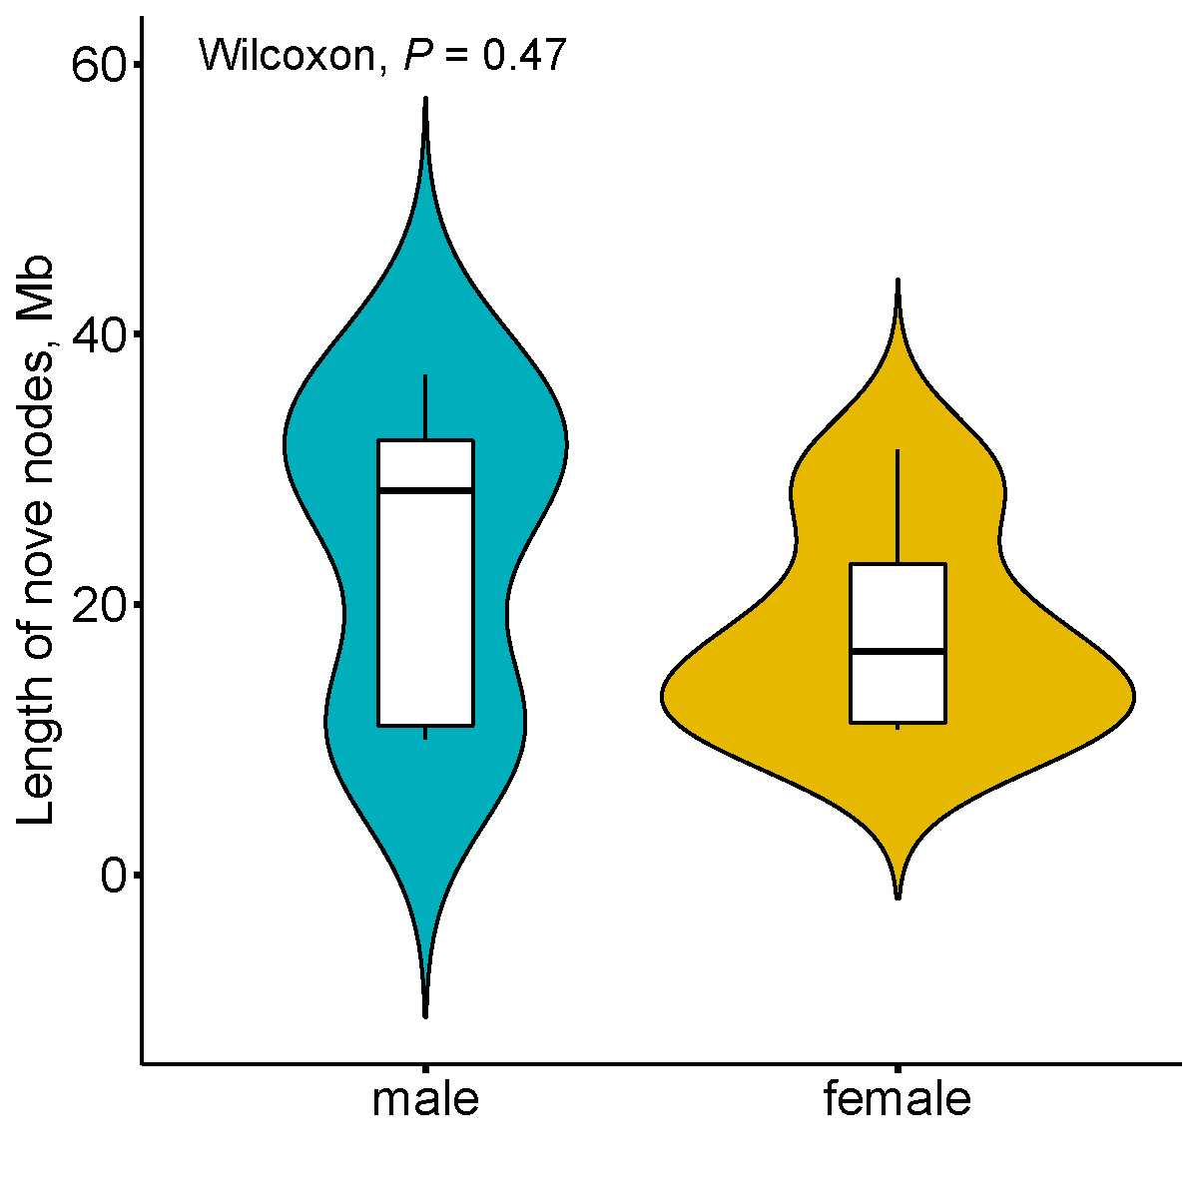
Fig. S3 Violin plot illustrating the cumulative length of non-reference sequences in males and female pigs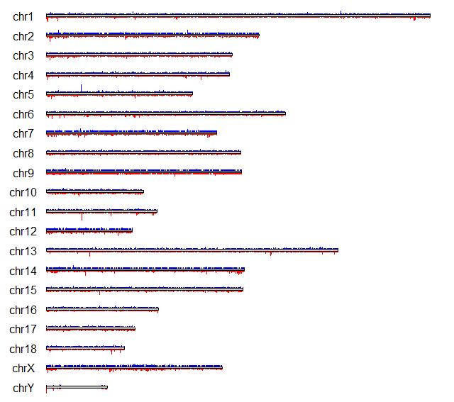
Fig. S4 Distribution of NRSs across the chromosomes. The blue squares represent cNRSs, while the red squares represent pNRSs
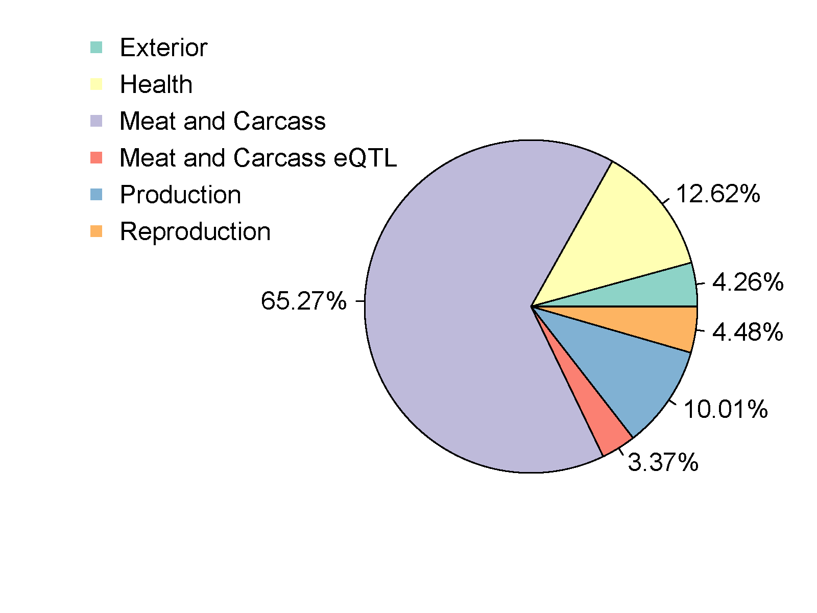
Fig. S5 Proportions of different QTL classes where cNRSs occurred
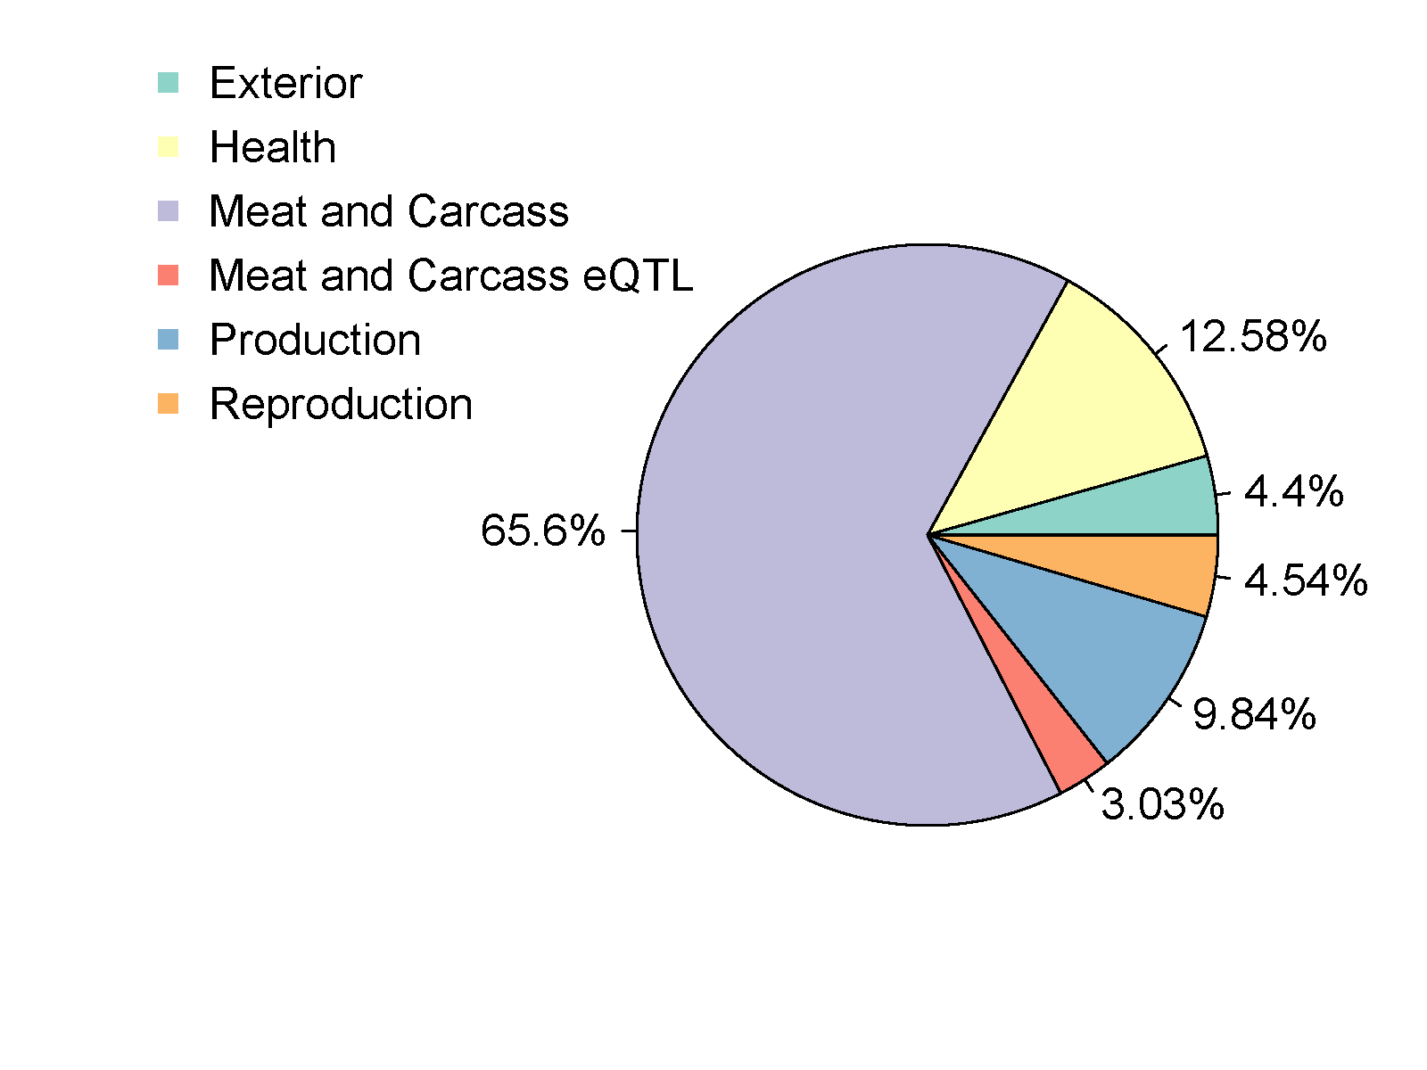
Fig. S6 Proportions of different QTL classes where pNRSs occurred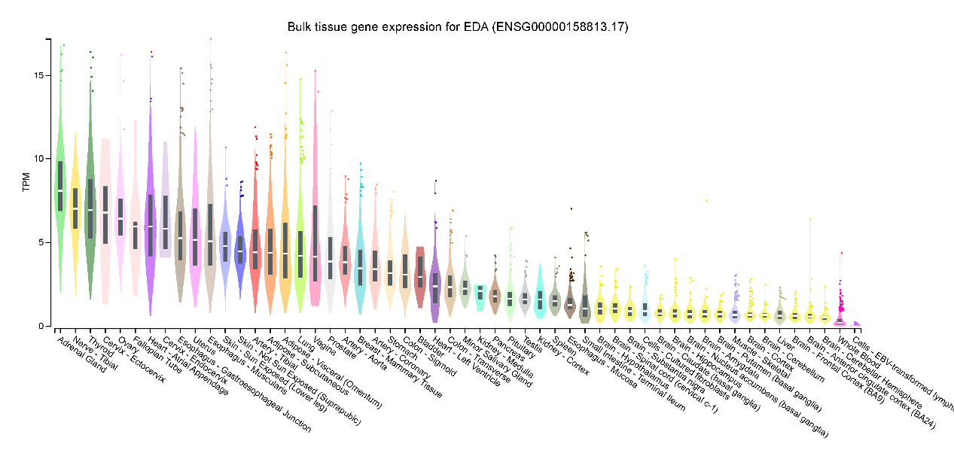
Fig. S7 The expression of EDA in different tissues in human Gtex data, produced through GTExPortal (https://gtexportal.org/)
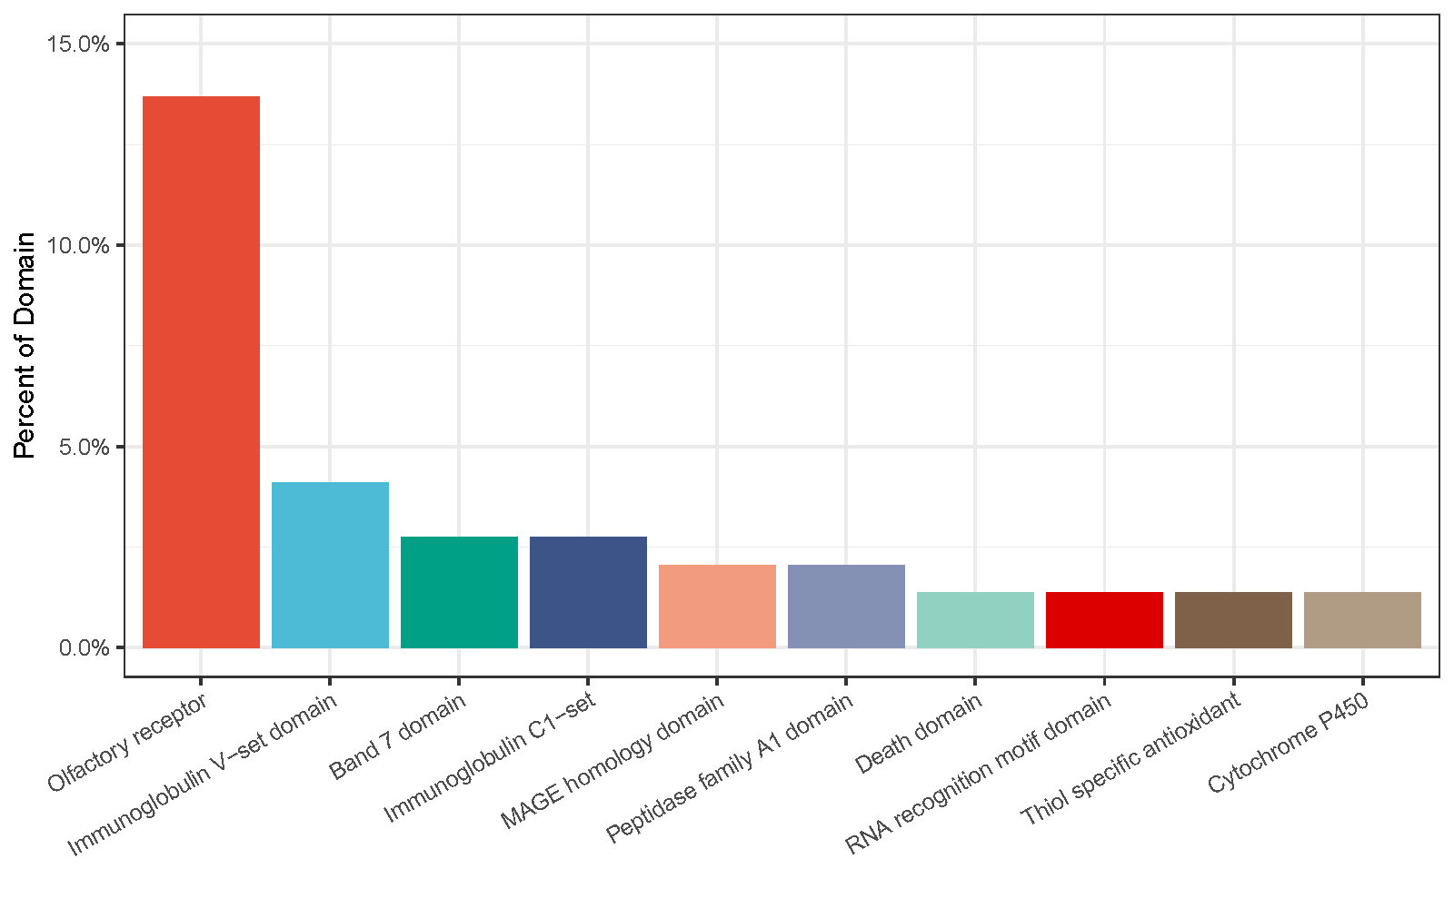
Fig. S8 Top 10 significant most frequently annotated entries in InterPro database

