Supplementary information
Postbiotics from Saccharomyces cerevisiae fermentation stabilize microbiota in rumen liquid digesta during grain-based subacute ruminal acidosis (SARA) in lactating dairy cows

Additional file 4 Concepts of stability, robustness, and resilience of rumen liquid microbiota. Longitudinal shifts in the proportion of phylum Firmicutes in Control and SCFPb2X as example for explanation of a. stability, b. robustness, and c. resilience concepts. Stability is defined as day-to-day variation in microbiome. Robustness explains the capacity of microbiome to resist changes that are forced by stressors, e.g., a metabolic challenge such as SARA. Resilience describes the capacity and the time it takes for the microbiome to return to equilibrium (if at all) after it has been pushed away from the equilibrium by the stressors, e.g., recovery after a metabolic challenge such as SARA

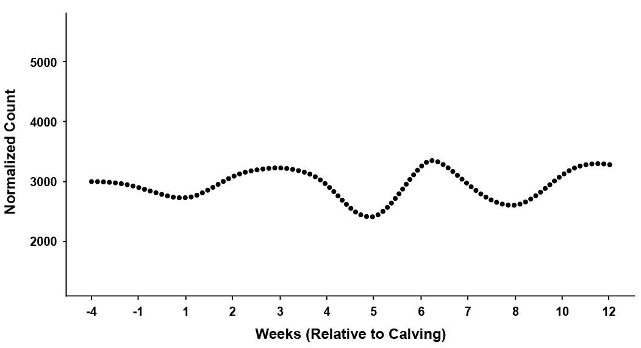
.

Firmicutes proportion
Weeks post-calving
Control
SARA1
SARA2
1st week
post-calving
SCFPb-2X
-4
0
5
8
12
1
3
2
4
6
7
9
10
STABILITY

Firmicutes proportion
SCFPb-2X

Weeks post-calving
Control
SARA1
SARA2
1st week
post-calving
-4
0
5
8
12
1
3
2
4
6
7
9
10
STABILITY
ROBUSTNESS
ROBUSTNESS
ROBUSTNESS

Firmicutes proportion
Weeks post-calving
Control
SARA1
SARA2
1st week
post-calving
-4
0
5
8
12
1
3
2
4
6
7
9
10
STABILITY
RESILIENCE
SCFPb-2X

