Fig.S1
Brightfield images showing the organoids incubated with WNT inhibitors including IWP-2 and IWR-1-endo. Scale bar, 200 μm. The six medium including BM, BM+EGF, BM+FGF2, BM+FGF7, BM+FGF10 and GM were incubated with organoids (passage 1) at day 0, respectively. The growth area of organoids was acquired using a microscope (Nikon, Tokyo, Japan) at d 2, d 4, and d 6.
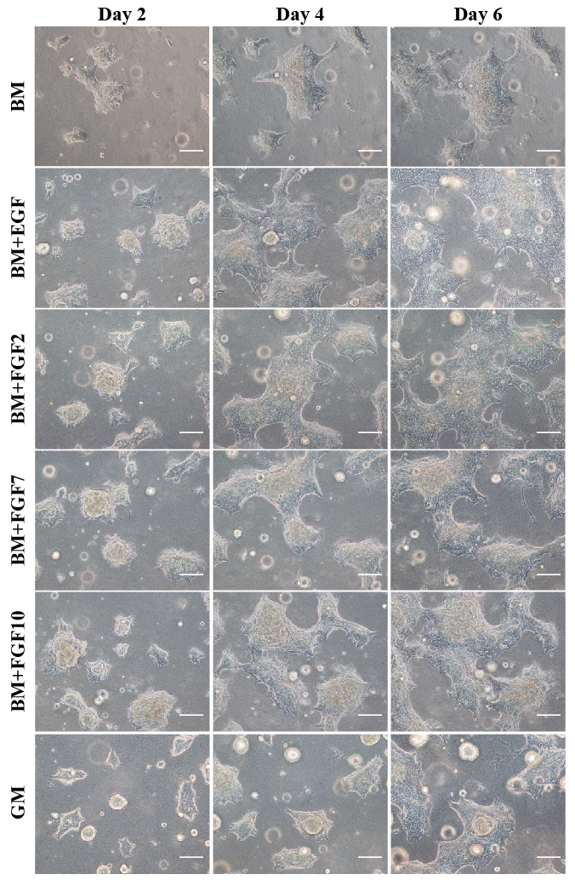
Fig. S2
Brightfield images showing the organoids incubated with various growth factors. Scale bar, 200 μm. To investigate whether the cultured organoids respond to the WNT pathway, we introduced two inhibitors of WNT, IWR-1-endo (S7086, Selleck Chemicals, Houston, United States) and IWP2 (S7085, Selleck Chemicals, Houston, United States) into the culture medium. The growth area of organoids was acquired using a microscope (Nikon, Tokyo, Japan) at day 1, 3, 5, 7 and 9.
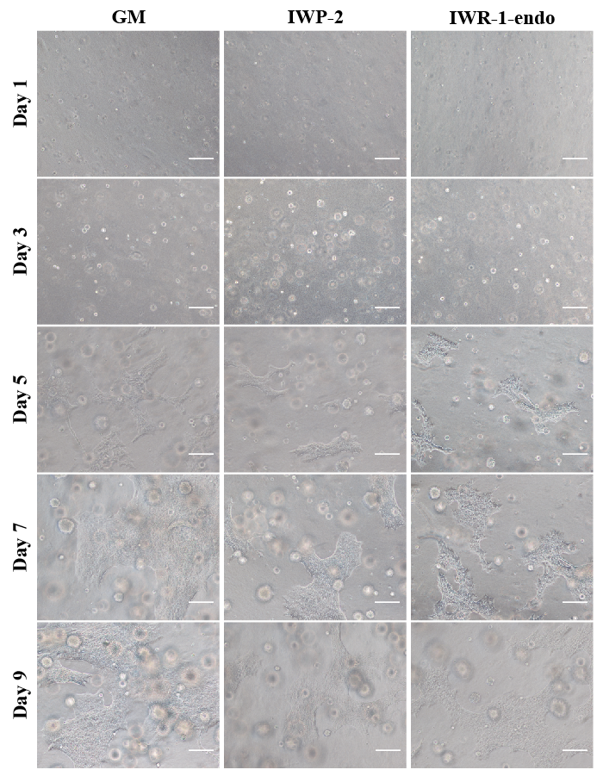

Table S1
Symbols and descriptions among genes related to lipid metabolism, milk protein and lactose synthesis investigated.

Xenobiotic and Cholesterol transport
ABCA1 | ATP-binding cassette, sub-family A (ABC1), member 1
ABCG2 | ATP-binding cassette, sub-family G (WHITE), member 2
Acetate and FA activation and intra-cellular transport
ACSS1 | acyl-CoA synthetase short-chain family member 1
ACSS2 | acyl-CoA synthetase short-chain family member 2
FABP3 | Fatty acid-binding protein, heart
Fatty acid synthesis and desaturation
ACACA | Acetyl-coenzyme A carboxylase alpha
FASN | Fatty acid synthase
SCD | Stearoyl-CoA desaturase (delta-9-desaturase)
Lipid droplet formation
PLIN2 | Perilipin 2
BTN1A1 | Butyrophilin, subfamily 1, member A1
XDH | Xanthine dehydrogenase
FA import into cells
CD36 | CD36 molecule (thrombospondin receptor)
Triacylglycerol synthesis
GPAM | Glycerol-3-phosphate acyltransferase, mitochondrial
DGAT2 | Diacylglycerol acyltransferase 2
Regulation of transcription
SREBF1 | Sterol regulatory element-binding transcription factor 1
PPARG | Peroxisome proliferator-activated receptor gamma
LXR | Liver X receptor
Sphingolipid synthesis
OSBPL10 | Oxysterol binding protein-like 10
Milk protein synthesis
CNS2 | Casein kappa
CNS3 | Casein beta
CSN1S1 | Casein alpha S1
CSN1S2 | Cain alpha S2
LGB | Beta lactoglobulin
Lactose synthesis
LALBA | Lactalbumin alpha

