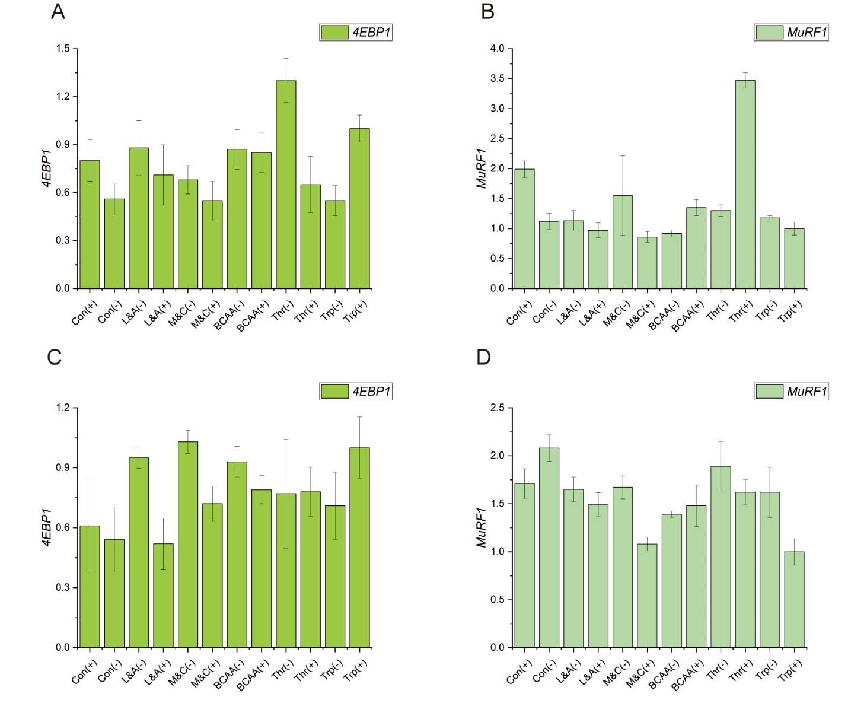
Fig. S1 Effects of amino acid combinations with different patterns on alterations of mRNA expressions in the breast muscle of AA broilers. Con(+): The normal-protein control group; Con(-): The low-protein control group; L&A(-): The lysine and arginine restriction group; L&A(+): The lysine and arginine supplementation group; M&C(-): The methionine and cysteine restriction group; M&C(+): The methionine and cysteine supplementation group; BCAA(-): The BCAA restriction group; BCAA(+): The BCAA supplementation group; Thr(-): The threonine restriction group; Thr(+): The threonine supplementation group; Trp(-): The tryptophan restriction group; Trp(+): The tryptophan supplementation group; Male-4EBP1 (A); Male-MuRF1 (B); Female-4EBP1 (C); Female-MuRF1 (D). 4EBP1: Eukaryotic translation initiation factor 4E-binding protein-1; MuRF1: Muscle ring finger 1. ^{a–d}Dissimilar letters represent significant difference among different treatments (P < 0.05)

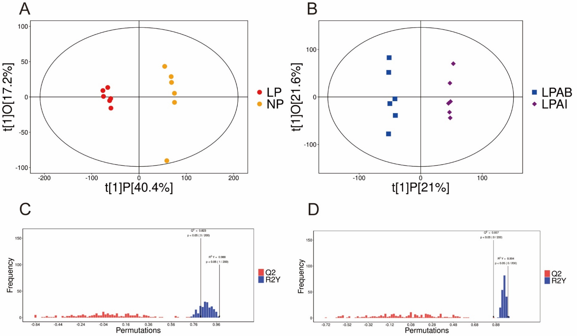
Fig. S2 Orthogonal partial least-squares discriminant analysis (OPLS-DA) of NP vs. LP liver metabolomics data (A) and LPAB vs. LPAI liver metabolomics data (B). The permutation test (100 times) of the OPLS-DA model of NP vs. LP (C) and LPAB vs. LPAI (D). NP: Normal CP diet; LP: Low-CP diet; LPAB: Low-CP amino acid balance diet; LPAI: Low-CP amino acid imbalance diet

