Table S1 Ingredient composition of the experimental diets (%, as­fed basis)
Ingredient | Diet
Corn | 52.42
Extruded corn | 10.00
Soybean meal | 13.11
Extruded full-fat soybean | 11.00
Whey powder | 5.00
Fish meal | 4.00
Soybean oil | 1.60
Dicalcium phosphate | 0.63
Limestone | 0.59
Salt | 0.30
Permix ¹ | 0.50
Lys | 0.36
Met | 0.14
Thr | 0.10
Trp | 0.05
Choline chloride | 0.20
Calculated composition
Net energy, kcal/kg | 2,618
Crude protein | 17.71
Ca | 0.65
P | 0.57
SID Lys, % | 1.35
SID Met+Cys, % | 0.78
SID Thr, % | 0.80
SID Trp, % | 0.25

Table S2 Primers used in the study
Primer | Nucleotide sequence (5′-3′)
MUC4
Forward | GTGCCTTGGGTGAGAGGTTA
Reverse | CACTCTGCCGTTCTCTTTCC
Total bacteria
Forward | ACTCCTACGGGAGGCAGCAG
Reverse | ATTACCGCGGCTGCTGG
Escherichia coli
Forward | CATGCCGCGTGTATGAAGAA
Reverse | CGGGTAACGTCAATGAGCAAA
Probe | AGGTATTAACTTTACTCCCTTCCTC
DRD1
Forward | CACAAGGCAAAACCCACGAG
Reverse | TCTGGTTGAGAACACTCCGC
DRD2
Forward | CCAGACCAGAGAAGAACGGAC
Reverse | GTTTTGCCATTGGGCATGGA
DRD3
Forward | ATGCCATGGGGAAAACGGAAC
Reverse | GCTGCAGGTGTAACAAGAGAGA
DRD4
Forward | CATCAGCGTGGACAGGTTCGT
Reverse | AAGGAGCACACGGACGAGTA
DRD5
Forward | CACAGGGACAAGGTAGGCTC
Reverse | GGAGATGGCGTAAGTTCGGT
β-actin
Forward | AATCCTGCGGCATCCACGAAAC
Reverse | CAGCACCGTGTTGGCGTAGAG

Table S3 Scoring system for histological changes in the jejunum
Score | Inflammatory | Epithelium | Lesion | Lesion degree
0 | None | None | None | None
1 | Lamina propria inflammatory mild infiltration | Isolated focal epithelial damage | Mucosal layer | 10-25%
2 | Mild infiltration and multifocal edema | Local injury and epithelial cytopenia | Mucosa and submucosa | 26-50%
3 | Extensive inflammatory infiltration, glandular separation and edema | Extensive damage deep into the bowel wall | Transmural | ＞50%

Table S4 Components of the used volume densities
Vv | Space of interest | Reference space
GFAP in muscularis | GFAP IR in muscularis | β3-Tubulin IR+ GFAP IR in muscularis
GFAP in submucosa | GFAP IR in submucosa | β3-Tubulin IR+ GFAP IR in submucosa
IR, immunoreactivity by immunofluorescence

Table S5 Primary and secondary antibodies used for immunofluorescence and western blot labeling
Antigen | Host | Dilution | Source | Cat#/RRID
F4/80 | Rabbit | 1:500 | Proteintech | 28463-1-AP
CD86 | Rabbit | 1:100 | Abcam | ab269587
Mannose | Rabbit | 1:100 | Genetex | GTX53806
CD3 | Rabbit | 1:200 | Proteintech | 17617-1-AP
CD49b | Mouse | 1:100 | MAB | MAB1998
Tubulin | Mouse | 1:100 | Proteintech | CL594-66240
GFAP | Rabbit | 1:100 | Proteintech | 23935-1-AP
IgG | Goat | 1:400 | SeraCare | 5220-0362
IgG | Rabbit | 1:400 | SeraCare | 5220-0336
IgG | Mouse | 1:400 | SeraCare | 5220-0341
IgG | Rat | 1:200 | SeraCare | 5220-0364
GAPDH | Rabbit | 1:10,000 | Proteintech | 10494-1-AP
ALDH1A1 | Mouse | 1:500 | Proteintech | 60171-1-lg
GAT1 | Rabbit | 1:1,000 | abcam | ab177483
PKA | Rabbit | 1:1,000 | Cell Signaling | 4781
PKC | Rabbit | 1:2,000 | Proteintech | 21991-1-AP
p65 | Rabbit | 1:1,000 | Cell Signaling | 3033
p-p65 | Mouse | 1:1,000 | Cell Signaling | 6956
Cytp450 | Rabbit | 1:500 | Bioss | Bs-14150R
5-Lox | Mouse | 1:4,000 | Proteintech | 66326-1-lg
Cox | Rabbit | 1:2,000 | absin | Abs131985
IgG | Mouse | 1:10,000 | Proteintech | SA00001-1
IgG | Rabbit | 1:10,000 | Proteintech | SA00001-2

Table S6 Environmental factor screening based on VIF analysis
Environmental factor | VIF
Fecal fluid content | 1.42
Macrophages | 6.13
M1 subtypes | 4.20
M2 subtypes | 3.02

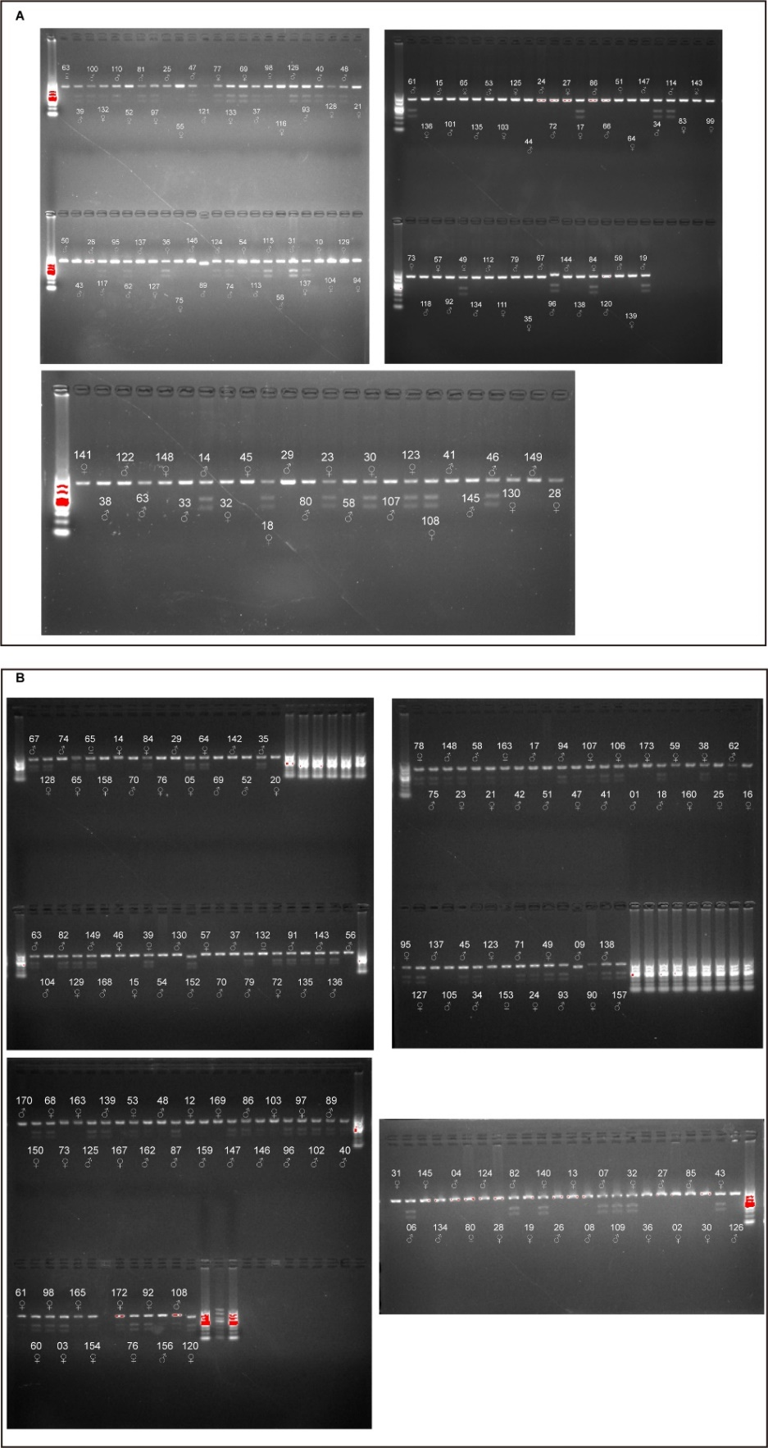
Fig. 1 F4 susceptibility screening results. A For infection model establishment. B For J25/Gen treatment
Fig. 2 Effects of graded levels ETEC challenge on piglets. A Experimental design. B Fecal fluid content analysis. Data are presented as mean ± SEM, n = 18; *, compared with the NC group, P＜0.05. C Diarrhea score: 0, normal; 1, loose stool; 2, moderate diarrhea; 3, severe diarrhea. Data are presented as mean ± SEM, n = 18. D Cytokines measured in the serum on d 0, after ETEC challenge for 24 h, and on d 5. Data are presented as mean ± SEM, n = 6. E Total bacteria and E. coli populations in the feces. Data are presented as mean ± SEM, n = 6. ANOVA followed by Tukey’s multiple comparisons test; different lowercase letters within each group indicate significantly different values (P＜0.05)

Fig. 3 J25’s effects on jejunum morphology, inflammation status and fecal microbiota output. A Morphological measurement of the jejunum. B and C Cytokines in the serum. D Cytokines in the jejunum. E Fecal E.coli and total bacteria detected on d 0, ETEC 24 h and d 5 by PCR. Data are presented as mean ± SEM, n = 8. ANOVA followed by Tukey’s multiple comparisons test; different lowercase letters within each group indicate significantly different values (P＜0.05)

Fig. 4 J25’s effects on ETEC-challenged mice. A Experimental design of repeated trials in the mouse model. B Body weight changes (relative to original weight, set as 100%). Data are presented as mean ± SEM, n = 18. C Diarrhea score. Scoring standards: 0, normal; 1, loose stool; 2, moderate diarrhea; 3, severe diarrhea. Data are presented as mean ± SEM, n = 18. D Representative images of the jejunum by H&E staining and histopathological scores. Data are presented as mean ± SEM, n = 6. E Cytokines levels in the serum. Data are presented as mean ± SEM, n = 6. F and G Representative FACS plots of CD3⁻CD49b⁺ (F) and F4/80⁺CD11b⁺ (G) staining of cells isolated from mouse jejunums, and quantification of the results. Data are presented as mean ± SEM, n = 4. ANOVA followed by Tukey’s multiple comparisons test; different lowercase letters within each group indicate significantly different values (P＜0.05)
Fig. 5 Relative abundance of predicted metabolic potential of microbes from ETEC and ETEC+J25 groups, as predicted by PICRUSt2

Fig. 6 Correlation matrix between microbiota and important parameters. Only genera with statistically significantly change are shown. Spearman correlation, *, P＜0.05; **, P＜0.01; ***, P＜0.001

Fig. 7 Significantly altered metabolites in neuron-related pathways identified by the metabolome. A–F Metabolites in the dopaminergic neuron pathway. (C, E–H) Metabolites in the serotonergic neuron pathway. (C, D, I, J) Metabolites in the glutamatergic neuron pathway. I and J Metabolites in the GABAergic neuron pathway. (C, K, L) Metabolites in the cholinergic neuron pathway. Data are presented as mean ± SEM, n = 8. ANOVA followed by Dunnett’s multiple comparisons test; different lowercase letters within each group indicate significantly different values (P＜0.05)

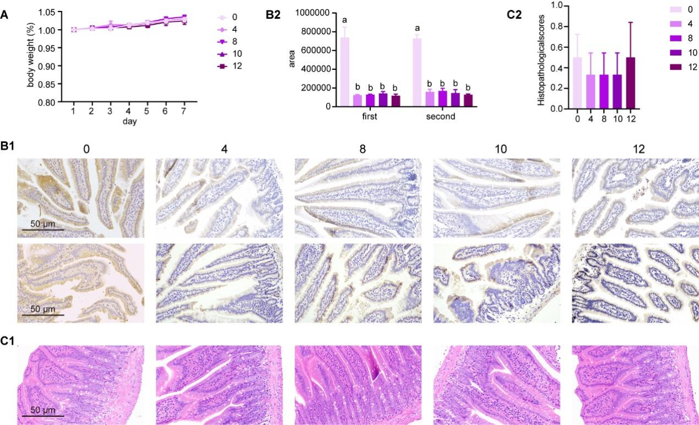
Fig. 8 Effects of graded levels of 6-OHDA lesions on mice. A Body weight changes (relative to original weight, set as 100%), d 1, n = 12; d 2–7, n = 6, data are presented as mean ± SEM. B Representative images of TH immunoreactivity by the immunohistochemistry method in the jejunum on d 1 (first, top of B1) and d 6 (second, bottom of B1), and relative immunolabeling quantification (B2). C Representative images of the jejunum by H&E staining on d 6 and histopathological scores. Data are presented as mean ± SEM, n = 6. ANOVA followed by Tukey’s multiple comparisons test; different lowercase letters within each group indicate significantly different values (P＜0.05)

Fig. 9 Gentamicin-induced resistance was significantly associated with altered microbiota structure. A Annotation results of differential metabolites between ETEC and Gen groups. B Differential metabolites in the vancomycin resistance pathway. Data are presented as mean ± SEM, n = 8. ANOVA followed by Dunnett’s multiple comparisons test; different lowercase letters within each group indicate significantly different values (P < 0.05). C Canonical Correspondence Analysis plot. The arrow length represents the strength of the correlation between the environmental variables and the microbes. The longer the arrow, the stronger the correlation. The perpendicular distance between the microbes and the environmental variable axes on the plot reflects their correlations. The less the distance, the stronger the correlation

