Additional file 1
Supplementary methods
Methods for RT-qPCR validation
Total RNA was isolated from yolk sac tissue, using RNeasy Universal kit (Qiagen, Hilden, Germany). RNA concentrations were determined by Nanodrop 1000 (Thermo Scientific, Waltham, MA, USA). Total RNA from each sample was reverse transcribed into cDNA, using a cDNA synthesis kit (Qiagen, Hilden, Germany). cDNA was verified by 1.5% agarose gel electrophoresis.
For qRT-PCR, 1 µL cDNA and 1 µL forward and reverse primers (4 nmol/L) were added to 5 µL SYBR green-based mix (QuantiNova, Qiagen, Hilden, Germany) and filled up with 3 µL RNAse free water to a total volume of 10 µL. The primer sequences (Sigma Aldrich, St. Louis, MO, USA) used for real-time PCR are listed in Table S1. RT-PCR was carried out on a Viia7 real-time PCR machine (Thermo Scientific, Waltham, MA, USA). All reactions were analysed in duplicate. PCR was performed under the following conditions: 2 min 95 °C, followed by 45 cycles of 5 s 95 °C and 20 s 60 °C. A melt curve was produced at the end of the run to determine single product amplification.
In SAS 9.4, the PROC CORR procedure was used to correlate log-transformed qRT-PCR data (Ct-values) with log-transformed RNAseq data (RPKM).
Table S1 Target genes and primer sequences of immune mediators used for RT-qPCR analysis
Gene | Accession No. | Primer sequence (5'→3')¹ | Reference
BACT | X00182 | F: CAACACAGTGCTGTCTGGTGGTA | (St. Paul et al., 2011)
 |  | R: ATCGTACTCCTGCTTGCTGATCC
CD3D | NM_205512.2 | F: TGTTGTCGCCACTGTCTTGCTG | (Song et al., 2021)
 |  | R: GTCCATCATTCCGCTCACCAAGG
IL8L1 | NM_205018.2 | F: CACGTTCAGCGATTGAACTC | (Santos et al., 2019)
 |  | R: GACTTCCACATTCTTGCAGTG
NFKB | XM_046915553.1 | F: GAAGGAATCGTACCGGGAACA | (Chiang et al., 2009)
 |  | R: CTCAGAGGGCCTTGTGACAGTAA
TGFB4 | M31160 | F: ACCTCGACACCGACTACTGCTT | (Lammers et al., 2010)
 |  | R: ATCCTTGCGGAAGTCGATGT
TNFA | XM_046927265.1 | F: CCCCTACCCTGTCCCACAA | (Liu et al., 2019)
 |  | R: TGAGTACTGCGGAGGGTTCAT
BACT β-Actin, CD3D CD3 δ subunit of T-cell Receptor Complex, IL8L1 Interleukin 8, NFKB Nuclear factor κB, TGFB4 Transforming growth factor β, TNFA Tumor necrosis factor α
¹F: forward primer; R reverse primer
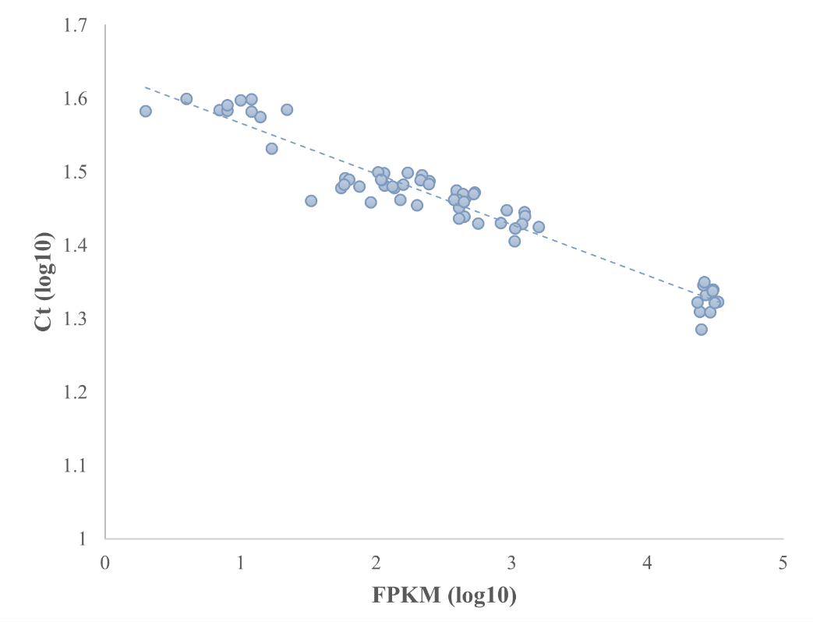
Fig. S1 Correlation between gene expression level of 6 candidate genes, using RNAseq and qPCR. Ct: CT value; FPKM: Fragments Per Kilobase of transcript per Million mapped reads. The results showed a high correlation coefficient (-0.93; P < 0.0001) between gene expression of these genes measured using qPCR (Ct value) and RNAseq (RPKM)
Supplementary results
Table S2 Differentially expressed genes in the yolk sac of broiler embryos at embryonic day 19.5, affected by in ovo delivery of carvacrol with a false discovery rate (FDR) of < 0.10
Gene | Log Fold Change | FDR | Expression in control group (saline) | Expression in carvacrol group
ATP6V0C | -0.68 | 0.041 | 7368 ± 482 | 5171 ± 546
C2CD3 | 1.27 | 0.053 | 106 ± 16 | 286 ± 55
DIO3 | -3.18 | 0.061 | 19 ± 8 | 2 ± 1
DSEL | 0.95 | 0.001 | 1190 ± 57 | 2496 ± 137
ENPP7 | 1.85 | 0.033 | 59 ± 11 | 228 ± 48
FJX1 | 1.45 | 0.081 | 11 ± 2 | 33 ± 6
FNIP1 | -1.10 | 0.002 | 502 ± 56 | 260 ± 30
HBE1 | 2.13 | 0.095 | 87 ± 22 | 396 ± 108
KHDRBS3 | -1.16 | 0.061 | 93 ± 12 | 46 ± 7
KLF5 | -1.23 | 0.061 | 570 ± 120 | 276 ± 35
OSCP1 | 3.86 | 0.002 | 13 ± 1 | 200 ± 60
TMEM38A | -0.66 | 0.053 | 2144 ± 180 | 1493 ± 118
TOPAZ1 | 2.56 | 0.006 | 2 ± 1 | 11 ± 1
ZFPM1 | -1.23 | 0.000 | 433 ± 51 | 205 ± 15
ATP6V0C ATPase H⁺ transporting V0 subunit c, C2CD3 C2 domain containing 3 centriole elongation regulator, DIO3 Deiodinase, iodothyronine type III, DSEL Dermatan sulfate epimerase like, ENPP7 Ectonucleotide pyrophosphatase/phosphodiesterase 7, FJX1 Four jointed box 1, FNIP1 Folliculin interacting protein 1, HBE1 Hemoglobin subunit epsilon 1, KHDRBS3 KH RNA binding domain containing, signal transduction associated 3, KLF5 Kruppel like factor 5, OSCP1 Organic solute carrier partner 1, TMEM38A Transmembrane protein 38A, TOPAZ1 Testis and ovary specific PAZ domain containing 1, ZFPM1 Zinc finger protein, FOG family member 1
Gene expression is showed as Fragments Per Kilobase per Millon mapped reads (Mean ± SE)

