Fig. S1. Variant set obtained by integrating two genotyping strategies (Single-reference genotyping and Graph-based genotyping). Files are displayed in blocks, with each step labeled on the right. Gray indicates input files.

Fig. S2. Principal component (PC) analysis (a) and ADMIXTURE analysis (b) based on single reference typing.

Fig. S3. Genome-wide distribution (sliding window = 50 kb, step size = 25 kb) of selective eliminations determined by fixed index (Fst) between DLW and QCB pigs using SVs.

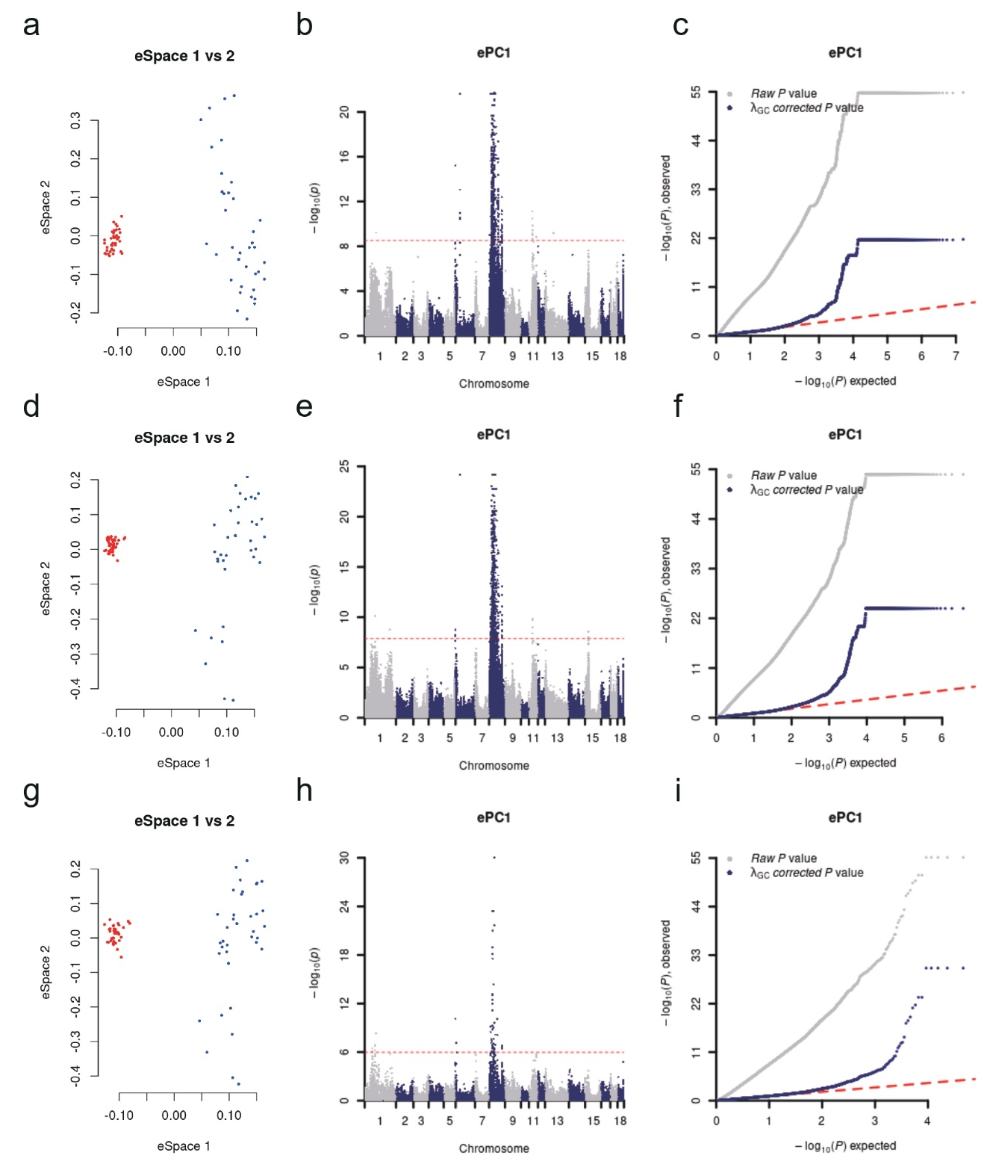

Fig. S4. EigenGWAS analysis was conducted across the whole genome for 37 QCB pigs and 40 DLW pigs. The red line represents the 0.05/n threshold, with eigenvector 1 used as a covariate. a-c The results of EigenGWAS analysis based on SNPs: a is a PCA plot, b is a Manhattan plot, and c is a QQ plot. d-f The EigenGWAS analysis results based on INDELs: d is a PCA plot, e is a Manhattan plot, and f is a QQ plot. g-i The EigenGWAS analysis results based on SVs: g is a PCA plot, h is a Manhattan plot, and i is a QQ plot.

