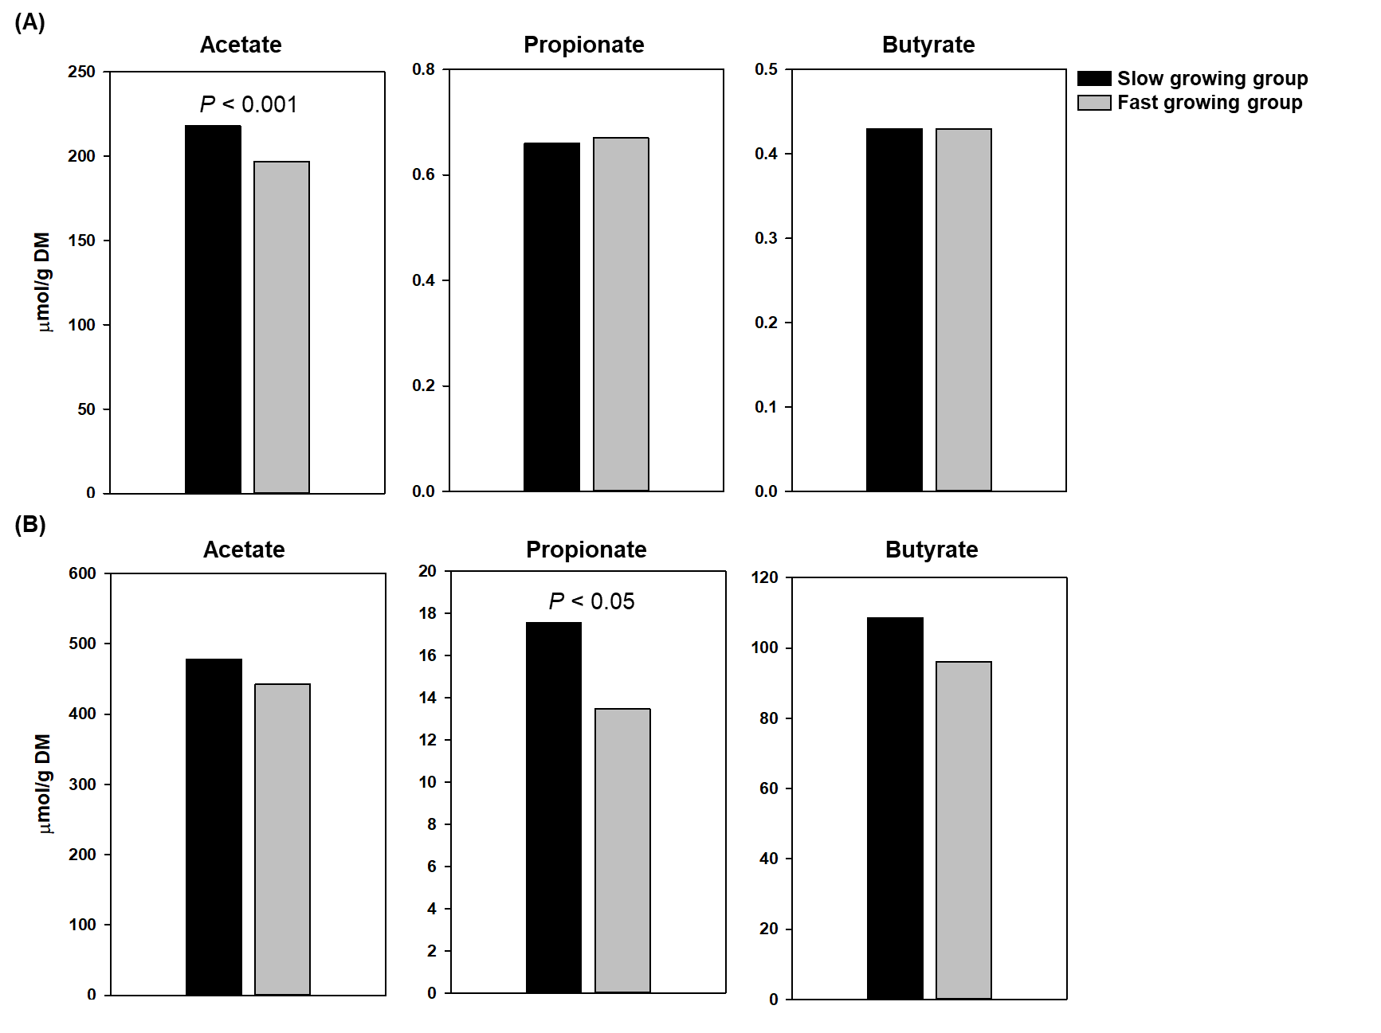
Fig. S2. Concentrations of acetate, propionate, and butyrate in (A) ileal and (B) cecal contents of slow and fast growing chickens at d 25.

