Additional file 4: Parameter tuning process of support vector regression
We used the python package sklearn.svm.SVR [36] for hyperparameter tuning and data analysis. Parameters and/or options are listed (see Additional file 2: Table S2).
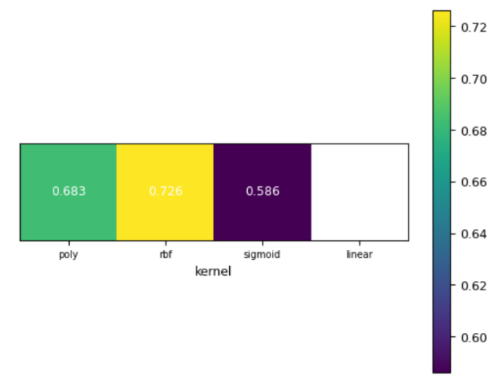
We started the tuning process by choosing a kernel. We used the same simulated data as was used in the tuning process of RF and again used the correlation between predicted values and TBV of animals from generation 16 as accuracy. We considered the kernels ‘poly’, ‘rbf’, ‘sigmoid’, and ‘linear’, respectively, while using default settings for other parameters.

Figure S1 Prediction accuracy for different kernel in SVR while using default setting for other parameters
We found that kernel ‘rbf’ reached the highest accuracy, so we used ‘rbf’ in our further tuning (Fig. S1). Then we tuned gamma. Both the ‘auto’ and ‘scale’ option are related to the number of features which is not fixed in our dataset, so we did not consider using a fixed number. We tried the options ‘auto’ and ‘scale’. We found that ‘scale’ resulted in a higher accuracy than ‘auto’, so we used the default setting, ‘scale’, in the further tuning process (Fig. S2).
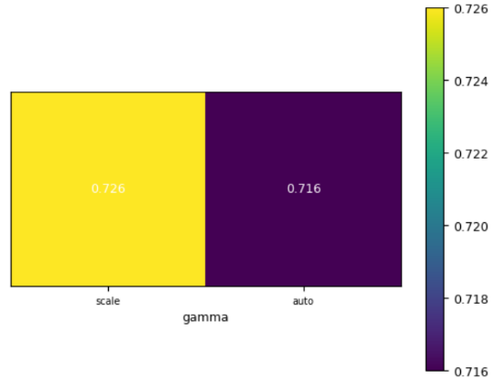
Figure S2 Prediction accuracy for different gamma options in SVR while using default setting for other parameters
Finally, we tuned parameter C, using 0.001, 0.01, 0.1, 0.4, 1, 4, 7, 10, 100, 1,000. We found that the prediction accuracy reached the highest accuracy when C was 1 (Fig. S3).

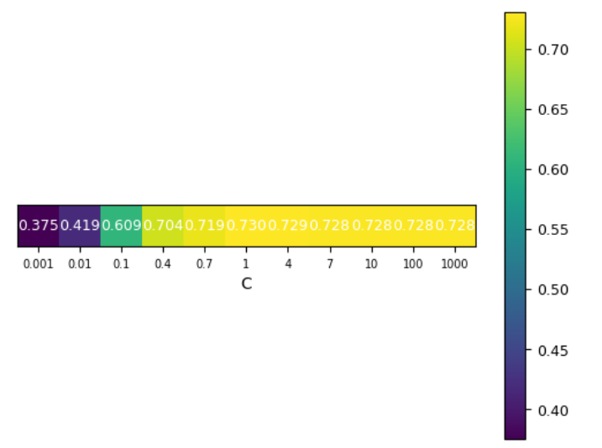
Figure S3 Prediction accuracy for different values for C in SVR while using default setting for other parameters
So we decided to use C of 1.

