Additional file 5
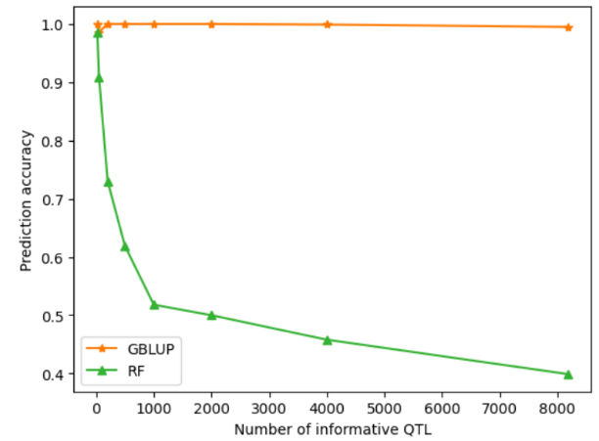
a

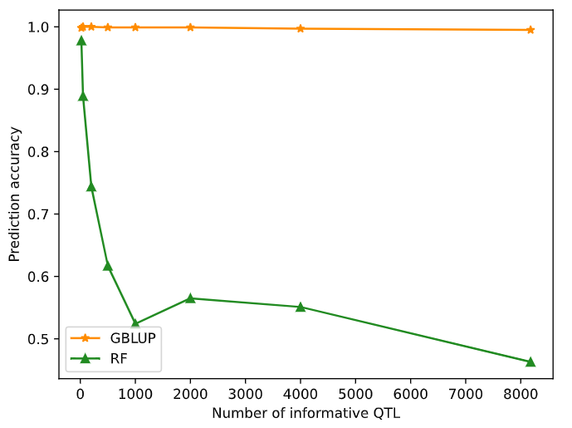
b

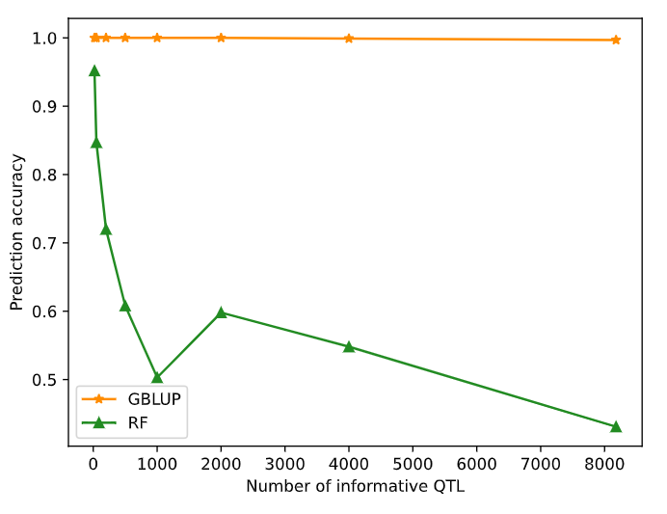
c

Figure S1 Prediction accuracy of RF and GBLUP using simulated dataset with different number of informative QTL. a) QTL only, b) QTL combined with SNPs that close to the QTL, and the number of SNPs was twice the number of QTL and c) QTL combined with fixed number (10,000) of SNPs

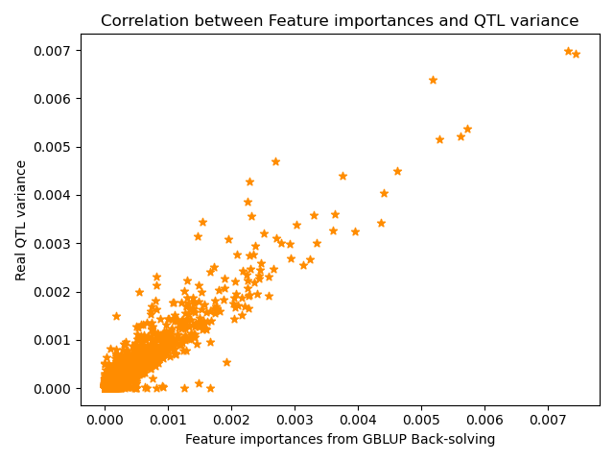
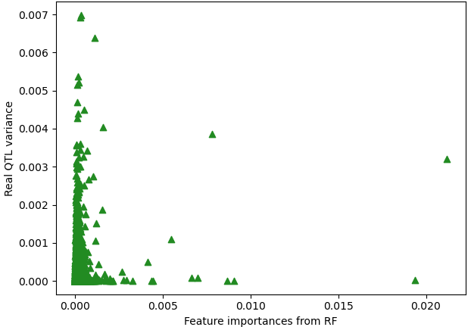

a b
Figure S2 Real QTL variance against variance or importance obtained from a) GBLUP and b) RF

