Fig. S1 Statistical analysis of the relative average optical density in immunohistochemical staining. A Lamin B protein. B P53 protein.

Fig. S2 The relative positive area of β-gal staining after transfection with miR-210a-5p inhibitor or mimic.

Fig. S3 The siRNAs interference efficiency of RASL11B.

Fig. S4 The relative positive area of β-gal staining after after treatment with si-RASL11B or OE-RASL11B.

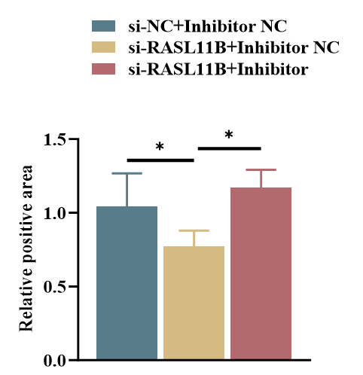
Fig. S5 The relative positive area of β-gal staining following co-transfection with miR-210a-5p inhibitor or NC and RASL11B siRNA or NC.

Fig. S6 The relative positive area of β-gal staining following co-treatment with Sorafenib or DMSO and OE-RASL11B or empty vector.

