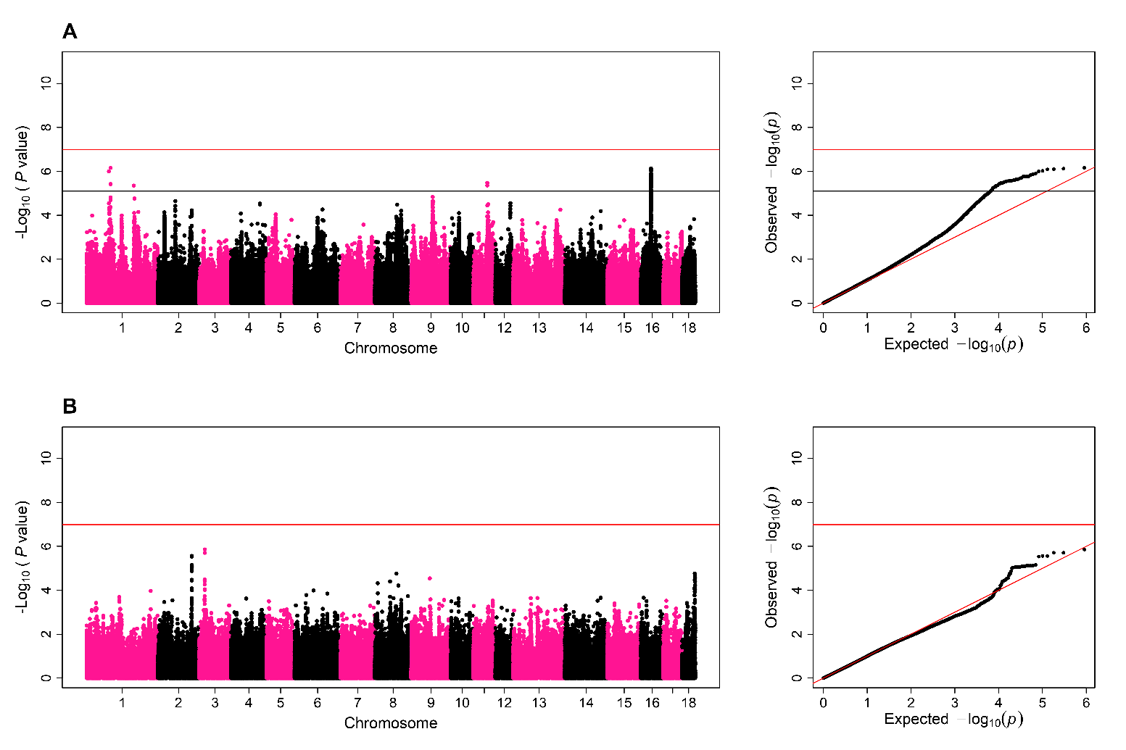
Manhattan plot and QQ-plot for the genome-wide association study of additive (A) and dominance/recessive (B) effects on ejaculate volume. In the Manhattan plots of the GWAS for both additive and dominance/recessive effects, each dot represents a SNP. The x-axis shows the chromosome position of SNP and the y-axis shows -log₁₀(P-values) for the association test. The red line shows the threshold for significant associations according to the Bonferroni criterion. The black line shows the threshold for suggestive associations according to a false discovery rate of 5%. In the QQ-plot of the GWAS for both additive and dominance/recessive effects, each dot also represents a SNP but the x-axis and y-axis show the expected and observed distribution of −log₁₀(P-values), respectively.

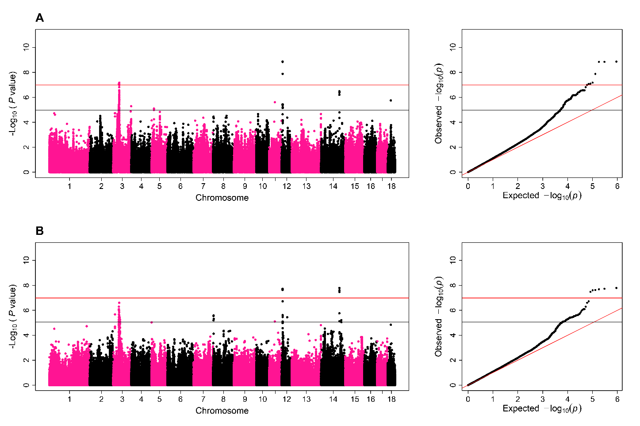
Manhattan plot and QQ-plot for the genome-wide association study of additive (A) and dominance/recessive (B) effects on ejaculate concentration. In the Manhattan plots of the GWAS for both additive and dominance/recessive effects, each dot represents a SNP. The x-axis shows the chromosome position of SNP and the y-axis shows −log₁₀(P-values) for the association test. The red line shows the threshold for significant associations according to the Bonferroni criterion. The black line shows the threshold for suggestive associations according to a false discovery rate of 5%. In the QQ-plot of the GWAS for both additive and dominance/recessive effects, each dot also represents a SNP but the x-axis and y-axis show the expected and observed distribution of −log₁₀(P-values), respectively.

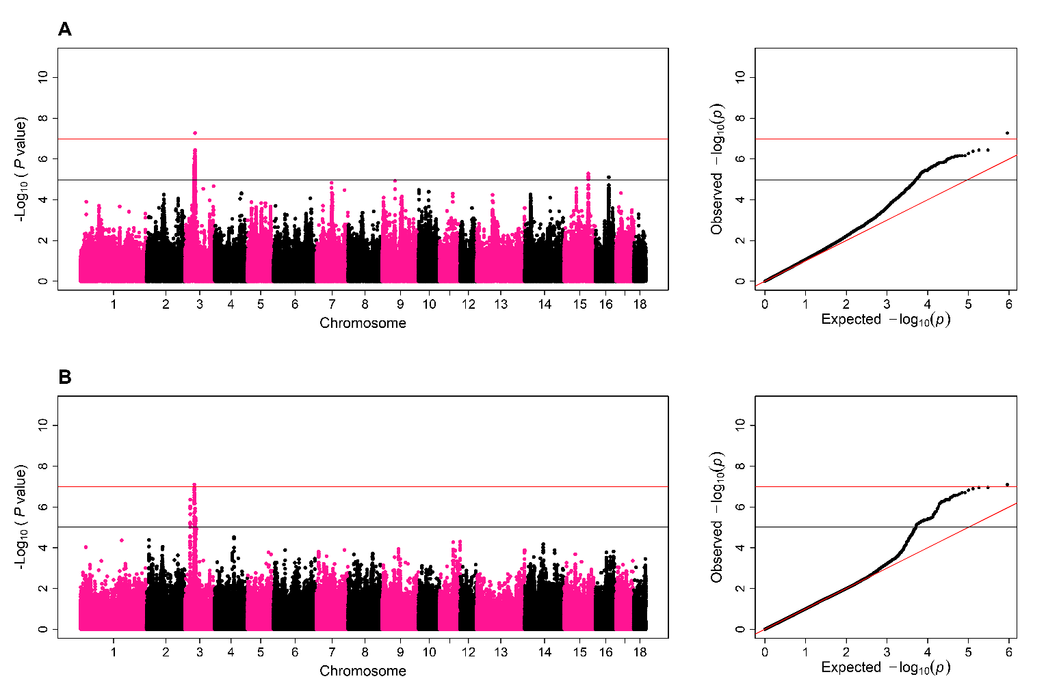
Manhattan plot and QQ-plot for the genome-wide association study of additive (A) and dominance/recessive (B) effects on total number of sperm cells in an ejaculate. In the Manhattan plots of the GWAS for both additive and dominance/recessive effects, each dot represents a SNP. The x-axis shows the chromosome position of SNP and the y-axis shows −log₁₀(P-values) for the association test. The red line shows the threshold for significant associations according to the Bonferroni criterion. The black line shows the threshold for suggestive associations according to a false discovery rate of 5%. In the QQ-plot of the GWAS for both additive and dominance/recessive effects, each dot also represents a SNP but the x-axis and y-axis show the expected and observed distribution of −log₁₀(P-values), respectively.

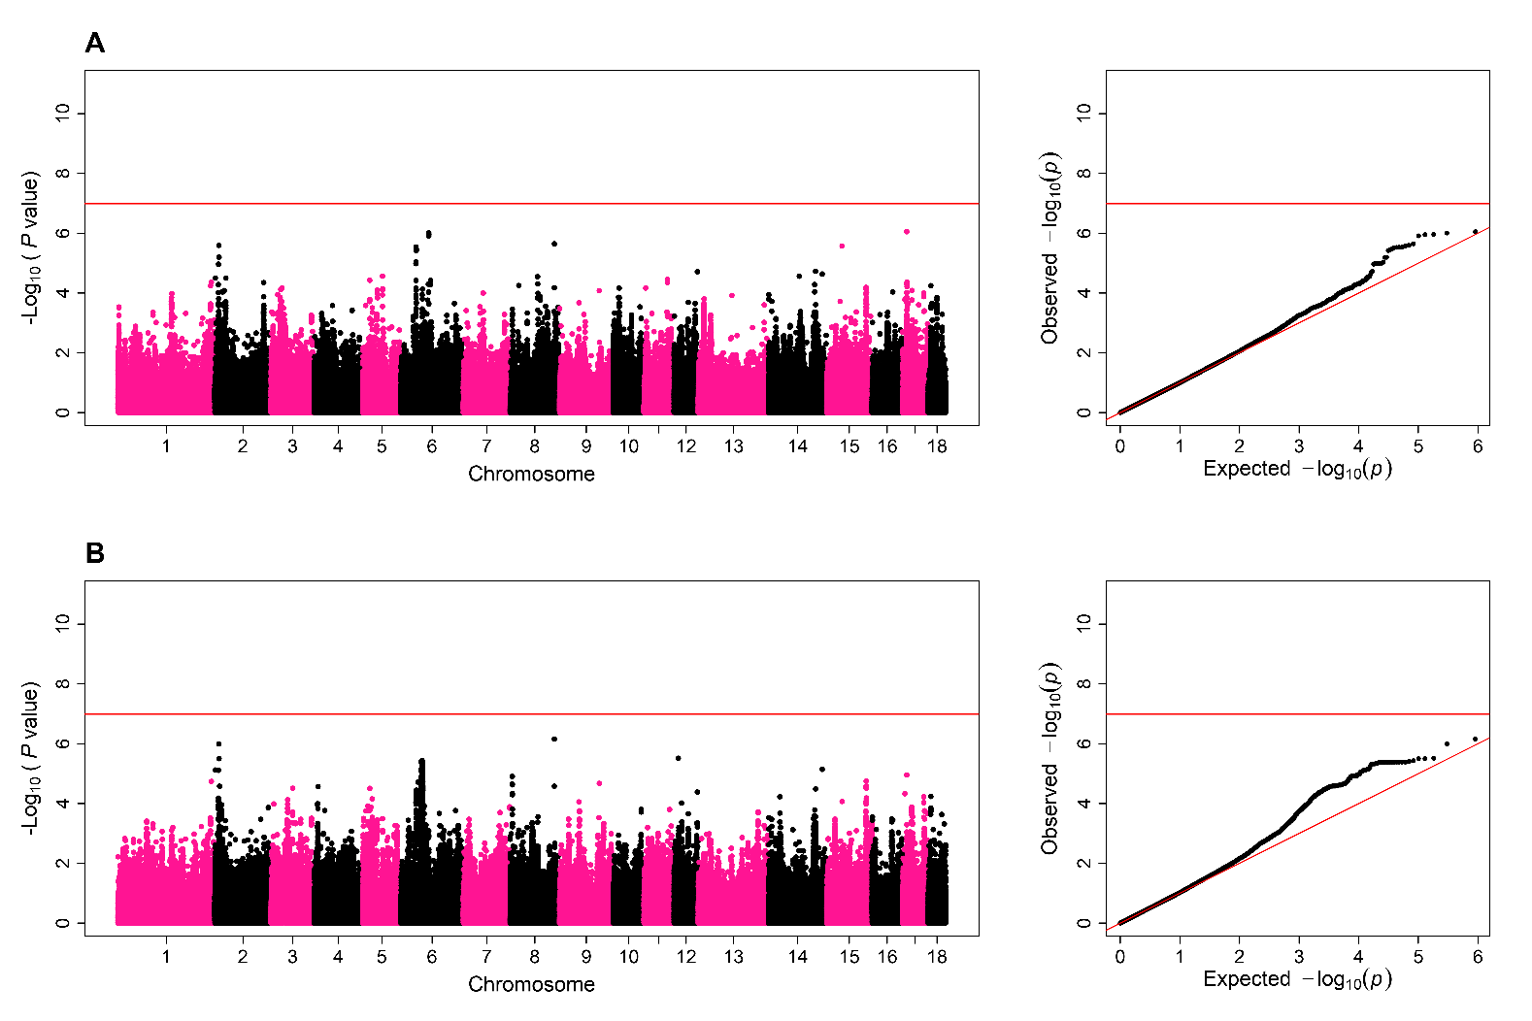
Manhattan plot and QQ-plot for the genome-wide association study of additive (A) and dominance/recessive (B) effects on total motility of fresh semen. In the Manhattan plots of the GWAS for both additive and dominance/recessive effects, each dot represents a SNP. The x-axis shows the chromosome position of SNP and the y-axis shows −log₁₀(P-values) for the association test. The red line shows the threshold for significant associations according to the Bonferroni criterion. The black line shows the threshold for suggestive associations according to a false discovery rate of 5%. In the QQ-plot of the GWAS for both additive and dominance/recessive effects, each dot also represents a SNP but the x-axis and y-axis show the expected and observed distribution of −log₁₀(P-values), respectively.

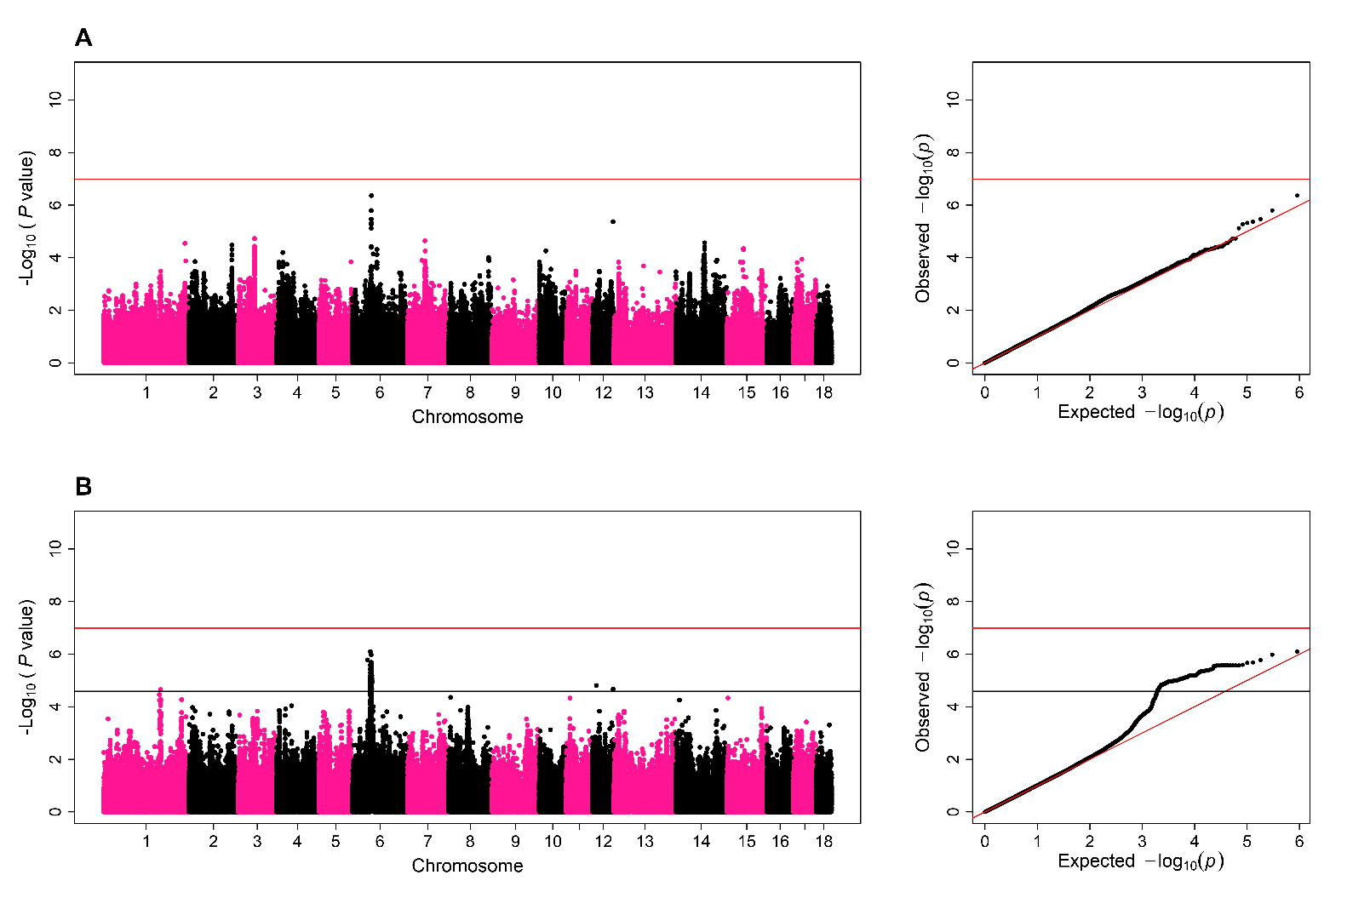
Manhattan plot and QQ-plot for the genome-wide association study of additive (A) and dominance/recessive (B) effects on progressive motility of fresh semen. In the Manhattan plots of the GWAS for both additive and dominance/recessive effects, each dot represents a SNP. The x-axis shows the chromosome position of SNP and the y-axis shows −log₁₀(P-values) for the association test. The red line shows the threshold for significant associations according to the Bonferroni criterion. The black line shows the threshold for suggestive associations according to a false discovery rate of 5%. In the QQ-plot of the GWAS for both additive and dominance/recessive effects, each dot also represents a SNP but the x-axis and y-axis show the expected and observed distribution of −log₁₀(P-values), respectively.

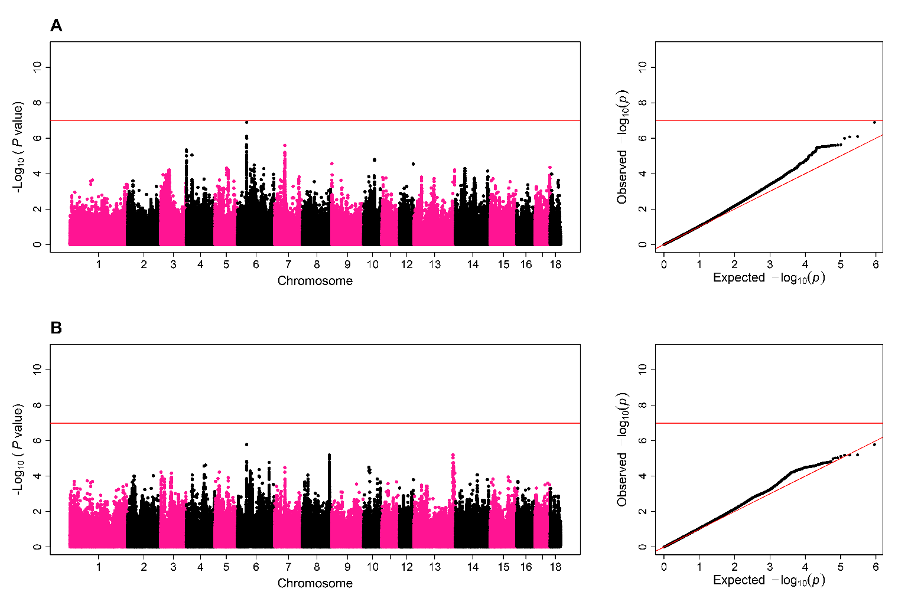
Manhattan plot and QQ-plot for the genome-wide association study of additive (A) and dominance/recessive (B) effects on total motility after three days of storage. In the Manhattan plots of the GWAS for both additive and dominance/recessive effects, each dot represents a SNP. The x-axis shows the chromosome position of SNP and the y-axis shows −log₁₀(P-values) for the association test. The red line shows the threshold for significant associations according to the Bonferroni criterion. The black line shows the threshold for suggestive associations according to a false discovery rate of 5%. In the QQ-plot of the GWAS for both additive and dominance/recessive effects, each dot also represents a SNP but the x-axis and y-axis show the expected and observed distribution of −log₁₀(P-values), respectively.
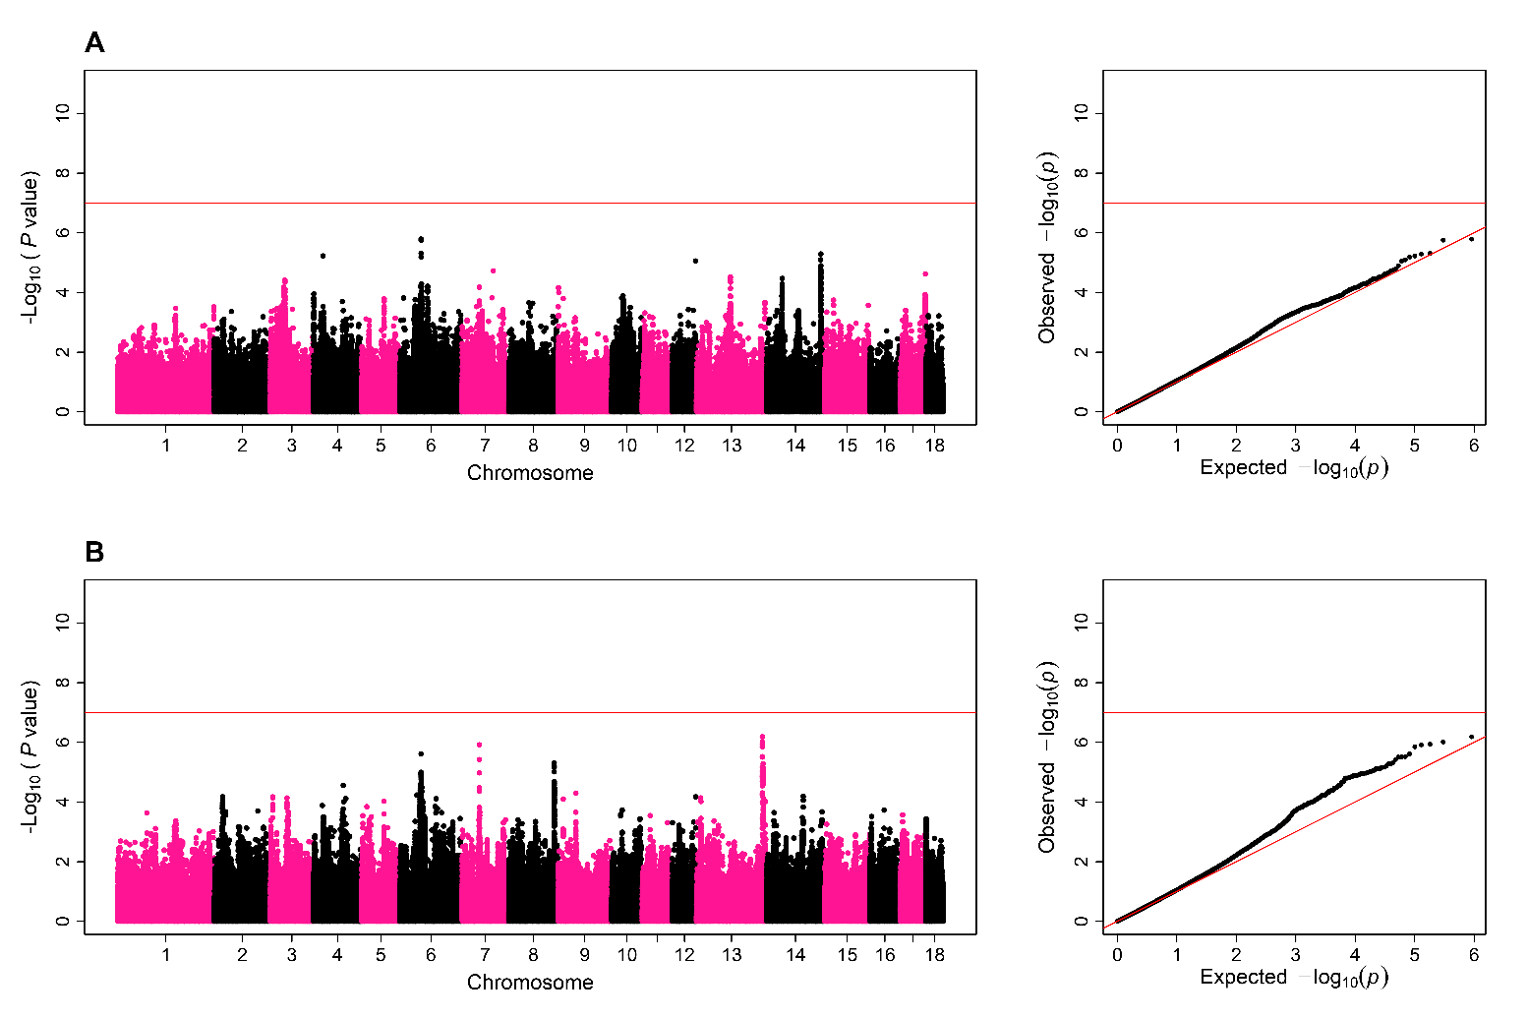
Manhattan plot and QQ-plot for the genome-wide association study of additive (A) and dominance/recessive (B) effects on progressive motility after three days of storage. In the Manhattan plots of the GWAS for both additive and dominance/recessive effects, each dot represents a SNP. The x-axis shows the chromosome position of SNP and the y-axis shows −log₁₀(P-values) for the association test. The red line shows the threshold for significant associations according to the Bonferroni criterion. The black line shows the threshold for suggestive associations according to a false discovery rate of 5%. In the QQ-plot of the GWAS for both additive and dominance/recessive effects, each dot also represents a SNP but the x-axis and y-axis show the expected and observed distribution of −log₁₀(P-values), respectively.

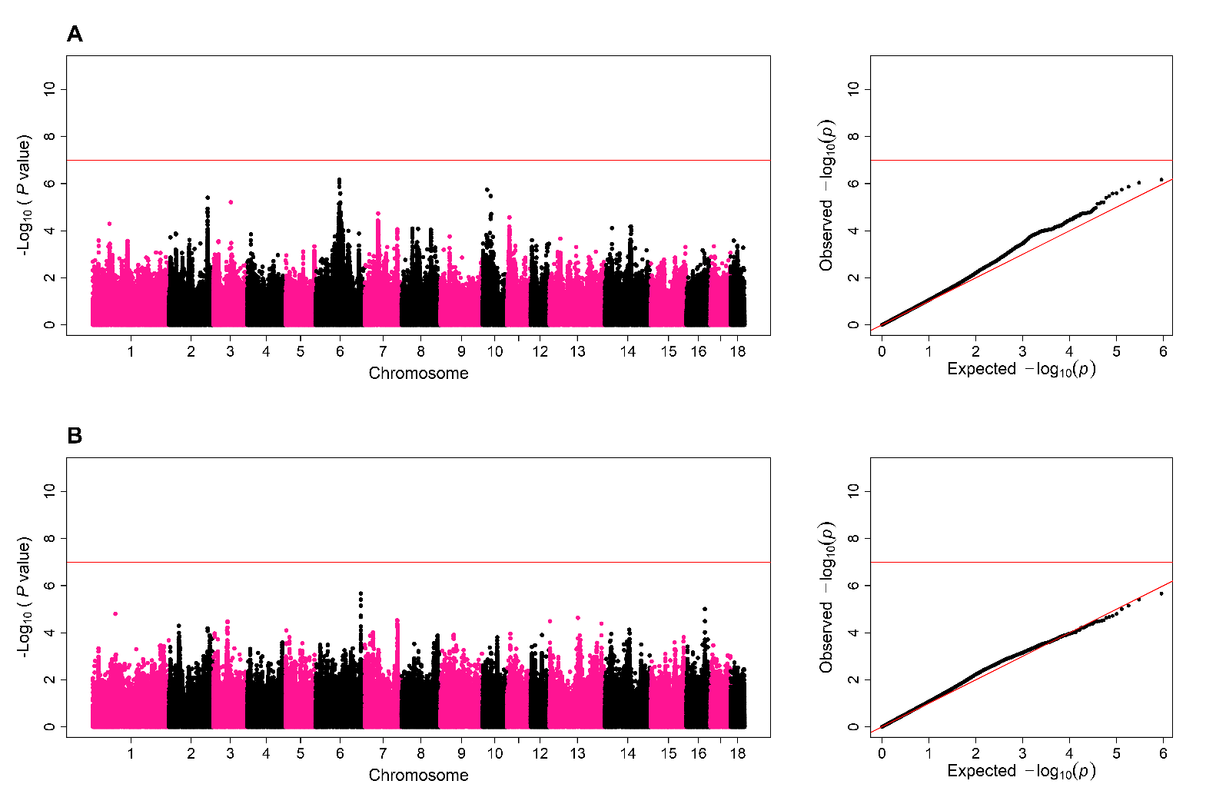
Manhattan plot and QQ-plot for the genome-wide association study of additive (A) and dominance/recessive (B) effects on total morphological abnormalities. In the Manhattan plots of the GWAS for both additive and dominance/recessive effects, each dot represents a SNP. The x-axis shows the chromosome position of SNP and the y-axis shows −log₁₀(P-values) for the association test. The red line shows the threshold for significant associations according to the Bonferroni criterion. The black line shows the threshold for suggestive associations according to a false discovery rate of 5%. In the QQ-plot of the GWAS for both additive and dominance/recessive effects, each dot also represents a SNP but the x-axis and y-axis show the expected and observed distribution of −log₁₀(P-values), respectively.

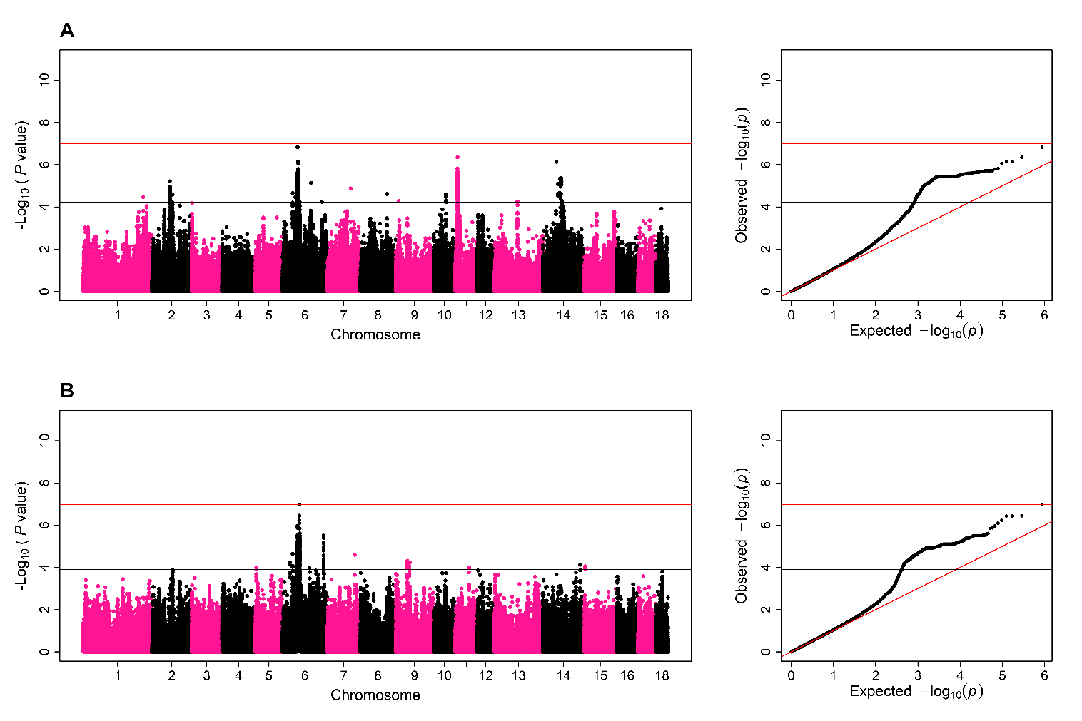
Manhattan plot and QQ-plot for the genome-wide association study of additive (A) and dominance/recessive (B) effects on total cytoplasmic droplets. In the Manhattan plots of the GWAS for both additive and dominance/recessive effects, each dot represents a SNP. The x-axis shows the chromosome position of SNP and the y-axis shows −log₁₀(P-values) for the association test. The red line shows the threshold for significant associations according to the Bonferroni criterion. The black line shows the threshold for suggestive associations according to a false discovery rate of 5%. In the QQ-plot of the GWAS for both additive and dominance/recessive effects, each dot also represents a SNP but the x-axis and y-axis show the expected and observed distribution of −log₁₀(P-values), respectively.

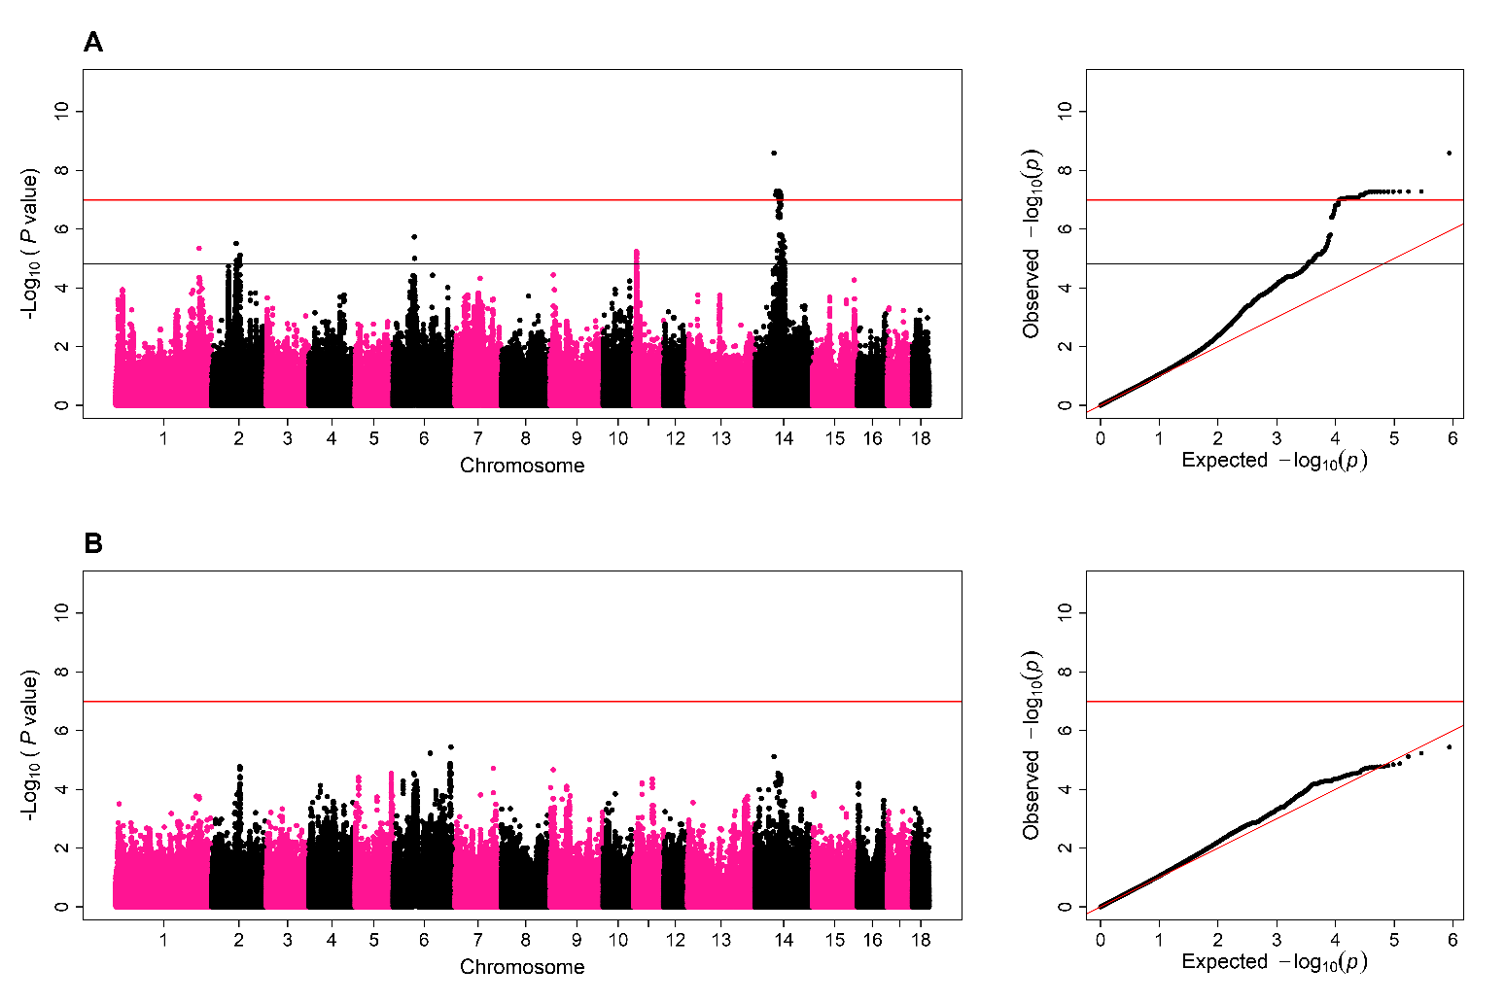
Manhattan plot and QQ-plot for the genome-wide association study of additive (A) and dominance/recessive (B) effects on proximal cytoplasmic droplets. In the Manhattan plots of the GWAS for both additive and dominance/recessive effects, each dot represents a SNP. The x-axis shows the chromosome position of SNP and the y-axis shows −log₁₀(P-values) for the association test. The red line shows the threshold for significant associations according to the Bonferroni criterion. The black line shows the threshold for suggestive associations according to a false discovery rate of 5%. In the QQ-plot of the GWAS for both additive and dominance/recessive effects, each dot also represents a SNP but the x-axis and y-axis show the expected and observed distribution of −log₁₀(P-values), respectively.

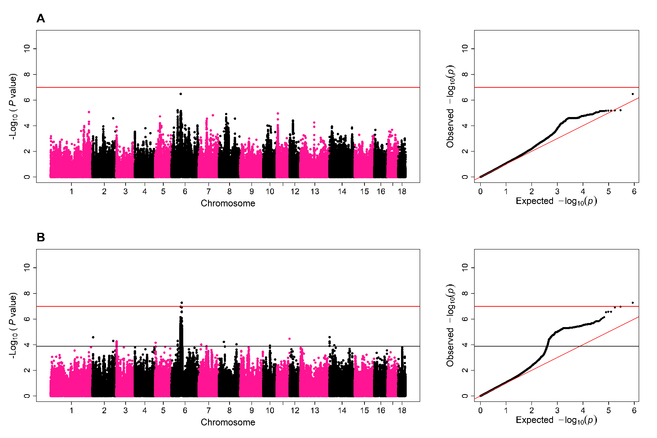
Manhattan plot and QQ-plot for the genome-wide association study of additive (A) and dominance/recessive (B) effects on distal cytoplasmic droplets. In the Manhattan plots of the GWAS for both additive and dominance/recessive effects, each dot represents a SNP. The x-axis shows the chromosome position of SNP and the y-axis shows −log₁₀(P-values) for the association test. The red line shows the threshold for significant associations according to the Bonferroni criterion. The black line shows the threshold for suggestive associations according to a false discovery rate of 5%. In the QQ-plot of the GWAS for both additive and dominance/recessive effects, each dot also represents a SNP but the x-axis and y-axis show the expected and observed distribution of −log₁₀(P-values), respectively.

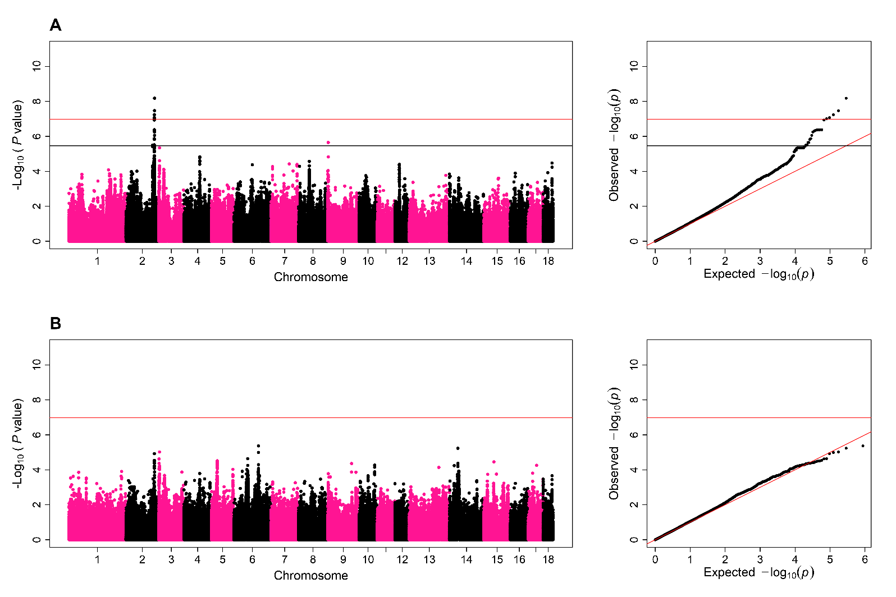
Manhattan plot and QQ-plot for the genome-wide association study of additive (A) and dominance/recessive (B) effects on distal midpiece reflex. In the Manhattan plots of the GWAS for both additive and dominance/recessive effects, each dot represents a SNP. The x-axis shows the chromosome position of SNP and the y-axis shows −log₁₀(P-values) for the association test. The red line shows the threshold for significant associations according to the Bonferroni criterion. The black line shows the threshold for suggestive associations according to a false discovery rate of 5%. In the QQ-plot of the GWAS for both additive and dominance/recessive effects, each dot also represents a SNP but the x-axis and y-axis show the expected and observed distribution of −log₁₀(P-values), respectively.

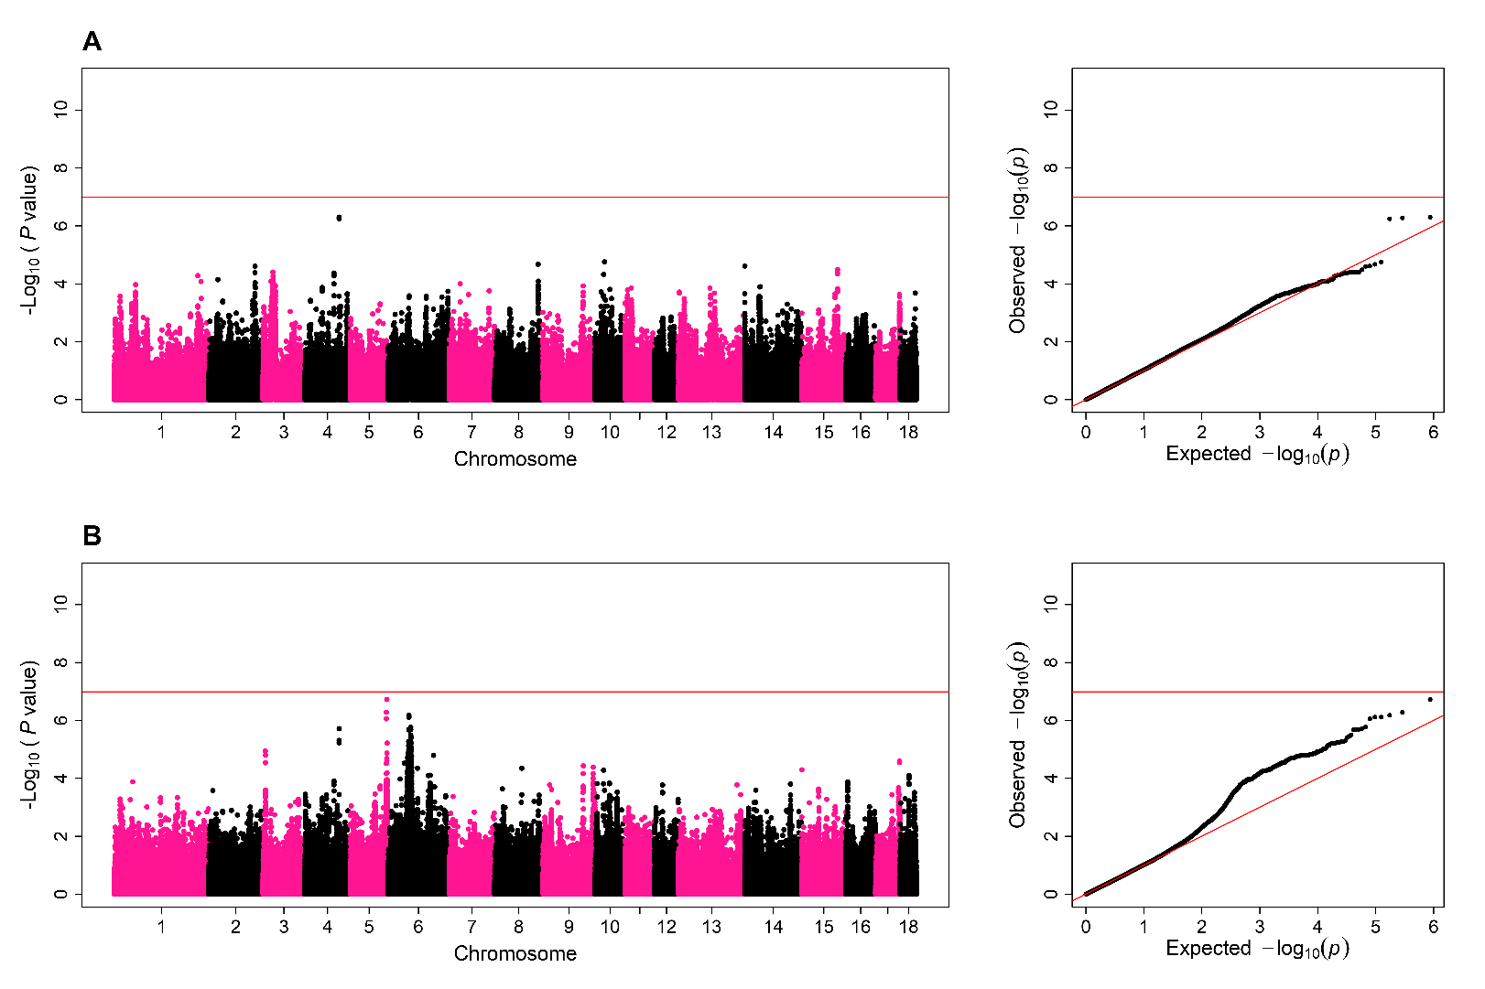
Manhattan plot and QQ-plot for the genome-wide association study of additive (A) and dominance/recessive (B) effects on bent tail. In the Manhattan plots of the GWAS for both additive and dominance/recessive effects, each dot represents a SNP. The x-axis shows the chromosome position of SNP and the y-axis shows −log₁₀(P-values) for the association test. The red line shows the threshold for significant associations according to the Bonferroni criterion. The black line shows the threshold for suggestive associations according to a false discovery rate of 5%. In the QQ-plot of the GWAS for both additive and dominance/recessive effects, each dot also represents a SNP but the x-axis and y-axis show the expected and observed distribution of −log₁₀(P-values), respectively.

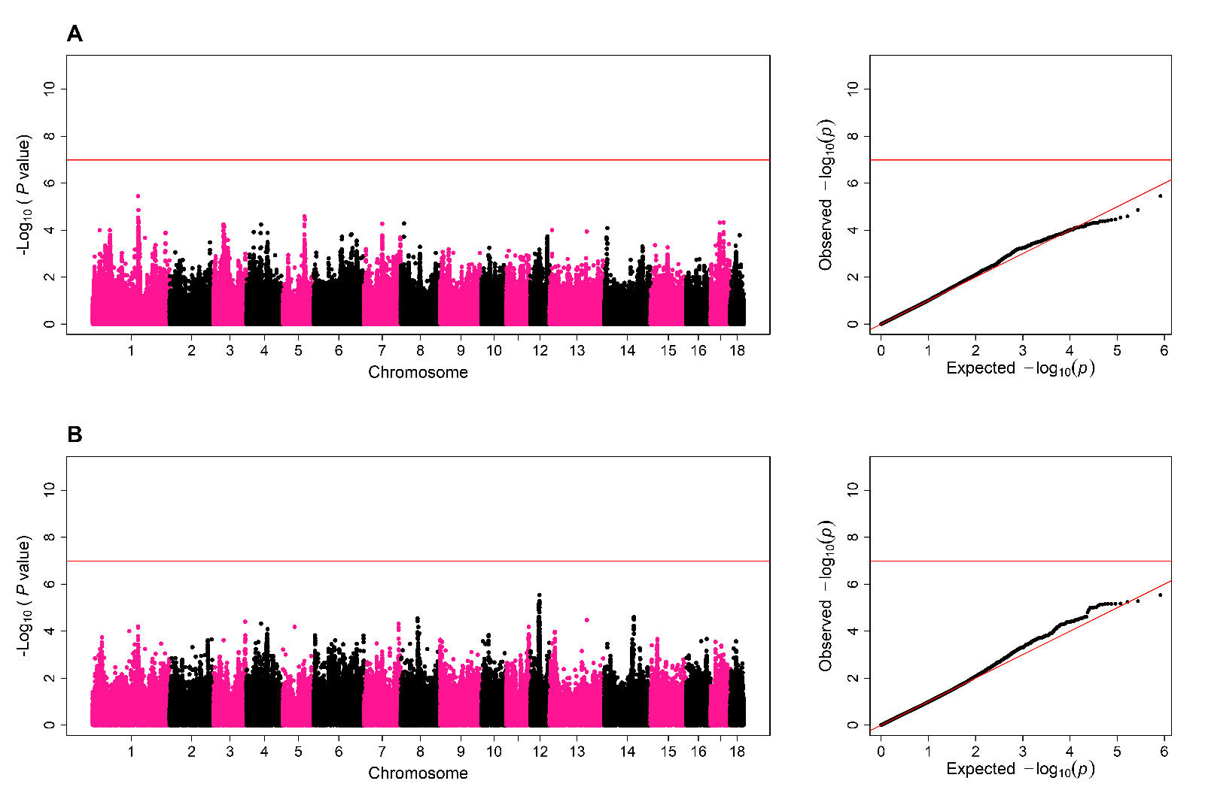
Manhattan plot and QQ-plot for the genome-wide association study of additive (A) and dominance/recessive (B) effects on abnormal acrosome. In the Manhattan plots of the GWAS for both additive and dominance/recessive effects, each dot represents a SNP. The x-axis shows the chromosome position of SNP and the y-axis shows −log₁₀(P-values) for the association test. The red line shows the threshold for significant associations according to the Bonferroni criterion. The black line shows the threshold for suggestive associations according to a false discovery rate of 5%. In the QQ-plot of the GWAS for both additive and dominance/recessive effects, each dot also represents a SNP but the x-axis and y-axis show the expected and observed distribution of −log₁₀(P-values), respectively.

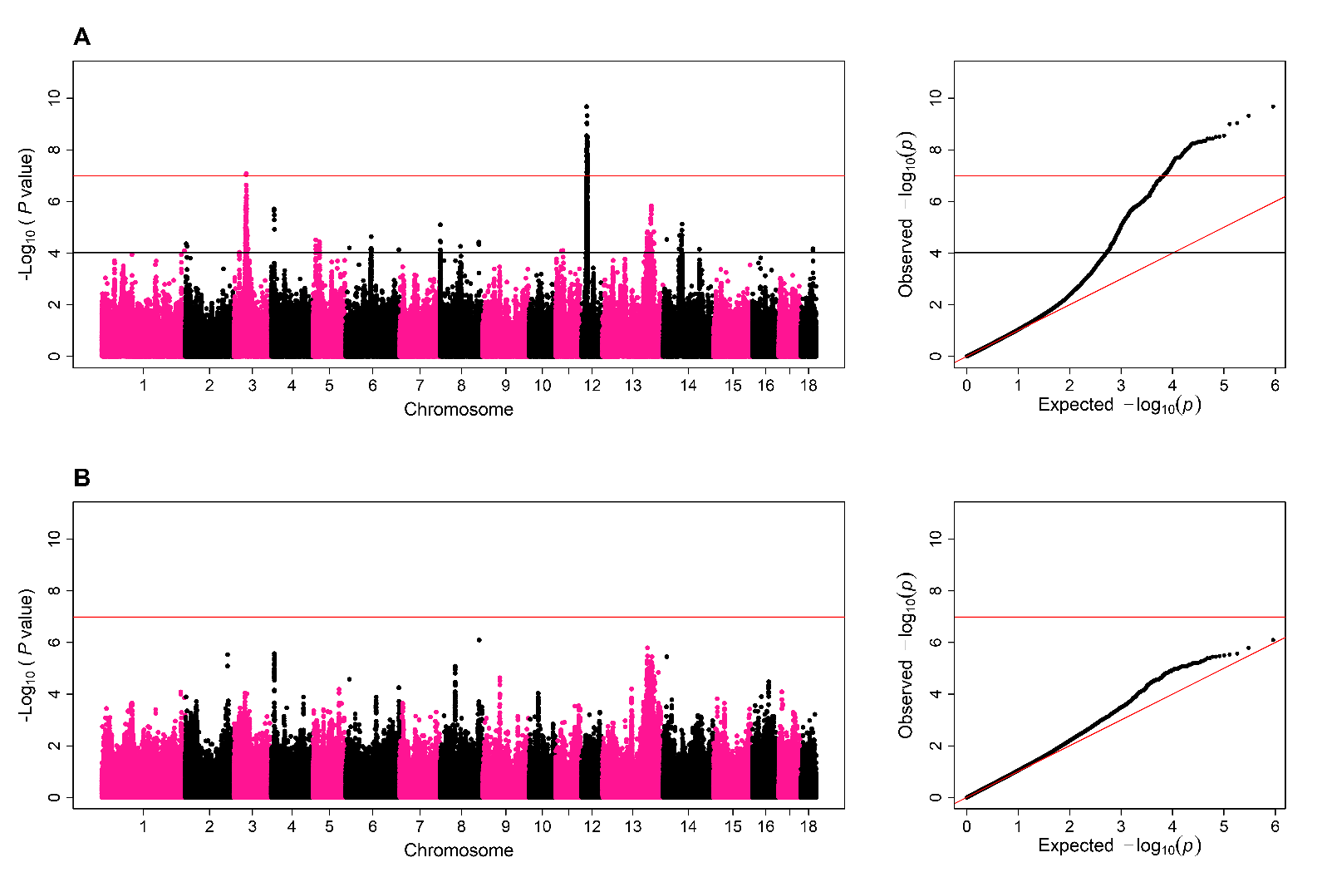
Manhattan plot and QQ-plot for the genome-wide association study of additive (A) and dominance/recessive (B) effects on abnormal head. In the Manhattan plots of the GWAS for both additive and dominance/recessive effects, each dot represents a SNP. The x-axis shows the chromosome position of SNP and the y-axis shows −log₁₀(P-values) for the association test. The red line shows the threshold for significant associations according to the Bonferroni criterion. The black line shows the threshold for suggestive associations according to a false discovery rate of 5%. In the QQ-plot of the GWAS for both additive and dominance/recessive effects, each dot also represents a SNP but the x-axis and y-axis show the expected and observed distribution of −log₁₀(P-values), respectively.

