Supplementary Figures

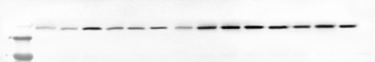
ZO-1
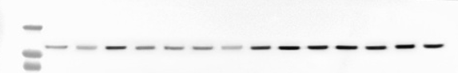
Clauding-1

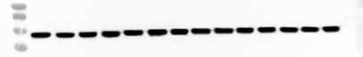
β-actin

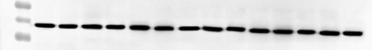
β-actin

