qRT-PCR validation of transcriptome sequencing data
To validate the transcriptome data, quantitative real-time polymerase chain reaction (qRT-PCR) was performed on key differentially expressed genes (GLUL, IDH1, CAMK2A, PDXK, FADS1, SCD, and NRG4) identified in the RNA-seq analysis. qRT-PCR was carried out using the SYBR Green I dye method on an Applied Biosystems QuantStudio™ 5 real-time quantitative PCR instrument (Thermo Fisher Scientific, USA). The reactions were prepared using the PerfectStart® Green qPCR SuperMix (+Universal Passive Reference Dye) kit (TransGen Biotech Co., Ltd., Beijing, China), following the manufacturer’s instructions (Table 1). Primers (Table 2) were designed based on goat (Capra hircus) gene sequences available in the NCBI database using the Primer-BLAST online tool (https://www.ncbi.nlm.nih.gov/tools/primer-blast/) and synthesized by Sangon Biotech Co., Ltd. (Shanghai, China). The relative expression levels of the target genes were calculated using the 2^{⁻ΔΔCt} method.

Table S8 Quantitative Real-time polymerase chain reaction system
Component | Volume
cDNA | 1 ul
Forward Primer（10 uM） | 0.6 ul
Reverse Primer（10 uM） | 0.6 ul
2xPerfectStart Green qPCR SuperMix | 10 ul
Nuclease-free Water | 7.8 ul
Total volume | 20 ul

Table S9 Gene primer sequences for qRT-PCR used to validate RNA-seq
Gene |  | Sequence（forward/reverse）
18S rRNA | Forward primer | GTGGTGTTGAGGAAAGCAGACA
18S rRNA | Reverse primer | TGATCACACGTTCCACCTCATC
IDH1 | Forward primer | GGACAAAAGCCGGGAAGAGA
IDH1 | Reverse primer | GACTCAGCTTACCTCCTGCG
GLUL | Forward primer | GGAGAAGAGCCAGCTGTCTAAG
GLUL | Reverse primer | CCACTCGGGCAACTCTTCTA
NRG4 | Forward primer | CAGTGTCCACCACGGAACTAC
NRG4 | Reverse primer | GTTGTGCGTGTCCTTAGCAG
CAMK2A | Forward primer | AAAGAAAGTCCAGTTCCAGCG
CAMK2A | Reverse primer | CTCTTGTTTCCGCACTTTGGT
pdxK | Forward primer | GCGGTGAACTCTGTCCAGTT
pdxK | Reverse primer | CATCACGGGGTCACACACATA
SCD | Forward primer | GTGATGTTCCAGAGGAGGTACT
SCD | Reverse primer | GGGGTTGATGGTCTTGTCGT
FADS1 | Forward primer | TGGCTCGTGATTGACCGAAA
FADS1 | Reverse primer | CCACAAAAGGATCCGTGGCA

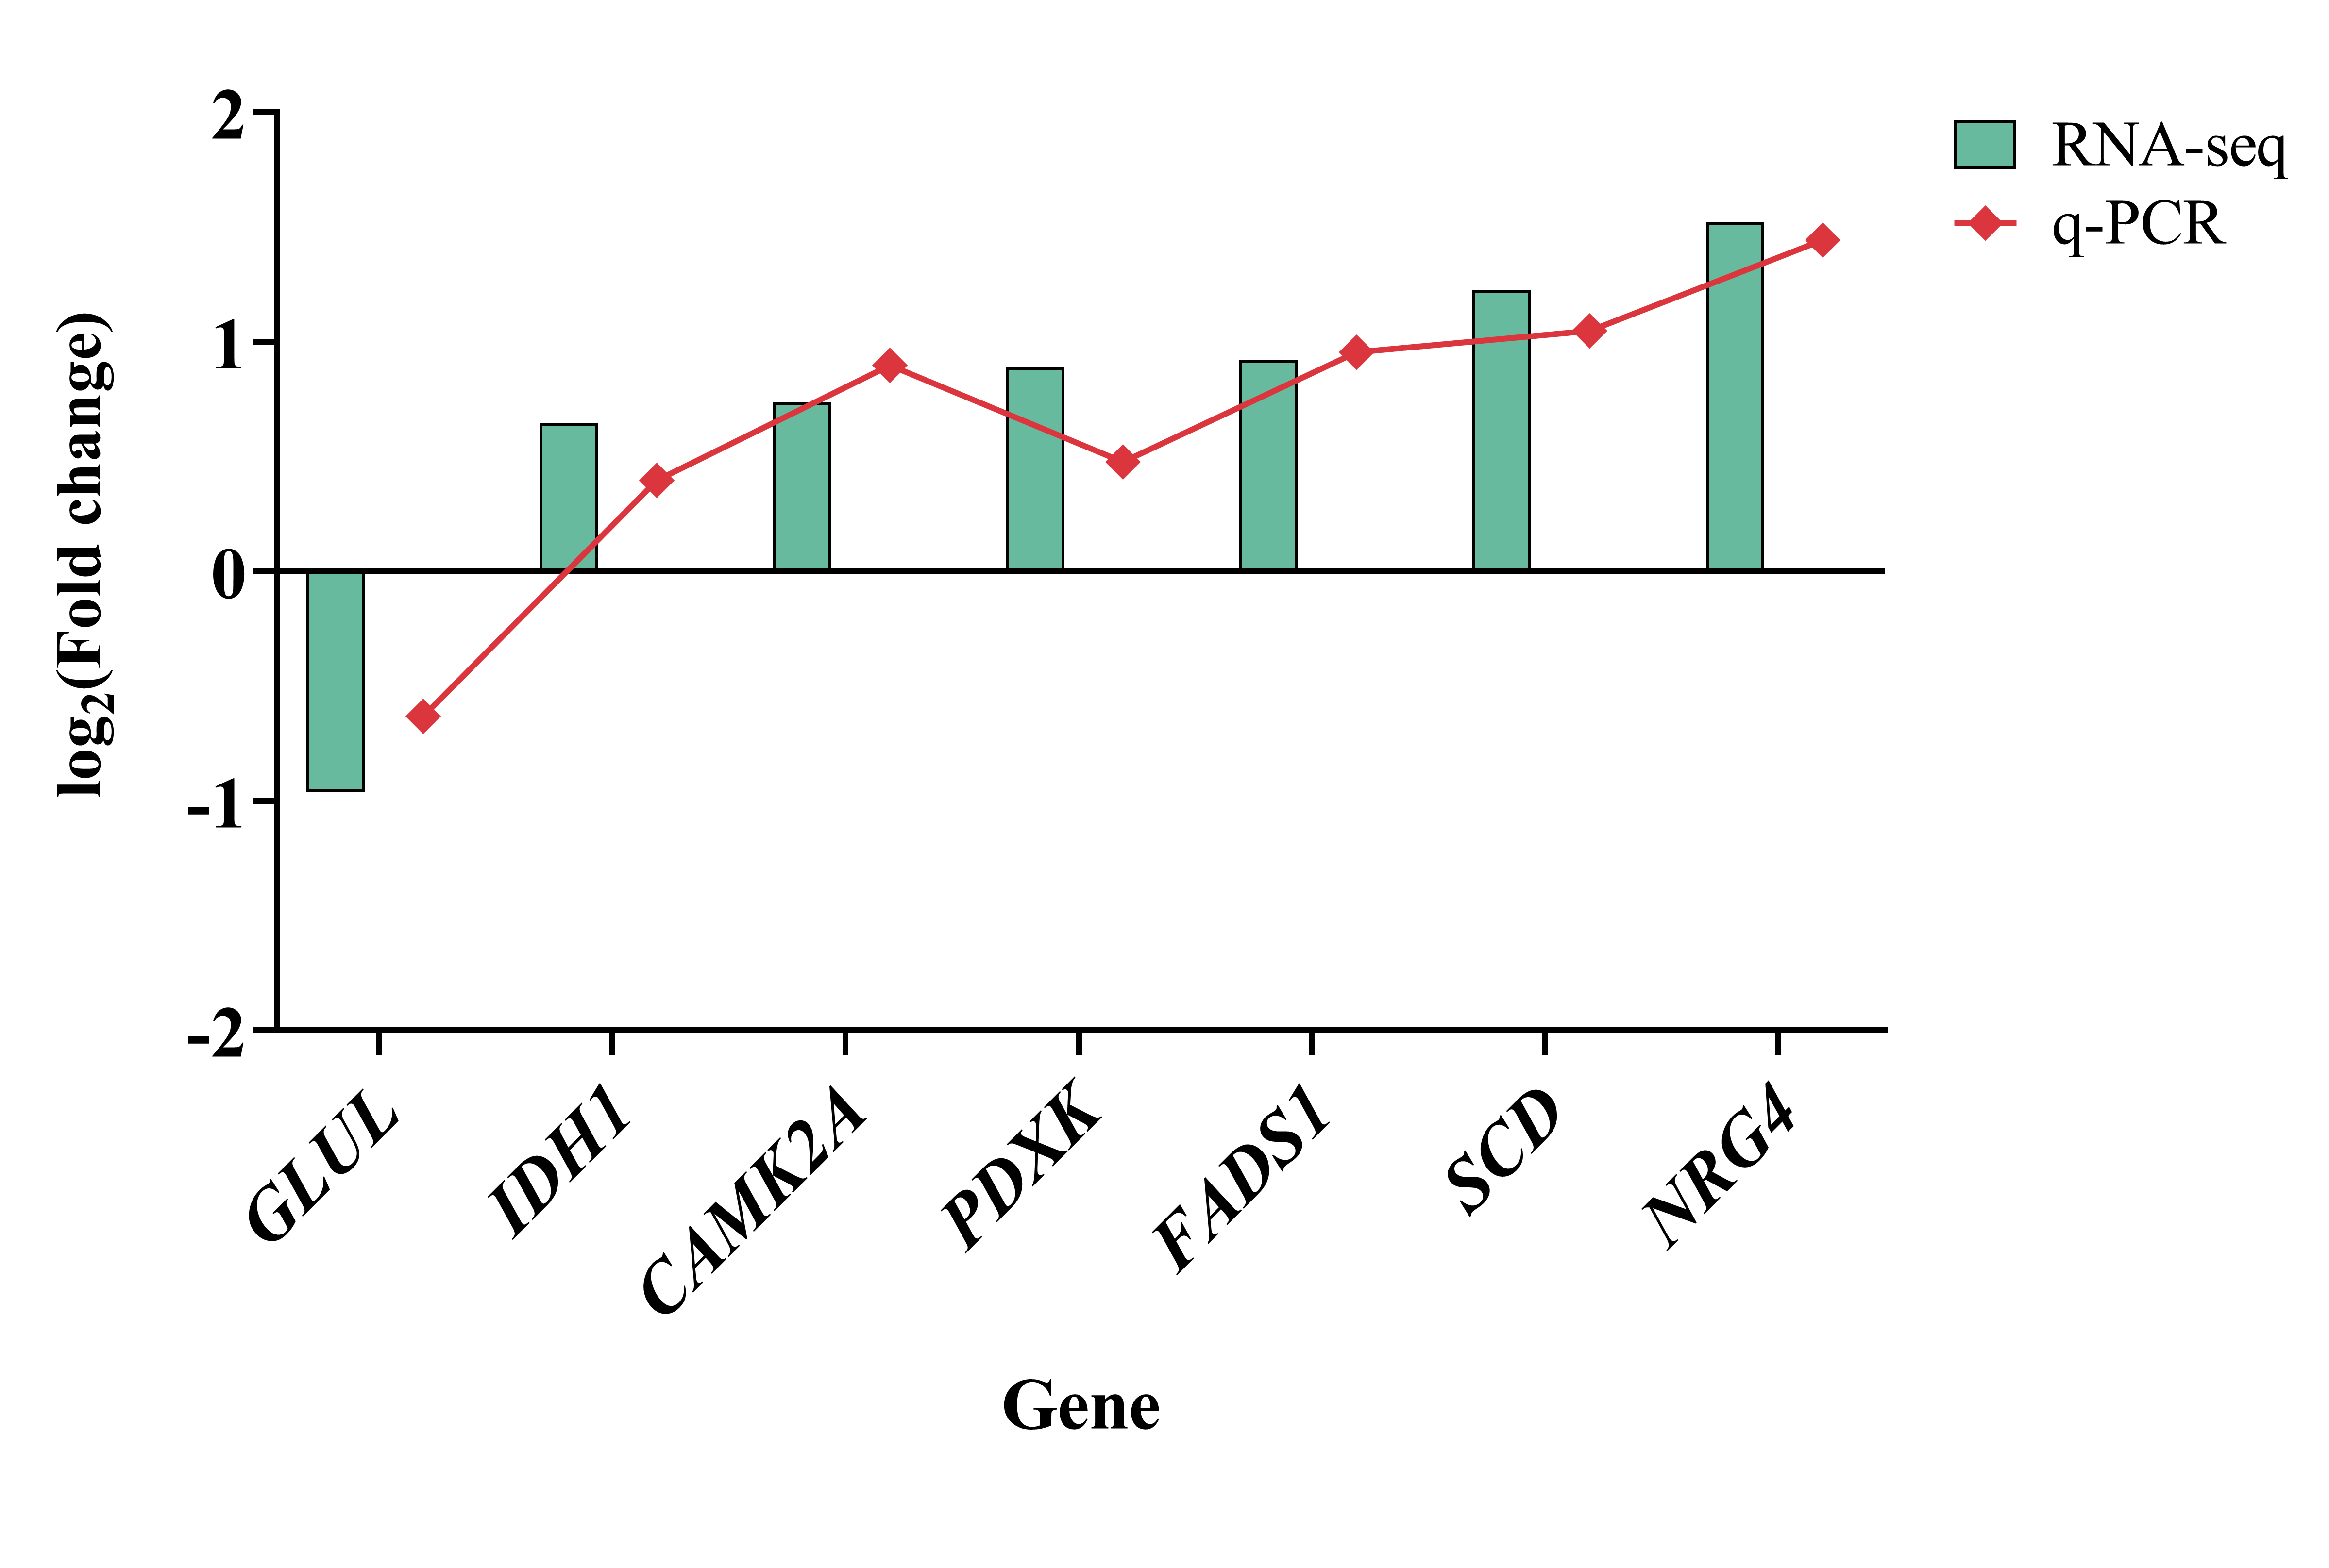
Figure S1 qRT-PCR validation of key differentially expressed genes in CON and 600PSE groups

