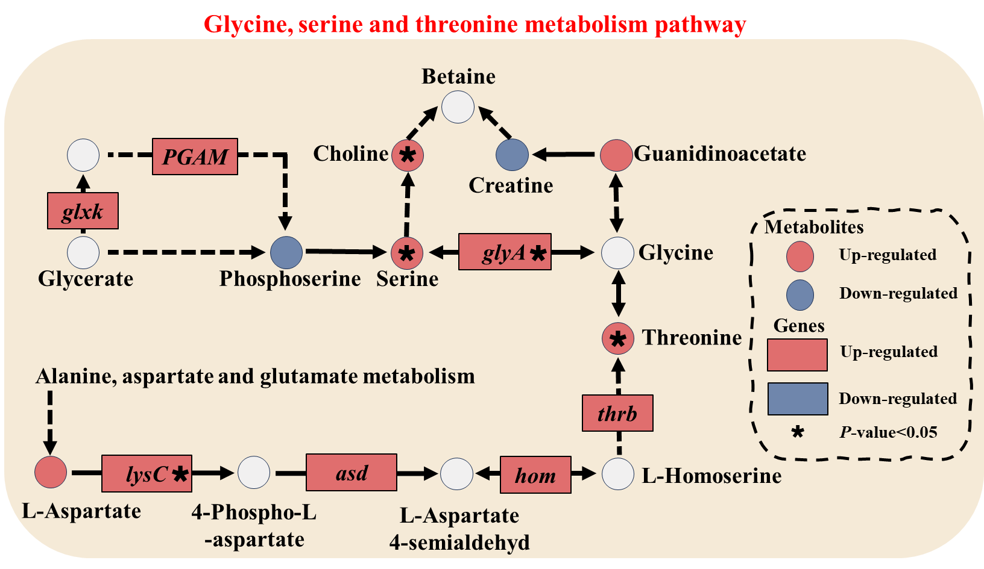
Figure S4 Differentially regulated metabolic pathway in glycine, serine, and threonine metabolism

