Supplemental Material

Outcome differences between PD-1/PD-L1 inhibitors based monotherapy and combination therapy in non-small-cell lung cancer with brain metastases

Haowei Wang, Fangfang Liu, Xiaoxia Chen, Chao Zhao, Xuefei Li, Caicun Zhou, Jie Hu, Qian Chu, Tao Jiang

Supplemental Figure S1……………………………………………………….………..2
Supplemental Figure S2……………………………………………………….………..3
Supplemental Figure S3……………………………………………………….………..4
Supplemental Figure S4……………………………………………………….………..5
Supplemental Table S1……………………………………………………………….…6
Supplemental Table S2……………………………………………………………….…9
Supplemental Table S3…………………………………………………………………11
Supplemental Table S4…………………………………………………………………13
Supplemental Table S5…………………………………………………………………15

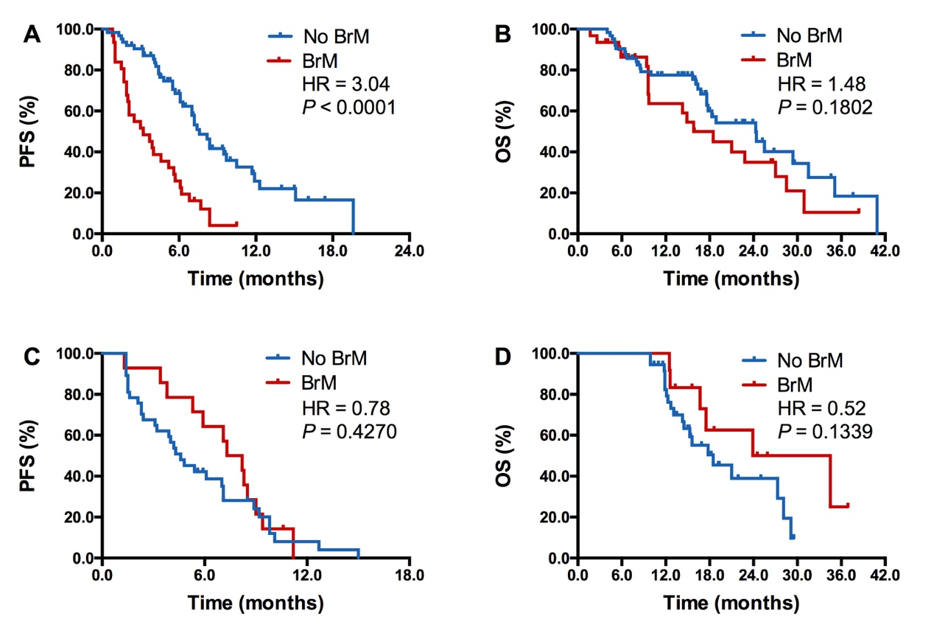
Supplemental Figure S1. Comparison of PFS and OS between patients with and without brain metastases. A, Comparison of PFS between patients with and without brain metastases in patients received anti-PD-1/PD-L1 antibodies plus chemotherapy; B, Comparison of OS between patients with and without brain metastases in patients received anti-PD-1/PD-L1 antibodies plus chemotherapy; C, Comparison of PFS between patients with and without brain metastases in patients received anti-PD-1/PD-L1 antibodies plus chemotherapy and anti-angiogenic therapy; D, Comparison of OS between patients with and without brain metastases in patients received anti-PD-1/PD-L1 antibodies plus chemotherapy and anti-angiogenic therapy. BrM, brain metastases.

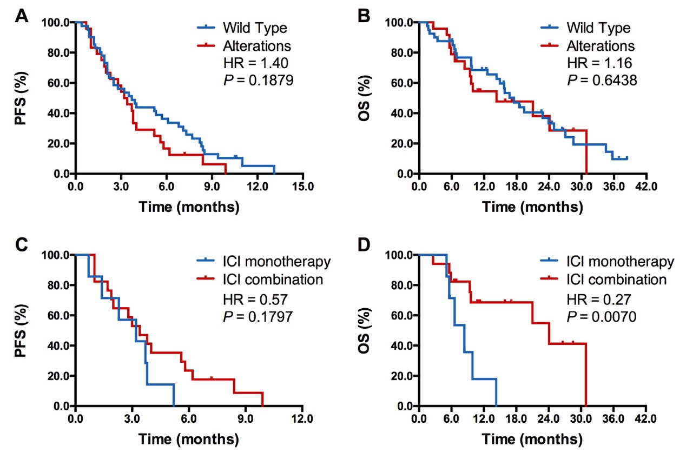
Supplemental Figure S2. Subgroup analysis in patients with BrM and driver gene alterations. A, Comparison of PFS between patients with and without driver gene alterations in BrM group; B, Comparison of OS between patients with and without driver gene alterations in BrM group; C, Comparison of PFS between ICI monotherapy and combination therapy group in patients with BrM and driver gene alterations; D, Comparison of OS between ICI monotherapy and combination therapy group in patients with BrM and driver gene alterations. BrM, brain metastases.

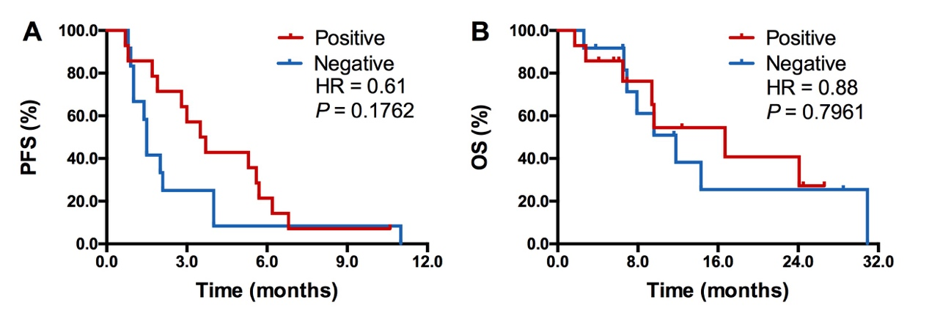
Supplemental Figure S3. Subgroup analysis in patients with BrM and PD-L1 expression result. A, Comparison of PFS between patients with and without high PD-L1 expression (cutoff = 50%) in BrM group; B, Comparison of OS between patients with and without high PD-L1 expression (cutoff = 50%) in BrM group. BrM, brain metastases.

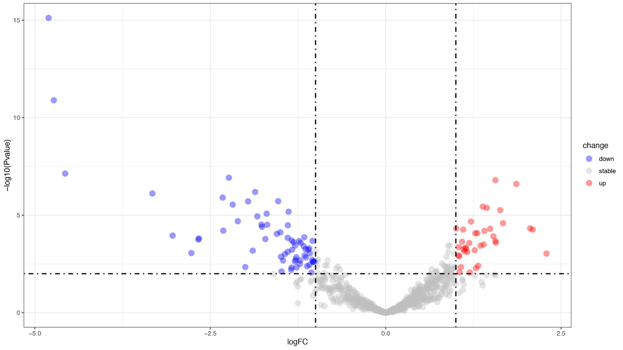
Supplemental Figure S4. Volcano plot showed all of the differential expression genes between eleven paired primary lung cancers and brain metastasis.

Supplemental Table S1. Baseline features of patients received ICI based monotherapy versus combination therapy.
 | Total (n=308, %) | ICI monotherapy (n=156, %) | ICI combination therapy (n=152, %) | P value
Median age, years (range) | 62 (20-89) | 64 (29-89) | 60 (20-80)
Sex
Male | 246 (79.9) | 126 (80.8) | 120 (78.9) | 0.6901
Female | 62 (20.1) | 30 (19.2) | 32 (21.1)
Smoking history
Current/former | 189 (61.4) | 103 (66.0) | 86 (56.6) | 0.0887
Never | 119 (38.6) | 53 (34.0) | 66 (43.4)
ECOG PS
0-1 | 282 (91.6) | 146 (93.6) | 136 (89.5) | 0.1939
2 | 26 (8.4) | 10 (6.4) | 16 (10.5)
Pathology
Adenocarcinoma | 194 (63.0) | 75 (48.1) | 119 (78.3)
Squamous carcinoma | 79 (25.6) | 63 (40.4) | 16 (10.5)
Others | 35 (11.4) | 18 (11.5) | 17 (11.2) | 0.9220
Driver gene alterations detection
EGFR | 28 (9.1) | 8 (5.1) | 20 (13.2)
ALK/ROS1/RET | 4 (1.3) | 1 (0.6） | 3 (2.0)
KRAS | 33 (10.7) | 17 (10.9) | 16 (10.5)
BRAF | 3 (1.0) | 1 (0.6) | 2 (1.3)
HER2 | 5 (1.6) | 0 (0.0) | 5 (3.3)
Wild type | 137 (44.5) | 69 (44.2) | 68 (44.7) | 0.9288
Unknown | 98 (31.8) | 60 (38.6) | 38 (25.0)
PD-L1 expression (IHC)
Positive | 117 (80.7) | 66 (88.0) | 51 (72.9) | 0.0210
Negative | 28 (19.3) | 9 (12.0) | 19 (27.1)
Unknown | 163 | 81 | 82
Liver Metastasis
Yes | 269 (87.3) | 134 (85.9) | 135 (88.8) | 0.4413
No | 39 (12.7) | 22 (14.1) | 17 (11.2)
Corticosteroid use before ICI
Yes | 102 (33.1) | 41 (26.3) | 61 (40.1) | 0.0098
No | 206 (66.9) | 115 (73.7) | 91 (59.9)
BrM before ICI based therapy
Yes | 83 (26.9) | 33 (21.2) | 50 (32.9) | 0.0202
No | 225 (73.1) | 123 (78.8) | 102 (67.1)
Symptoms at start of ICI
Asymptomatic BrM | 50 (60.2) | 23 (69.7) | 27 (54.0) | 0.1527
Symptomatic BrM | 33 (39.8) | 10 (30.3) | 23 (46.0)
ICI treatment line
1 | 83 (26.9) | 21 (13.5) | 62 (40.8) | <0.0001
2 | 124 (40.3) | 83 (53.2) | 41 (27.0)
3 | 64 (20.8) | 28 (17.9) | 36 (23.7)
>3 | 37 (12.0) | 24 (15.4) | 13 (8.5)
Systemic response
PR | 81 (26.3) | 30 (19.2) | 51 (33.6) | 0.0043
SD | 127 (41.2) | 61 (39.1) | 66 (43.4) | 0.0005
PD | 89 (28.9) | 63 (40.4) | 26 (17.1)
NE | 11 (3.6) | 2 (1.3) | 9 (5.9)
BrM, brain metastasis; ECOG PS,Eastern Cooperative Oncology Group performance status; ICI, immune checkpoint inhibitor; IHC, immunohistochemistry; PR, partial response; SD, stable disease; PD, disease progression.

Supplemental Table S2. Univariate and multivariate analyses of clinical parameters on progression-free survival and overall survival in all included patients.
Factor | Univariate analysis |  |  |  | Multivariate analysis
Factor | HR (log rank) | 95% CI | P value |  | HR (log rank) | 95% CI | P value
Progression-free survival
Sex (Female/male) | 1.368 | 1.005-1.862 | 0.047 |  | 1.117 | 0.749-1.664 | 0.588
Age (≥65/<65) | 1.202 | 0.929-1.556 | 0.162
Smoking (yes/no) | 0.771 | 0.595-1.000 | 0.050 |  | 0.788 | 0.560-1.108 | 0.110
ECOG PS (>1/0) | 1.377 | 0.871-2.177 | 0.171
Histology (adeno/non-adeno) | 0.887 | 0.684-1.151 | 0.369
Brain metastasis (yes/no) | 1.639 | 1.322-2.406 | <0.001 |  | 1.734 | 1.315-2.287 | <0.001
Liver metastasis (yes/no) | 1.923 | 1.357-2.725 | <0.001 |  | 1.585 | 1.106-2.271 | 0.012
PD-L1 expression (yes/no or unknown) | 0.901 | 0.696-1.166 | 0.428
Driver gene mutation (yes/no or unknown) | 1.040 | 0.770-1.405 | 0.797
Corticosteroid use before ICI (yes/no) | 1.267 | 0.971-1.655 | 0.082 |  | 1.298 | 0.985-1.710 | 0.064
Treatment line (1/>1) | 0.636 | 0.473-0.855 | 0.003 |  | 0.776 | 0.566-1.063 | 0.114
Treatment (ICI monotherapy/ICI combination) | 1.511 | 1.175-1.943 | 0.001 |  | 1.597 | 1.210-2.108 | 0.001
Overall survival
Sex (Female/male) | 1.088 | 0.750-1.579 | 0.655
Age (≥65/<65) | 1.357 | 1.001-1.840 | 0.049 |  | 1.270 | 0.927-1.741 | 0.137
Smoking (yes/no) | 0.848 | 0.625-1.152 | 0.292
ECOG PS (>1/0) | 1.590 | 0.883-2.860 | 0.122
Histology (adeno/non-adeno) | 0.685 | 0.503-0.933 | 0.016 |  | 0.869 | 0.626-1.204 | 0.398
Brain metastasis (yes/no) | 1.170 | 0.842-1.651 | 0.341
Liver metastasis (yes/no) | 1.455 | 0.970-2.183 | 0.070 |  | 1.473 | 0.979-2.217 | 0.063
PD-L1 expression (yes/no) | 0.692 | 0.502-0.953 | 0.024 |  | 0.712 | 0.515-0.984 | 0.040
Driver gene mutation (yes/no) | 1.122 | 0.779-1.616 | 0.536
Corticosteroid use before ICI (yes/no) | 1.106 | 0.806-1.517 | 0.532
Treatment line (1/>1) | 0.614 | 0.425-0.887 | 0.009 |  | 0.749 | 0.510-1.100 | 0.141
Treatment (ICI monotherapy/ICI combination) | 2.071 | 1.528-2.808 | <0.001 |  | 1.842 | 1.326-2.560 | <0.001
HR: hazard ratio; CI: confidence interval; ECOG PS,Eastern Cooperative Oncology Group performance status; ICI, immune checkpoint inhibitor; No., number.

Supplemental Table S3. Univariate and multivariate analyses of clinical parameters on progression-free survival and overall survival in patients received ICI based monotherapy.
Factor | Univariate analysis |  |  |  | Multivariate analysis
Factor | HR (log rank) | 95% CI | P value |  | HR (log rank) | 95% CI | P value
Progression-free survival
Sex (Female/male) | 0.753 | 0.486-1.167 | 0.205
Age (≥65/<65) | 1.109 | 0.784-1.570 | 0.559
Smoking (yes/no) | 0.705 | 0.485-1.026 | 0.068 |  | 0.711 | 0.487-1.037 | 0.076
ECOG PS (>1/0) | 1.096 | 0.447-2.688 | 0.840
Histology (adeno/non-adeno) | 0.974 | 0.688-1.380 | 0.883
Brain metastasis (yes/no) | 1.746 | 1.168-2.610 | 0.007 |  | 1.614 | 1.058-2.462 | 0.026
Liver metastasis (yes/no) | 1.628 | 1.026-2582 | 0.039 |  | 1.396 | 0.860-2.268 | 0.177
PD-L1 expression (yes/no or unknown) | 0.864 | 0.602-1.240 | 0.428
Driver gene mutation (yes/no or unknown) | 1.076 | 0.667-1.736 | 0.763
Corticosteroid use before ICI (yes/no) | 1.193 | 0.801-1.776 | 0.385
Treatment line (1/>1) | 0.887 | 0.531-1.480 | 0.645
Overall survival
Sex (Female/male) | 0.993 | 0.593-1.661 | 0.978
Age (≥65/<65) | 1.398 | 0.929-2.104 | 0.108
Smoking (yes/no) | 0.935 | 0.606-1.443 | 0.761
ECOG PS (>1/0) | 1.894 | 0.763-4.717 | 0.169
Histology (adeno/non-adeno) | 1.314 | 0.874-1.974 | 0.189
Brain metastasis (yes/no) | 1.792 | 1.135-2.829 | 0.012 |  | 1.653 | 1.012-2.700 | 0.045
Liver metastasis (yes/no) | 1.608 | 0.948-2.729 | 0.078 |  | 1.315 | 0.745-2.319 | 0.345
PD-L1 expression (yes/no) | 0.942 | 0.609-1.458 | 0.788
Driver gene mutation (yes/no) | 1.008 | 0.588-1.727 | 0.976
Corticosteroid use before ICI (yes/no) | 1.249 | 0.803-1.943 | 0.324
Treatment line (1/>1) | 0.797 | 0.424-1.497 | 0.480
HR: hazard ratio; CI: confidence interval; ECOG PS, Eastern Cooperative Oncology Group performance status; ICI, immune checkpoint inhibitor; No., number.

Supplemental Table S4. Univariate and multivariate analyses of clinical parameters on progression-free survival and overall survival in patients received ICI based combination therapy.
Factor | Univariate analysis |  |  |  | Multivariate analysis
Factor | HR (log rank) | 95% CI | P value |  | HR (log rank) | 95% CI | P value
Progression-free survival
Sex (Female/male) | 0.731 | 0.472-1.134 | 0.162
Age (≥65/<65) | 1.522 | 1.024-2.262 | 0.038 |  | 1.212 | 0.795-1.848 | 0.371
Smoking (yes/no) | 0.773 | 0.535-1.117 | 0.171
ECOG PS (>1/0) | 1.335 | 0.774-2`.3102 | 0.298
Histology (adeno/non-adeno) | 0.979 | 0.627-1.529 | 0.926
Brain metastasis (yes/no) | 1.873 | 1.283-2.736 | 0.001 |  | 2.055 | 1.355-3.115 | 0.001
Liver metastasis (yes/no) | 2.292 | 1.341-3.917 | 0.002 |  | 2.336 | 1.322-4.128 | 0.003
PD-L1 expression (yes/no or unknown) | 0.708 | 0.484-1.034 | 0.074 |  | 0.588 | 0.396-0.874 | 0.009
Driver gene mutation (yes/no or unknown) | 1.117 | 0.751-1.662 | 0.584
Corticosteroid use before ICI (yes/no) | 1.552 | 1.069-2.254 | 0.021 |  | 1.494 | 1.005-2.221 | 0.047
Treatment line (1/>1) | 0.627 | 0.426-0.922 | 0.018 |  | 0.688 | 0.463-1.021 | 0.063
Overall survival
Sex (Female/male) | 0.772 | 0.447-1.331 | 0.352
Age (≥65/<65) | 1.100 | 0.687-1.762 | 0.691
Smoking (yes/no) | 0.614 | 0.390-0.966 | 0.035 |  | 0.632 | 0.402-0.996 | 0.048
ECOG PS (>1/0) | 1.887 | 0.866-4.112 | 0.110
Histology (adeno/non-adeno) | 0.976 | 0.558-1.705 | 0.931
Brain metastasis (yes/no) | 1.006 | 0.623-1.623 | 0.981
Liver metastasis (yes/no) | 1.207 | 0.637-2.290 | 0.564
PD-L1 expression (yes/no) | 0.501 | 0.312-0.805 | 0.004 |  | 0.513 | 0.320-0.825 | 0.006
Driver gene mutation (yes/no) | 1.042 | 0.628-1.729 | 0.872
Corticosteroid use before ICI (yes/no) | 1.218 | 0.767-1.934 | 0.403
Treatment line (1/>1) | 0.728 | 0.450-1.176 | 0.194
HR: hazard ratio; CI: confidence interval; ECOG PS, Eastern Cooperative Oncology Group performance status; ICI, immune checkpoint inhibitor; No., number.

Supplemental Table S5. Univariate and multivariate analyses of clinical parameters on progression-free survival and overall survival in patients with BM.
Factor | Univariate analysis |  |  |  | Multivariate analysis
Factor | HR (log rank) | 95% CI | P value |  | HR (log rank) | 95% CI | P value
Progression-free survival
Sex (Female/male) | 2.058 | 1.219-3.475 | 0.007 |  | 1.527 | 0.801-2.907 | 0.199
Age (≥65/<65) | 1.035 | 0.615-1.740 | 0.898
Smoking (yes/no) | 0.532 | 0.334-0.848 | 0.008 |  | 0.596 | 0.331-1.074 | 0.085
ECOG PS (>1/0) | 1.408 | 0.609-3.253 | 0.423
Histology (adeno/non-adeno) | 0.805 | 0.463-1.400 | 0.442
No. of BrMs (<3/>3) | 0.999 | 0.638-1.564 | 0.997
Liver metastasis (yes/no) | 1.583 | 0.862-2.909 | 0.139
PD-L1 expression (yes/no or unknown) | 0.671 | 0.401-1.122 | 0.128
Driver gene mutation (yes/no or unknown) | 1.364 | 0.831-2.240 | 0.220
Corticosteroid use before ICI (yes/no) | 1.319 | 0.811-2.147 | 0.265
Symptoms at start of ICI (yes/no) | 1.070 | 0.677-1.693 | 0.772
Treatment line (1/>1) | 0.794 | 0.471-1.336 | 0.385
Treatment (ICI monotherapy/ICI combination) | 1.513 | 0.952-2.404 | 0.080 |  | 1.706 | 1.061-2.745 | 0.028
Overall survival
Sex (Female/male) | 1.153 | 0.621-2.139 | 0.652
Age (≥65/<65) | 1.187 | 0.632-2.228 | 0.595
Smoking (yes/no) | 0.974 | 0.562-1.689 | 0.925
ECOG PS (>1/0) | 4.623 | 0.637-33.553 | 0.130
Histology (adeno/non-adeno) | 0.831 | 0.439-1.570 | 0.568
No. of BrMs (<3/>3) | 0.900 | 0.521-1.554 | 0.705
Liver metastasis (yes/no) | 2.229 | 1.146-4.333 | 0.018 |  | 1.234 | 0.599-2.541 | 0.568
PD-L1 expression (yes/no or unknown) | 0.710 | 0.419-1.491 | 0.468
Driver gene mutation (yes/no or unknown) | 1.079 | 0.581-2.003 | 0.810
Corticosteroid use before ICI (yes/no) | 1.272 | 0.686-2.358 | 0.444
Symptoms at start of ICI (yes/no) | 1.038 | 0.596-1.807 | 0.896
Treatment line (1/>1) | 0.732 | 0.342-1.563 | 0.420
Treatment (ICI monotherapy/ICI combination) | 3.441 | 1.923-6.157 | <0.001 |  | 3.204 | 1.696-6.052 | <0.001
HR: hazard ratio; CI: confidence interval; ECOG PS, Eastern Cooperative Oncology Group performance status; ICI, immune checkpoint inhibitor; No., number; BrMs, brain metastasis.

