SUPPLEMENTAL MATERIAL
Targeting and cytotoxicity of CAR-T grafted with PD-1 extramembrane domain
Ang Zhang^{1,3†}, Shenyu Wang^{1, 2†}, Yao Sun^{2†}, Yikun Zhang^{3†},Long Zhao², Yang Yang², Lei Xu² , Yangyang Lei², Jie Du⁴, Hu Chen^{1‡},，Lian Duan¹, Mingyi He³, Lintao Shi³, Lei Liu³, Quanjun Wang⁴*, Liangding Hu²*, Bin Zhang²*
1 Academy of Military Medical Sciences, Academy of Military Sciences, Beijing 100850; PR China.
2 Senior Department of Hematology, the Fifth Medical Center of Chinese PLA General Hospital, Beijing 100071; PR China.
3 Department of Hematology, Strategic Support Force Medical Center, Beijing, China
4 SAFE Pharmaceutical Research Institute Co., Ltd.
†These authors contributed equally to this work.
‡ Deceased
Correspondence should be addressed to Zhang Bin: Senior Department of Hematology, the Fifth Medical Center of Chinese PLA General Hospital, Beijing 100071; PR China. Tel +86 010 66 947 125 Email zb307ctc@163.com;
Hu Liangding: Senior Department of Hematology, the Fifth Medical Center of Chinese PLA General Hospital, Beijing 100071; PR China. Tel +86 010 66 947 171 Email huliangding@sohu.com;
Wang Quanjun: SAFE Pharmaceutical Research Institute Co., Ltd, chief scientist, China Tel: +86 18611782967 Email wangquanjunbeijing@163.com

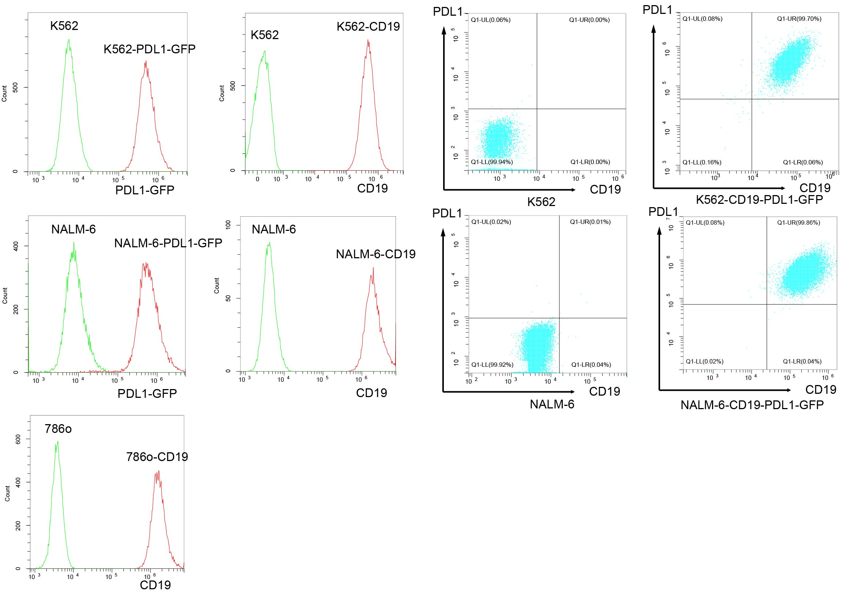Figure S1 Characterization of different tumor cells.
The expression of CD19 and PDL1 on engineered tumor cells was determined by flow cytometry. The GFP protein were co-expressed with PDL1 as an indicator of protein level. GFP, green fluorescent protein.

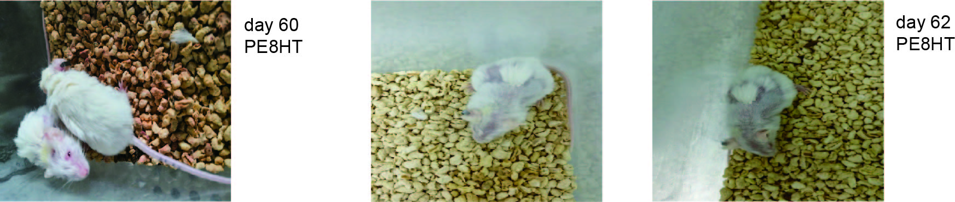
Figure S2 the mice administered PE8HT CAR-T cells presented severe side effects at day 60 and 62, including depilation and irritability.

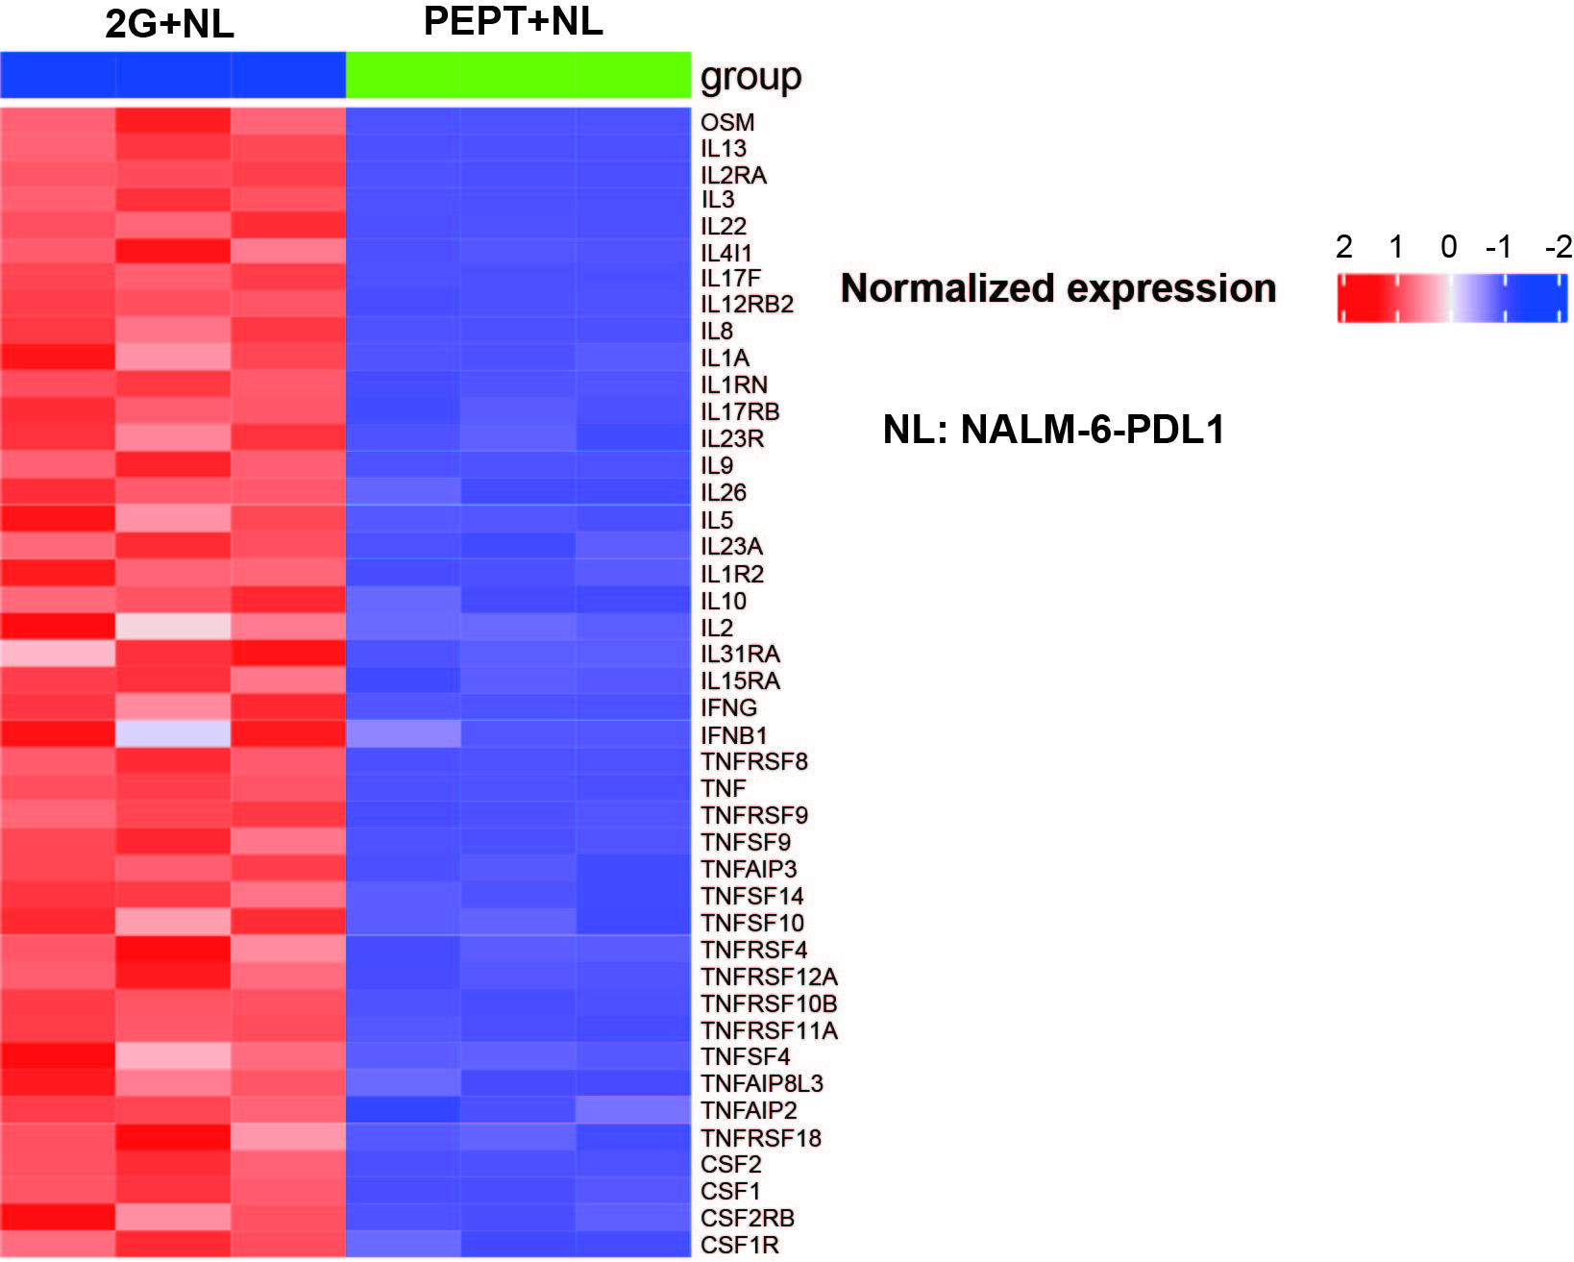
Figure S3 Heat map of selected cytokines enriched in genes significantly upregulated or downregulated in 2G T vs. PEPT CAR-T cells after stimulation with NALM-6-PDL1 cells at E:T of 1:1 for 48 hours.
Gene set enrichment analysis (GSEA) revealed that PEPT CAR-T cells exhibited a decrease transcriptome level of proinflammatory cytokines compared to 2G CAR-T cells when stimulated with NALM-6-PDL1 cells. For each pathway, a single sample enrichment score was calculated, and the mean was taken per response group. A color gradient ranging from dark blue to dark red indicates the mean normalized enrichment score (ranging from –2 to +2) of pathways enriched in induced (red) or repressed (blue) genes. The result is mean values ± SD of triplicate from a single experiment.

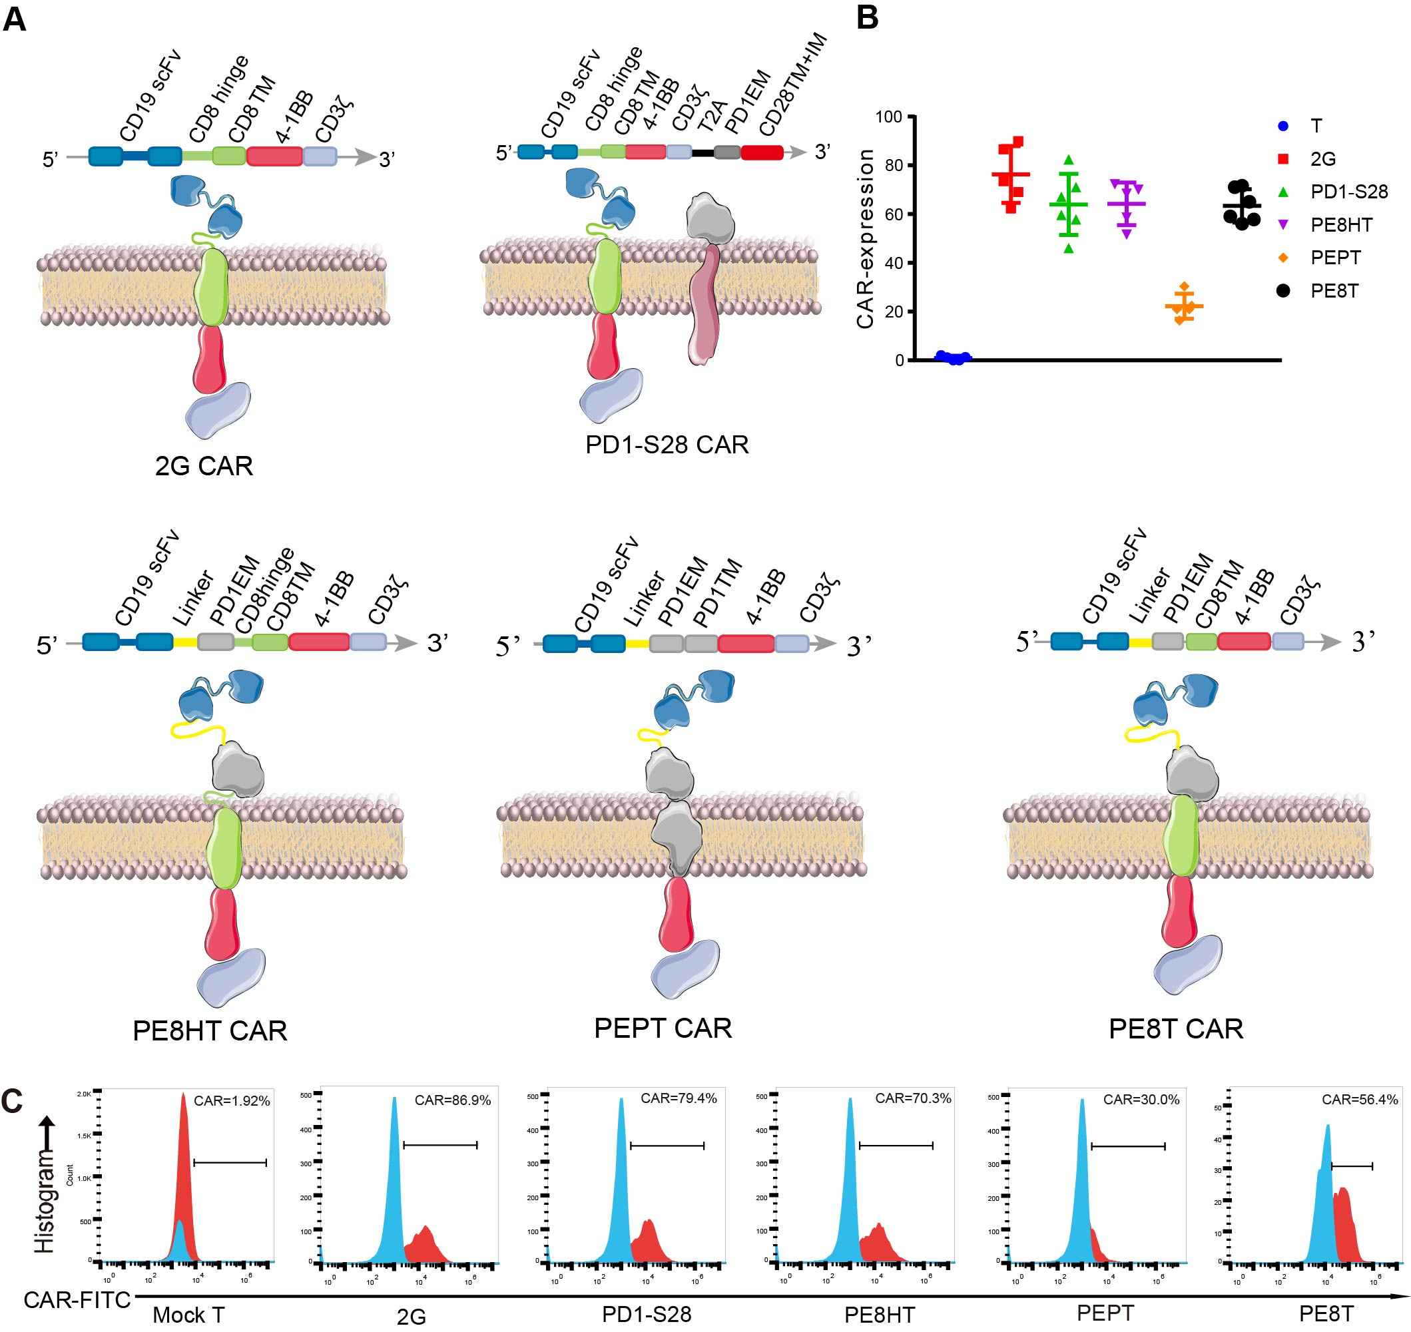
Figure S4 Schematic diagram and expression efficiency of 2G, PD1-S28, PE8HT, PEPT and PE8T
A Diagrammatic model of 2G, PD1-S28, PE8HT, PEPT and PE8T Schematic of five chimeric antigen receptors (CARs) containing variations in the hinge, extramembrane, and transmembrane domains.
- C Expression efficiency of 2G, PD1-S28, PE8HT, PEPT and PE8T on T cells 5-6 days after culture in vitro determined by flow cytometry (mean ± SD, n = 5). B Results are representative of five experiments with T cells from at least three different healthy donors. C Representative plots are shown.

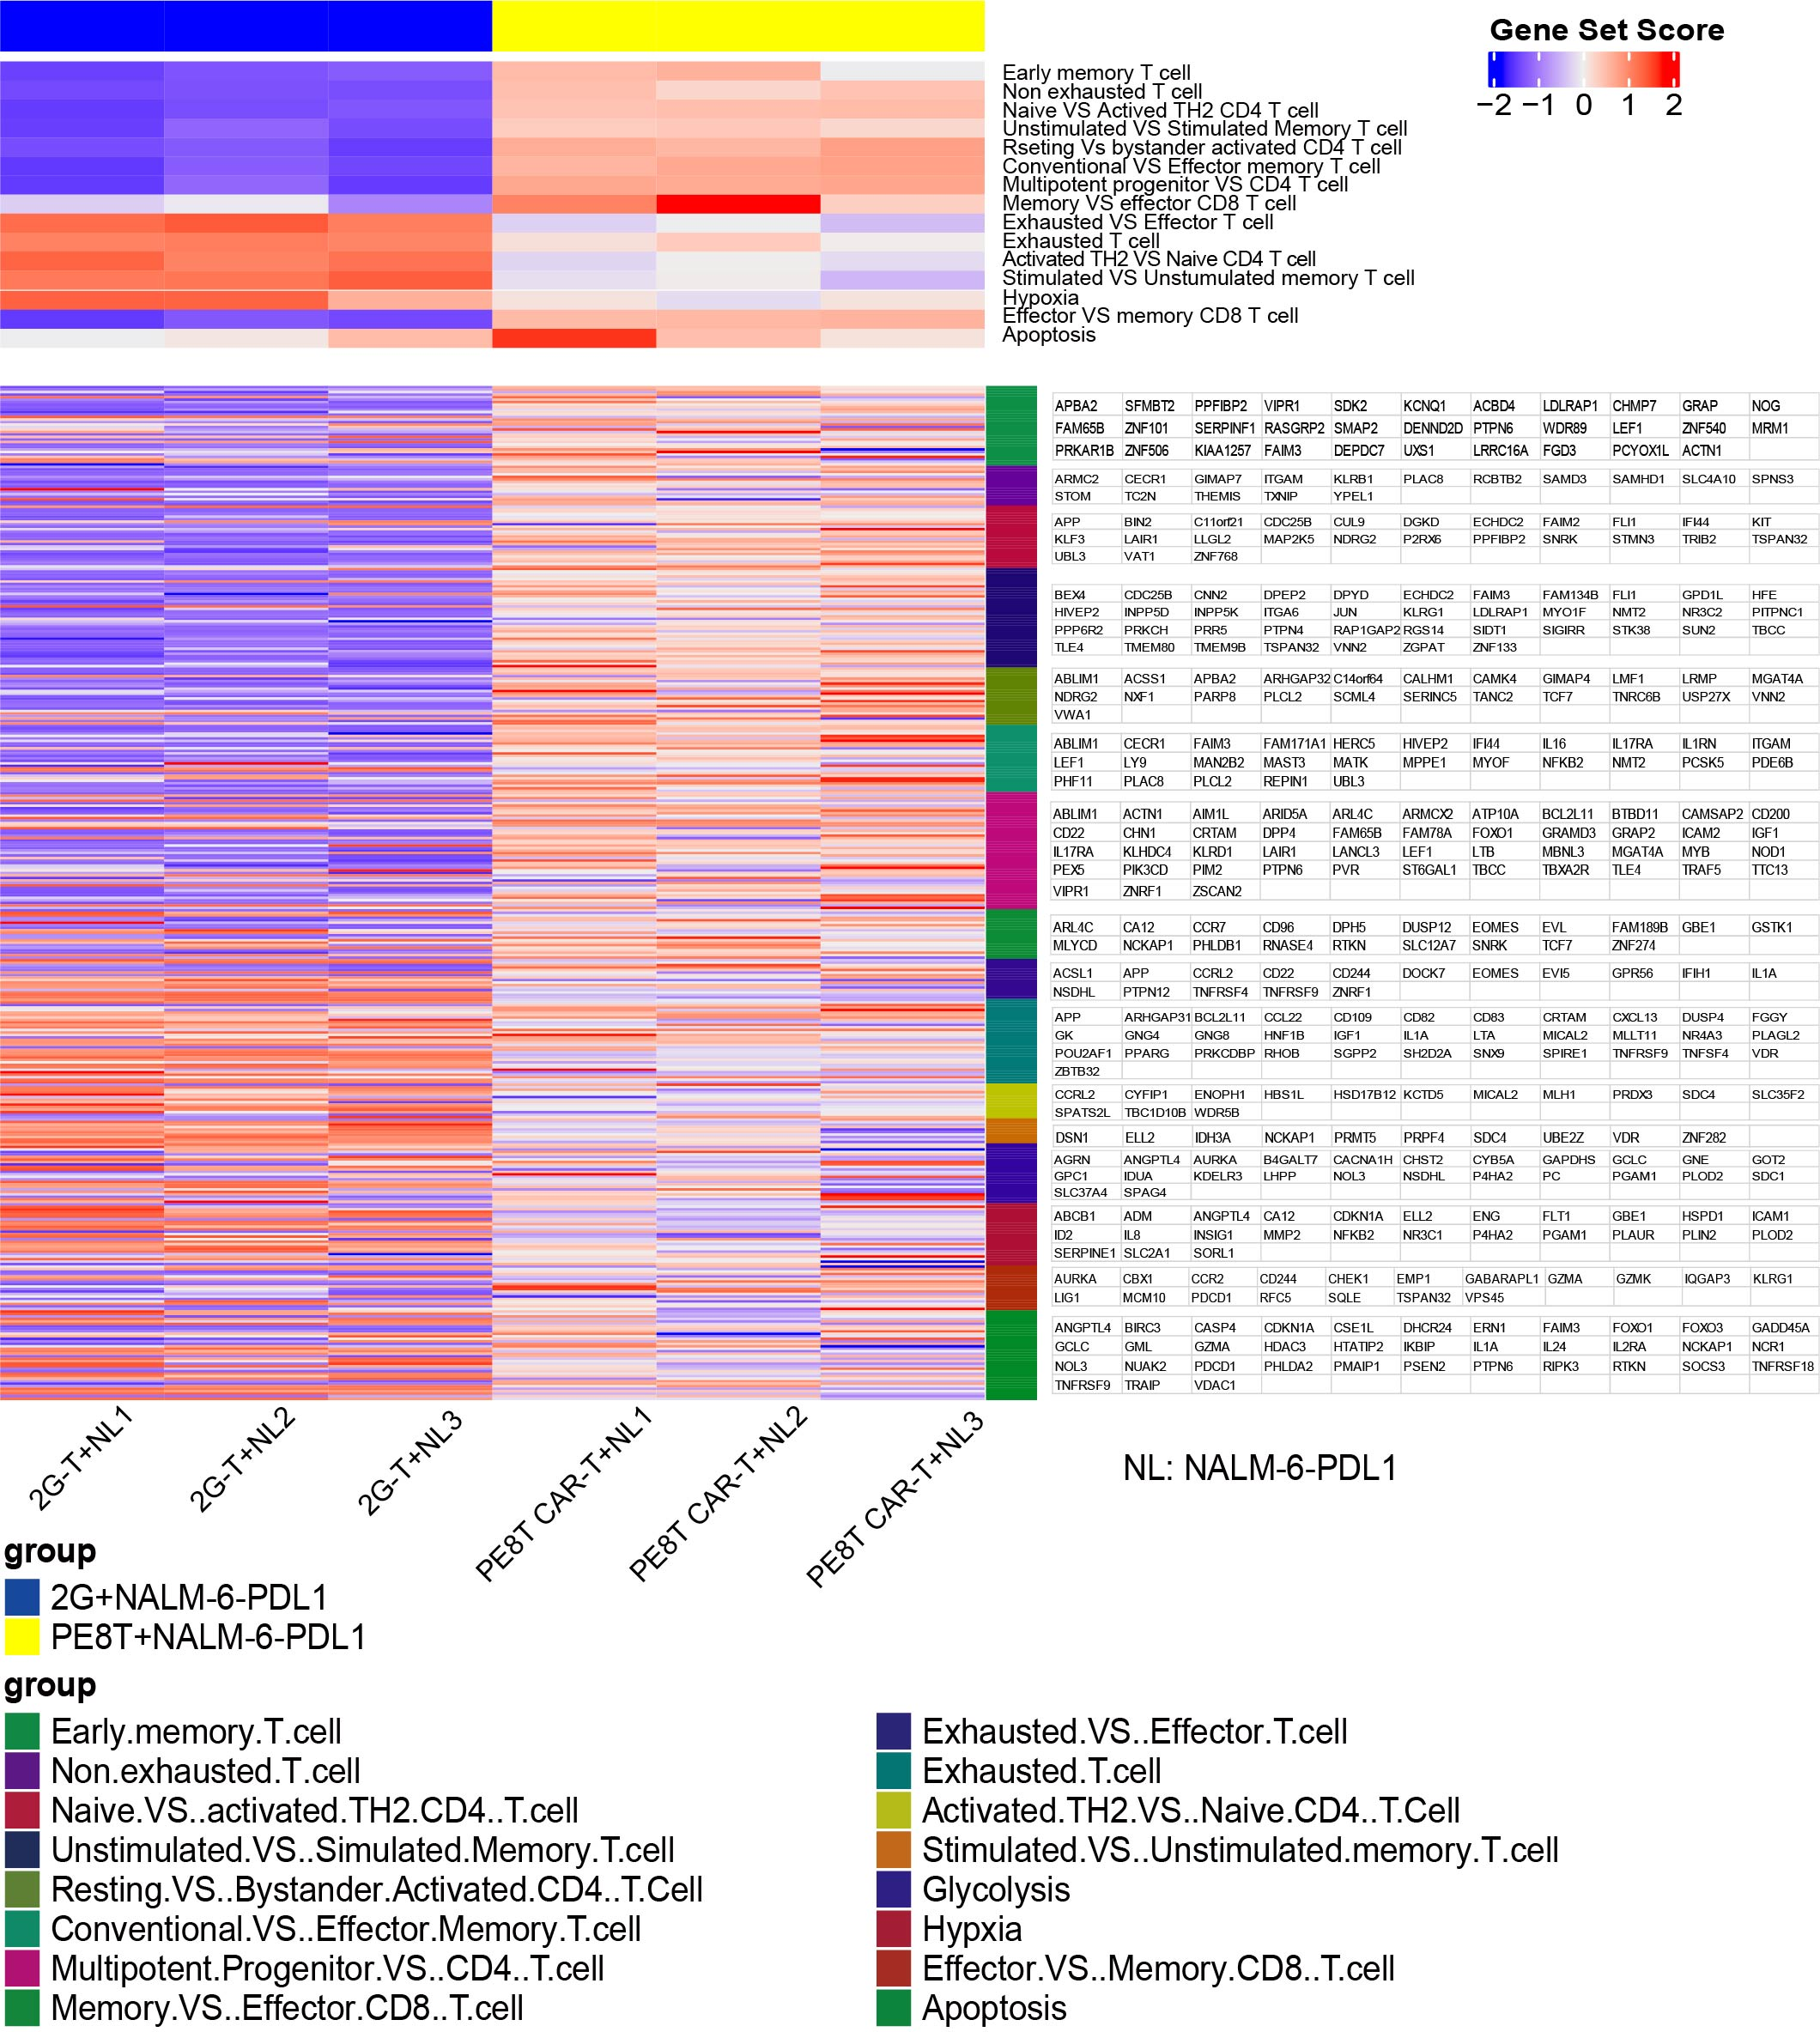
Figure S5 Heat map of selected pathways enriched in genes significantly upregulated or downregulated in 2G T vs. PE8T CAR-T cells after stimulation with NALM-6-PDL1 cells at E: T of 1:1 for 48 hours.
PE8T CAR-T cells exhibited enrichment in memory-related genes and demonstrated lower levels of effector differentiation, exhaustion, and apoptosis compared to 2G CAR-T cells when challenged with CD19+PDL1+ tumor cells. For each pathway, a single sample enrichment score was calculated, and the mean was taken per response group. A color gradient ranging from dark blue to dark red indicates the mean normalized enrichment score (ranging from –2 to +2) of pathways enriched in induced (red) or repressed (blue) genes.

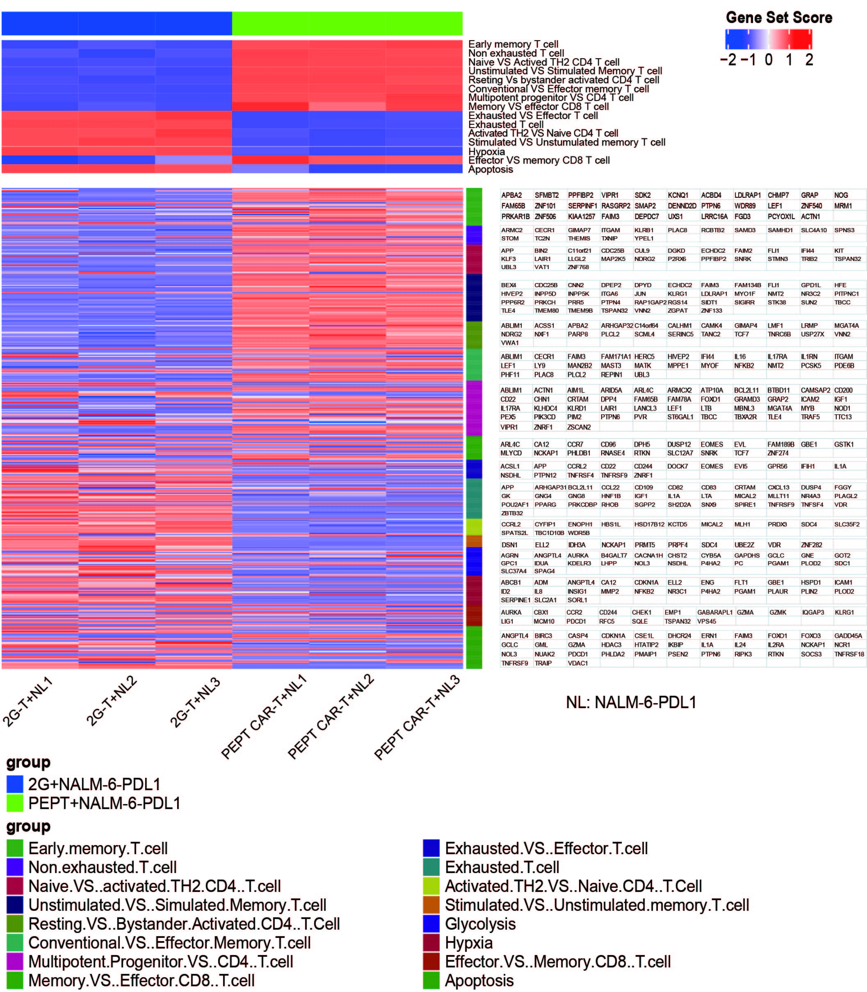
Figure S6 Heat map of selected pathways enriched in genes significantly upregulated or downregulated in 2G T vs. PEPT CAR-T cells after stimulation with NALM-6-PDL1 cells at E: T of 1:1 for 48 hours.
PEPT CAR-T cells exhibited enrichment in memory-related genes and demonstrated lower levels of effector differentiation, exhaustion, and apoptosis compared to 2G CAR-T cells when challenged with CD19+PDL1+ tumor cells. For each pathway, a single sample enrichment score was calculated, and the mean was taken per response group. A color gradient ranging from dark blue to dark red indicates the mean normalized enrichment score (ranging from –2 to +2) of pathways enriched in induced (red) or repressed (blue) genes.

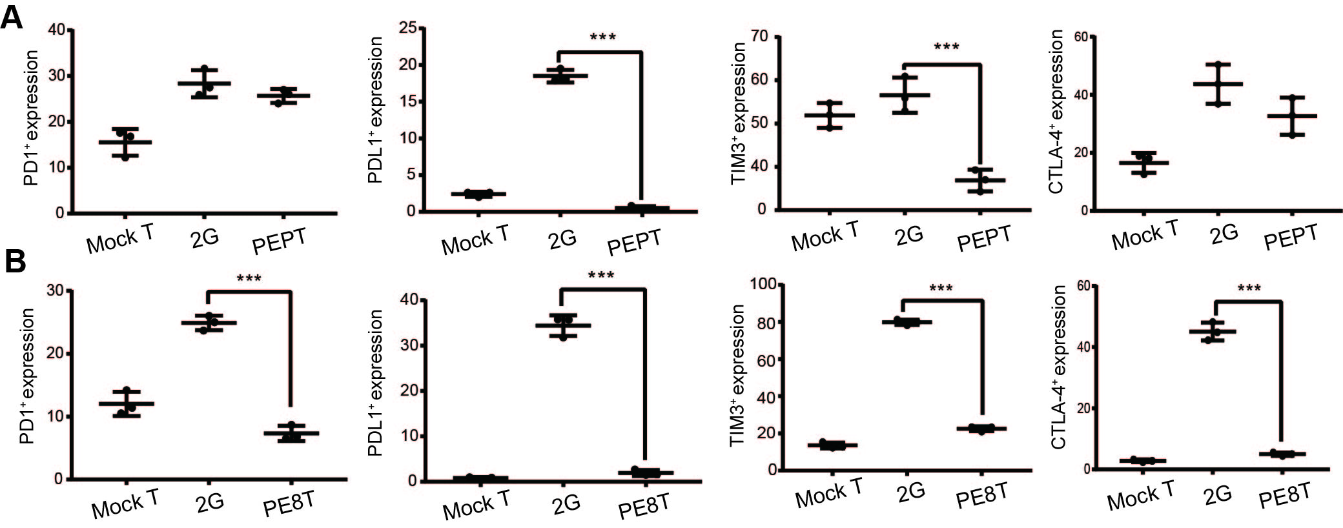
Figure S7 PEPT and PE8T CAR-T cells incubated with tumor cells exhibit a phenotype of less differentiation and exhaustion by flow cytometry
The expression of inhibitor receptors, including PD-1, PD-L1, LAG-3, and CTLA-4 on different CAR T cells was measured by flow cytometry after incubation with NALM-6 cells at E:T of 1:1 for 24 h (mean ± SD, n = 3). Data are depicted from three independent experiments with T cells from three healthy donors. A, 2G T vs. PEPT CAR-T, B, 2G T vs. PE8T CAR-T.

