Intratumoral Prevotella intermedia promotes the progression of oral squamous cell carcinoma by inhibiting the expression of tumor suppressors and affecting the tumor microenvironment

Yifan Zhou, Yao Qin, Jingjing Ma, Zhiyuan Li, Weiwei Heng, Lei Zhang, Hong Liu, Ruowei Li, Miaomiao Zhang, Qiao Peng, Pei Ye, Ning Duan, Ting Liu*, Wenmei Wang*, Xiang Wang*

Supplementary information

Supplementary Figure S1. 16S rRNA partial sequence of P. intermedia in the NCBI database.
Supplementary Figure S2. The number of differentially expressed genesinduced by heat-killed P. intermedia in the transplanted OSCC tumors of mice by transcriptomic analyses.
Supplementary Figure S3. Chord diagrams showing the effectof heat-killed P. intermedia on the transcriptomics of differential genes and pathways.
Supplementary Table S1. Heat-killed P. intermedia-induced differentially expressed genes in transplanted OSCC tumormodel mice. (Classic and putative tumorsuppressor genes are in red and orange, respectively.)

Supplementary Figure S1. 16S rRNA partial sequence of P. intermedia in the NCBI database. In our present study, the16S rRNA-targeted oligonucleotide probe (RNAscope™ Probe- B-P.intermedia-16SrRNA-C1) used for Prevotella intermedia was designed and developed based on the sequence in the NCBI database, the specificity of which can be confirmed by NCBI database searches and RNAscope studies.

Supplementary Figure S2. The number of differentially expressed genesinduced by heat-killed P. intermedia in the transplanted OSCC tumors of mice by transcriptomic analyses.

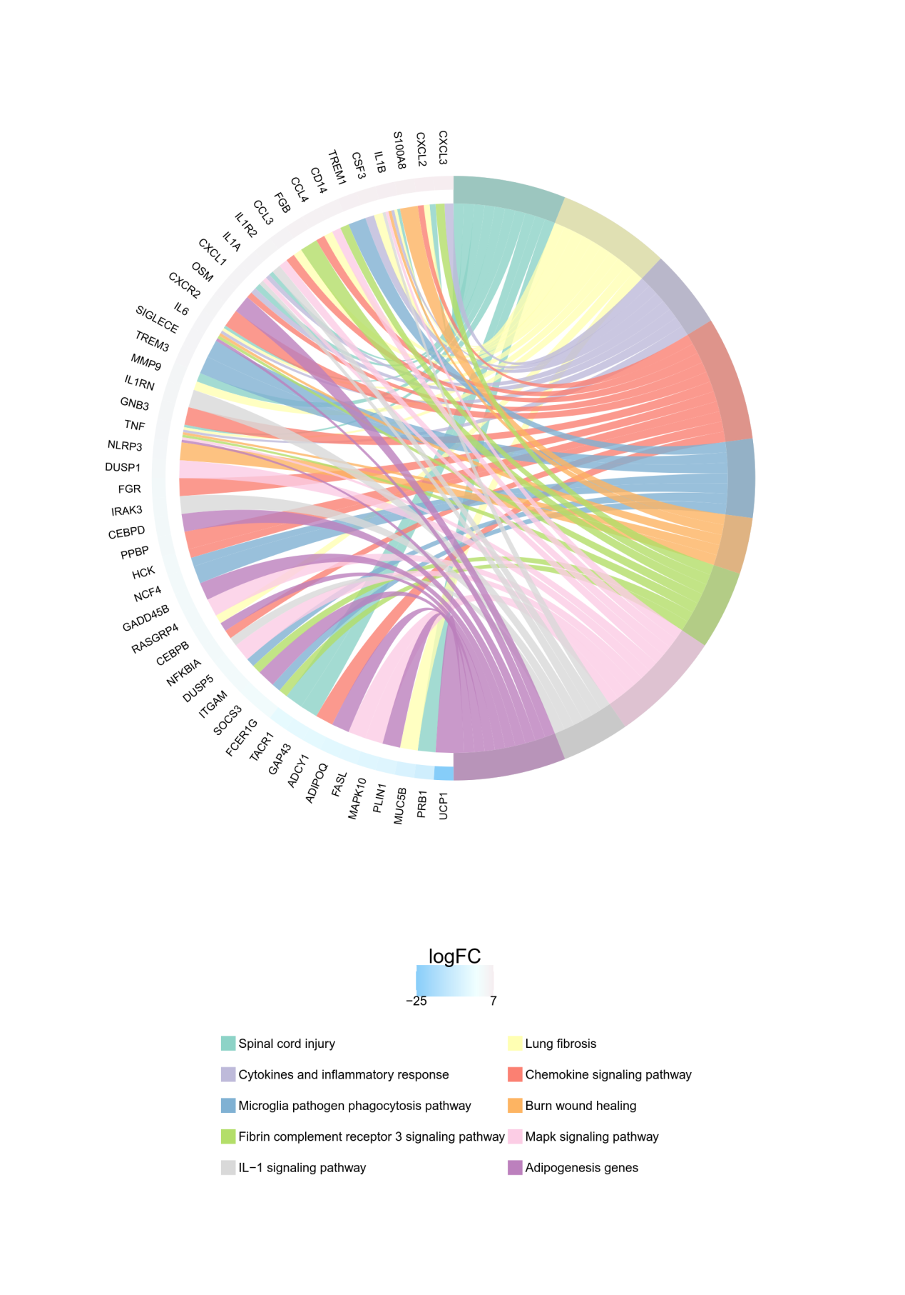
Supplementary Figure S3. Chord diagrams showing the effectof heat-killed P. intermedia on the transcriptomics of differential genes and pathways.

