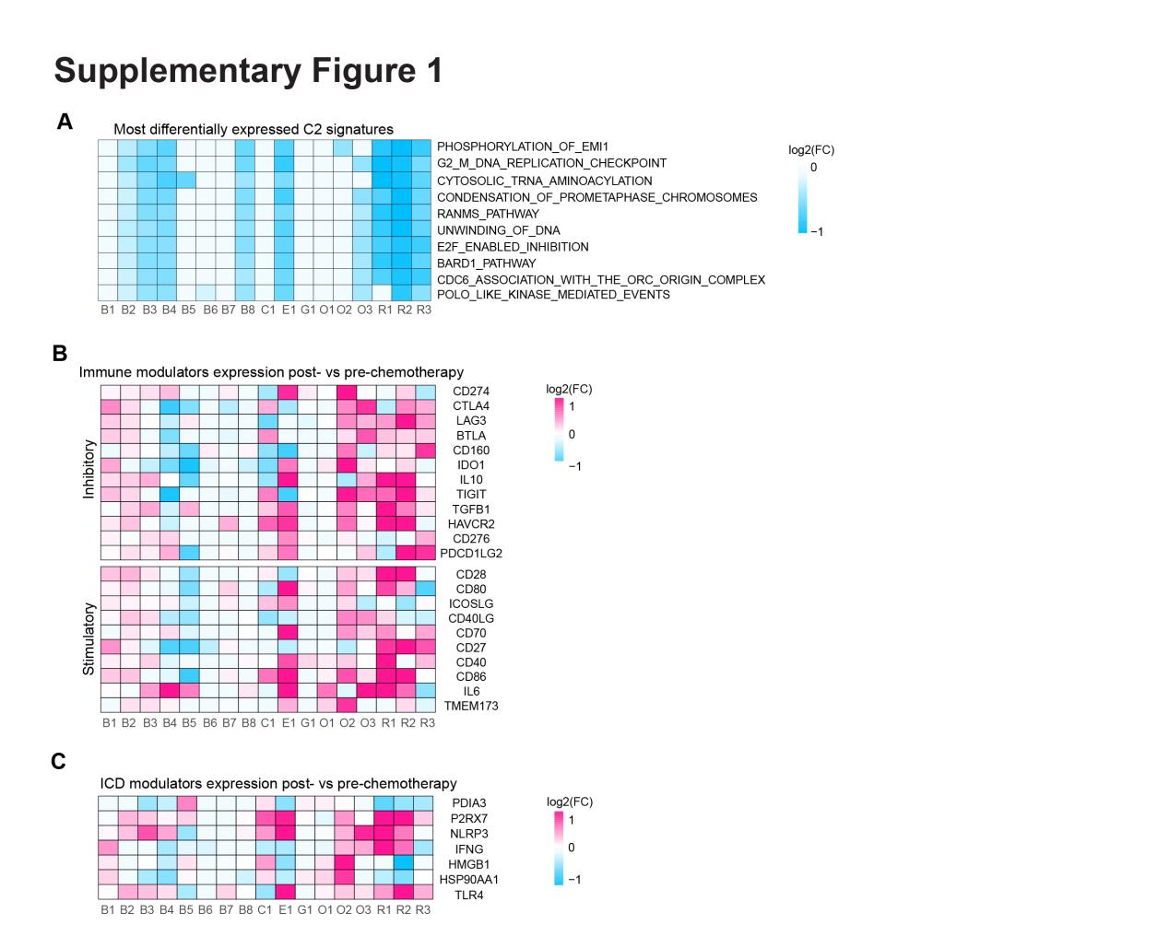Figure S1. Canonical pathway signature scores, immune infiltrates and modulators changes induced by chemotherapy
- Heat map illustrating log2(FC) of 10 most widely significantly differentially expressed canonical pathway signature scores across 17 datasets.
- Heat map shows the changes in expression (log2(FC)) of inhibitory and stimulatory immune modulators in patients before and after chemotherapy.
- Heat map shows the changes in expression (log2(FC)) of seven immunogenic cell death (ICD) modulators between post- and pre-chemotherapy patients.

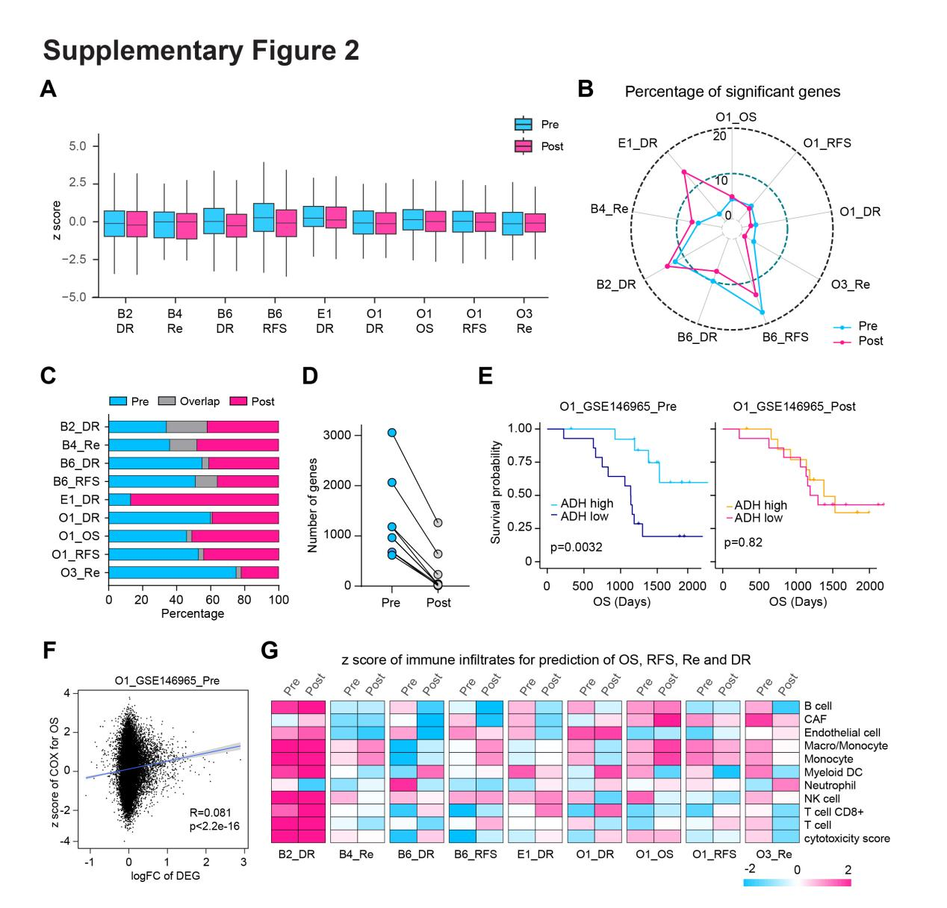
Figure S2. Predictivity of features in pre- and post-chemotherapy samples for drug response and survival
- Distrbution of z score of whole transcriptomic genes for the prediction of overall survival (OS), recurrence free survival (RFS), recurrence (Re) and drug response (DR) in pre-chemotherapy and post-chemotherapy patients samples across nine datasets in three cancers.
- Radar plot showing the percentage of significant gene (p<0.05) for the prediction of OS, RFS, Re and DR in pre-chemotherapy and post-chemotherapy patients samples across 9 datasets in three cancers.
- Bar plot displaying the fraction of shared significant prognostic genes (overlap) between significant genes derived from patient samples before chemotherapy and significant genes derived from patient samples after chemotherapy.
- The number of significant prognostic genes in patient samples before and after chemotherapy was compared across nine datasets in three types of cancer. Each dot represents one dataset.
- Kaplan-Meier plots displaying the prognostic ability of ADH in pre-chemotherapy patient sample and in post-chemotherapy patient sample in dataset GSE146965.
- Pearson correlation between the gene expression changes (log2(FC) of post- vs pre-chemotherapy) and the z score of genes in COX regression models for OS in pre-chemetherapy patient samples.
- Heat map showing the z score of immune infiltrates for prediction of OS, RFS, Re and DR in pre-chemotherapy and post-chemotherapy patients samples across nine datasets in three cancers.

